This file will walk you through creating a WolframAlpha AppId for use in the file WolframAlpha.cs

1. go to https://developer.wolframalpha.com/portal/signup.html and create an account. A free non-commercial account will be fine.

2. verify the email on your account. Wolfram will not recognize your AppId until this is done.

3. Go to https://developer.wolframalpha.com/portal/myapps/ and click "Get an AppId" near the top righthand corner.

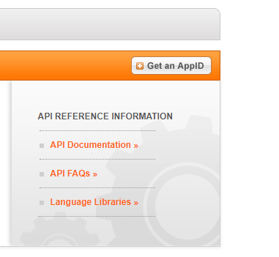

4. Enter the application name and description and click "Get AppId"

5. Copy the "APPID" (second entry) in the pop-up window before clicking "OK"

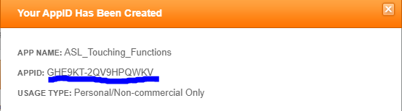

If you clicked "OK" before copying the AppId, click the "Edit" button below your app name and copy the AppID.

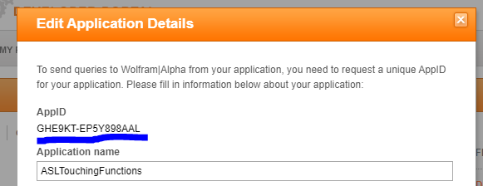

6. In file WolframAlpha.cs, replace the AppId in all WolframAlphaClient declarations in quotation marks and save the file.

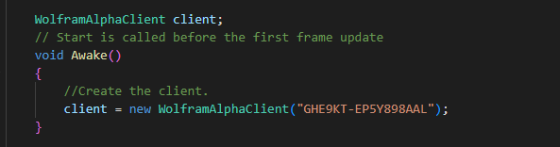

If you are creating a new project and wish to utilize this functionality, you will need to do the following:

1. Download NuGet from https://github.com/GlitchEnzo/NuGetForUnity

2. Drag the download object into your unity scene and click "install". If correctly done a new dropdown tab should appear between "Component" and "Window".

3. Click NuGet->Manage NuGet Packages.

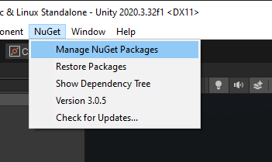

4. Click the "Show Prerelease" box and enter "wolframalpha" into the search bar.

5. Install "Genbox.WolframAlpha" by Ian Qvist

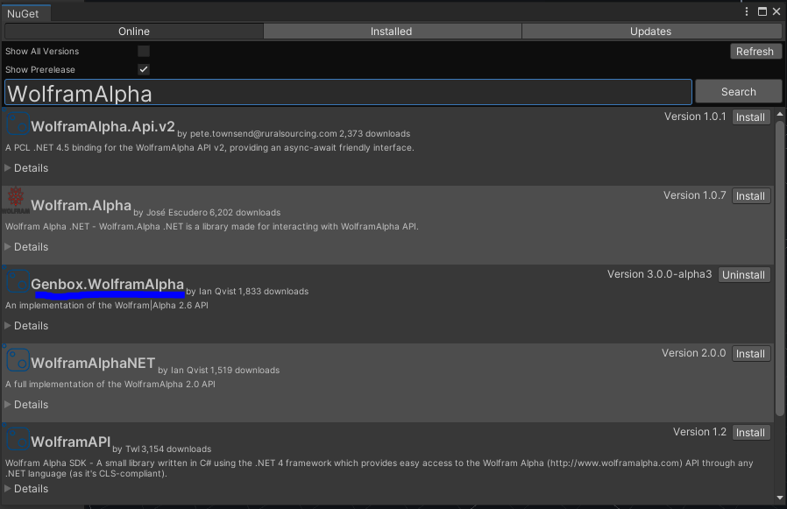

A full API for Genbox.WolframAlpha can be found at https://github.com/Genbox/WolframAlpha