# UFCFTR-30-3

# Distribute & Enterprise Software Development

# Sprint Review Form

|  |  |
| --- | --- |
| Group: | 32 |
| Sprint: | Sprint 1 |
| Members: | Nuraly Baktygaliyev, Yerzhan Bugenov, Denis Zhmurenko, Ilyas Utenov, Artem Kaluhin |

<<Burn-down Chart>>

The burndown chart for this sprint may appear irregular at first glance because we spent the initial 3–4 days finalizing our board design and breaking down tasks in alignment with our sprint goals. After completing all the planned work for Sprint 1, we pulled in some backlog items to ensure continuous progress. As a result, the chart shows a steadier decline once tasks were fully defined, and then a slight uptick or plateau when new tasks were introduced, reflecting our ongoing effort to keep the workload balanced and maintain momentum.

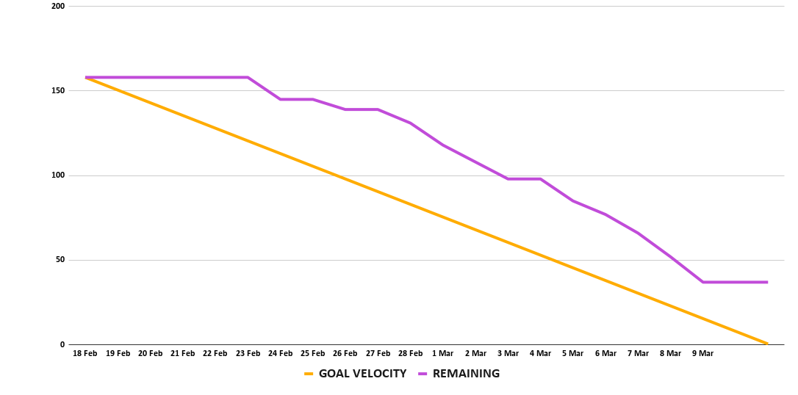

<<Backlog list>>

Kanban Board in our project serves as a visual tool for assigning tasks to statuses and tracking current progress. Columns (Todo, In Progress, Review, Test, Done) help us see where each task stands and what the overall workload balance is in the team.

With up-to-date statuses and regular task status updates, we were able to respond quickly and keep the entire team informed of progress. During Sprint 1, this allowed us to easily complete scheduled tasks on time and even take on additional tasks

For the live Kanban Board and Roadmap, please refer to the links below

Kanban Board:  
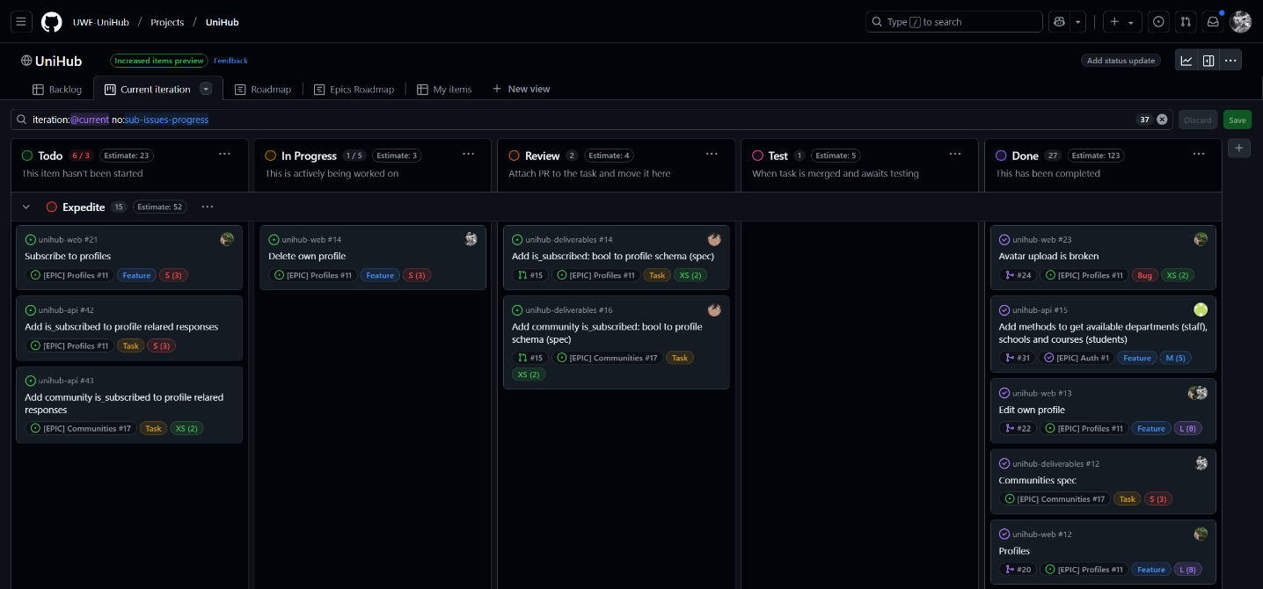

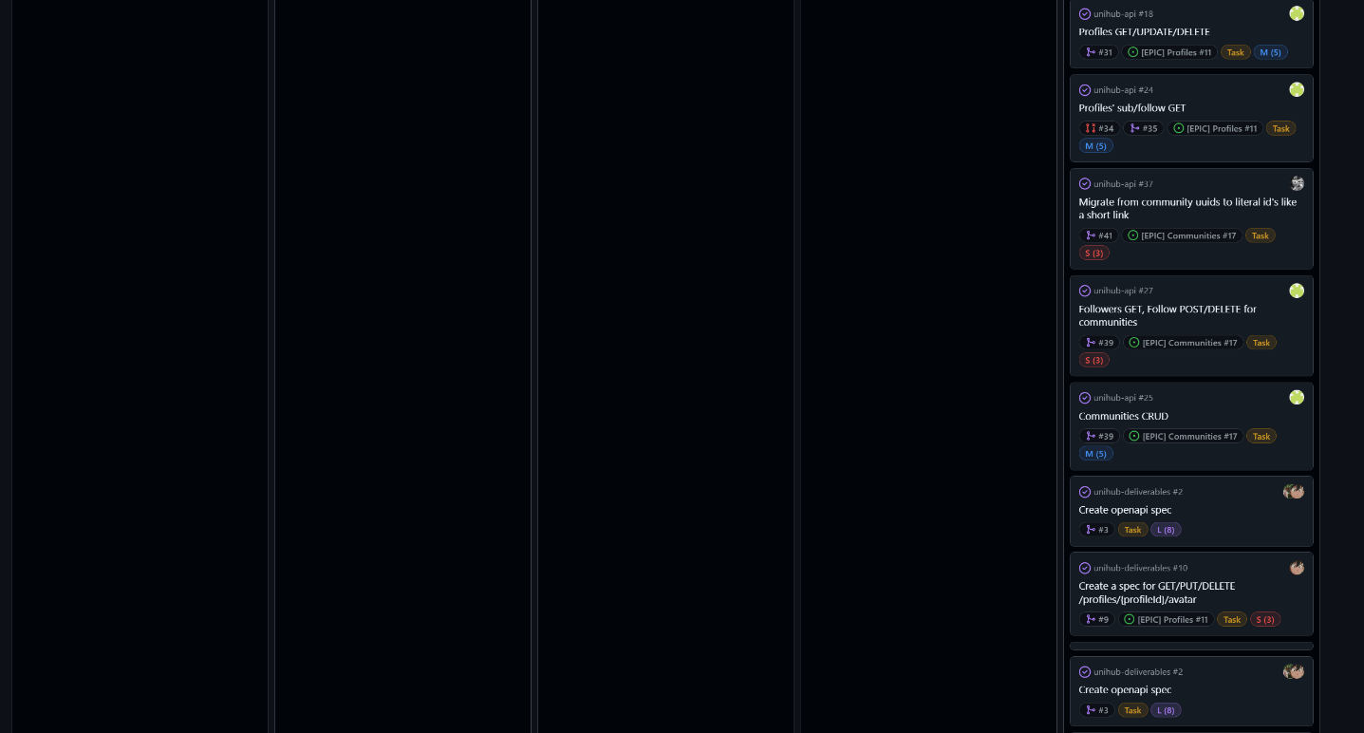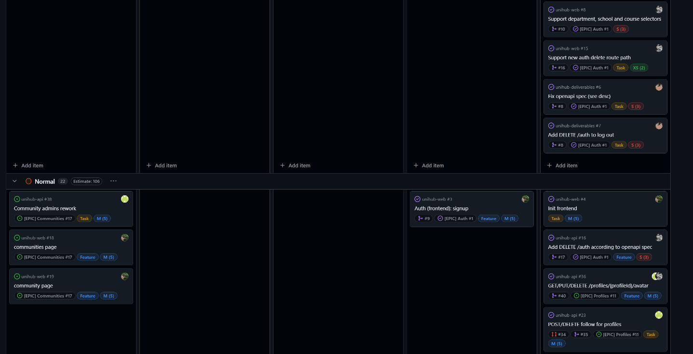

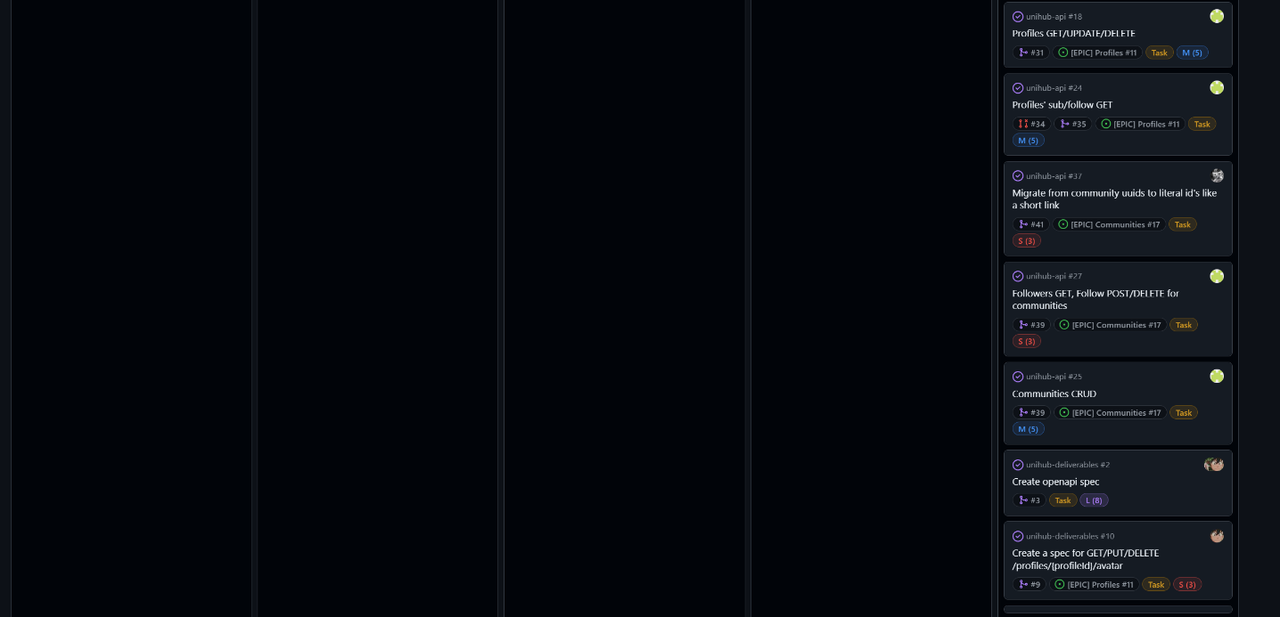

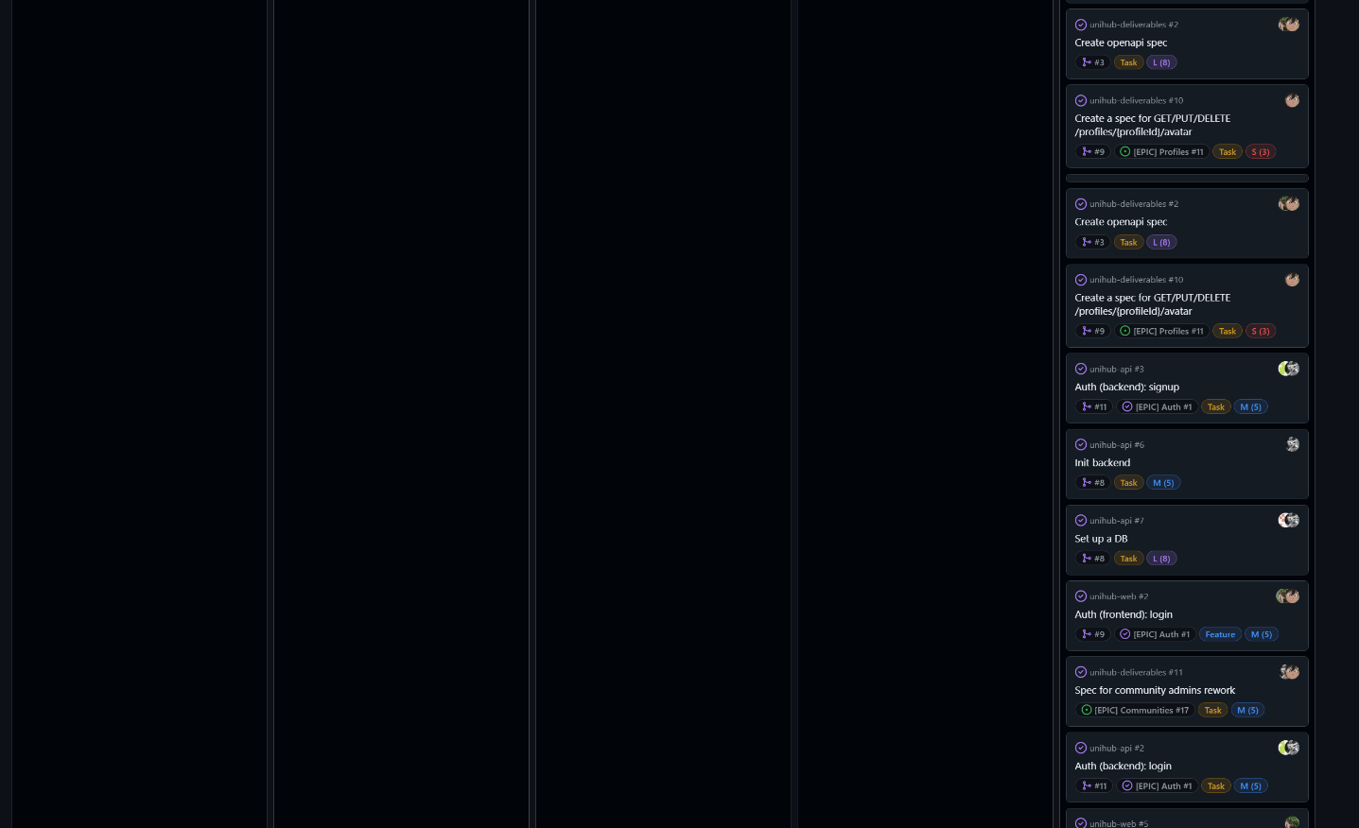

Roadmap:

<<Communication Issues>>

During this sprint, we faced an issue where Artem worked on tasks that were not yet planned in the sprint backlog, completing work ahead of schedule. This caused some misalignment with our sprint plan and made it harder to track progress effectively. However, we addressed the issue by ensuring better synchronization within the team and reinforcing adherence to the sprint backlog. Now, all tasks are properly planned, and this problem has been resolved.

<<Reflections>>

Throughout this sprint, our team not only met but significantly surpassed the initial goals outlined in our backlog and roadmap. From the very beginning, we demonstrated a clear structure in our planning process, confidently identifying all roles within the team and meticulously assigning tasks to maximize efficiency. Our Kanban Board was well organized, and we kept it updated with precise status changes, giving us full visibility of our progress at every stage. We completed each planned task ahead of schedule, and because our capacity allowed it, we brought some of the second-sprint tasks forward, ensuring continuous momentum.

In terms of team dynamics, the collaboration has been outstanding. Regular stand-ups and consistent communication channels (text discussions, quick voice calls, and code reviews) helped us maintain alignment and promptly address any potential bottlenecks. We capitalized on a robust feedback loop: everyone was open to suggestions, and improvements were swiftly integrated into our workflow. This high level of synergy and responsiveness led to a smooth development process, allowing us to exceed expectations for a typical Sprint 1.

Each member was assigned roles and responsibilities in a way that played to their strengths, and we established a well-defined schedule of delivery that we not only met but improved upon. Moreover, we demonstrated an advanced level of database and login functionality planning by containerizing our DB setup early, ensuring a scalable foundation for future features.

One of our standout good practices was our approach to continuous improvement. Rather than waiting for retrospective sessions to apply changes, we introduced enhancements to our workflow on the fly, which maintained a high level of productivity and quickly resolved minor blockers. This proactive mindset helped us remain agile and adapt our tasks as needed while preserving the integrity of the main branch (protected by strict review processes).

Overall, our efforts in Sprint 1 resulted in a robust, forward-looking product foundation. We have laid out an efficient path for subsequent sprints by taking on future tasks earlier and maintaining excellent communication. This not only highlights our collective commitment to quality but also showcases our ability to work cohesively under a well-defined plan. As a result, we are well-positioned to continue delivering at a high standard in the upcoming sprints.

<<Relevant Links>>

GitHub organization: [UWE UniHub](https://github.com/UWE-UniHub)

Kanban Board: [Current iteration · UniHub](https://github.com/orgs/UWE-UniHub/projects/1/views/3)

Roadmap: [Roadmap · UniHub](https://github.com/orgs/UWE-UniHub/projects/1/views/6)

Swagger (API Documentation): [SwaggerUI](https://uwe.dyzoon.dev/api/swagger/)