# UFCFTR-30-3

# Distribute & Enterprise Software Development

# Sprint Review Form

|  |  |
| --- | --- |
| Group: | 32 |
| Sprint: | Sprint 2 |
| Members: | Nuraly Baktygaliyev, Yerzhan Bugenov, Denis Zhmurenko, Ilyas Utenov, Artem Kaluhin |

<<Burn-down Chart>>

The burndown chart for this sprint shows a relatively steady decrease in the total number of remaining tasks, reflecting consistent progress throughout the iteration. Toward the end, it levels off, indicating that only a small set of tasks remains, all of which are planned to be finished by the end of the week, aligning with our sprint goals and timeline.

<<Backlog list>>

In our project, the Kanban Board acts as a dynamic, visual guide for assigning tasks to the appropriate status and continuously monitoring our progress. The columns (Todo, In Progress, Review, Test, Done) clearly show how work is distributed at any given moment and allow us to quickly identify which tasks are nearing completion or need immediate attention. By consistently updating task statuses and holding frequent check‐ins, we not only stay ahead of schedule but also gain enough momentum to tackle additional tasks beyond our original plan. During Sprint 2, this proactive approach has enabled us to finish our primary workload faster than anticipated and confidently integrate extra items into our workflow without sacrificing quality or team cohesion.

For the live Kanban Board and Roadmap, please refer to the links below

**Kanban Board:**

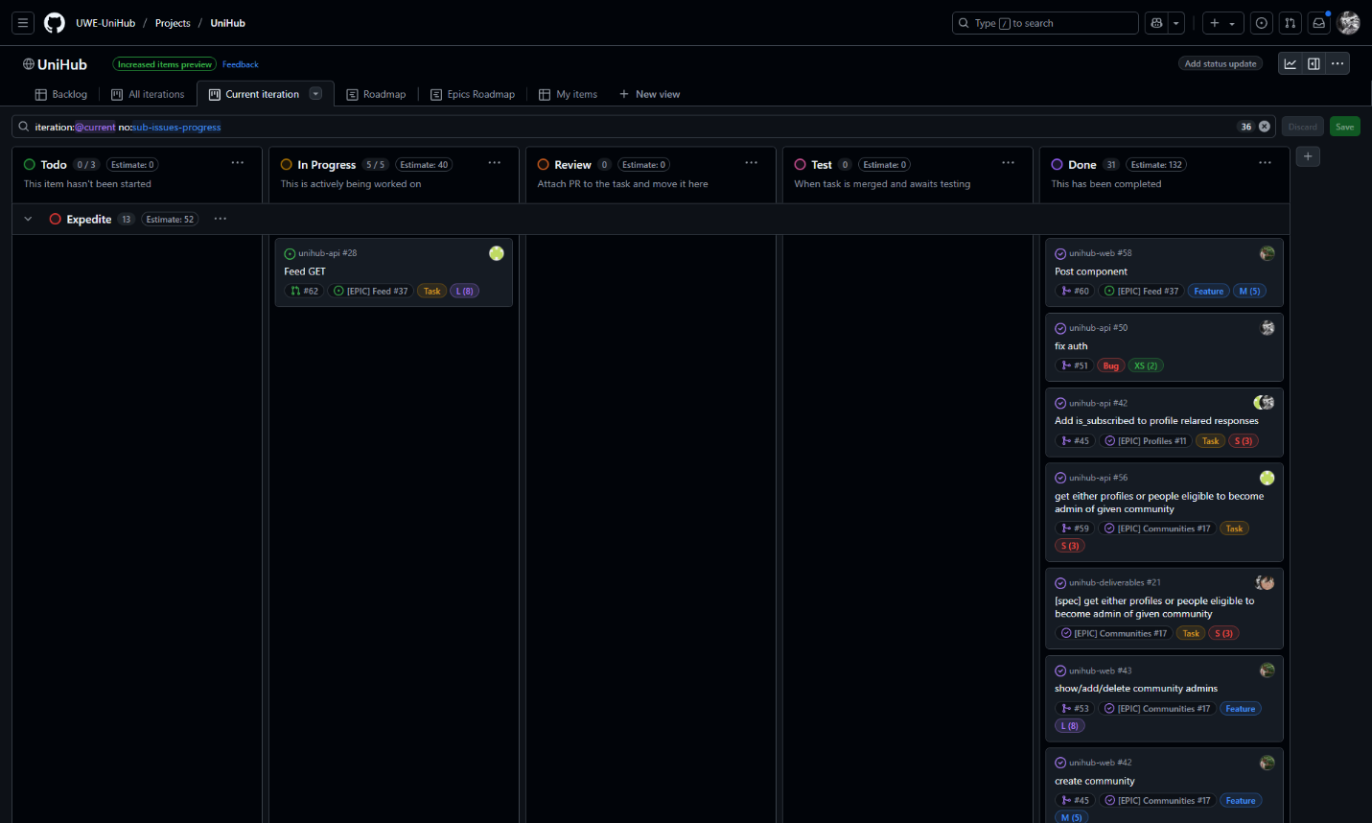

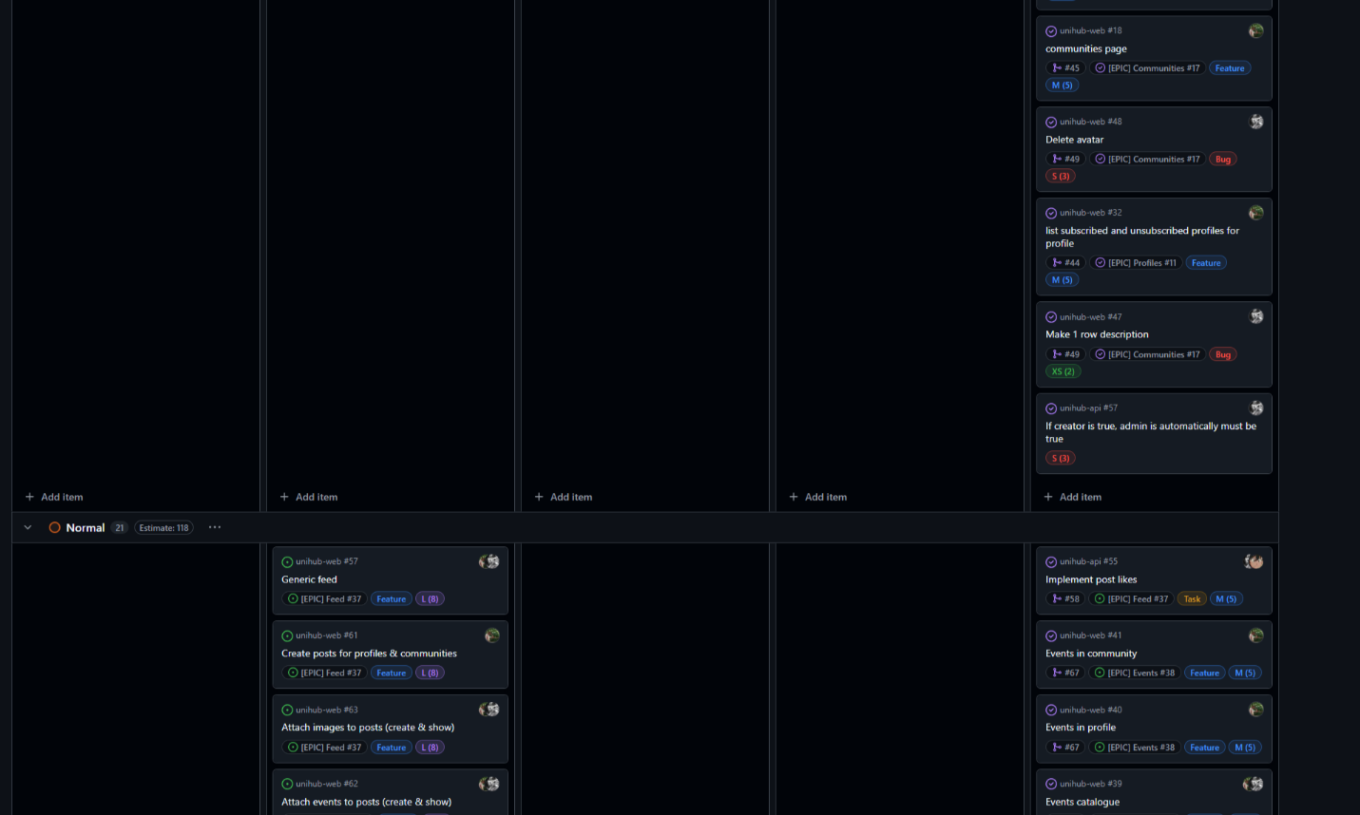

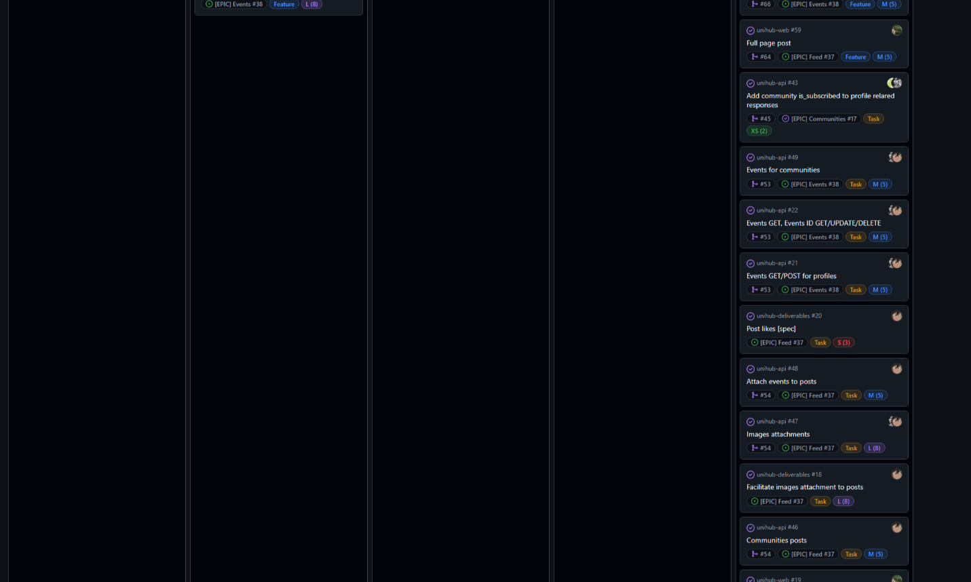

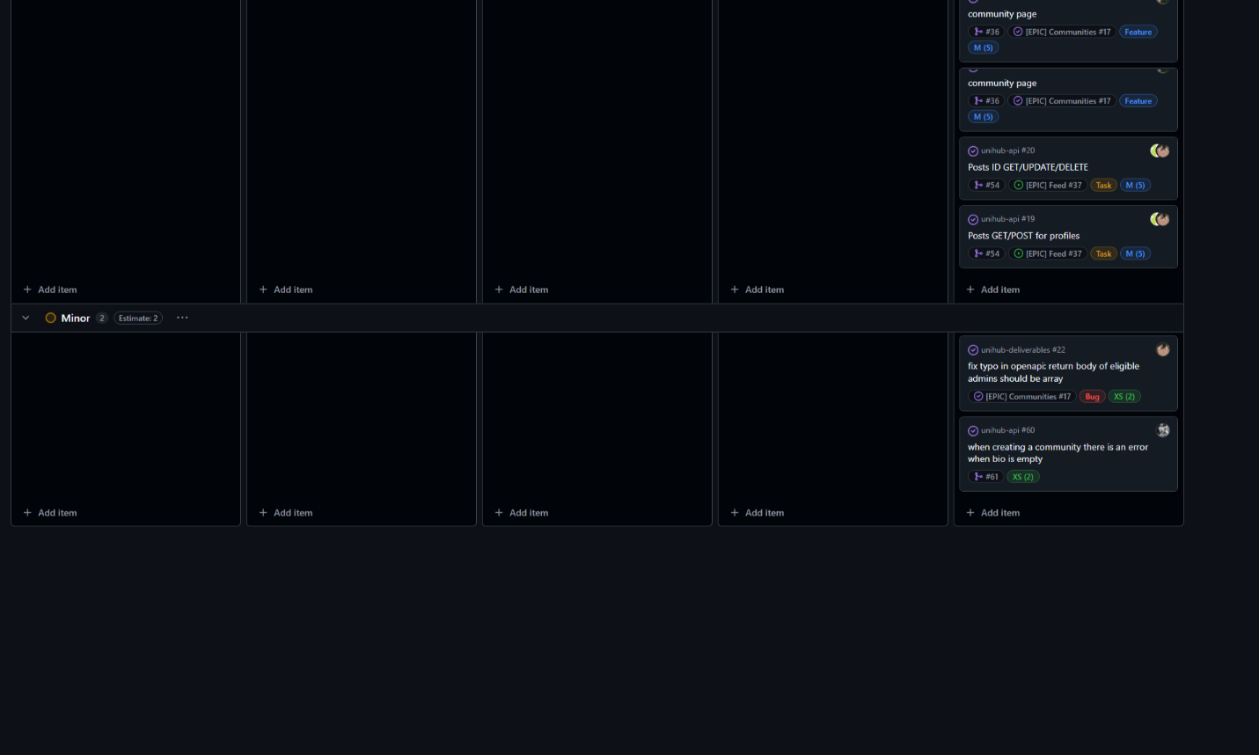

**Roadmap:**

<<Communication Issues>>

During Sprint 2, our team encountered a minor communication gap when a few newly created tasks were not clearly relayed to all members. This caused a moment of confusion about priorities and ownership. However, we promptly identified the oversight during our next stand-up meeting. By reassigning the tasks transparently and updating our Kanban Board to reflect the changes, we resolved the issue before it could impact our overall progress. This swift response ensured minimal disruption, reinforcing the importance of proactive communication and regular status checks to keep everyone aligned.

<<Reflections>>

Over the course of Sprint 2, our team demonstrated a high level of organization, collaboration, and adaptability, ultimately surpassing many of our initial goals. Building on our groundwork from Sprint 1, we began by refining our Kanban Board processes and revalidating each team member’s role and responsibilities, ensuring a comfortable and optimal distribution of tasks. This approach allowed us to maintain excellent coverage of both frontend and back‐end requirements, aligning closely with our product backlog updates. By clearly mapping each task to the correct sprint objective, we mitigated any potential overlap or redundancy early on.

A key highlight of this sprint was our architectural improvements, particularly around containerizing the application to better isolate services and enhance scalability. We invested time in reviewing our core modules—both in the back‐end logic and the UI components—to ensure the system’s overall design was secure, efficient, and easy to modify. This architecture not only streamlined our workflow but also positioned us favorably for upcoming integration efforts and more complex feature sets. Recognizing the importance of futureproofing, we planned and documented minimal yet crucial enhancements, such as tuning our viewer components and scheduling additional security measures for the next iteration.

Throughout Sprint 2, the team consistently demonstrated initiative by tackling new tasks ahead of schedule when capacity allowed. Our stand‐up meetings became a vital touchpoint for verifying progress, redistributing tasks when needed, and ensuring that each member was fully aware of the sprint’s evolving priorities. As a result, our burndown chart showed a smooth, steady decline in outstanding tasks, and we were able to integrate extra backlog items without compromising quality. This proactive mindset meant that by the midpoint of the sprint, we had effectively delivered most of our planned features, with only a few remaining items to be refined and tested.

Communication remained a strong focus area. Despite encountering a minor issue where newly created tasks were momentarily not broadcast to all members; we rapidly resolved it during our next stand‐up session. This quick fix prevented any larger disruptions and reinforced our commitment to keeping channels open for updates, feedback, and clarifications. We also enhanced our reporting methods—standups, pull request reviews, and scheduled checks to maintain momentum and avoid bottlenecks. This emphasis on clarity allowed us to manage dependencies effectively, ensuring each task aligned with the broader sprint objectives.

From a teamwork perspective, everyone exhibited a thorough understanding of their roles, and any outstanding tasks were promptly identified and assigned. Our balanced approach to role distribution helped prevent overload on any single team member and fostered a sense of shared ownership over the deliverables. The cooperative dynamic, built upon mutual respect and consistent communication, facilitated both rapid development and thoughtful quality checks. This synergy was evident in the improvements we achieved: new tasks emerged, were quickly assigned, and subsequently integrated into the product with minimal friction.

In summary, Sprint 2 stands out for its well‐executed planning, robust technical design, and cohesive team dynamics, which reflect our ongoing commitment to continuous improvement. By solidifying our architecture, refining our workflow, and maintaining excellent communication, we established a strong foundation for future sprints. Our deliverables speak to the thoroughness and adaptability of our process, positioning us well to keep meeting—and exceeding—the criteria for first-class performance.

<<Relevant Links>>

GitHub organization: [UWE UniHub](https://github.com/UWE-UniHub)

Kanban Board: [Current iteration · UniHub](https://github.com/orgs/UWE-UniHub/projects/1/views/3)

Roadmap: [Roadmap · UniHub](https://github.com/orgs/UWE-UniHub/projects/1/views/6)

Swagger (API Documentation): [SwaggerUI](https://uwe.dyzoon.dev/api/swagger/)