# Prerequisites

# Configuration file

## Purpose and Use

Use Notepad++, use INI file language

## AGOL section

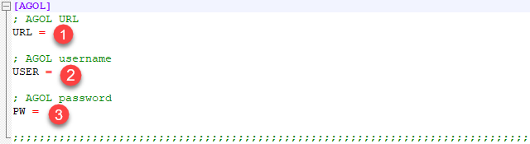

ArcGIS Online credentials are the main focus of this section. Below are descriptions of each input. These inputs play a role in accessing the participating ArcGIS Online Organizational/Portal account[1].

1. **AGOL URL**: the ArcGIS Online URL where the login credentials will be passed through

The main ArcGIS website URL ([www.arcgis.com](http://www.arcgis.com)) is recommended, but any ArcGIS URL that accepts login credentials can be used.

1. **AGOL username**: The participating ArcGIS Online account's username
2. **AGOL password**: the participating ArcGIS Online account's password

## SQL section

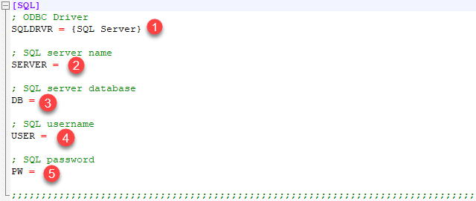

Microsoft (MS) SQL Server authentication credentials are the main focus of this section. Below are descriptions of each input. These inputs play a role in accessing the participating MS SQL Server database management system. This connection is possible using the open source Python module [*pyodbc*](https://github.com/mkleehammer/pyodbc). The methods used in this section of the configuration file/script are detailed in the *pyodbc* documentation[2].

1. **ODBC Driver**: the reference to the distributed ODBC driver for SQL Server

It is preferred to have the latest ODBC driver (version 17 as of this document's creation), but the generic {SQL Server} is used as default. Refer to *pyodbc* documentation concerning syntax in updating this section. The curled brackets are required as shown in the *pyodbc* documentation.

1. **SQL server name**: the server name of the participating MS SQL Server
2. **SQL server database**: the database name of the participating MS SQL Server
3. **SQL username**: the participating MS SQL Server username
4. **SQL password**: the participating MS SQL Server password

## SCRIPT section

## 

# A close up of a map Description automatically generatedArcGIS Online/SQL Server Data Synchronization script

1. <https://developers.arcgis.com/python/guide/using-the-gis/>
2. <https://github.com/mkleehammer/pyodbc/wiki/Connecting-to-SQL-Server-from-Windows>