Introduction to Programing with Python
  - Module 08 – Creating Applications (This final assignment is worth 300 points)

Overview
In this assignment, you will learn about how to create multi-module applications. Course assignments help you learn through reading, watching demonstrations, performing programming in Python, and reflecting on what you learned through writing.
This assignment includes the following tasks:
- Read module text.
- Watch the module videos.
- Create an application.
- Document your knowledge.
- Submit your work.
Tip: Consider the following questions while you work through the module to help you focus:
- What is the difference between a class and a module?
- How do you connect one module to another?
- What is an import alias?
- What is the "main" module?
- What are four examples of UML diagrams?
- What is a Test Harness?
- What is Unit Testing?

Task 1: Read Module Notes and Watch Videos.
Start the assignment by reading the module’s Notes document and watching the module's demonstration videos. You will find the Notes document within the Module06.zip file on the Canvas Module page. You will also find the links to videos in that same section.

Task 2: Watch the assignment videos.
Please watch the following video, in addition to the videos and demonstrations you watched in the module.
- Unit Tests in Python || Python Tutorial || Learn Python Programming (external site)
- Python Tutorial for Beginners 9: Import Modules and Exploring The Standard Library (external site)

Task 3: Create an application (150 points)
Create a Python application that demonstrates what you have learned in the course.
Important: Start by opening and reviewing the starter file Assignment08-Starter.py! While the code is similar to what we have done in the past modules it is not exactly the same. For example, we are using employee instead of student data this time. So, make sure to read the code carefully to note the differences.

Acceptance Criteria
Your application must include the following features and code to be accepted as complete:

Files Named:
- There is a file named data_classes.py
- There is a file named processing_classes.py
- There is a file named presentation_classes.py
- There is a file named main.py
- There is a file named test_data_classes.py
- There is a file named test_processing_classes.py
- There is a file named test_presentation_classes.py

Script Header:
- The script headers are included in all files your name, the current date, and activity.

Constants:
- FILE_NAME: str = "EmployeeRatings.json"
- MENU: str = '''
---- Employee Ratings ------------------------------
Select from the following menu:
1. Show current employee rating data.
2. Enter new employee rating data.
3. Save data to a file.
4. Exit the program.
--------------------------------------------------
'''

Variables:
- employees: list = [] # a table of employees data
- menu_choice = ''

Classes:
- The application includes a class named FileProcessor.
- The application includes a class named IO.
- The application includes a class named Person.
- The application includes a class named Employee.
- All classes include descriptive document strings.

Class Properties:
- The application includes properties for first_name: str and defaults to an empty string.
- The application includes properties for last_name: str and defaults to an empty string.
- The application includes properties for review_date: datetime.date and defaults to "1900-01-01.
- The application includes properties for review_rating: int and defaults to 3.
- The application's properties must include simple validation code.

Class Methods:
- The application includes a __str__() method to extract comma-separate data from its data objects.

Functions:
- All functions include descriptive document strings.
- All functions the include exception blocks use the output_error_messages() function for handling error messages.
- All non-instance functions use the @staticmethod decorator (The ones in the FileProcessor and IO classes.)
- The application includes functions with the following names and parameters:
  - output_error_messages(message: str, error: Exception = None)
  - output_menu(menu: str)
  - input_menu_choice()
  - output_employee_data(employee_data: list)
  - input_employee_data(employee_data: list, employee_type: object)
  - read_employee_data_from_file(file_name: str, employee_data: list, employee_type: object)
  - write_employee_data_to_file(file_name: str, employee_data: list):

Input / Output:
- On menu choice 1, the presents the collected data. (Note this is a different order that we used previously!)
- On menu choice 2, the application prompts the user to enter the employee's first name and last name, followed by the review date and rating.
- Data collected for menu choice 2 is added to a two-dimensional list table (list of Employee objects).

Processing
- When the application starts, the contents of the "EmployeeRatings.json" are automatically read into a two-dimensional list of Employee object rows. (Tip: Make sure to put some starting data into the file or you will get an error!)
- On menu choice 3, the application saves it's data to the file named "EmployeeRatings.json".
- On menu choice 4, the application ends.

Error Handling
- The application provides structured error handling when the file is read into the list of employee rows.
- The application provides structured error handling when the user enters a first name.
- The application provides structured error handling when the user enters a last name.
- The application provides structured error handling when the user enters a review date (YYYY-MM-DD).
- The application provides structured error handling when the user enters a review rating (1,2,3,4, or 5).
- The application provides structured error handling when the data is written to the file.

Test:
- The application takes the user's input for an employee's first, last name, review date and rating.
- The application validates the user's input for an employee's first, last name, review date and rating.
- The application displays the user's input for employee's first, last name, review date and rating.
- The application saves the application's data into "EmployeeRatings.json" as valid JSON syntax.
- The application allows users to enter multiple employee reviews.
- The application allows users to display multiple employee reviews.
- The application allows users to save multiple employee reviews to a file.
- The application runs correctly in both PyCharm and from the console or terminal.

Source Control: NA

Task 4: Document Your Application (70 points)
After you have created and tested your Python application, create a document describing the application. Please save your document as a PDF or Markdown file called EmployeeRatings_README.pdf (or EmployeeRatings_README.md if you want to challenge yourself.)

Task 5 - Write and Post a Lessons Learned (70 points)
At the end of the final, take some time and reflect on your progress and ask yourself; "what did I learn in this course that will help me go forward?"
After that:
- Write a one-page report on what you learned during this class. It can be a partial page, but let's make it a bit more than a single paragraph. Tell me what you discovered about programming, the learning process, and how your journey specifically. Save your document as a PDF file and turn it in with the other files.
- Once your Word document is written, post its contents (not the file) on the Discussion board (Lessons Learned). This process helps everyone get a chance to see how others experienced the course!

Task 6: Organize and Submit your work (10 points)
Now place your documents (and your Images folder if you made one) with your Python scripts into a folder named A08.
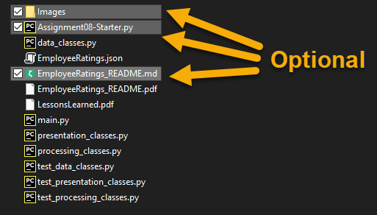
Then compress the folder into a ".zip" file, before finally uploading the file to the class assignment page on Canvas.
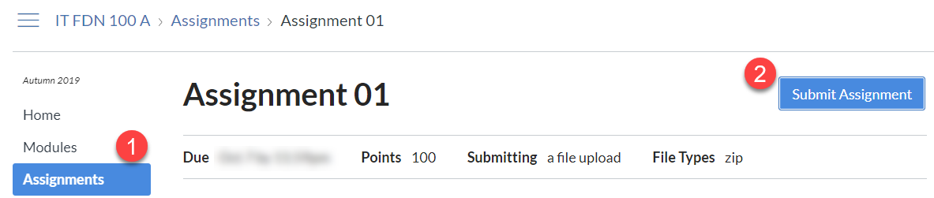
Notes:
- Use the discussion board to request help on the assignment.
- The assignment can be completed using the lectures, assignment videos and reading, and module labs. You do not need to locate additional resources outside of the course material to complete it.

Important: The Final cannot be late!
Each quarter, students forget that they must submit their work no later than the last day of the course. If it is late, you will lose out on all 300 points. So, turn in what you have, even if it is not completely done!
Pay attention to this deadline or you may fail the course!

