Co-locating TPOS Saildrones, a Seaglider, and the MOTIVE Cruise in Fall of 2024

#### MOTIVE / R/V Sikuliaq Cruise Information:

MOTIVE = Mixing belOw Tropical Instability waVEs

Cruise proposal can be found [here](https://drive.google.com/file/d/1pkkJyoAj-utb6Bi37EsiG_UgH_F32UGm/view?usp=share_link)

**Lead PI:** Caitlin Whalen (UW-APL)

**Co-PIs:** Jim Moum (OSU-COAS - not on voyage), Gunnar Voet (Scripps), Amy Waterhouse (Scripps - not on voyage)

Mooring will be deployed in Nov 2024 and recovered in Dec 2025 (the following year).

* **Dates for 2024 cruise:**
* Nov 3-4: mobilize in Honolulu
* Nov 5: depart Honolulu
* Dec 8: arrive Honolulu
* Dec 9: complete the demob
* Tentative dates for 2025 cruise:
* Nov 25: mobilize at Honolulu
* Nov 26: depart Honolulu
* Dec 19: arrive Honolulu
* Dec 20: complete demobilization

Summary of cruise objectives:

* Understand if TIW-induced downward-propagating internal waves elevate wave and turbulent mixing activity
* Understand if there is an energy cascade of large scale internal waves interacting with TIWs
* Understand if small scale internal waves dissipate energy at critical layers a the edges of TIW eddies
* Understand how the modulation of this turbulent mixing impacts the transport of heat in the equatorial Pacific

#### Question:

Is frontogenesis occurring at the leading edge of Tropical Instability Waves in the equatorial Pacific, and if so, what are the underlying mechanisms and impacts on local oceanographic conditions?

1. Is frontogenesis occurring?
   1. What surface and subsurface in situ evidence indicates that frontogenesis is taking place?
2. What are the underlying Mechanisms?
   1. What are the dynamical processes driving frontogenesis at the leading edge of TIWs? Are there specific patterns in ocean currents, vorticity, or shear that contribute to the formation and intensification of the front?
   2. How do wind stress, equatorial currents, and instabilities in the ocean circulation contribute to frontogenesis?
3. What are the impacts on local oceanographic conditions?
   1. How does frontogenesis influence vertical motions in the water column, and what are the implications for mixing and stratification?
   2. What are the impacts of frontogenesis on biogeochemical properties, such as nutrient distribution and primary productivity?

#### Objective:

Investigate air-sea interactions and subsurface dynamics associated with the leading edge front (LEF) of Tropical Instability Waves.

Using two Saildrones equipped with meteorological and ASVCO2 packages, surface temperature and conductivity sensors, and downward-facing ADCPs (measuring currents from 5m to 80m), we will analyze air-sea interactions, impacts on biogeochemistry, and currents and shear as the Saildrones traverse the LEF at 140W. Alongside the two Saildrones, a Seaglider will provide complementary profiles of temperature, conductivity, backscatter (470 nm, 695 nm, and 700 nm), and oxygen from the surface to 990m between 1N and 4N along 140W. Year-long moorings deployed by the MOTIVE cruise in November 2024 will include two upward-facing ADCPs (300 kHz at 150m and 75 kHz at 900m) and 20 xpods on each mooring (see figure from the cruise proposal below).

# MOTIVE - Saildrone/Seaglider Plans

*(subject to change as needed)*

*Updated by Katie Kohlman 12 Sep 2024*

____________________________________________________________________________

### Glider Background

SG195 is equipped to measure temperature, conductivity, oxygen, and backscatter (470, 695, and 700 nm). Vertical velocity along profiles will also be estimated using the predicted flight vs. actual flight patterns. The Seaglider will be performing surface to 990 m dives and sampling on the descent and ascent with horizontal resolution of 0.6 km. **Glider is planned to transit between 0.5N and 4N** (subject to change(!)).

*Limitations:*

* Maximum dives (surface to 990 m) = 900 dives (4 dives/day)
* Typical horizontal distance per day = 20 km

*Transit dives/times required:*

* 0N, 140W to Honolulu = 120 days (560 dives)
* Glider transit window: Feb 08 to Jun 08.

*On site dives/times:*

* 0N, 140W = 85 days (340 dives)
* Five one-way crossings between 1N and 4N along 140W
* **Maximum on-site glider window: Nov 15 to Feb 08.**

____________________________________________________________________________

### Saildrone Background

As part of NOAA/PMEL’s Tropical Pacific Observing System (TPOS) Saildrone Missions, two Saildrones (SD1033 & SD1090) will attempt to collocate with the Seaglider and MOTIVE Cruise in mid-November. Both SD1033 & SD1090 are equipped with meteorological & ASVCO2 packages, surface temperature, conductivity, and chlorophyll, and a downward facing ADCP (from which 5-100 m currents can be derived).

Two Saildrones will be completing a Go-USV box (similar to the one in TPOS 2023 Mission [here](https://www.pmel.noaa.gov/ocs/ocs-saildrone-mission-blog-tpos-2023-mission)) and are estimated **to arrive at 0N, 140W within Nov 21-22.**

*This is based on the approximations from Rick Mozolic @ Saildrone Inc. below:*

* The total transit from HQ Alameda to 0N, 140W via 10N,125 & 0N, 125W is approximately 3,200nm.
* Based on a 2kt average speed down to 0N, 125W and then 3kt average speed to 0N, 140W using equatorial current, the ***NON STOP*** transit to 0N, 140W will take 62-67 days.
* If we depart HQ Alameda on 10SEP, that has us getting to 0N, 140W on approximately 11-16NOV.

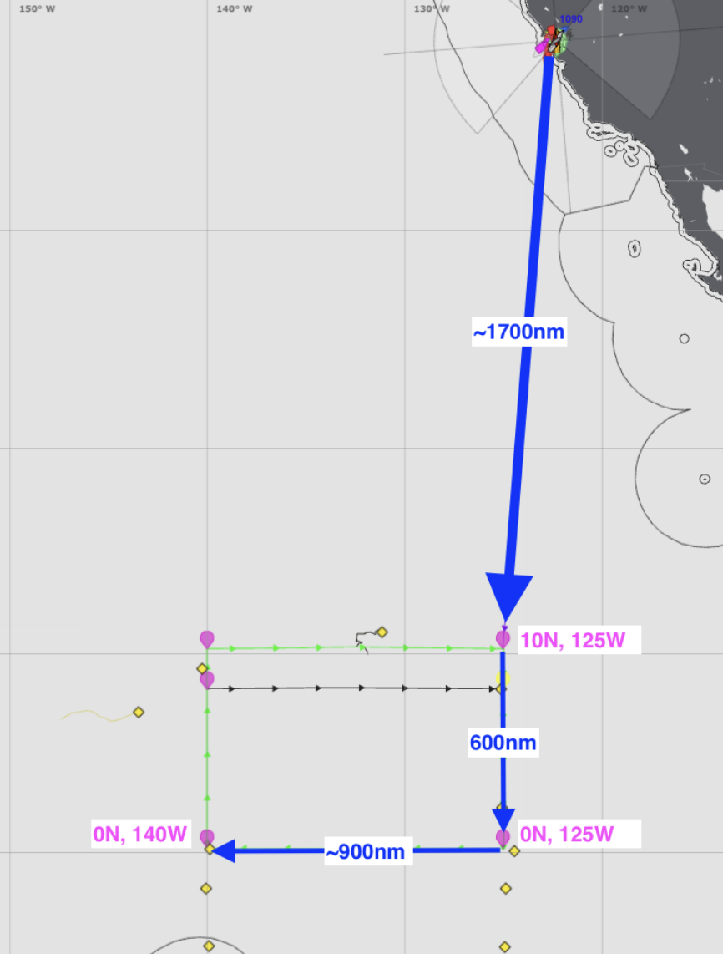

Figure 1. Estimated travel path and box for two Saildrones (SD1033 & SD1090).

____________________________________________________________________________

## Glider Deployment and Co-location w/ Saildrones

The Saildrones will initially travel south to 0N, 125W. After arriving at 0N, 125W, they will turn west and head to 0N, 140W, following anticipated westward currents. Upon reaching 0N, 140W, the Saildrones will complete three passes between 1N and 4N, co-locating with the glider sometime between Nov 11-16. The glider will then complete five meridional transits before transiting to Honolulu, HI.

Note: This is subject to change due to phase of TIW, positioning of cruise, etc….

*Glider timeline (Assuming that 85 days will be spent on site and 0.5-4N transits):*

**Deploy glider between 0.5N and 2N: Nov 15th (dependent on MOTIVE Operations & Saildrone locations).**

Complete northward transit to 4N: Nov 30

Complete southward transit to 0N: Dec 14

Complete northward transit to 4N: Dec 31

Complete southward transit to 0N: Jan 14

Complete northward transit to 4N: Jan 30

Start transit to Honolulu: Jan 30 - Feb 8

Arrive in Honolulu: Around Jun 8

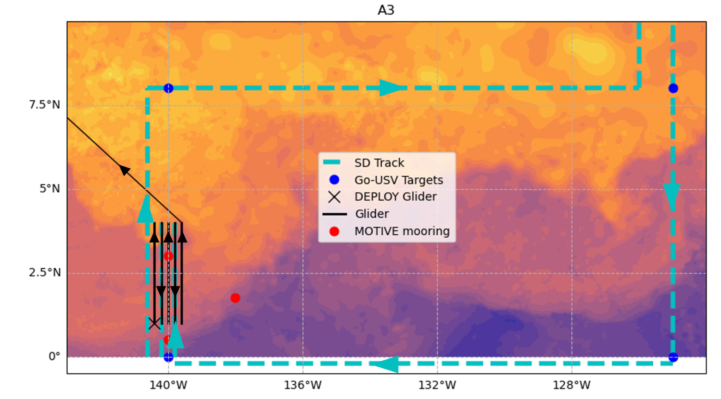

Figure 2. llustration showing plan. Saildrone tracks are shown as cyan dashed lines. Blue dots highlight boundaries of the Go-USV region. Red dots show locations of MOTIVE moorings to be placed by Whalen in Nov 2024 and to be recovered in Nov 2025. Solid black lines represent glider north/south transiting between 1N and 4N along 140W. Contours are arbitrary daily sea surface temperatures from 07 Dec 2017.

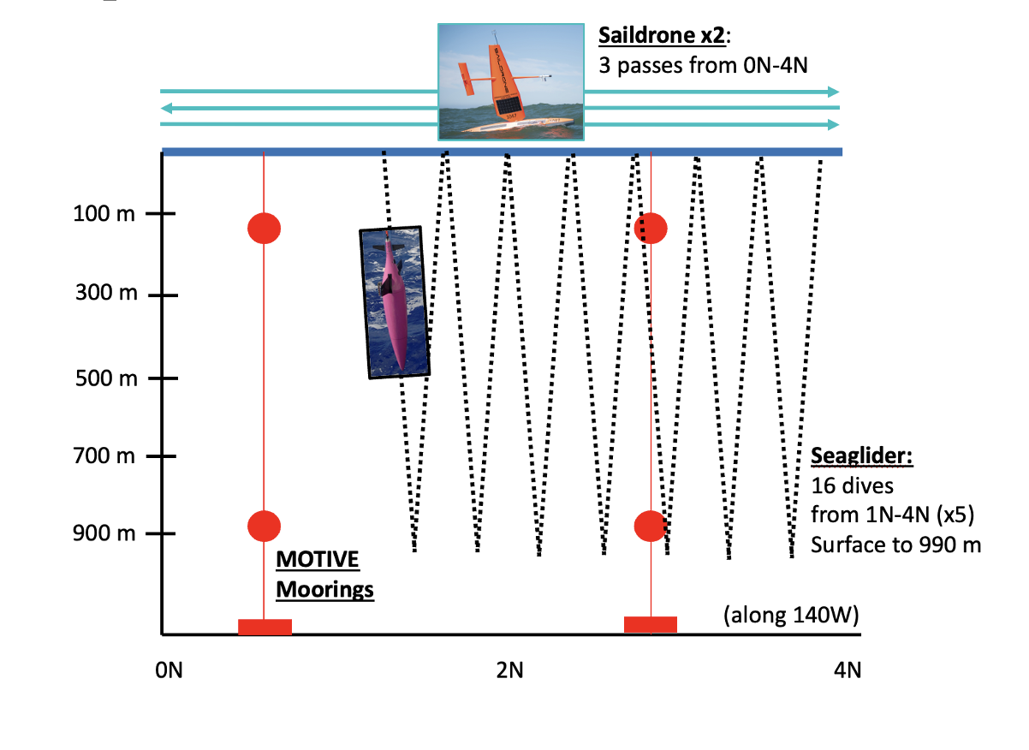

Figure 3. Illustration showing general plan for colocation of Seaglider, MOTIVE moorings, and Saildrones.

# Glider Planning

#### Instruments

###### SBE41 - underway thermosalinograph (unpumped)

Last calibrated: 1-Aug-2020

SN: 236

###### AA4330 - underway optode

Last calibrated: 2013 (unknown)

SN:

###### Wlbb2fl - underway backscatter fluorescence puck

Last calibrated: 28-Dec-2012

SN: BB2FM6 386

#### Current estimates

Taken from Firing (1987):

* Averaged U speeds (over 16 months) that the glider will likely encounter
* Taken from 159 W
* Data was collected from 1982-1983 (El Nino conditions)

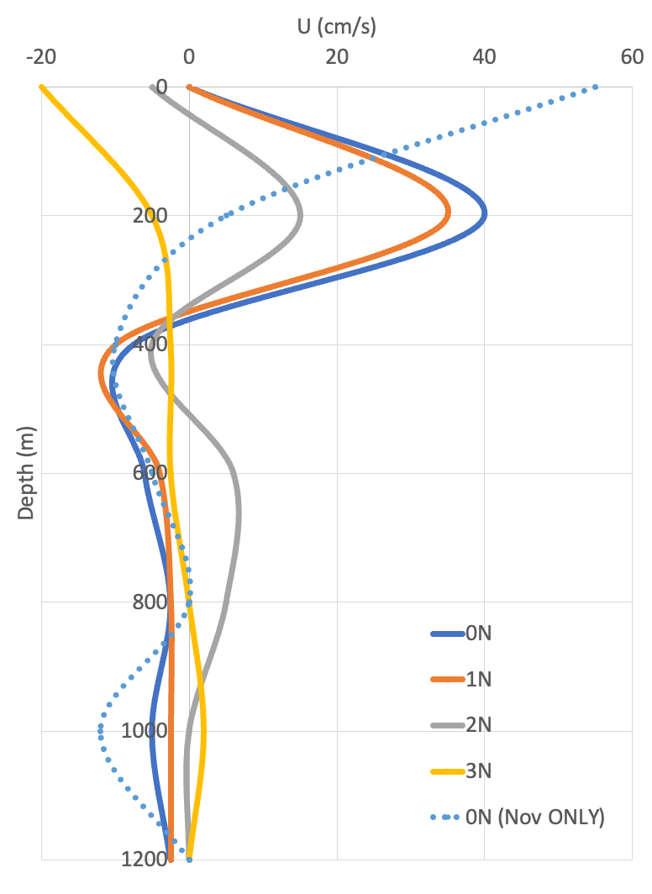

Wkrtki and Kilonsky (1983)

* Based on cruises from 1979-1980 (weak El Nino)

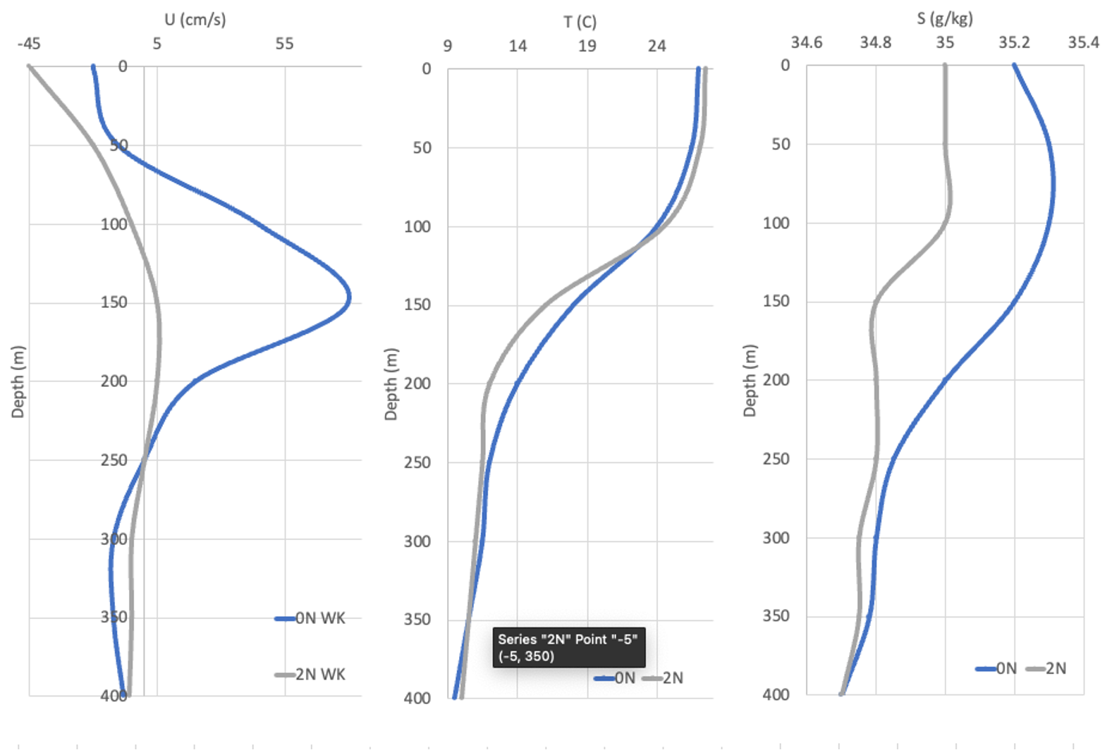

#### Oxygen Calibration

Too coarse resolution of NCEP and too little time and frequency of dives, in situ calibration likely not the best option. Could be a ‘check’ throughout the mission, but likely to avoid ground truthing values. Need to perform end point calibrations pre-cruise. On cruise, collect RH, P, airT at time of deployment and while on site with glider.

##### Two end-point method

Drift Characteristics of SBE36 Dissolved Oxygen Optode Sensors (Ren et al. 2023)

* Manufacturer’s calibration is 24 point calibration (4 oxy and 6 temp values). Recommended to perform two end-point calibrations after 6 mo of manufacturer’s calibration.
* Two end point calibration can correct optode and measurements of drift over **5 years** 
  + Majority of drift is proportional with oxy conc
    - Small adjustment needed at very low concentrations
  + Removes error of long time drift with uncertainty of 0.5% or 0.5 umol/kg
  + 9% change of gain in 3.7 years
* SBE63 uses same principle as Aanderaa optode
  + Organometallic molecule: platinum porphyrin as the luminophore and sensor membrane
    - Is excited with blue light and subsequently releases energy through fluorescence. In presence of oxygen, collisions with other molecules returns to original energy stat in non radiative process: *dynamic quenching*
    - See Ren et al. (2023) or notes for how to apply end point numbers to adjust pre and post mission!
  + First end-point: FULL SATURATION
    - In air method
      * Need pressure, temp, RH adjusted to height
    - In water method (air bubbler)
      * Need pressure, temp, RH (= 1 for water) adjusted to height
  + Second end-point: ZERO SATURATION
    - Sodium sulfite solution (strips solution of dissolved oxygen)
    - See Aanderra product manual (Aanderaa, 2015)
    - Will also need pressure and temperature
  + Consider collocated bottle samples of dissolved oxygen

##### In-situ Calibration

###### Accurate O2 measurements on modified Argo floats using in situ air calibrations (Bushinsku et al., 2016)

* Aanderra oxygen optodes on Argo floats (down to 2000 m)
* Use atmospheric oxygen to perform on-going, in situ calibrations
* Nighttime air readings are often much better!!
* Helps with initial offset and subsequent drift
* LINEAR correction

Step #1: Lab calibration

* Water calibration - following Bushinsky and Emerson (2013)
* Air response - following Bushinsky and Emerson (2013)

Step #2: Float modification

* Optode on 61 cm stalk (the further the better)
* Every 2 min for 1 hour sample atmospheric oxygen before dive

Step #3: Calculated ‘true’ atmospheric oxygen

* Use optode temperature and NCEP reanalysis P and RH interpolated to location and time of float surface air periods (Bittig and Kortzinger, 2015)

NCEP values are very very low resolution, how accurate of a reading can we expect? Maybe just take P, RH, and AirT measurements at deployment?

###### In situ phase-domain calibration of oxygen optodes on profile floats (Drucker & Riser, 2016)

* In situ method to recalculate oxygen from optode phase and temperature
* Recalibrates two coefficients of modified Stern-Volmer equation (in raw phase space)
* Can easily be adapted to take advantage of floats with air measurement capabilities

##### T_SLOITER data on glider from previous mission

* AA4330 O2, AirSat, Temp, CalPhase, TCPhase

**/home/jails/uwssc/gliderjail/home/sg194/2024_05_31_colvos_triple**

* $T_LOITER,0
  + The time (seconds) to loiter after going neutral at apogee and before pitching up and becoming positively buoyant for the climb.
  + G&C and sampling intervals during the loiter state are controlled by the appropriate depth bins in the science file.
* $T_SLOITER,60
  + This data is stored in the dive .dat and .nc files (need to check to see if it is stored in the timeseries .nc file).
    - Top row is actual values, additional rows are different from previous additions. Careful of units (e.g., ms)
  + Need to write a script to separate this data and calculate expected air oxy from NCEP.
  + How to apply this before the next dive.. ?

#### Basestation prep

* Storage? Delete data from previous missions? 58% of 28.9GB currently full
* 2004 to 2024 firmware update?

#### Test dive (Shileshole - Oct 2024)

Prior to dive:

* Update firmware
* Check pressure sensor reading (look back at previous missions for discrepancies)

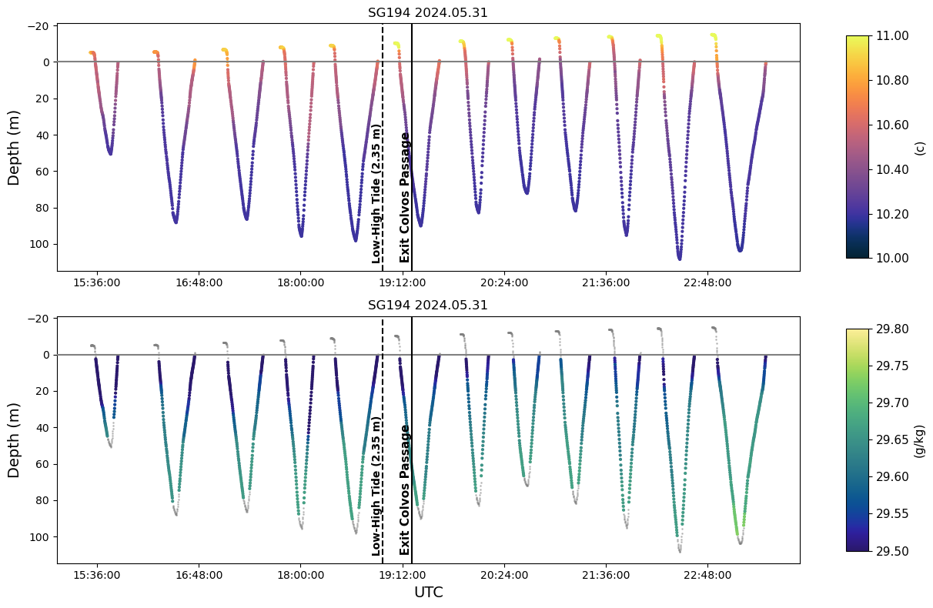

SG194 appears to have incorrect pressure/depth readings. The plots above suggest that the glider was recording temperature measurements almost 20 m near the end of the mission. There appears to be significant drift in the surface readings as the mission goes on.

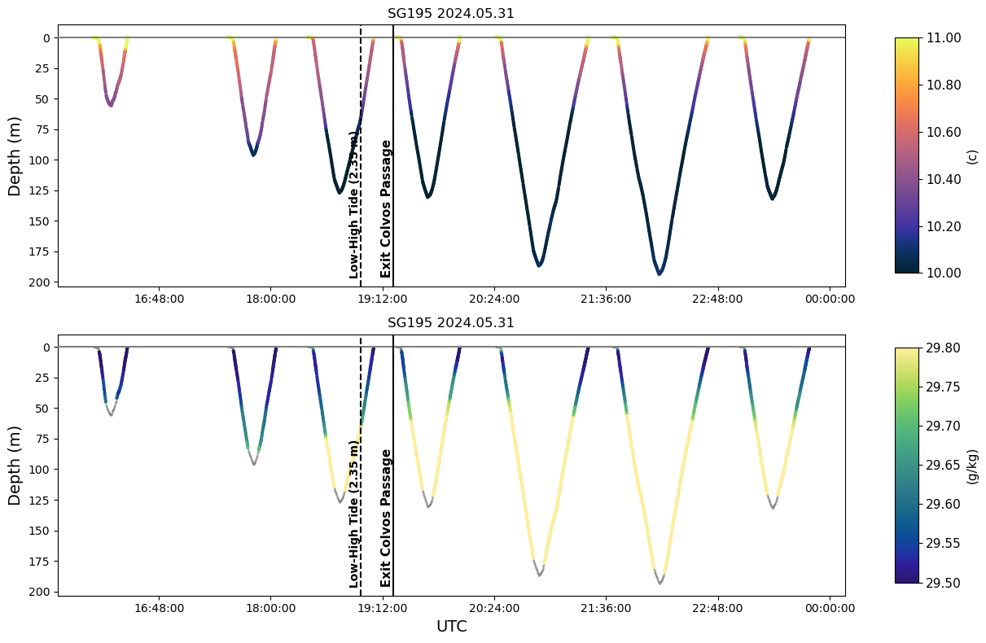

SG195 (same as above but for 195). Surface readings appear to be accurate.

* Replace optode
* Determine oxygen calibration techniques to attempt prior to mission

#### Newport (Oct 22)

* Pack knife, gloves, pliers to be shipped
* Check GO-BGC filtration system
* Practice pH/Alk sampling