The recursion has not exit condition as it will recurse infinitely taking half of return value forever when n is not a power of 2

pdb

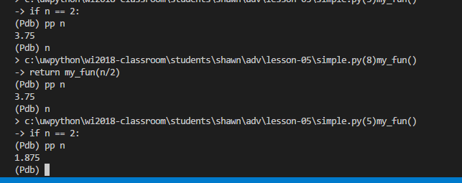

pycharm debugger

