

**CometUI**

**User Guide**

Comet UI Version 1.0.0.0

Comet Search Engine Version 2015.02 rev. 0

Contents

Introduction 3

View and Edit Search Settings 4

Database Search Settings Tab 5

Output Settings Tab 6

Enzyme Settings Tab 7

Mass Settings Tab 10

Static Mods Tab 12

Var Mods Tab 13

Misc Tab 15

Save Search Settings 17

Import/Export Search Settings 18

Import Search Settings 18

Export Search Settings 18

# Introduction

This document describes features of the CometUI application, a Windows-based graphical user interface used to run the Comet search engine and interrogate results. Users can also use CometUI to edit Comet search parameters, and import/export them from/to a “.params” file used by the command line version of the Comet search engine.

Users can download CometUI from the [Comet website](http://comet-ms.sourceforge.net). Launching the application will bring up the following window:

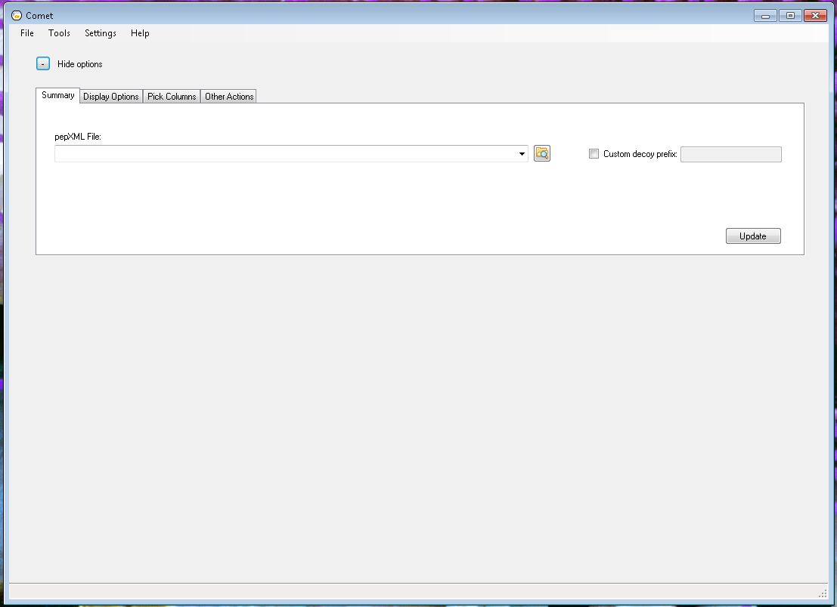

This document will describe how to navigate this window to perform the following tasks:

* View and Edit Search Settings
* Save Search Settings
* Import/Export Search Settings
* Run Search
* View Search Results

# View and Edit Search Settings

All the search parameters and their default values in the Search Settings dialog correspond to [Comet search parameters](http://comet-ms.sourceforge.net/parameters/parameters_201501/) listed on the Comet website. To view/edit the search parameters, open the Search Settings dialog:

1. Click on the “**Settings**” menu:

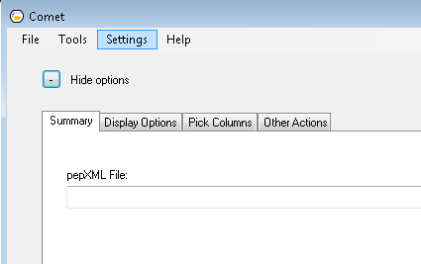

1. Choose the “**Search Settings…**” menu item:

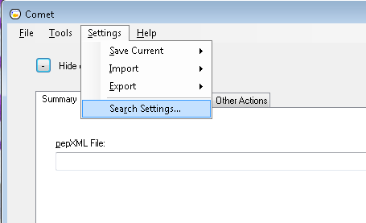

1. The following dialog should open up:

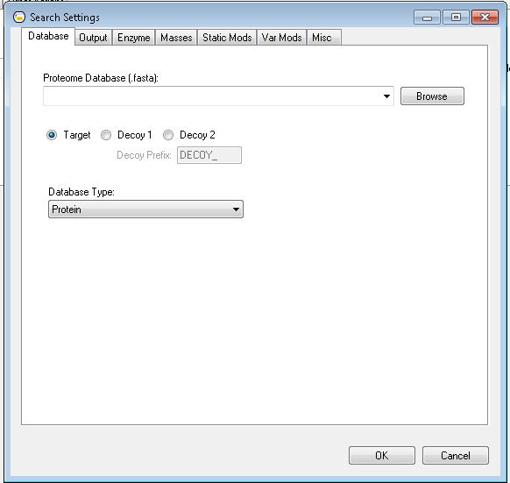

## Database Search Settings Tab

The “**Database**” tab on the Search Settings dialog contains the following search parameters related to the database to be used for the Comet search:



* “**Proteome Database**” edit box corresponds to the “*[database_name](http://comet-ms.sourceforge.net/parameters/parameters_201501/database_name.php)*” Comet search parameter.



* “**Target/Decoy/Decoy 1**” radio buttons correspond to the “*[decoy_search](http://comet-ms.sourceforge.net/parameters/parameters_201501/decoy_search.php)*” parameter, and the “**Decoy Prefix**” edit box corresponding to the “*[decoy_prefix](http://comet-ms.sourceforge.net/parameters/parameters_201501/decoy_prefix.php)*” parameter.



* “**Database Type**” drop-down corresponding to the “*[nucleotide_reading_frame](http://comet-ms.sourceforge.net/parameters/parameters_201501/nucleotide_reading_frame.php)*” parameter.

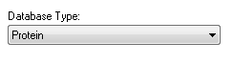

## Output Settings Tab

The “**Output**” tab on the Search Settings dialog contains the following search parameters related to the type of output generated by the Comet search:

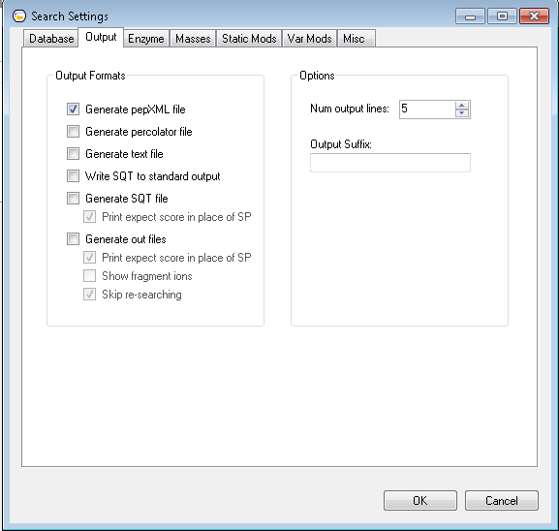

* The following output format checkboxes correspond to the Comet search parameters indicated:
  + “**Generate pepXML file**” 🡪 “*[output_pepxmlfile](http://comet-ms.sourceforge.net/parameters/parameters_201501/output_pepxmlfile.php)*”
  + “**Generate percolator file**” 🡪 “*[output_percolatorfile](http://comet-ms.sourceforge.net/parameters/parameters_201501/output_percolatorfile.php)*”
  + “**Generate text file**” 🡪 “*[output_txtfile](http://comet-ms.sourceforge.net/parameters/parameters_201501/output_txtfile.php)*”
  + “**Write SQT to standard output**” 🡪 “*[output_sqtstream](http://comet-ms.sourceforge.net/parameters/parameters_201501/output_sqtstream.php)*”
  + “**Generate SQT file**” 🡪 “[*output_sqtfile*](http://comet-ms.sourceforge.net/parameters/parameters_201501/output_sqtfile.php)”
  + “**Print expect score in place of SP**” 🡪 “*[print_expect_score](http://comet-ms.sourceforge.net/parameters/parameters_201501/print_expect_score.php)*”
  + “**Generate out files**” 🡪
  + “**Print expect score in place of SP**” 🡪 “*[print_expect_score](http://comet-ms.sourceforge.net/parameters/parameters_201501/print_expect_score.php)*”
  + “**Show fragment ions**” 🡪 “*[show_fragment_ions](http://comet-ms.sourceforge.net/parameters/parameters_201501/show_fragment_ions.php)*”
  + “**Skip researching**” 🡪“*[skip_researching](http://comet-ms.sourceforge.net/parameters/parameters_201501/skip_researching.php)*”
* The “**Num of output lines**” text box corresponds to the “*[num_output_lines](http://comet-ms.sourceforge.net/parameters/parameters_201501/num_output_lines.php)*” Comet search parameter.

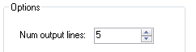

* The “**Output Suffix**” text box corresponds to the “*[output_suffix](http://comet-ms.sourceforge.net/parameters/parameters_201501/output_suffix.php)*” Comet search parameter.

## Enzyme Settings Tab

The “**Enzyme**” tab on the Search Settings dialog contains the following search parameters used in the Comet search:

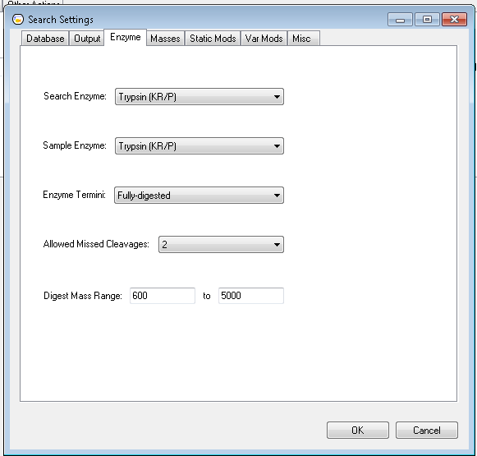

* The “**Search Enzyme**” drop-down corresponds to the “*[search_enzyme_number](http://comet-ms.sourceforge.net/parameters/parameters_201501/search_enzyme_number.php)*” Comet search parameter:

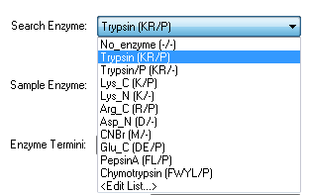

Clicking on the “**<Edit List…>**” item at the bottom of the drop-down list opens the following “**Enzyme Info**” dialog to allow users to edit the enzyme information listed in the drop down:

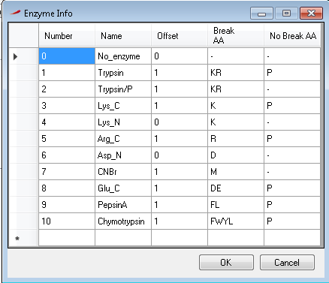

This dialog corresponds to the *“****[COMET_ENZYME_INFO]***” list at the bottom of Comet “.params” files.

* The “**Sample Enzyme**” drop-down corresponds to the “*[sample_enzyme_number](http://comet-ms.sourceforge.net/parameters/parameters_201501/sample_enzyme_number.php)*” Comet search parameter:

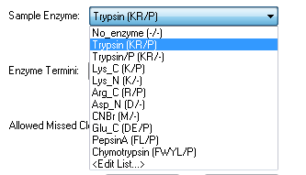

The **“<Edit List…>**” item opens up the same “**Enzyme Info**” dialog as above.

* The “**Enzyme Termini**” drop-down corresponds to the “*[num_enzyme_termini](http://comet-ms.sourceforge.net/parameters/parameters_201501/num_enzyme_termini.php)*” Comet search parameter:

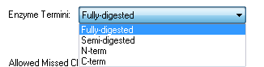

* The “**Allowed Missed Cleavages**” drop-down corresponds to the “*[allowed_missed_cleavage](http://comet-ms.sourceforge.net/parameters/parameters_201501/allowed_missed_cleavage.php)*” Comet search parameter:

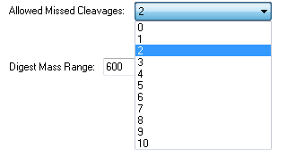

* The “**Digest Mass Range**” edit boxes correspond to the “*[digest_mass_range](http://comet-ms.sourceforge.net/parameters/parameters_201501/digest_mass_range.php)*” Comet search parameter:



## Mass Settings Tab

The “**Masses**” tab on the Search Settings dialog contains precursor and fragment mass options used in the Comet search, such as mass units and tolerances:

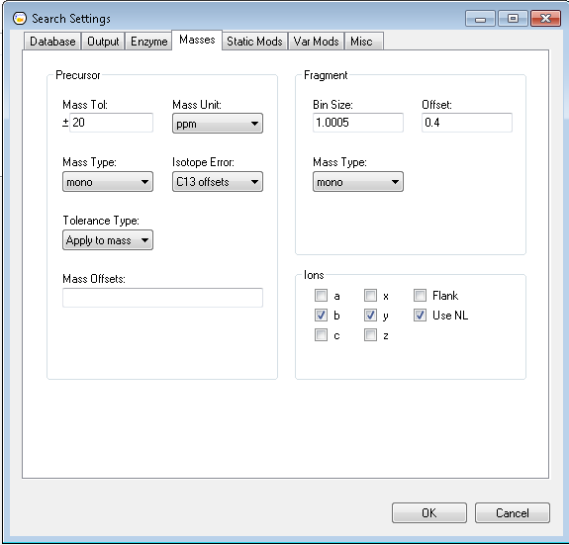

* The following “**Precursor**” mass options correspond to the Comet search parameters indicated:

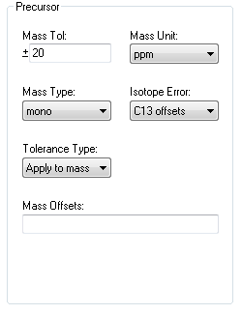

* + “**Mass Tol**” edit box 🡪 “*[peptide_mass_tolerance](http://comet-ms.sourceforge.net/parameters/parameters_201501/peptide_mass_tolerance.php)*”
  + “**Mass Unit**” drop-down 🡪 “*[peptide_mass_units](http://comet-ms.sourceforge.net/parameters/parameters_201501/peptide_mass_units.php)*”
  + “**Mass Type**” drop-down 🡪 “*[mass_type_parent](http://comet-ms.sourceforge.net/parameters/parameters_201501/mass_type_parent.php)*”
  + “**Isotope Error**” drop-down 🡪 ”*[isotope_error](http://comet-ms.sourceforge.net/parameters/parameters_201501/isotope_error.php)*”
  + “**Tolerance Type**” drop-down 🡪 “***precursor_tolerance_type***”
  + “**Mass Offsets**” edit box 🡪 “*mass_offsets*”
* The following “**Fragment**” mass options correspond to the Comet search parameters indicated below:

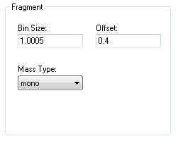

* + “**Offset**” edit box 🡪 “*[fragment_bin_offset](http://comet-ms.sourceforge.net/parameters/parameters_201501/fragment_bin_offset.php)*”
  + “**Mass Type**” drop-down 🡪 “*[mass_type_fragment](http://comet-ms.sourceforge.net/parameters/parameters_201501/mass_type_fragment.php)*”
  + “**Bin Size**” edit box 🡪 “*[fragment_bin_tol](http://comet-ms.sourceforge.net/parameters/parameters_201501/fragment_bin_tol.php)*”
* The following “**Ions**” mass options correspond to the Comet search parameters indicated below:

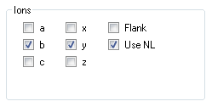

* + “**a**” check box 🡪 “*[use_A_ions](http://comet-ms.sourceforge.net/parameters/parameters_201501/use_A_ions.php)*”
  + “**b**” check box 🡪 “*[use_B_ions](http://comet-ms.sourceforge.net/parameters/parameters_201501/use_B_ions.php)*”
  + “**c**” check box 🡪 “*[use_C_ions](http://comet-ms.sourceforge.net/parameters/parameters_201501/use_C_ions.php)*”
  + “**x**” check box 🡪 “*[use_X_ions](http://comet-ms.sourceforge.net/parameters/parameters_201501/use_X_ions.php)*”
  + “**y**” check box 🡪 “*[use_Y_ions](http://comet-ms.sourceforge.net/parameters/parameters_201501/use_Y_ions.php)*”
  + “**z**” check box 🡪 “*[use_Z_ions](http://comet-ms.sourceforge.net/parameters/parameters_201501/use_Z_ions.php)*”
  + “**Use NL**” check box 🡪 “*[use_NL_ions](http://comet-ms.sourceforge.net/parameters/parameters_201501/use_NL_ions.php)*”

## Static Mods Tab

The “**Static Mods**” tab on the Search Settings dialog contains static modification parameters used by the Comet search:

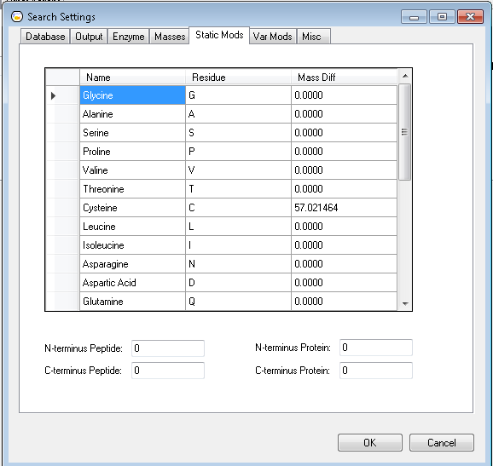

* The following table items correspond to the Comet search parameters indicated:

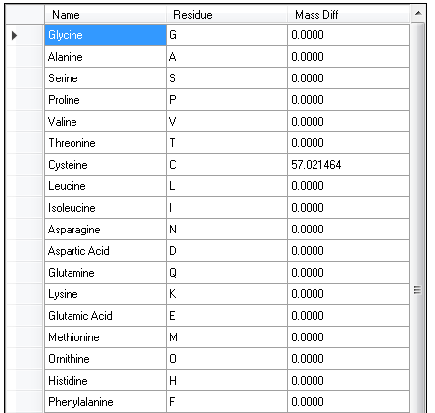

* + “**Glycine**” 🡪 “*[add_G_glycine](http://comet-ms.sourceforge.net/parameters/parameters_201501/add_G_glycine.php)*”
  + “**Alanine**” 🡪 “*[add_A_alanine](http://comet-ms.sourceforge.net/parameters/parameters_201501/add_A_alanine.php)*”
  + “**Serine**” 🡪 “*[add_S_serine](http://comet-ms.sourceforge.net/parameters/parameters_201501/add_S_serine.php)*”
  + “**Proline**” 🡪 “*[add_P_proline](http://comet-ms.sourceforge.net/parameters/parameters_201501/add_P_proline.php)*”
  + “**Valine**” 🡪 “*[add_V_valine](http://comet-ms.sourceforge.net/parameters/parameters_201501/add_V_valine.php)*”
  + “**Threonine**” 🡪 “*[add_T_threonine](http://comet-ms.sourceforge.net/parameters/parameters_201501/add_T_threonine.php)”*
  + “**Cysteine**” 🡪 “*[add_C_cysteine](http://comet-ms.sourceforge.net/parameters/parameters_201501/add_C_cysteine.php)*”
  + “**Leucine**” 🡪 “*[add_L_leucine](http://comet-ms.sourceforge.net/parameters/parameters_201501/add_L_leucine.php)*”
  + “**Isoleucine**” 🡪 “*[add_I_isoleucine](http://comet-ms.sourceforge.net/parameters/parameters_201501/add_I_isoleucine.php)*”
  + “**Asparagine**” 🡪 “*[add_N_asparagine](http://comet-ms.sourceforge.net/parameters/parameters_201501/add_N_asparagine.php)*”
  + “**Aspartic Acid**” 🡪 “*[add_D_aspartic_acid](http://comet-ms.sourceforge.net/parameters/parameters_201501/add_D_aspartic_acid.php)*”
  + “**Glutamine**” 🡪 “*[add_Q_glutamine](http://comet-ms.sourceforge.net/parameters/parameters_201501/add_Q_glutamine.php)*”
  + “**Lysine**” 🡪 “*[add_K_lysine](http://comet-ms.sourceforge.net/parameters/parameters_201501/add_K_lysine.php)*”
  + “**Glutamic Acid**” 🡪 “*[add_E_glutamic_acid](http://comet-ms.sourceforge.net/parameters/parameters_201501/add_E_glutamic_acid.php)*”
  + “**Methionine**” 🡪 “*[add_M_methionine](http://comet-ms.sourceforge.net/parameters/parameters_201501/add_M_methionine.php)*”
  + “**Ornithine**” 🡪 “*[add_O_ornithine](http://comet-ms.sourceforge.net/parameters/parameters_201501/add_O_ornithine.php)*”
  + “**Histidine**” 🡪 “*[add_H_histidine](http://comet-ms.sourceforge.net/parameters/parameters_201501/add_H_histidine.php)*”
  + “**Phenylalanine**” 🡪 “*[add_F_phenylalanine](http://comet-ms.sourceforge.net/parameters/parameters_201501/add_F_phenylalanine.php)*”

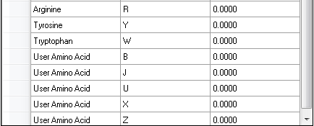

* + “**Arginine**” 🡪 “*[add_R_arginine](http://comet-ms.sourceforge.net/parameters/parameters_201501/add_R_arginine.php)*”
  + “**Tyrosine**” 🡪 “*[add_Y_tyrosine](http://comet-ms.sourceforge.net/parameters/parameters_201501/add_Y_tyrosine.php)*”
  + “**Tryptophan**” 🡪 “*[add_W_tryptophan](http://comet-ms.sourceforge.net/parameters/parameters_201501/add_W_tryptophan.php)*”
  + “**User Amino Acid (B)”** 🡪 “*[add_B_user_amino_acid](http://comet-ms.sourceforge.net/parameters/parameters_201501/add_B_user_amino_acid.php)*”
  + “**User Amino Acid (J)”** 🡪 “*[add_J_user_amino_acid](http://comet-ms.sourceforge.net/parameters/parameters_201501/add_J_user_amino_acid.php)*”
  + “**User Amino Acid (U)”** 🡪 “*[add_U_user_amino_acid](http://comet-ms.sourceforge.net/parameters/parameters_201501/add_U_user_amino_acid.php)*”
  + “**User Amino Acid (X)”** 🡪 “*[add_X_user_amino_acid](http://comet-ms.sourceforge.net/parameters/parameters_201501/add_X_user_amino_acid.php)*”
  + “**User Amino Acid (Z)”** 🡪 “*[add_Z_user_amino_acid](http://comet-ms.sourceforge.net/parameters/parameters_201501/add_Z_user_amino_acid.php)*”
* The “**N-terminus Peptide**” text box corresponds to the “*[add_Nterm_peptide](http://comet-ms.sourceforge.net/parameters/parameters_201501/add_Nterm_peptide.php)*” parameter:



* The “**C-terminus Peptide**” text box corresponds to the “*[add_Cterm_peptide](http://comet-ms.sourceforge.net/parameters/parameters_201501/add_Cterm_peptide.php)*” parameter:



* The “**N-terminus Protein**” text box corresponds to the “*[add_Nterm_protein](http://comet-ms.sourceforge.net/parameters/parameters_201501/add_Nterm_protein.php)*” parameter:



* The “**C-terminus Protein**” text box corresponds to the “*[add_Cterm_protein](http://comet-ms.sourceforge.net/parameters/parameters_201501/add_Cterm_protein.php)*” parameter:

## Var Mods Tab

The “**Var Mods**” tab on the Search Settings dialog contains variable modification parameters used by the Comet search:

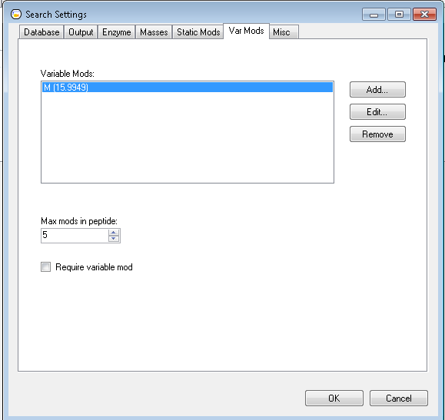

* The items in the “**Variable Mods**” list below correspond to the Comet variable mod parameters “[*variable_mod0N*](http://comet-ms.sourceforge.net/parameters/parameters_201501/variable_mod01.php)”, where N ranges from 0-9.

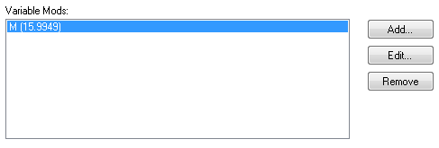

To add a variable modification, click on the “**Add…**” button on the right to open up the “**Add Variable Mod**” dialog below, and use this dialog to specify the various fields of the variable modification (these [variable mod fields](http://comet-ms.sourceforge.net/parameters/parameters_201501/variable_mod01.php) are described in more detail on the Comet website):

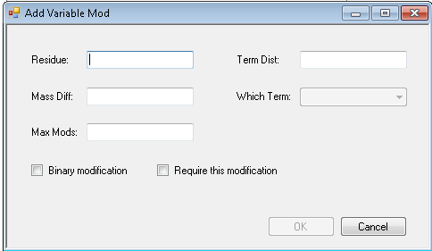

* + The “**Residue**” text box corresponds to the second field on the variable mod parameter – the residue(s) that the modifications are possibly applied to.
  + The “**Mass Diff**” text box corresponds to the first field on the variable mod parameter – specify the modification mass difference.
  + The “**Max Mods**” text box corresponds to the fourth field on the variable mod parameter – specify the maximum number of modified residues possible in a peptide for this modification entry.
  + The “**Binary modification**” check box corresponds to the third field on the variable mod parameter – specify whether the modification is a variable modification or a binary one.
  + The “**Require this modification**” check box corresponds to the seventh field on the variable mod parameter – specify whether peptides must contain this modification.
  + The “**Term Dist**” text box corresponds to the fifth field on the variable mod parameter – specify the distance the modification is applied to from the respective protein terminus.
  + The “**Which Term**” drop-down corresponds to the sixth field on the variable mod parameter – specify which protein terminus the distance constraint is applied to.

To edit a variable mod, go back to the “**Variable Mods**” tab, select the variable mod item in the “**Variable Mods**” list and click on the “**Edit…**” button to open up the “**Edit Variable Mod**” dialog, which is virtually identical to the “Add Variable Mod” dialog above, except with the fields populated to reflect the variable mod selected from the list.

To remove a variable mod from the “**Variable Mods**” list, just select the item and click on the “**Remove**” button.

* The “**Max Mods in Peptide**” text box corresponds to the “*[max_variable_mods_in_peptide](http://comet-ms.sourceforge.net/parameters/parameters_201501/max_variable_mods_in_peptide.php)*” parameter:



* The “**Require variable mod**” check box corresponds to the “*[require_variable_mod](http://comet-ms.sourceforge.net/parameters/parameters_201501/require_variable_mod.php)*” parameter:



## Misc Tab

The “**Misc**” tab on the Search Settings dialog contains miscellaneous Comet search parameters:

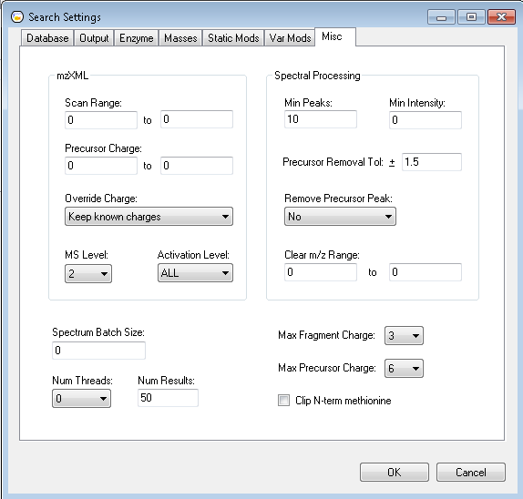

* The following “**mzXML**” fields correspond to the following Comet search parameters:

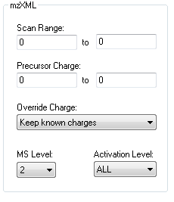

* + “**Scan Range**” text boxes 🡪 “*[scan_range](http://comet-ms.sourceforge.net/parameters/parameters_201501/scan_range.php)*”
  + “**Precursor Charge**” text boxes 🡪 “*[precursor_charge](http://comet-ms.sourceforge.net/parameters/parameters_201501/precursor_charge.php)*”
  + “**Override Charge**” drop-down 🡪 “*[override_charge](http://comet-ms.sourceforge.net/parameters/parameters_201501/override_charge.php)*”
  + “**MS Level**” drop-down 🡪 “*[ms_level](http://comet-ms.sourceforge.net/parameters/parameters_201501/ms_level.php)*”
  + “**Activation Level**” text boxes 🡪 “*[activation_method](http://comet-ms.sourceforge.net/parameters/parameters_201501/activation_method.php)*”
* The following “**Spectral Processing**” fields correspond to the following Comet search parameters:

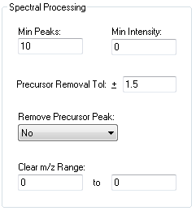

* + “**Min Peaks**” text box 🡪 “*[minimum_peaks](http://comet-ms.sourceforge.net/parameters/parameters_201501/minimum_peaks.php)*”
  + “**Min Intensity**” text box 🡪 “*[minimum_intensity](http://comet-ms.sourceforge.net/parameters/parameters_201501/minimum_intensity.php)*”
  + “**Precursor Removal Tol**” text box 🡪 “*[remove_precursor_tolerance](http://comet-ms.sourceforge.net/parameters/parameters_201501/remove_precursor_tolerance.php)*”
  + “**Remove Precursor Peak**” drop-down 🡪 “*[remove_precursor_peak](http://comet-ms.sourceforge.net/parameters/parameters_201501/remove_precursor_peak.php)*”
  + “**Clear m/z Range**” text boxes 🡪 “*[clear_mz_range](http://comet-ms.sourceforge.net/parameters/parameters_201501/clear_mz_range.php)*”
* The rest of the miscellaneous parameters correspond to the following Comet search parameters:

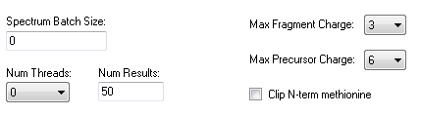

* + The “**Spectrum Batch Size**” text box corresponds to the “*[spectrum_batch_size](http://comet-ms.sourceforge.net/parameters/parameters_201501/spectrum_batch_size.php)*” parameter.
  + The “**Num Threads**” drop-down corresponds to the “*[num_threads](http://comet-ms.sourceforge.net/parameters/parameters_201501/num_threads.php)*” parameter.
  + The “**Num Results**” text box corresponds to the “*[num_results](http://comet-ms.sourceforge.net/parameters/parameters_201501/num_results.php)*” parameter.
  + The “**Max Fragment Charge**” drop-down corresponds to the “*[max_fragment_charge](http://comet-ms.sourceforge.net/parameters/parameters_201501/max_fragment_charge.php)*” parameter.
  + The “**Max Precursor Charge**” drop-down corresponds to the “*[max_precursor_charge](http://comet-ms.sourceforge.net/parameters/parameters_201501/max_fragment_charge.php)*” parameter.
  + The “**Clip N-term methionine**” checkbox corresponds to the “*[clip_nterm_methionine](http://comet-ms.sourceforge.net/parameters/parameters_201501/clip_nterm_methionine.php)*” parameter.

# Save Search Settings

To save any changes made to the search settings:

1. Click on the “**Settings**” menu:



1. Choose the “**Save Current… 🡪 Search Settings**” menu item:

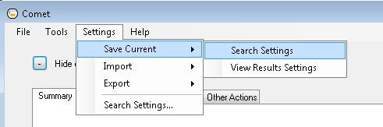

1. Click on the “**OK**” button on the confirmation dialog that pops up:

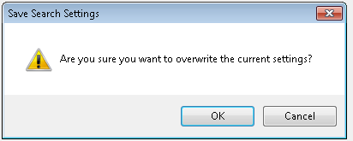

Now, if the CometUI application is rebooted, the changes made to the search settings will be preserved.

Alternatively, if changes were made to the search settings, and the user tries to close the CometUI application without saving these changes, the following dialog will appear giving the user a chance to save the changes by clicking on the “**Yes**” button.

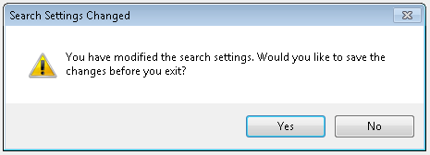

# Import/Export Search Settings

The CometUI application allows users to import Comet search settings from a “.params” Comet parameter file, as well as export the settings in the UI to a “.params” file.

## Import Search Settings

To import the search settings:

1. Click on the “**Settings**” menu:

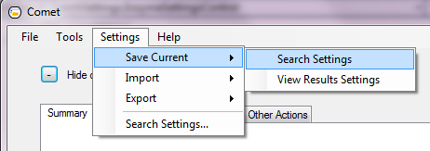

1. Choose the “**Import** 🡪 **Search Settings**” menu item:

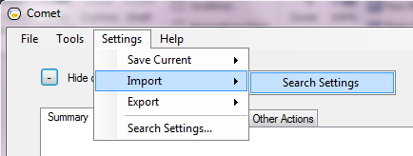

1. The following “**Import Search Settings**” dialog should open up:

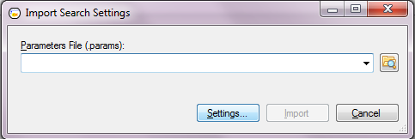

Note: The “**Settings…**” button can be used to view the current settings in CometUI.

1. Use the folder browse button on this dialog to browse to the “*.params*” file to be imported, and click on the “**Import**” button:

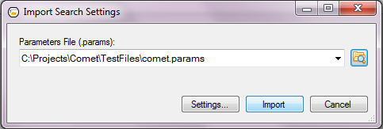

## Export Search Settings

The