Software setup for the VanquishNeo

Install SII for Xcalibur
Download the latest version of SII for Xcalibur and Vanquish Neo Driver:
https://thermo.flexnetoperations.com/control/thmo/login

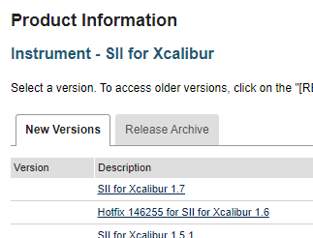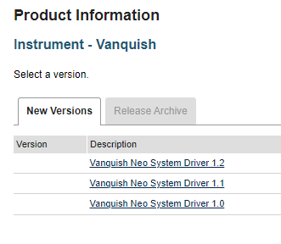

Mount SII and install it using the Install.exe, note it takes a long time to install SII.
Find the readme file and follow the instructions:
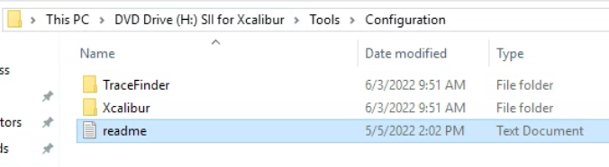

In order for SII for Xcalibur 1.7 to work with Xcalibur versions 4.5 or later, please follow the steps below:

1. Copy the two configuration files in this folder (\Tools\Configuration\Xcalibur) to the Xcalibur program folder, usually C:\Xcalibur\system\programs.
a. If prompted to overwrite, select Yes.
2. Using the HomePage application:
a. Verify that the SII for Xcalibur status window displays at least the direct control button.
b. Verify that the Instrument Setup program starts.

3. TraceFinder only: Copy the configuration file in this folder (\Tools\Configuration\TraceFinder) to the TraceFinder program folder, usually C:\Program Files\Thermo\Tracefinder\Version 5.0
a. If prompted to overwrite, select Yes.
4. Using the TraceFinder application:
a. Verify that the SII for Xcalibur status window displays at least the direct control button.
b. Verify that the Instrument Setup program starts.

Install the Vanquish Neo system Driver
Extract the Vanquish Neo driver zip file
To install the Vanquish Neo driver, run the following program from the distributed installer package:
Thermo.Chromeleon.Vanquish.Neo.Driver.1.2.msi
Reboot the PC

With the Vanquish connected, configure the Vanquish Neo UHPLC system in SII:

- Open the Chromeleon Services Manager and start the Instrument Controller (if not started automatically on system start), from the taskbar notification area:
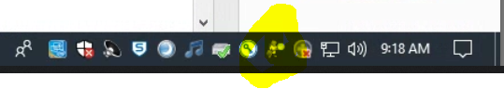

- For Thermo Xcalibur/SII for Xcalibur installations open Xcalibur Instrument Configuration, select SII for Xcalibur and configure device, press Configure / Configure Device and add a new Instrument (Figure 2).
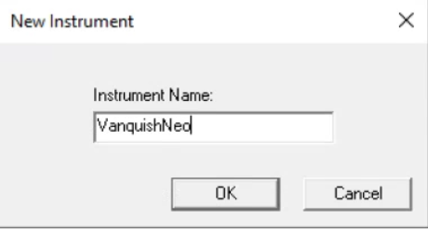
Figure 2: New instrument

- Add a new module and select HPLC: Vanquish followed by Vanquish Neo System. Enter the Vanquish System Controller IP address (Figure 3). The IP address of the Vanquish Neo system can be displayed and modified on the Vanquish UI – Settings Panel – Connectivity. For details please refer to the Vanquish UI release notes and user manual.
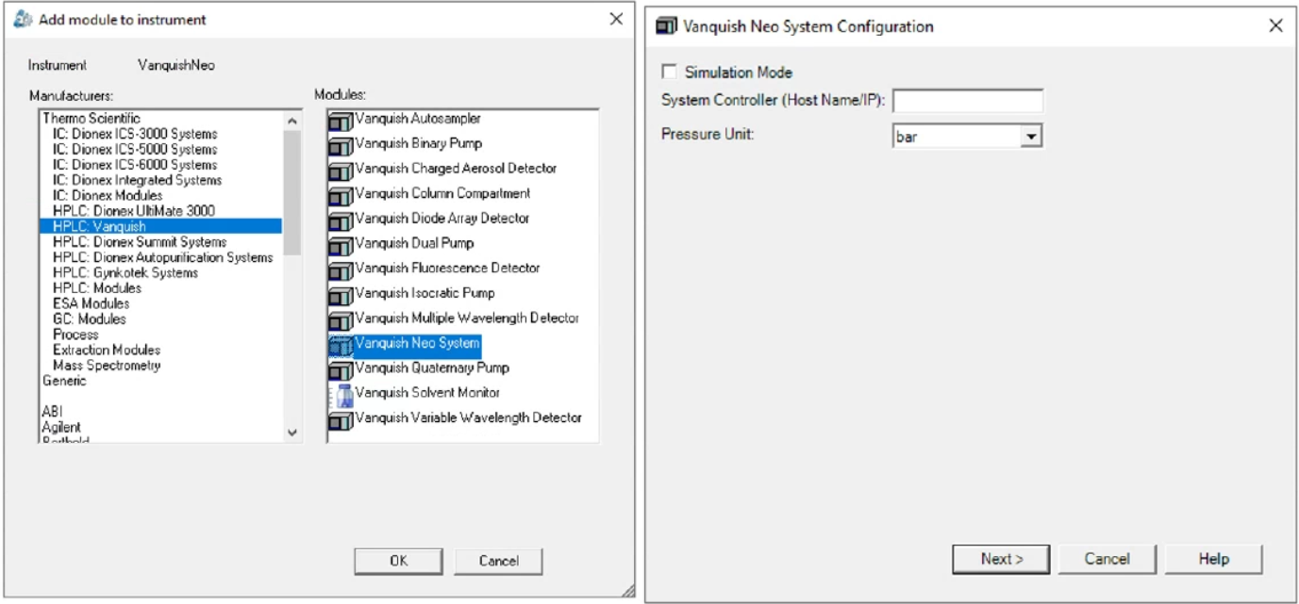
Figure 3: Add new module to the instrument and set the system controller IP address
- After the IP (172.16.0.104) address is entered and the system was successfully connected to the instrument control PC, the configured modules of the Vanquish Neo system are displayed (Figure 4).
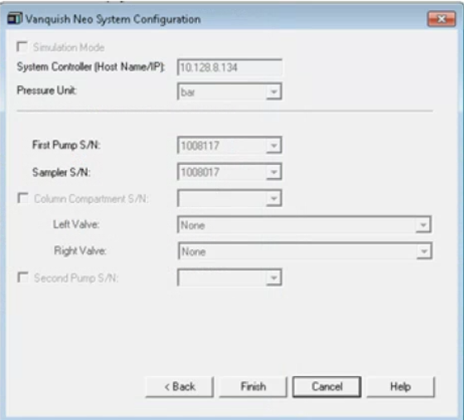

- Add the mass spectrometer and save Instrument Cofiguration
- Open Xcalibur
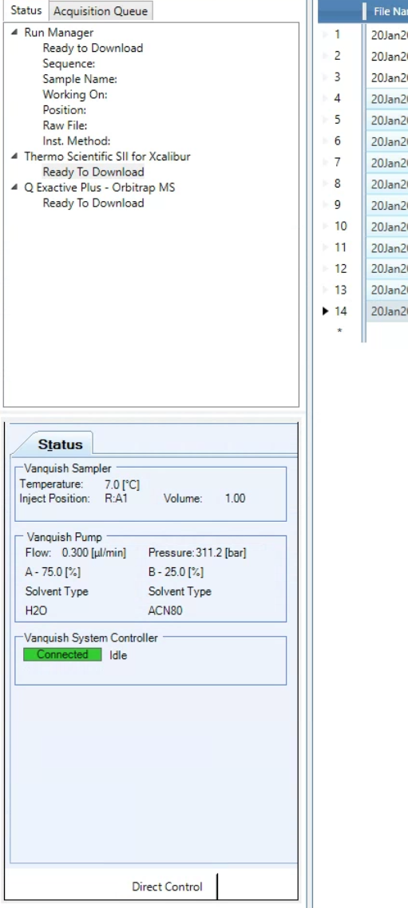

Setup the Gradient

