UWPR Resources Usage Guidelines
Contents
UWPR Resources Usage Guidelines 1
Overview 2
UW internal 2
All other collaborators 2
Collaboration initiation and instrument scheduling 3
Register and log in 3
Submit project information 3
Submit billing information 3
Sign up for instrument time, review costs 3
Instrument usage 4
Training 4
Setup time 4
What you should provide 4
What the UWPR provides 4
When you’re done 4
Data analysis 4
Billing 5
The time blocks are 5

Overview

UW internal

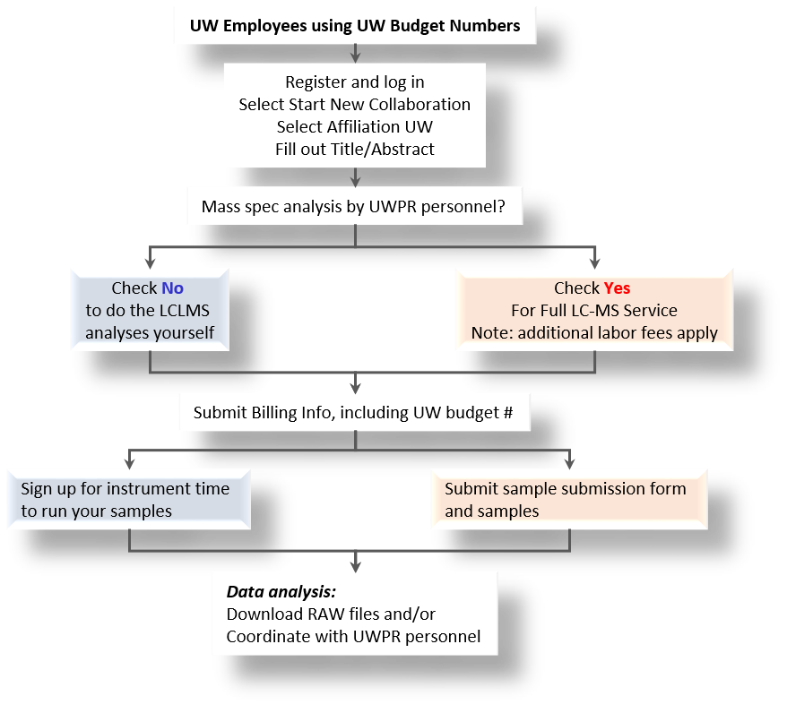

All other collaborators
UWPR is currently only working with UW researchers that have UW budget number.

Collaboration initiation and instrument scheduling

Register and log in
New users must register first, and then login via the website: https://proteomicsresource.washington.edu/index.php

Submit project information
Click on “Start new collaboration” and submit an abstract briefly describing your project. Note the affiliation you choose will determine the rate you will be charged for this project. Only choose UW affiliation if you have an active UW budget number. Otherwise choose Non-Profit (for non-profit organizations or other Universities) or Commercial.
UW employees using UW budget numbers can choose between self-service and full LC-MS service (check “Mass Spec analysis by UWPR personnel?” yes or no respectively) Note: different rates apply.

Submit billing information
After submitting the abstract you need to submit billing information: view the project page and click on [Add New Payment Method] and enter all the billing info (you’ll need the budget number and expiration date and contact information).

Sign up for instrument time, review costs
If you selected self-service, you’ll be able to schedule instrument time. NOTE: If you are a new user, please email us to setup your sign up privileges.

Do NOT block instrument time unnecessarily! Or your self sign up rights can and will be revoked.

All others will have to coordinate with UWPR personnel to schedule time full LC-MS service.
You can sign up for time blocks (min 4hrs), starting at 10am or 2pm and ending at 2pm, 6pm or 10am. As you sign up for instrument time the associated cost is calculated and displayed in a pop-up window. There is set-up fee plus the cost for the instrument time. There is also a link to a summary page with a complete history for this project, all the instrument time/cost and billing status. The total cost for each project/budget number will be displayed on the project page.
If you can’t use the time you scheduled, cancel it as soon as possible but no later than 48hr before the start time of the time block you wish to cancel, after that you will no longer be able to cancel your time. Note: you will be charged for time you schedule and don’t or can’t cancel yourself!!
If you sign up into the weekend, be prepared to come in and clean up during the weekend.

Instrument usage

Training
In order to use the resources, you will have to undergo the appropriate training and follow all the usage guidelines. The level of instruction is such that following completion of the initial training (usually 2 to 4 hrs) and several periods of supervised use; the researcher may exercise independent, unattended use of an instrument with instructor approval. The training is instrument specific and is provided during the signed up instrument time. Training has to be coordinated with UWPR staff.
You can use our LC-MS setup procedure EASYnLC(pdf) as a guide, during and after training.

Setup time
NOTE: There is setup time required for UWPR staff to get the instrument ready for you, typically this should take less than 30mins. So if your scheduled time starts at 10am, you should be able to start using the instrument by 10:30am.

What you should provide
- Samples (they should be ready to go, digested and cleaned (no salts, no detergents)), we have a centrifuge for a final spin down and pipettes and tips to transfer them to the autosampler vials,
- Autosampler vials
- Columns/trap: you should provide your own columns and trap columns; if you don’t have column packing equipment you can coordinate with UWPR staff to use the packing stations at the UWPR.
- LC-MS commonly used consumables (xls) contains a list of materials
- There is a column packing guide on our website under methods/LC-MS (Packing capillary columns (pdf) )

What the UWPR provides
- Mass spectrometers: the instruments are calibrated and maintained by UWPR personnel, do not run any calibrations!
Check our website for current instrumentation ( https://proteomicsresource.washington.edu/resources.php )
- HPLC: the instruments are maintained by UWPR personnel!!
Check our website for current instrumentation ( https://proteomicsresource.washington.edu/resources.php )
- HPLC Buffers (A: 0.1% Formic Acid in Water, Optima LC/MS [Fisher # LS118-4], B: 0.1% Formic Acid in 80% Acetonitrile, Optima LC/MS [Fisher # LS122500])
- Basic lab equipment and supplies, centrifuges, vortex, fridge and -20 freezer for short term sample storage, pipettes and tips, gloves, Eppendorf tubes etc

When you’re done
- Clean up (don’t forget your samples), take all your belongings back to your lab (column/trap, vials, samples etc)
- Copy your data (if data is left on pc, we will copy it to our cluster and retain a copy for ~one year)
- Return keycard. Note you’ll be given a keycard to access the lab. There is a 20.- dollar charge for lost/stolen keycards. The keycard has to be returned to UWPR staff by the end of your scheduled time.
- You will be charged instrument time until the key card is returned and all your stuff is cleaned up.

Data analysis
If you need assistance with data analysis, coordinate with Jimmy Eng.

Billing
Once a month you (or your billing contact person) will be invoiced by Dept. Genome Sciences administration
Current rates are accessible on the home page when you log in.

Billing is based on the instrument time scheduled/used:
  - The setup fee applies to each consecutive time block that you sign up for. If you sign up for one 24hr block you’ll be charged one stup fee. If you sign up for three 8hr blocks, you’ll be charged three setup fees.
  - There is a 48 hrs cancellation period for instrument time, i.e. you can cancel time up to 48hr before the start time of the time block you want to cancel, after that the system will no longer allow you to make changes.
So it’s very simple: you will be charged for the instrument time you didn’t or couldn’t cancel yourself.
  - You will be charged instrument time until you clean up and return the keycard.
  - If you finish early and clean up/return the key card before the next time block starts, unused time will be backed out to the end of you last acquisition (always rounding up to the next full hour) but no more than back to the end of the previous time block:
    - e.g. if you are signed up until 10 am, time from the end of you last acquisition (always rounding up to the next full hour) will be backed out, maximum back to 6 pm the day before.
    - if you are signed up until 6pm, time will be backed out to max 2 pm that same day.
    - if you are signed up until 2pm, time will be backed out to max 10 am that same day.
    - So for example, if you wish to sign up for the whole weekend (e.g. until Mon 10am), so you don’t have to cleanup during the weekend, and your last run finishes e.g. Saturday morning, you will be charged until Sun 6pm.
  - If you can’t make it in to clean up and ask UWPR personnel to clean up for you, you will be charged the full time block (no time will be backed out).
  - If you sign up into the weekend, be prepared to come in and clean up your stuff during the weekend.

The time blocks are
The instrument start and end times are limited to ensure efficient usage of the instruments:
There are two start times: 10am and 2pm and three end times: 10am, 2pm and 6pm.
This will limit the time to sign up for instruments to three basic blocks:
- two 4 hr blocks 10am - 2pm and 2pm - 6pm
- one 8 hr block 10am – 6pm
- and 24 hr block 10am – 10am and 2pm – 2 pm

