UWPR Resources Usage Guidelines
Contents
UWPR Resources Usage Guidelines 1
Overview 1
UW internal 1
All other collaborators 1
Collaboration initiation and sample submission 2
Register and log in 2
Submit project information 2
Submit billing information 2
Submitting samples for analysis 2
Billing 2

Overview

UW internal

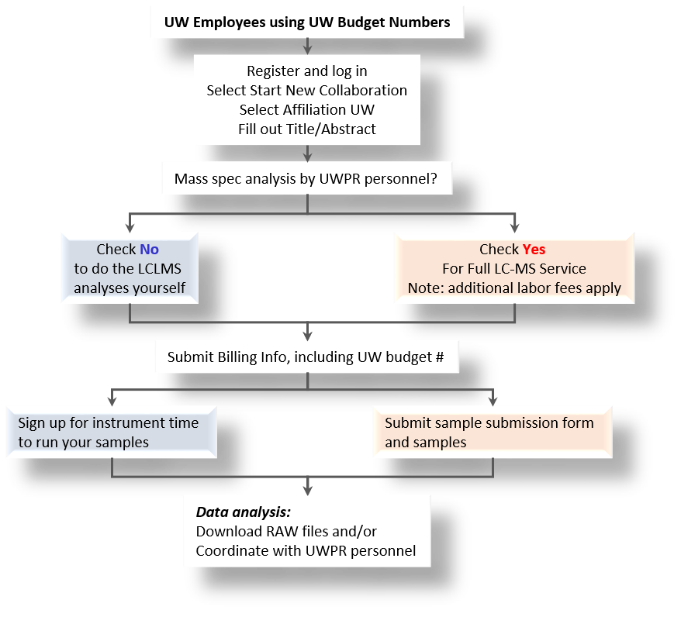

All other collaborators
UWPR is currently only working with UW researchers that have UW worktags (budget number).

Collaboration initiation and sample submission
Feel free to email us to get started, we’re happy to answer any questions you may have.

Register and log in
New users must register first, and then login via the website: https://proteomicsresource.washington.edu/index.php

Submit project information
Click on “Start new collaboration” and submit an abstract briefly describing your project.
Affiliation: choose University of Washington. Note you will need a current UW worktag as payment method.
UW employees using UW worktags can choose between self-service and full LC-MS service (check “Mass Spec analysis by UWPR personnel?” no for self-service or yes for if the LC_MS analysis will be done by UWPR personnel) Note: different rates apply.

Submit billing information
After submitting the abstract, you need to submit payment information: view the project page and click on [Add New Payment Method] and enter all the billing info (you’ll need a UW worktag, expiration date and contact information of the person managing the worktag).

Submitting samples for analysis
We currently don’t do any sample preparation. You will have to digest the proteins of interest and clean up the peptides prior to submitting samples. Peptides should be salt and detergent free. You can either submit them dry or in 0.1% formic acid in water.

Please submit a sample submission form every time you submit samples for analysis. This is an xlsx file you can download from the homepage after you log in. We use that file to track experimental details and will upload it to your project for future reference.

Then coordinate a time with us to drop off the samples. Once we have the samples and submission form, we will schedule instrument time for the LC-MS analysis. As soon as the analysis is complete, we will upload the raw files and perform the database searches. We’ll email you when the analysis is complete and you can access the search results, linked to your project online.
For an overview of the tools used and a data analysis primer visit:
https://proteomicsresource.washington.edu/protocols06/primer/

Billing
Once a month you (or your billing contact person) will be invoiced by Dept. Genome Sciences administration
Current rates are accessible on the home page when you log in.

Billing is based on the instrument time used for the analysis:
  - The setup fee applies to each consecutive block of instrument time.
  - There is a two hour minimum for us to setup a new column and run a system suitability standard.
  - After that it will take about 2hrs per sample/replicate and 45 min for a blank (if desired) to run your samples.
  - You can review the current rates by downloading the xlsx file from the homepage after you log in. Note the fees with additional labor apply.
On your project page there is a link “Instrument time scheduled for project” to a summary page with a complete history for this project, with all the instrument time/cost and billing status for each worktag used under that project.

