Using the Log Viewer
You can use the Log Viewer to look at the pressure trace of all the RAW files you acquired. All that data is stored on the on-board hard drive on the EASYnLC.
Using the Log Viewer 1
Download and Install LogViewer 1
Copy files from EASYnLC hard drive to local PC 2
Compress files into a .zip file 3
Open the .zip file with LogViewer 3
Mount the EASYnLC hard drive to file explorer: 6

Download and Install LogViewer
You can download the latest version from Thermo’s Knowledge base: https://www.unitylabservices.com/en/support/knowledge-bases.html

navigate to Chromatography & Mass spectrometry / Chromatography / LCMSsystems/EASYnLC
look for EASY-nLC Logviewer Current Version:

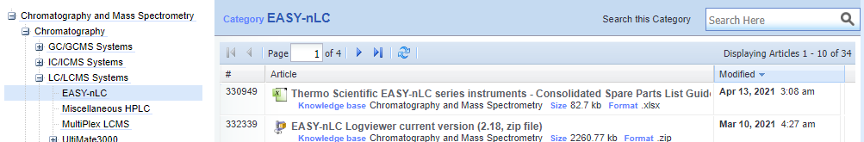

Extract the zip file and open the Log Viewer (you can move or copy the LogViewer2_18.exe file to the desktop):
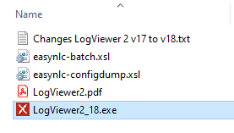

Copy files from EASYnLC hard drive to local PC
Open file explorer and click on “admin (\\172.16.0.104) (Z:)”, if it prompts you for a log in and password use “admin” for both.
Note if the “admin (\\172.16.0.104) (Z:)” is not present or if you have to map for the first time follow the instructions at the end of this document “Mount the EASYnLC hard drive to file explorer”.
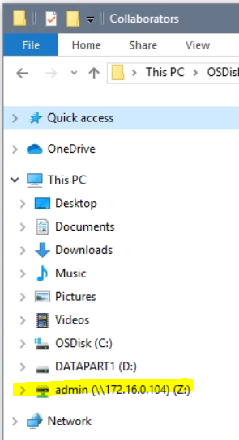

Double click on “batchLog”:
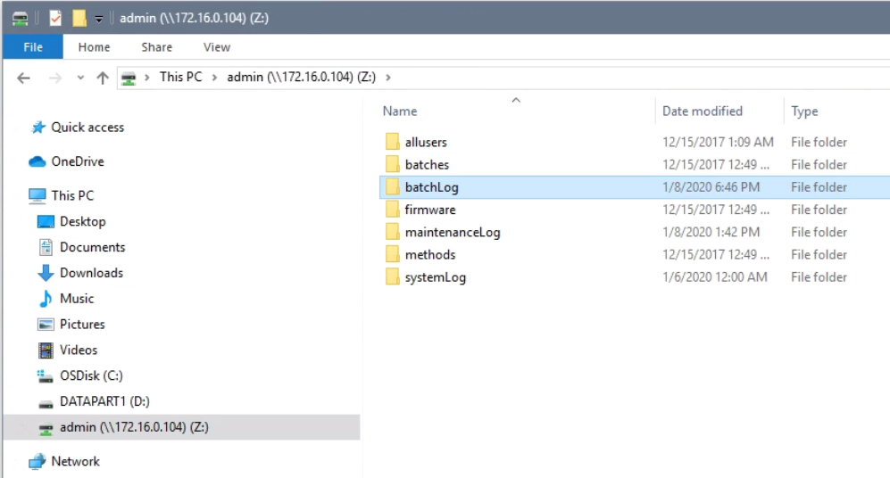

Now you should see a folder for each RAW file you acquired. Sort by “Date modified” to list the newest ones on top.
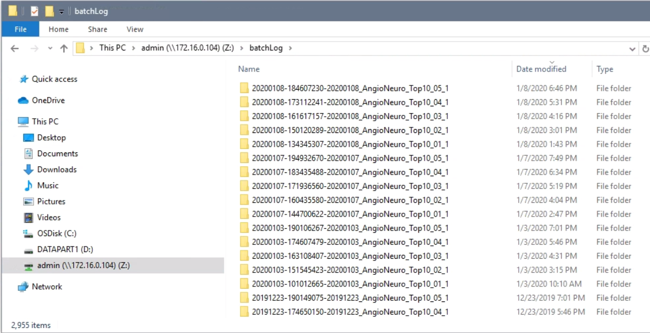

To copy the folders, drag the ones you want to look at to your folder on the local PC.
If you get a security error, acknowledge it by clicking “OK”:
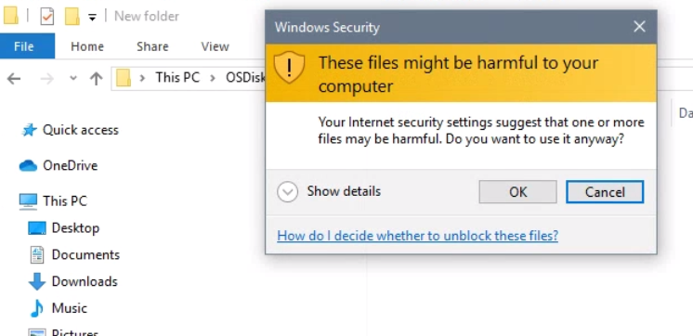

The folder should copy to the folder you selected:
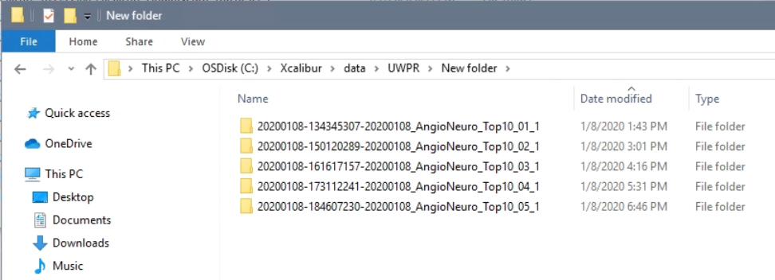

Compress files into a .zip file
To create a zip file, select all the folders, do a right mouse click and select “Send to” and then “Compressed (zipped) folder”:
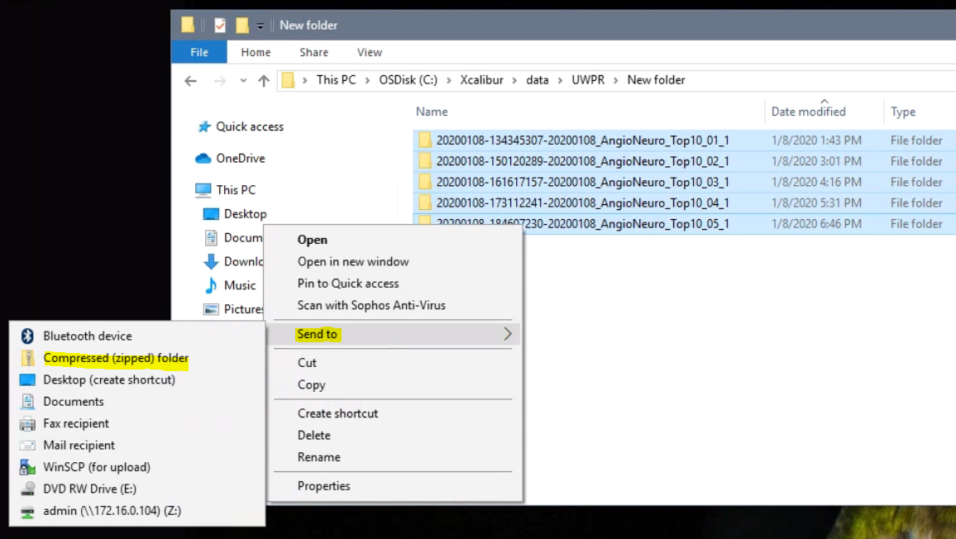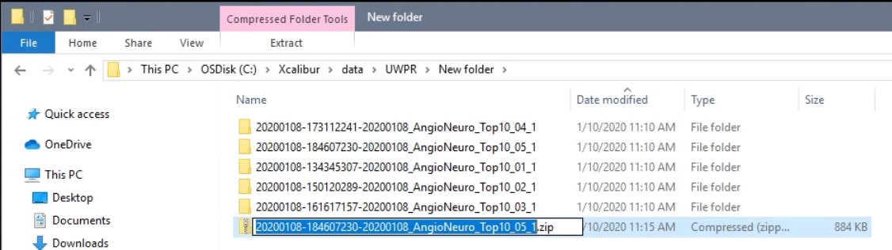

You can rename it or leave the default:
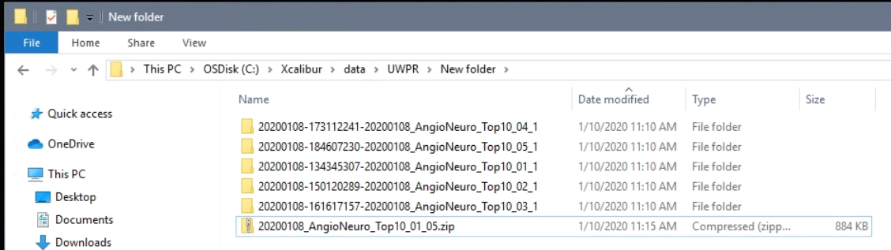

Open the .zip file with LogViewer
Now open LogViewer, double click on the icon on the desktop:
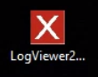

Go to file open, and navigate to the zip file you just created, select it and hit “open”:
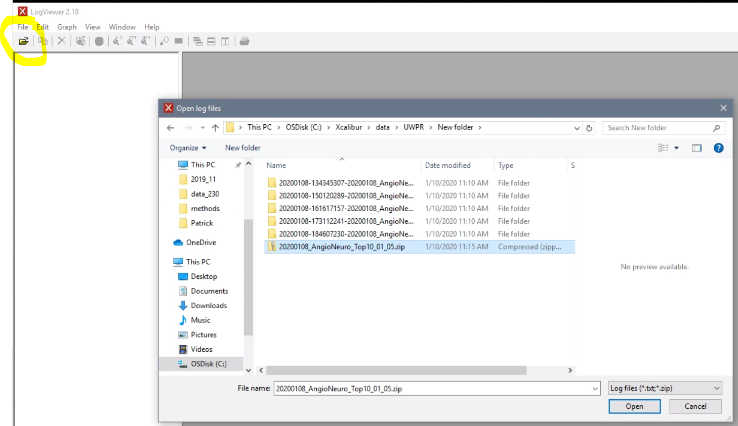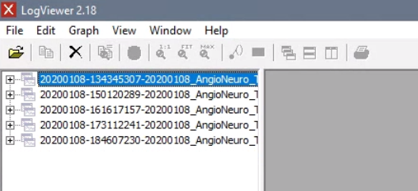

Expand the tree on the left by clicking on the “+”, and select the traces you want to look at:
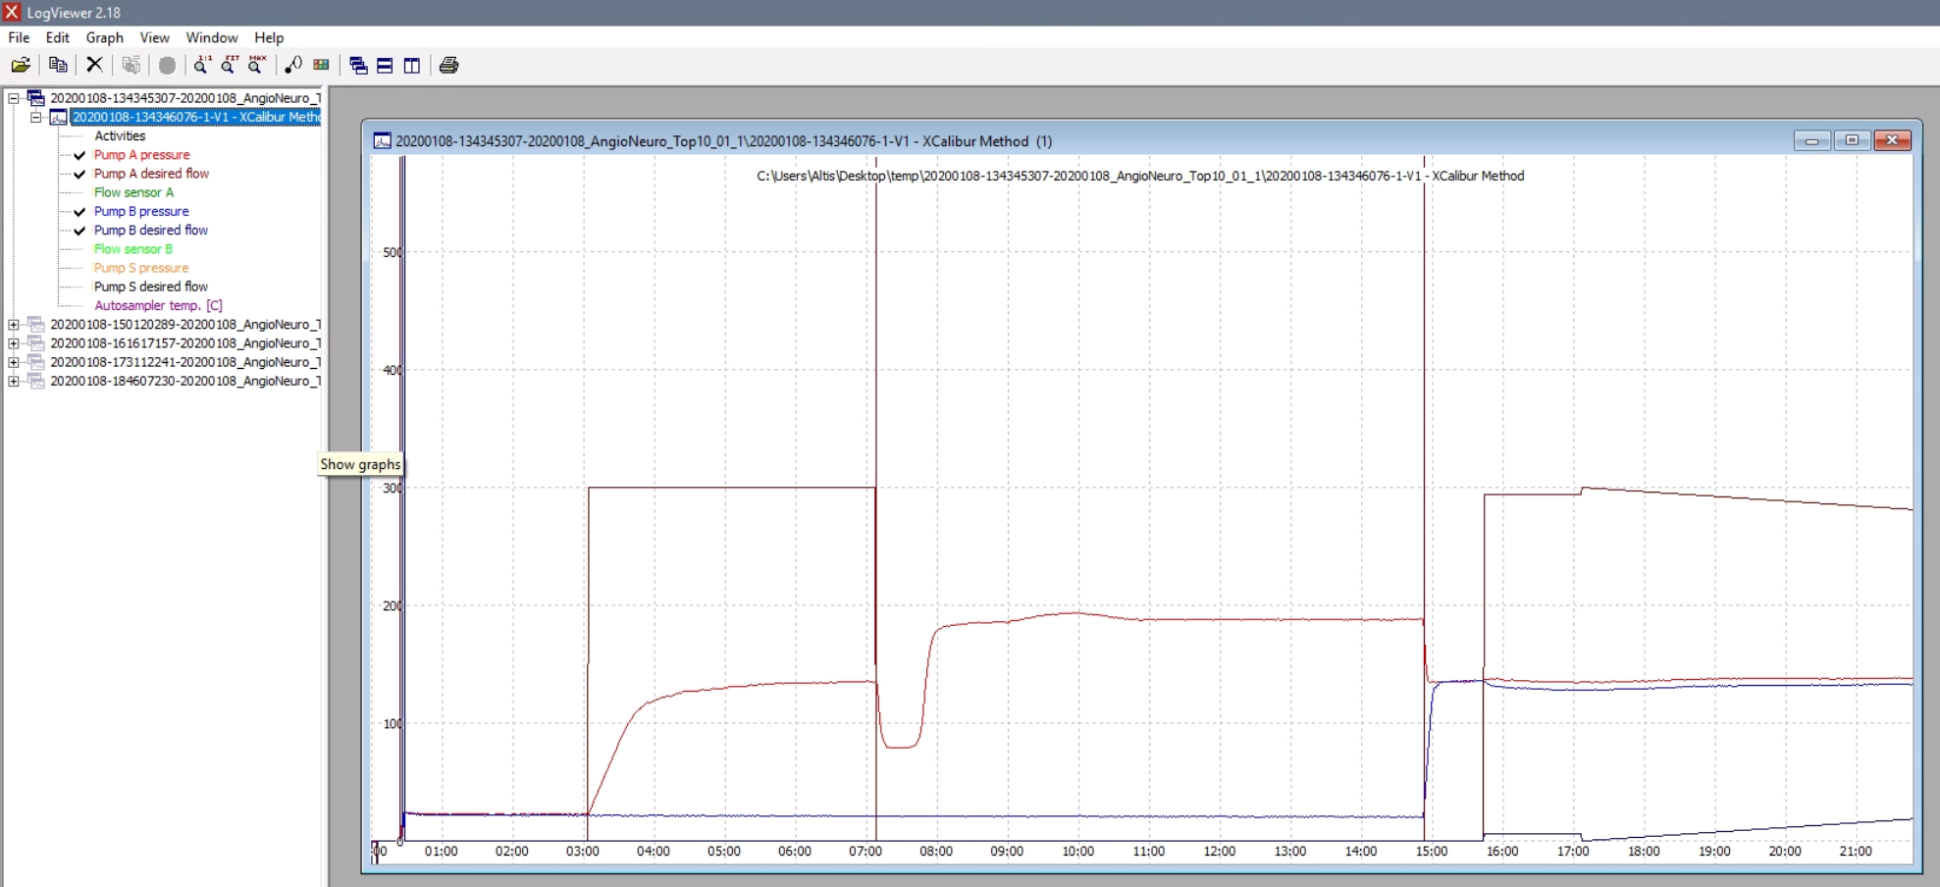

Note it’ll likely only show part of the chromatogram, click on “FIT” to see the entire chromatogram:
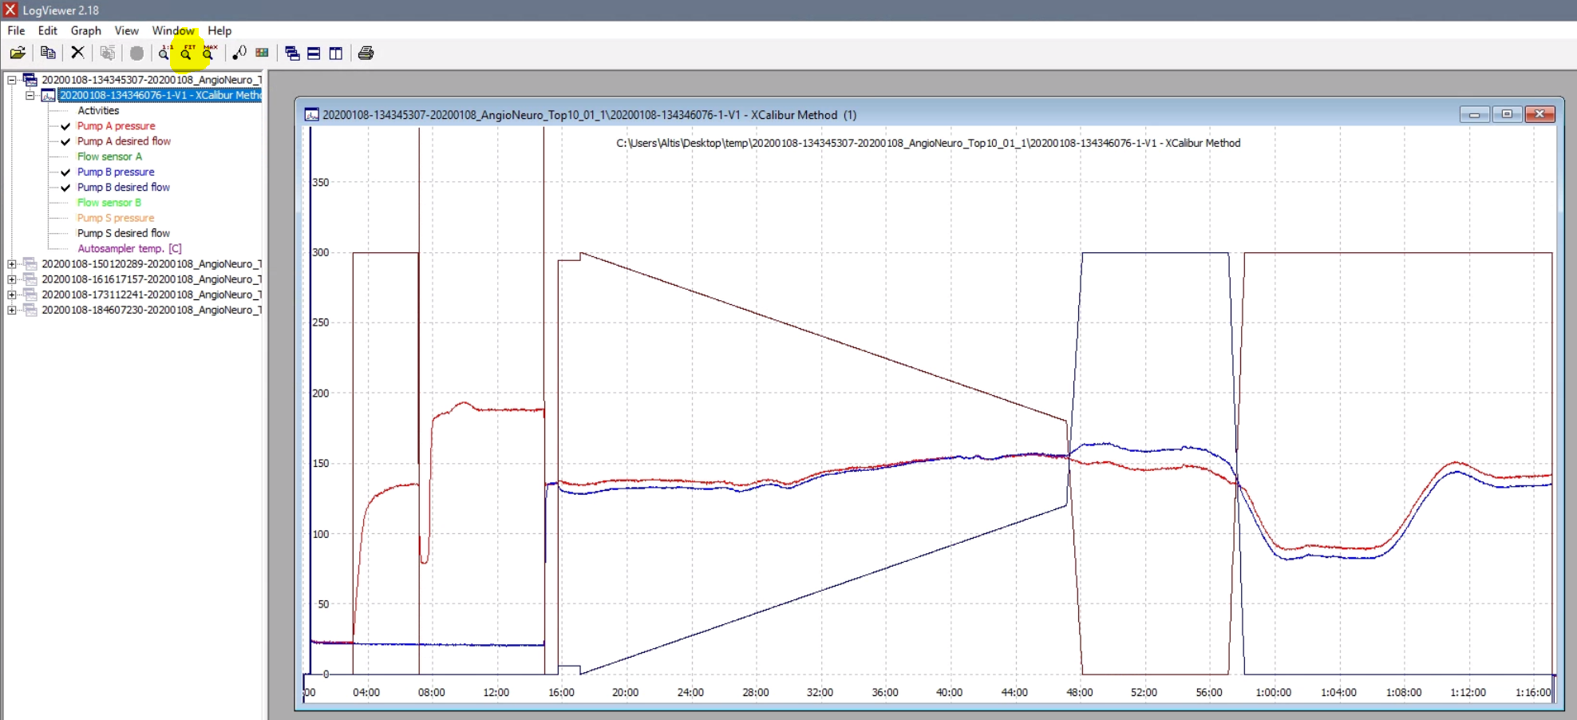

You can open a second one and tile them:
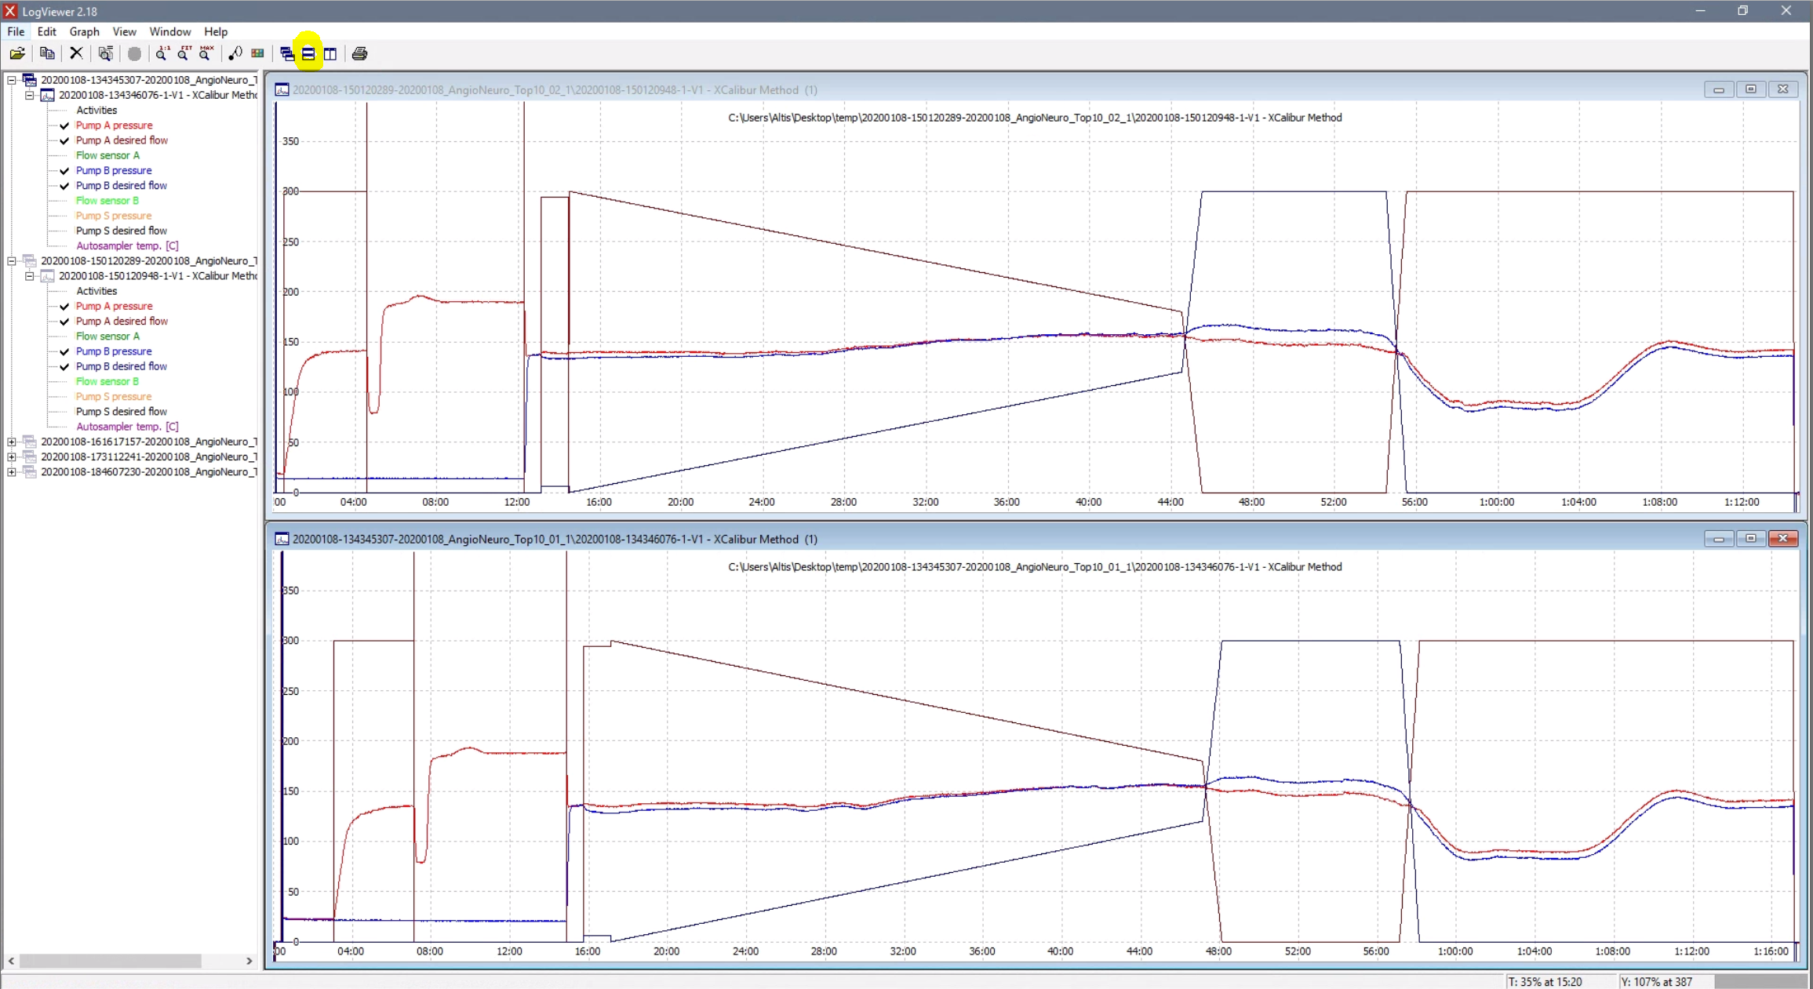

Or you can select “compare graphs” to show them all in one window:
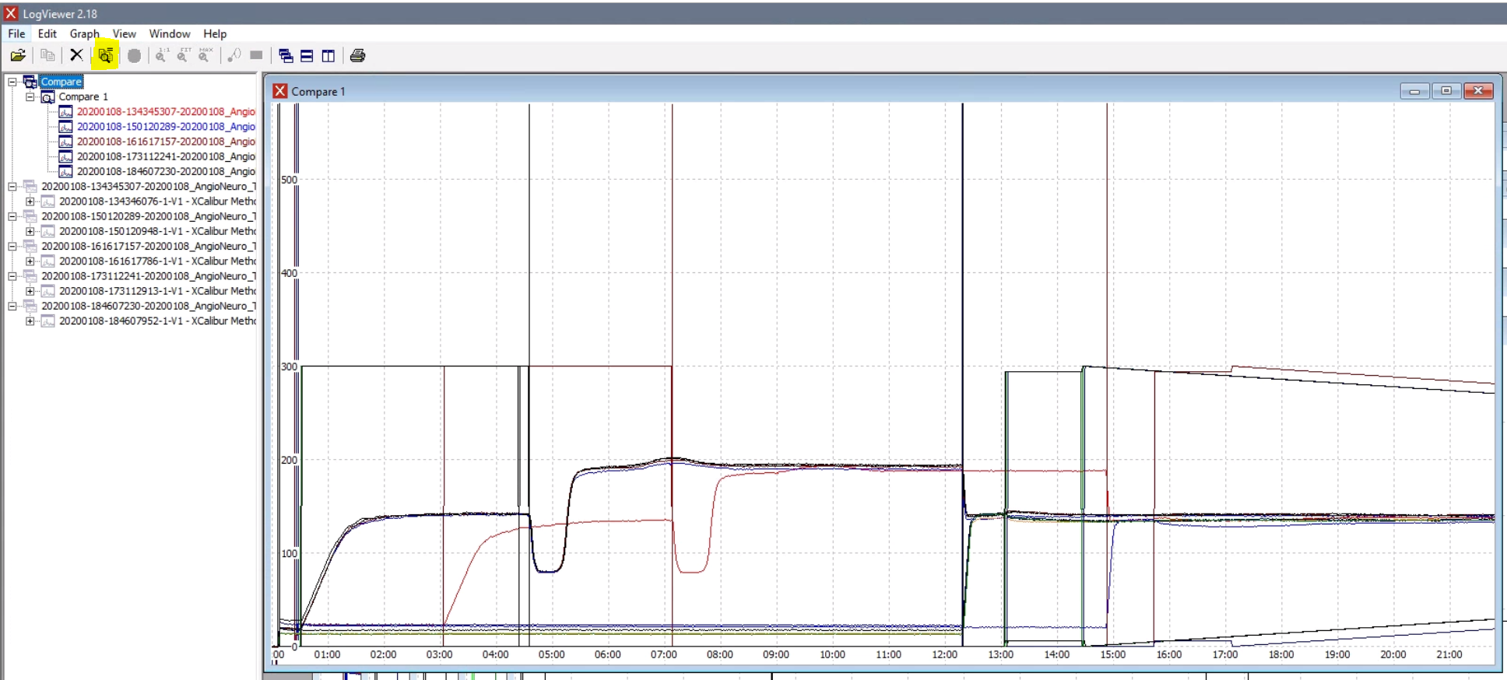

Mount the EASYnLC hard drive to file explorer:
From the start menu, under windows system Open the run command and enter the IP of the EASYnLC in this form \\172.16.0.104\
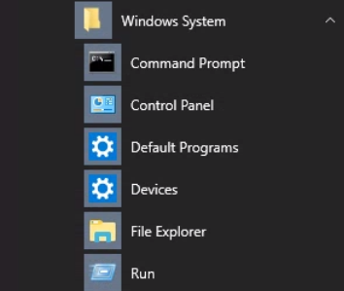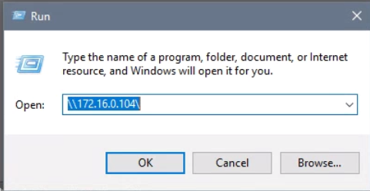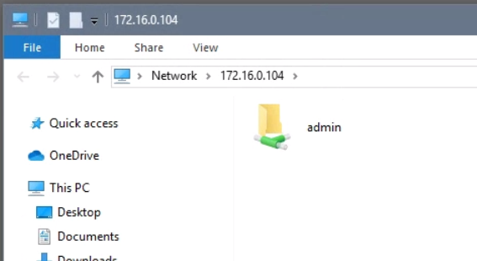

Do a right mouse click on the admin drive and select Map network drive and hit finish:
