How to setup the EASYnLC method

Sample pickup and loading
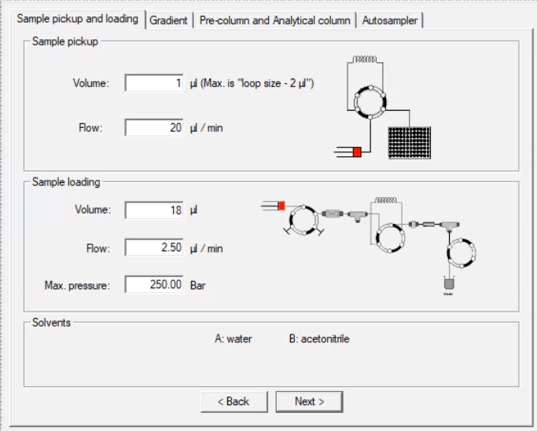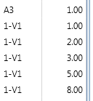
Xcalibur injection vol 1-8 µl

Sample pickup:

- Note: the injection volume in the Xcalibur sequence overwrites the Sample pickup volume in the method, so just set it at 1ul
- Sample pickup flow should be 20ul/min, that is the optimal syringe speed for aqueous solutions

Sample loading:
- So you need to make sure the at the Sample loading Volume in the method is sufficient to load the entire sample onto the column
- Always set the Sample loading Volume = 2 x injection volume + 2 µl
- But always use a minimum of 6 µl (1-2 µl of sample volume)
- e.g. if you load 4 µl of sample: 2 x 4 µl + 2 µl = 10 µl
- The basic method provided by UWPR will have a loading volume of 18 µl to allow for 1-8 µl sample injection volumes (set in Xcalibur sequence list)
- To speed up the sample loading time you can change the Sample loading Volume to a minimum
- If you only load 1 µl you can set the Sample loading volume to 6 µl instead, but you have to remember to increase the sample loading volume if you ever inject more than 1 µl.
- You can use a max pressure limit (e.g. 150-250 bar) for the loading instead of the flow rate, this way the system will determine the highest flowrate to give you the desired max pressure
- If you set both the Flow and Max. pressure the system will not exceed either one of them.
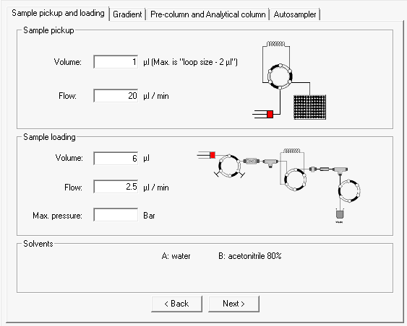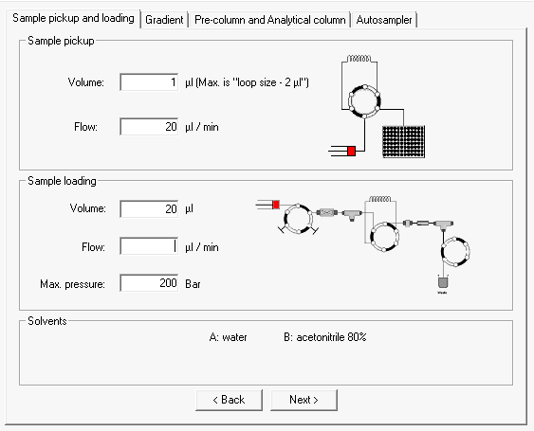

Setup the Gradient
- Buffer A: 0.1 % Formic Acid in Water (Fisher Water with 0.1% Formic Acid (v/v), Optima™ LC/MS Grade, LS118)
- Buffer B: 0.1 % Formic Acid, 80% Acetonitrile in Water (Fisher Water with 0.1% Formic Acid (v/v), Optima™ LC/MS Grade, LS122500)
- Note Buffer B is 80% Acetonitrile, so keep that in mind when setting up the gradient.
- Most peptides elute between 10-30% Acetonitrile, or ~12.5-37.5 % B
- Here is an Example gradient we used for a complex mixture (Hela whole cell lysate digest with Trypsin):
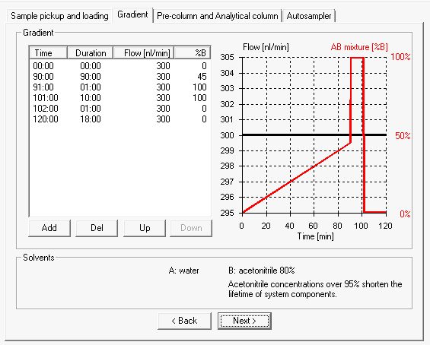
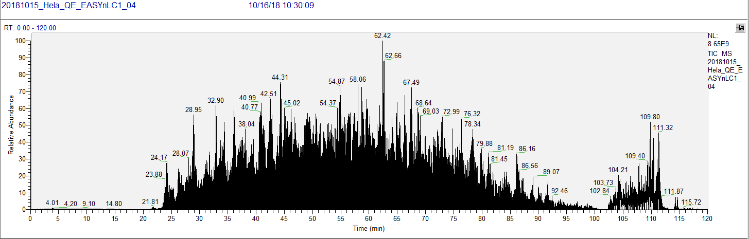

Pre-column and Analytical column

- Thermo recommends to use volume of 20 µl for the analytical column equilibration (and end the gradient above at 102 min after the 100% B wash)
- We usually do the equilibration at the end of the run and continue to acquire data so we have a visual confirmation that the column equilibrated (in the screen shot above you see the 100% B wash peak 103-113 mins)
- In this case we do not need to do an extensive equilibration at the beginning of the run
- Instead, we found if we do 0.3 - 1 µl at 0.30 µ/min that is sufficient, and does not cost us any extra time as it is done at the same time the sample is loaded into the loop.
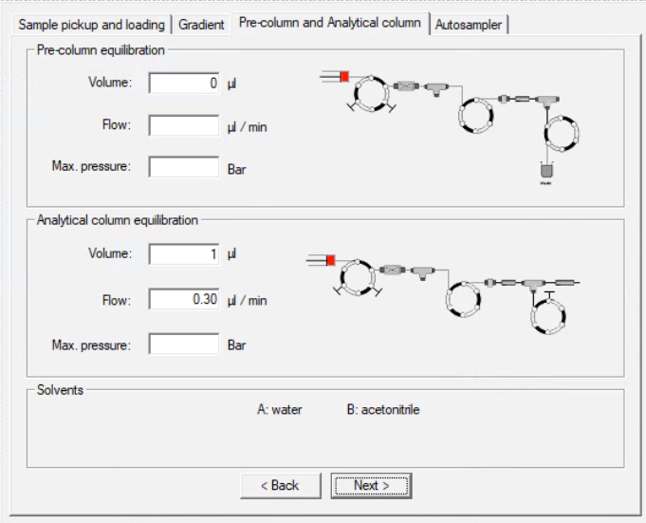

- We found if we eliminate the Analytical column equilibration we get some Acetonitrile onto the column at the very beginning of the run and we lose some peptides:
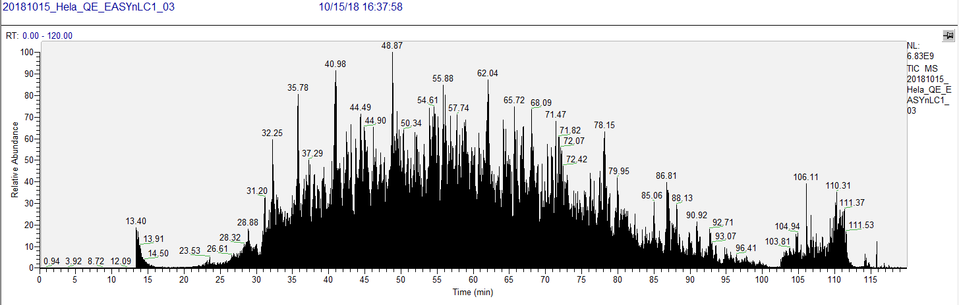
Note the “Ghost” peak if Analytical column equilibration is omitted.

Autosampler
- The standard wash volume determines how much buffer A (Bottle 3) will be used to rinse the injection needle, e.g. 50 µl.
- We recommend to use the custom setting to include an acetonitrile (buffer B in Bottle 1) wash as well:

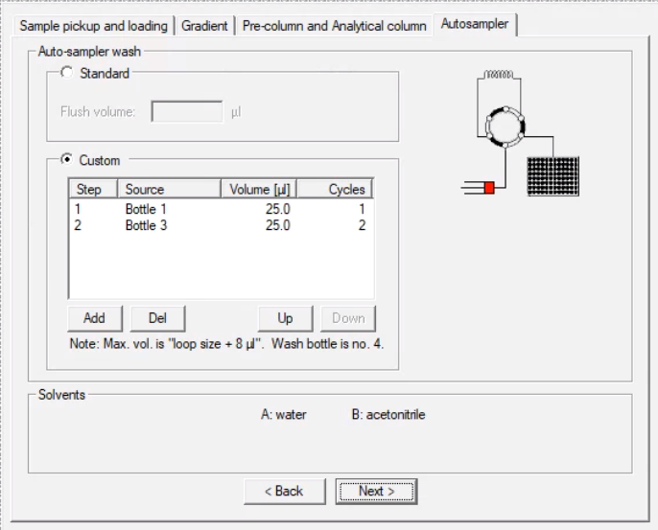

Xcalibur setup
- Note: the injection volume in the Xcalibur sequence overwrites the Sample pickup volume in the method
- In Xcalibur the sample position
- The Vial rack Positions are 1-V1, 1-V2, … 1-V6, e.g. AngioNeuro is in 1-V1
- For the 6 x 8 plate the vial positions are A1, A2, ….. A8; B1, B2, ….. B8; …; F1, F2, ….. F8
- For the 96-well plate the vial positions are A1, A2, ….. A12; B1, B2, ….. B12; …; H1, H2, ….. H12

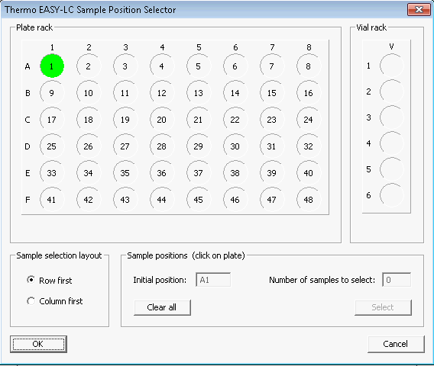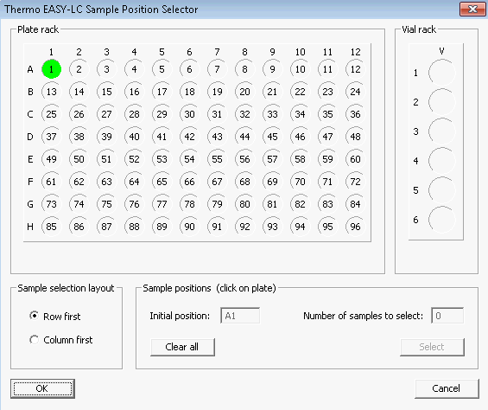

Changing the plate configuration

At UWPR we use two plate types 6x8 and 96well, to switch between them follow the steps below

- Close Xcalibur, methods, Qual browser etc.
- You can leave the virtual display and Tune window open
- Open instrument configuration (should be pinned to the start menu)
- Select the EASYnLC and hit configure
- Click on “Test configuration” wait for the “connection OK” turn green
- Under Autosampler Configuration, go to the plate installed and select the plate format you want to use
- Note our systems are only calibrated for 6x8 vials and 96 well plate
- You can click on Edit to see the layout or change the row/number layout if you wish
- Hit “OK” and then “Done” to close the instrument configuration window

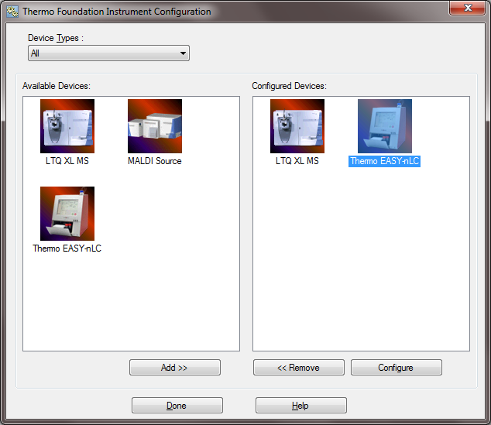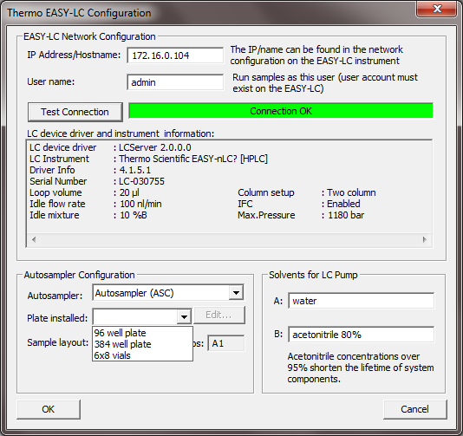

Now you have to change the plate on the HPLC itself:
- On the EASYnLC home screen click on the plate
- Click on Goto Calibration

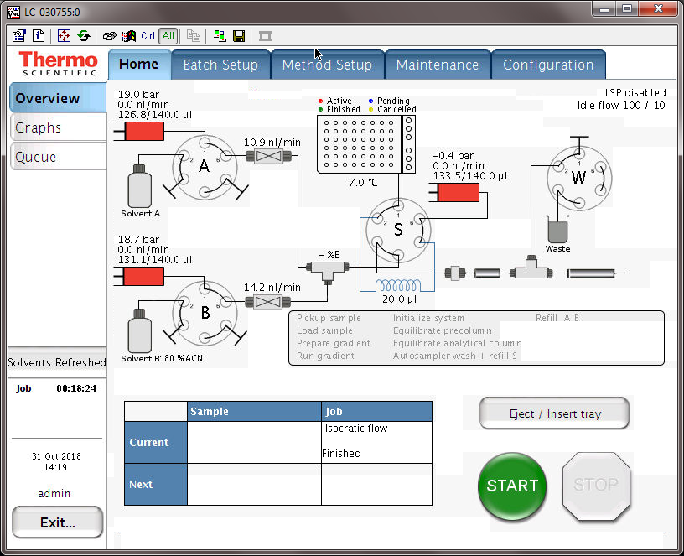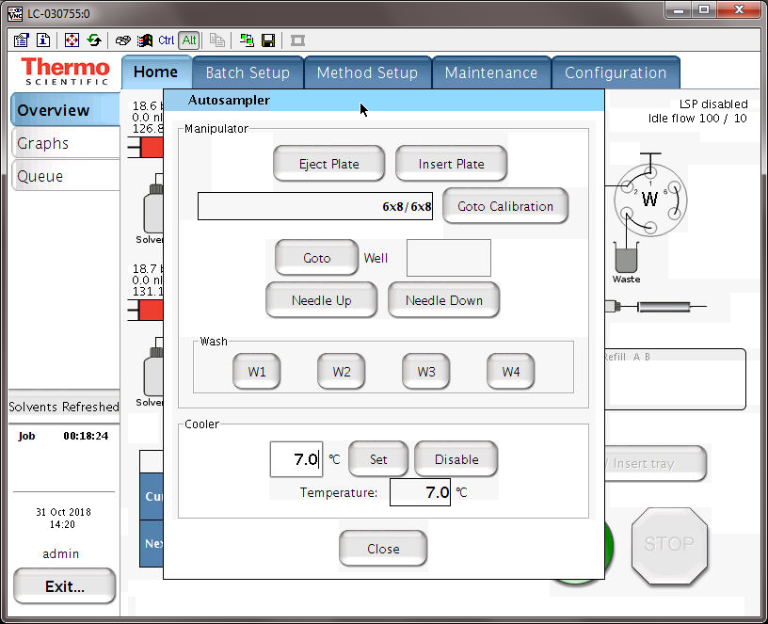

- Alternatively you can go to Maintenance/Devices/Cooled Autosampler/Tools

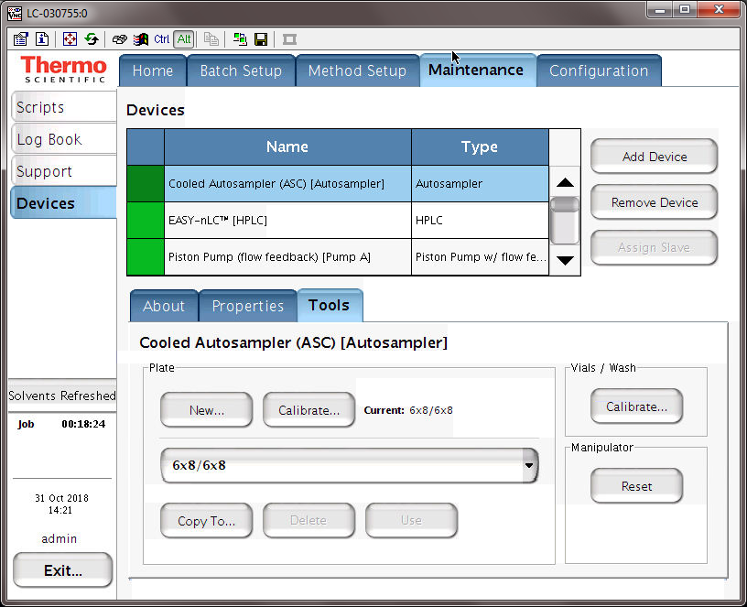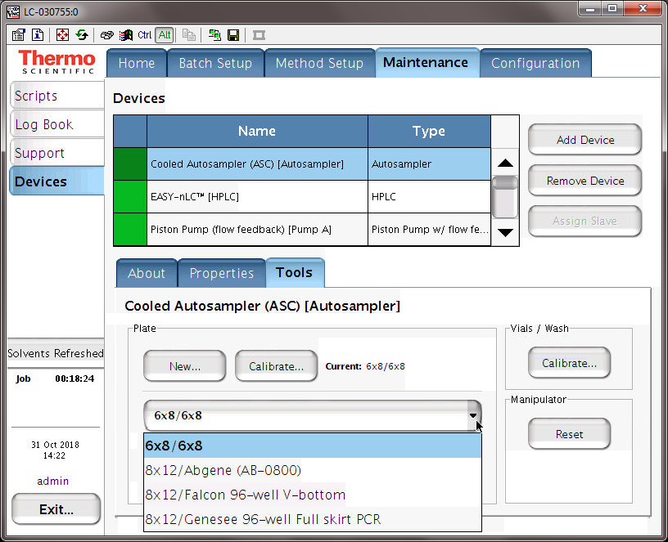

- Select the plate you want to use from the pull down menu
- Hit “Use” and acknowledge the pop up

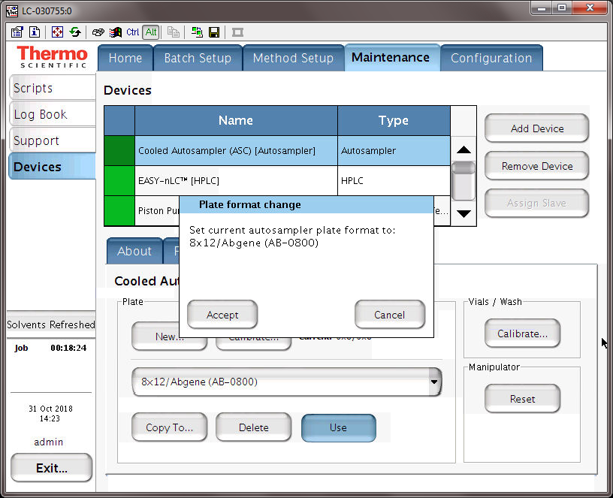

- Now re-open Xcalibur and you should be able to select the sample positions that correspond to your plate
- 6x8: A1-A8, B1-B8, … F1-F8
- 8x12: A1-A12, B1-B12, …. H1-H12
- Note the vial position for the 6 vials on the right side is 1-V1 through 1-V6

