Updating Software on EASYnLC 1200 (4.1 to 4.2)

Check the current software version
First, check your current software by clicking on the Thermo logo in the upper left corner of the touchscreen

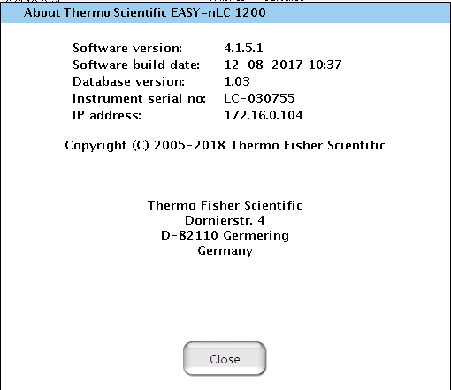

Download the latest software
Go to UnityLab Services Knowledge Base:
https://kb.unitylabservices.com/?cid=12822&c=13142&cpc=6ITL8W331lHP4be4y374f8RrmM25sBFoAQc

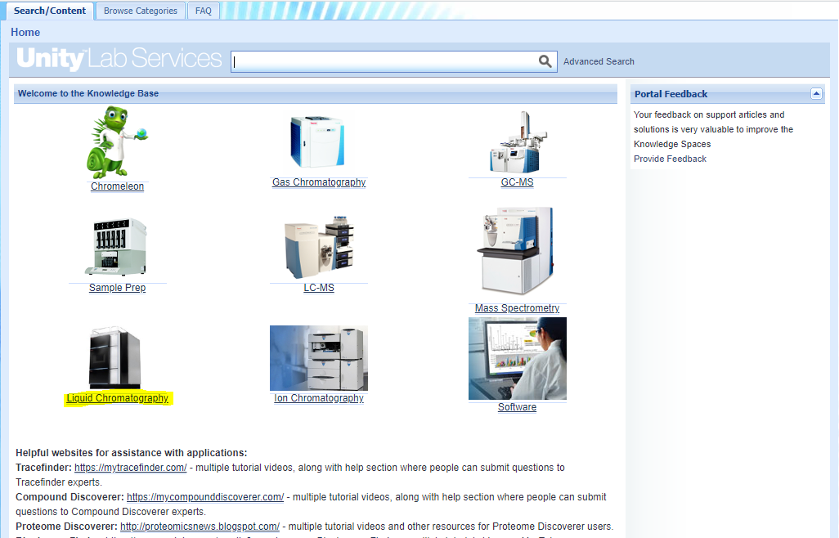

Navigate to Liquid Chromatography and find EASYnLC and download the latest SW version:
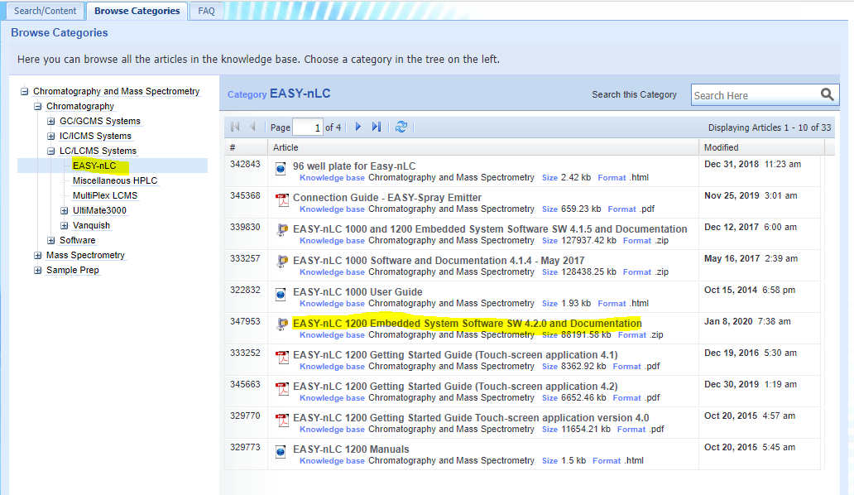

Note: When you click on the software, a popup should open, if not you may have popup blocker on.

After the download is done, extract the zip file and open the folder, you should see two files:
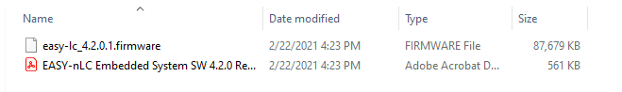

Copy those two files on a USB stick (Note if the EASY does not recognize the USB stick it may be too big, I used a 32GB and it worked)

Install new software
Insert the USB stick into one of the two USB ports on the backside of the instrument.
Then click on “Exit” on the touchscreen to exit the application.
On the start screen, you should now see the “Upgrade Software” button, double click on it and wait until the software is upgraded and the Login screen appears:
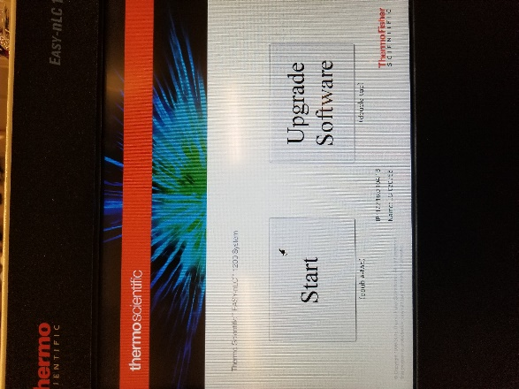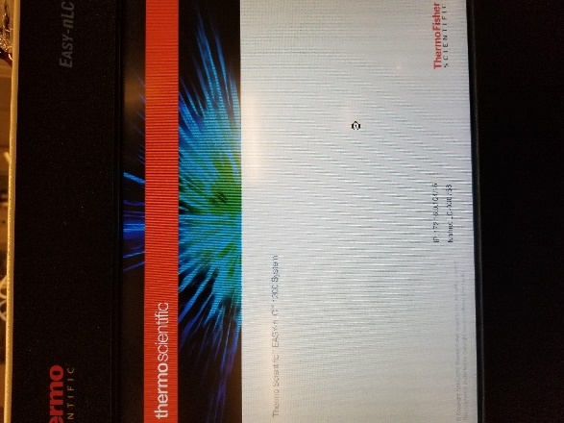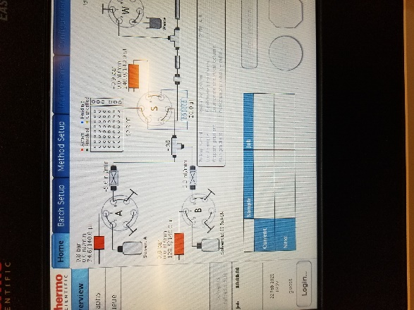

Login with your regular admin password, after you log in it will show you the new master key (this is new in SW4.2.0), take a picture or write it down:

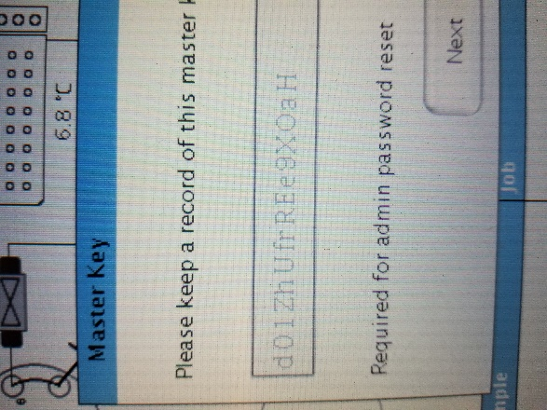

Hit next and it will prompt you to enter that key. Note that number 0 and capital O, as well as the number 1, small letter l and capital letter I look very similar. If you get an error when entering the key you may need to try to substitute them. If you enter it incorrectly it will show you a back button and you’ll see the key again.

Check the connection and startup the virtual display
You will also need that key in Putty to reconnect the TightVNC Viewer. Please reference our other document on how to initially setup the TightVNC Viewer:
https://proteomicsresource.washington.edu/docs/EASYnLC_setup_virtual_display.pdf

Make sure you have LC devices 3.2 SP2 (or newer) installed
Now open Instrument Configuration, select the EASYnLC and hit configure. It will need the admin password you normally use to log in via the touchscreen (not the Master Key), then test the connection as you normally would.
Hit ok and done to close the Instrument Configuration window.

Now open putty, login as hplc
And enter the new Master Key as password (Note if you wrote it down you can copy it and do a right mouse click in putty to paste it)

Change the password in Putty
If you don’t like that key you can change the password:

Once you logged in type “passwd” and hit enter
It will prompt you for the “(current) UNIX password”: enter the master key you just used to log in
Then it will prompt you to “Enter new UNIX password”: type the new password of choice it has to be at least 6 characters
Then it will prompt you to “Retype new UNIX password”: enter the new password again
It should confirm that the password updated successfully
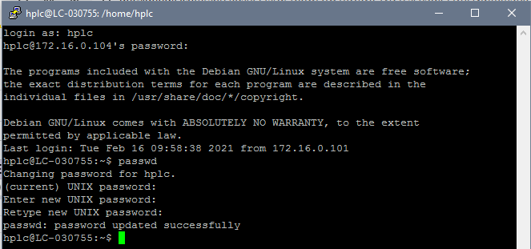

Now type: x11vnc -q -display :0
And hit enter
If it looks like this your good to go:
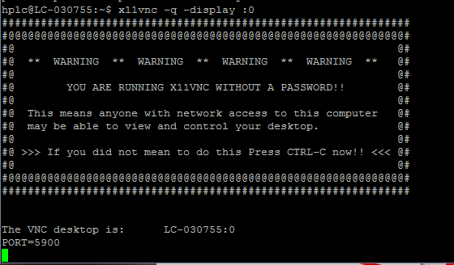

If not try this command instead:
x11vnc -env FD_XDM=1 -auth guess

Now you can open the TightVNC as usual.

