Alternate solvent filters for EASY nLC

- We noticed air leaks originating from the inline solvent filter cartridge that was originally installed with our EASY nLC
- After removing the filter we no longer observed air in the lines
- So we decided to add small “frit in a ferrule” filters instead
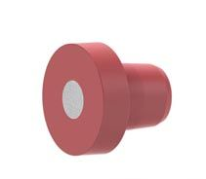
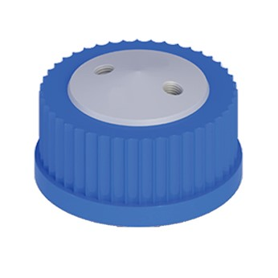
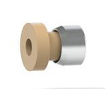



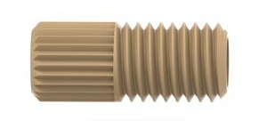

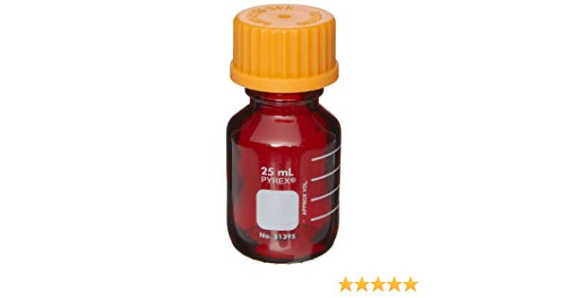
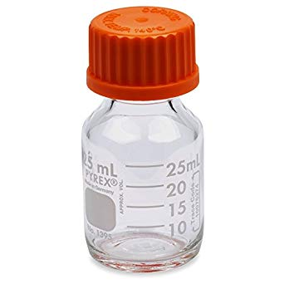
- We also added an air vent with a frit
Optional
air vent
1
1
2
2
3
4
5
6

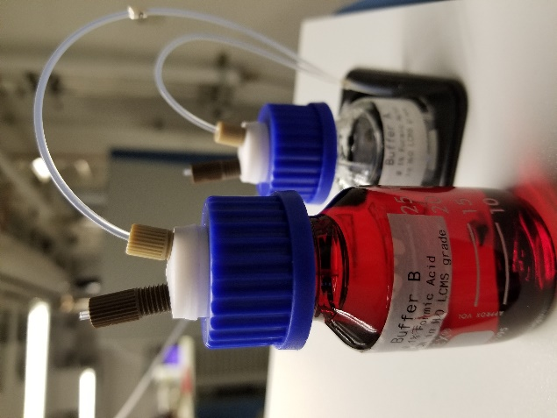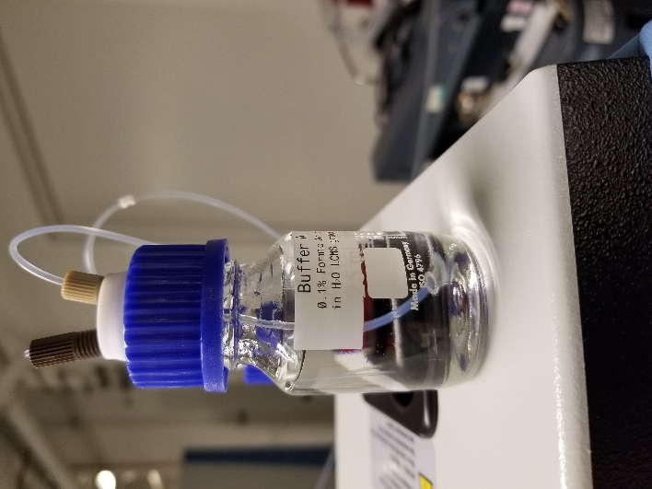

Item | Description | Part number | vendor
1 | Super Flangeless™ Headless Nut, Short, PEEK 1/4-28 Flat-Bottom, for 1/16" or 1/32" OD | P-232 | IDEX/Upchurch
2 | Frit-in-a-Ferrule™ 10µm Super Flangeless™ Tefzel™ (ETFE)/SST Ring | P_276 | IDEX/Upchurch
3 | Super Flangeless™ Ferrule w/SST Ring, 1/4-28 Flat-Bottom, for 1/16" OD | P-250 | IDEX/Upchurch
4 | Cole-Parmer™ VapLock™ Solvent Delivery Caps  GL25, 2 x 1/4"-28 UNF(F) ports, EW-12018-54 | 13-311-054 | Fisher
5 | PYREX™ Low-Actinic Media/Solution Bottles 25 ml capacity | 13-646-20 | Fisher
6 | PYREX™ Reusable Media Storage Bottles 25 ml capacity | 06-423A | Fisher

Note to install the “frit in a ferrule” at the end of the solvent lines we used strong tweezers or pliers to push the ss ring over the flange. Sonicating the frit in water before installing it may help to remove air from the frit.

