How to switch between trapping and no-trapping mode

- You can look at the home page on the EASY to see which mode it currently is in

Without trap shows a straight line With trap shows the trap column
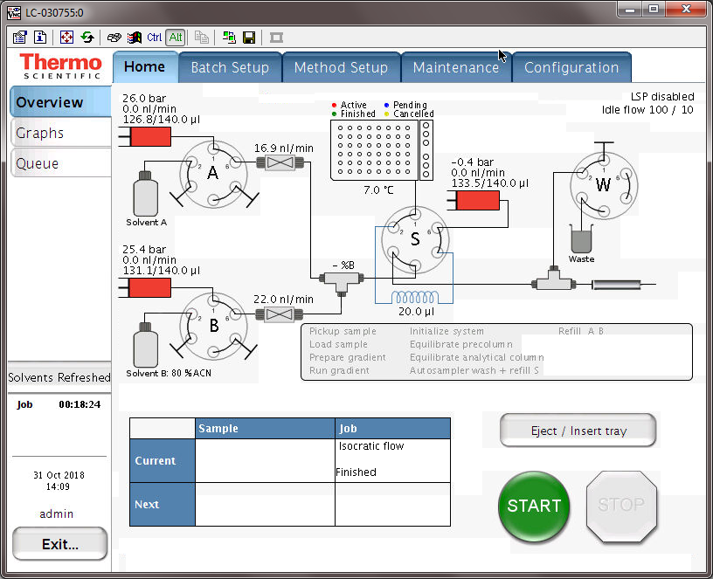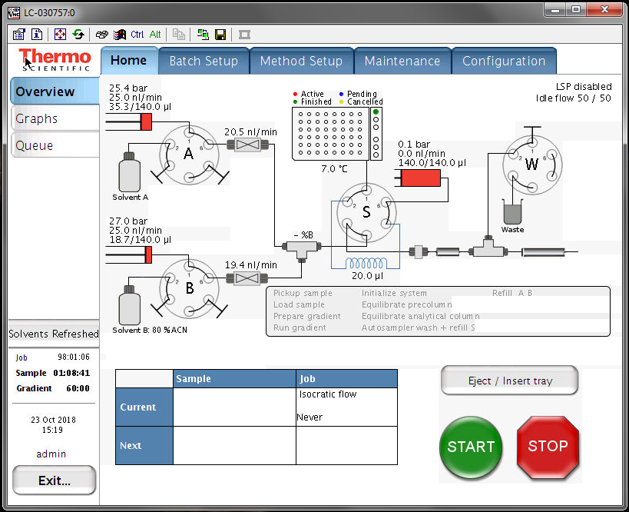

- To switch the trapping mode click on the Maintenance/Devices/EAY-nLC [HPLC]/Properties
- To select no-trap mode check the box next to “One column setup”
- To select trapping mode uncheck the next to “One column setup”
- Hit “Apply” and accept the popup confirmation window

No-trap mode (using analytical column only) Trap mode (using trap and analytical column)
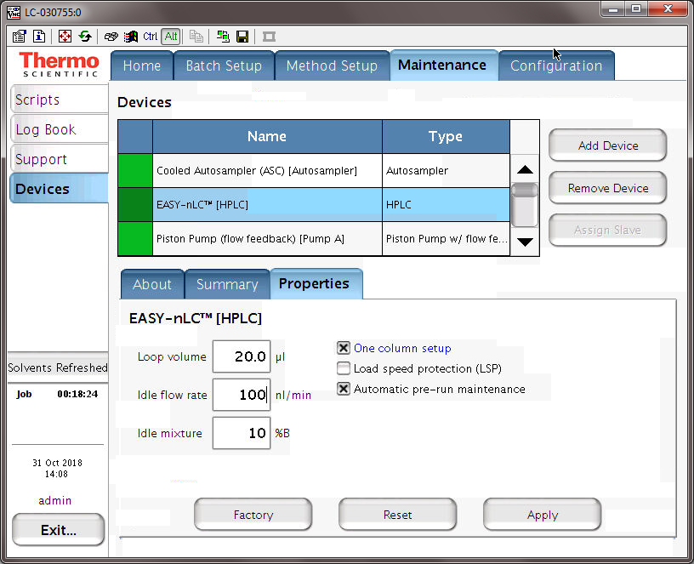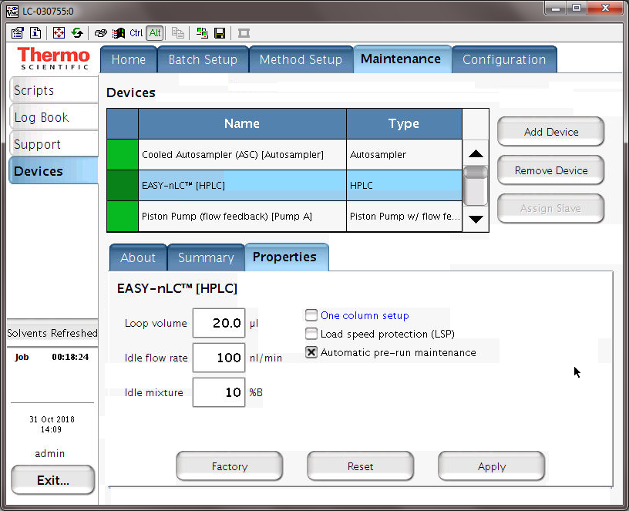

Make sure your pluming is setup correctly
- In trap mode put a trap column in front of the analytical column
- In no-trap mode replace the trap column with an empty fused silica
- That’s it.

Now make sure the sample loading in the method is setup correctly
- For no-trap mode we recommend to load at lower flowrates e.g. 0.3 µl/min, or set the max pressure instead e.g. 150-200 bar
- the loading volume should be: 2 x sample volume + 2µl
- But always use a minimum of 6 µl (1-2 µl of sample volume)
- e.g. if you load 4 µl of sample: 2 x 4 µl + 2 µl = 10 µl

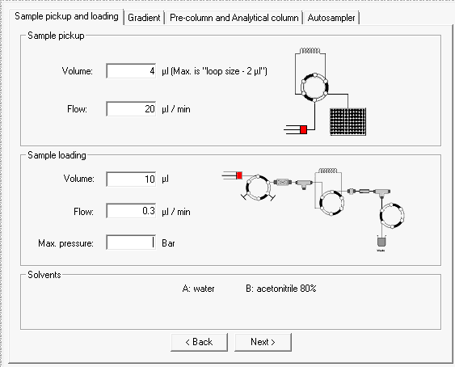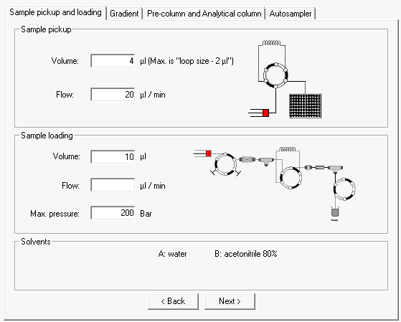

- For trap mode you can load at higher flowrates e.g. 2.5 µl, or set the max pressure instead e.g. 150-200 bar
- the loading volume should be: 2 x sample volume + 2µl
- But always use a minimum of 6 µl (1-2 µl of sample volume)
- e.g. if you load 4 µl of sample: 2 x 4 µl + 2 µl = 10 µl

