Reconnecting and starting up TightVNC viewer (e.g. after a PC reboot)

- Open instrument configuration (should be pinned to the start menu)
- Click on “ThermoEASY-nLC” and then click on “Configure”
- The “Thermo EASY-LC Configuration” window should open,
- Note the IP Address (172.16.0.104), user name (admin) and password (admin) should be filled in
- Click on “Test Connection” the bar to the right should change color to green and display “Connection OK”
- Under Autosampler Configuration select the correct “Plate installed”: typically we use 6x8 vials
- Click “OK” and then “Done”
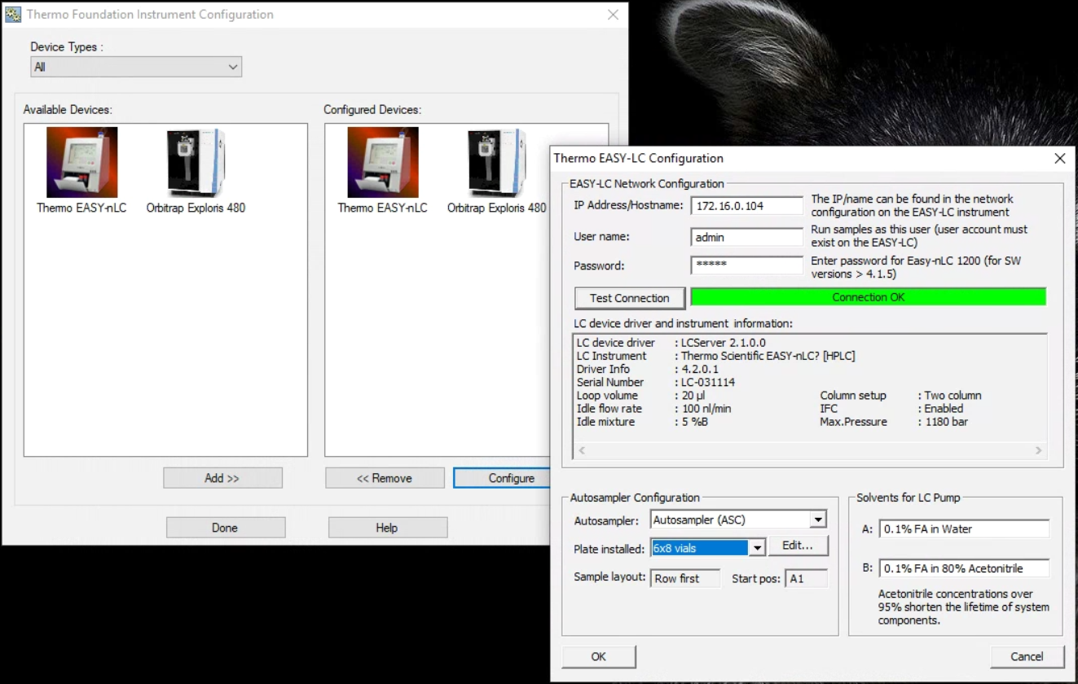

Start virtual display
- Double click on PuTTY (located on the desktop), select “EASY nLC” and hit “Open”

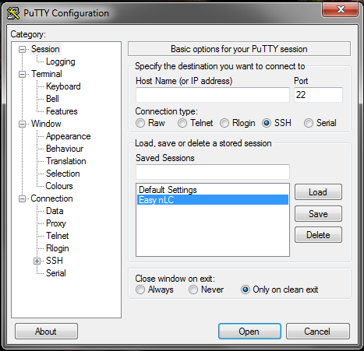
- The PuTTY window will open up prompting to login and then password:
Login as: hplc
hplc@172.16.0.104’s password: hplchplc
- (Note the default password on older EASYnLC running SW4.1 was hplc, with SW4.2 the password is the Master Key, unless you changed it. At UWPR we changed all of them to hplchplc.)

- Hit the up arrow to reload the last command or type: x11vnc -q -display :0

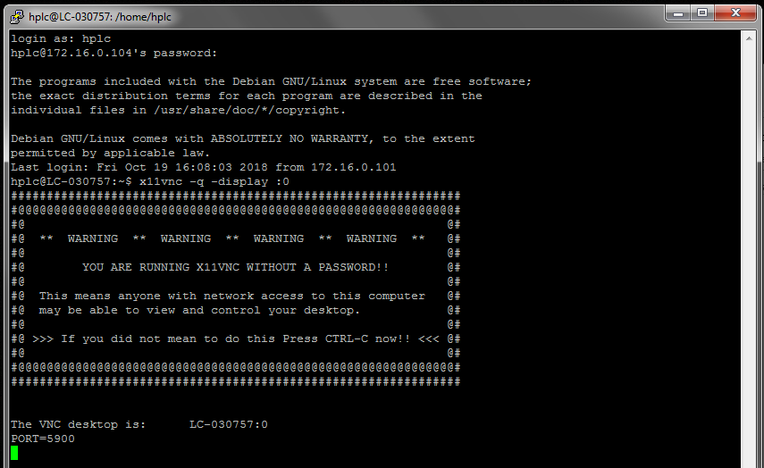
- If you don’t see the above window, try the alternate command: x11vnc -env FD_XDM=1 -auth guess
- For our EASY7/LC-031114 we use that command, all the others work with the original one)
- You can minimize the Putty window, but don’t close it.

- Now double click on the TightVNC icon (located on the desktop)
- The TightVNC Server should be: localhost::5901
- And hit “Connect”

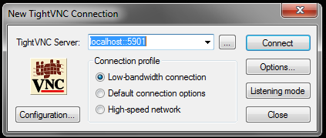

- Now the virtual display should open up and allow you to control the EASYnLC from the PC.

