Setup TightVNC viewer

To control the EASYnLC from the PC rather than via the touch screen you will need to install a virtual display.

The EASY should have been installed and connected to a PC running Xcalibur.

The engineer should have set the IP address on the EASY during install
You can view the IP under the configuration tab
Its likely 172.16.0.104, but make sure you check.
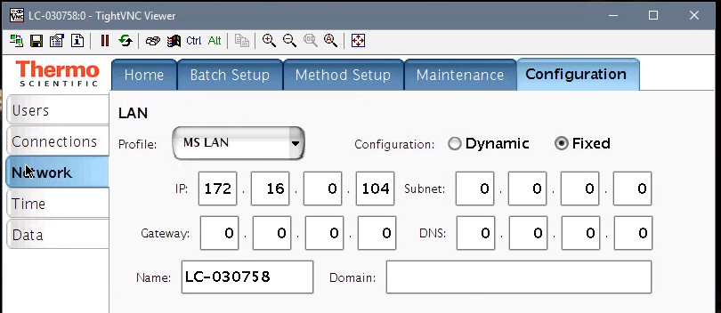

Download and install Putty and TightVNC

Putty: http://www.chiark.greenend.org.uk/~sgtatham/putty/download.html
Download the putty.exe for Windows on Intel x86. The icon can be saved directly to the desktop, no install is required.

TightVNC: http://www.tightvnc.com/download.html
Download the self installing package for windows and choose only to install the TightVNC Viewer during the install.

Select custom:
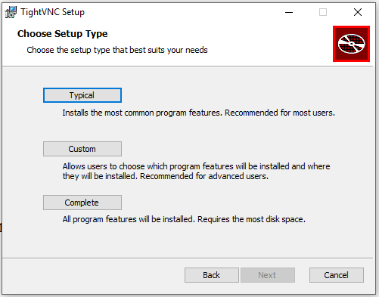

We only need the Viewer, so I would only install the Viewer only, not the Server.
To do that click on TightVNC Server and select “Entire feature will be unavailable”, you should see a red X, that way the server will not be installed.

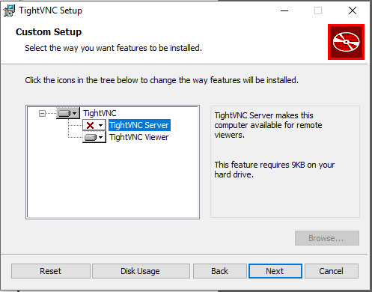

Then follow through the rest of the installation.

Configure Putty

1. Start Putty
2. Go to Connection/SSH/Tunnels
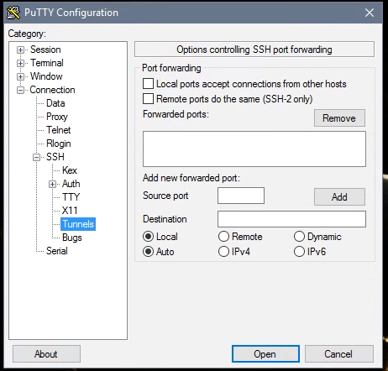

3. Enter the Source Port on your PC you want to use. Typically it will be 5901. If you want more Connections, you have to use a free port e.g. 5902, 5903 etc.
4. Enter the Destination: localhost:5900 and click the Add button .
Note: 5900 is NOT the port number you have used in the previous step!
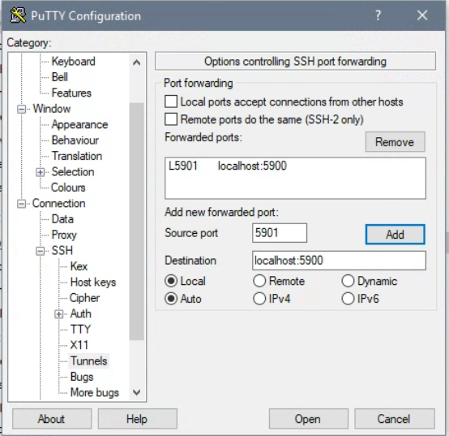

5. Next, enter the Session tab
6. In the Host Name, enter the IP address of the EASYnLC, this can be found on the EASY nLC by going to Configuration Tab…select Network.
7. In the Saved Sessions box, type in a name to save this script for future use and click Save. The EASYnLC should appear in the box below the Saved Sessions field.

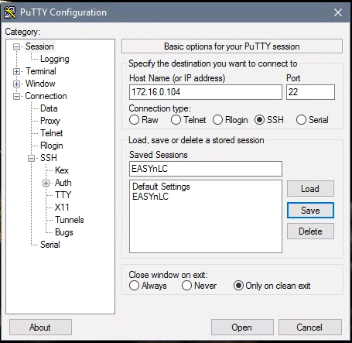

8. Slect EASYnLC and Click the Open button (or double click on the EASYnLC)
9. Press Yes if you get the Putty Security Alert pop-up message. (this will only happen the first time you start Putty).

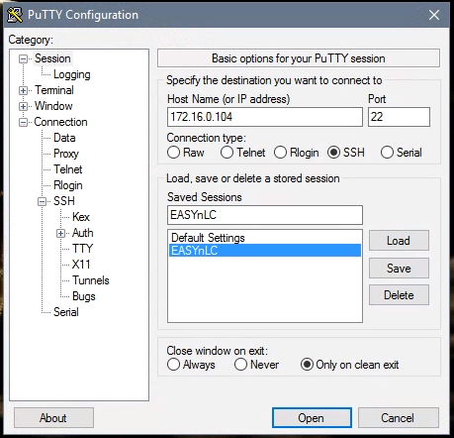

11. Login as:
user: hplc
password (SW v 4.1): hplc
password (SW v 4.2): MasterKey

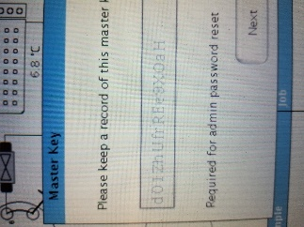
Note that number 0 and capital O, as well as the number 1, small letter l and capital letter I look very similar. If you get an error when entering the key you may need to try to substitute them.

Note after you log in you can change the password, with SW v 4.2 “hplc” is too short, it has to be longer than that.
Go to the end of this document for details on how to change the password.

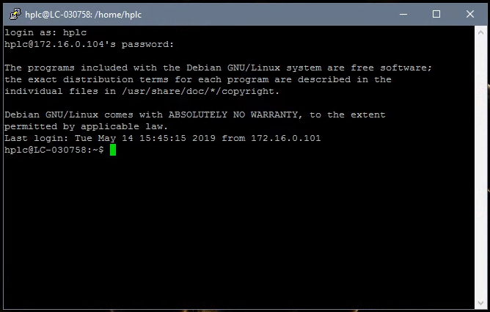

12. On the command line type: x11vnc –q –display :0
(Please note there is a single space bar between c –q, q –display and display :0)

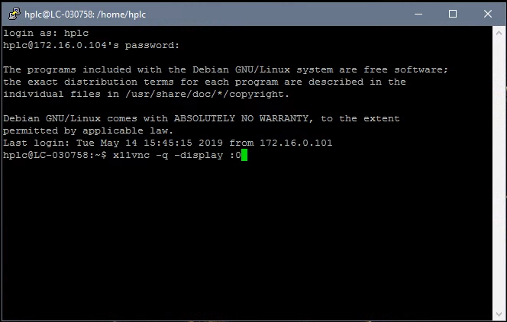

and press Enter.

13. You should now see the following:

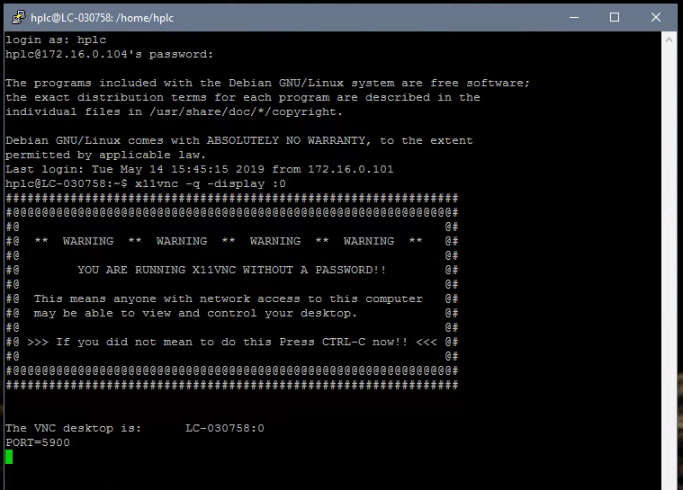

If you don't see that type this alternate command: x11vnc -env FD_XDM=1 -auth guess

14. The EASY-nLC is now ready to be remote controlled. Minimize this window without
closing it. Continue with the TightVNC session.

Start the TightVNC session

1. Start the TightVNC viewer
2. Enter: localhost::5901 Use the port number you used in the Putty session (here:
5901). Please remember to type two colons (::) between localhost and 5901.

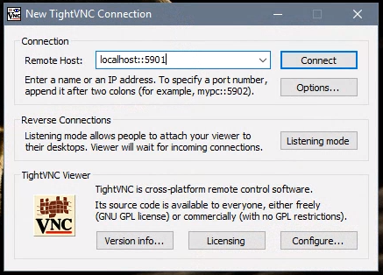

3. Press the Connect button.
4. You should see the screen on the remote EASY-nLC:

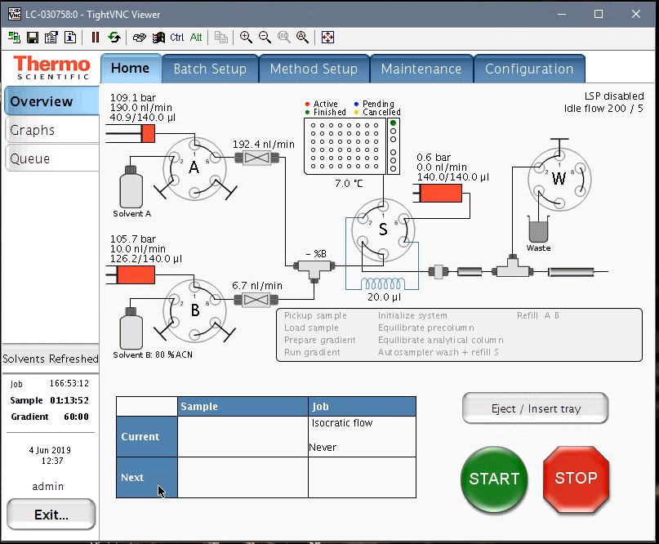

Note if you get an error:


Try rebooting the EASYnLC and possibly the PC and reconnect as described below.

Reconnecting and starting up TightVNC viewer (e.g. after a PC reboot)

Check EASYnLC connection
- Open instrument configuration (should be pinned to the start menu)
- Click on “ThermoEASY-nLC” and then click on “Configure”
- A new window should open, click on “Test Connection” the bar to the right should change color to green and display “Connection OK”
- Under Autosampler Configuration select the correct “Plated installed”: typically we use 6x8 vials
- Click “OK” and then “Done”
- 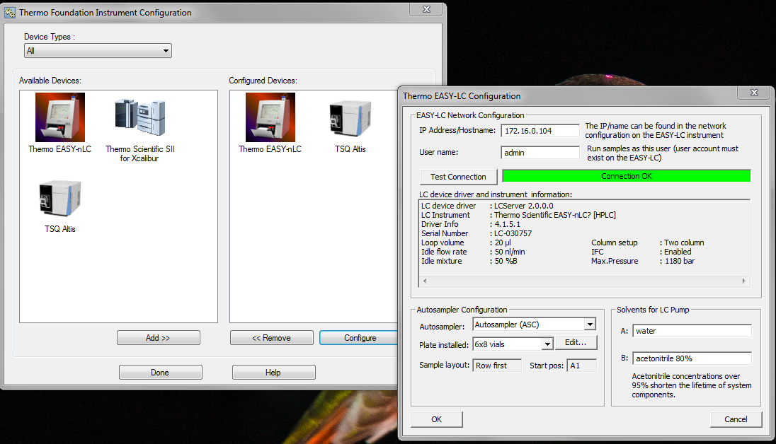

Start virtual display

- Double click on PuTTY (located on the desktop), select “EASY nLC” and hit “Open”

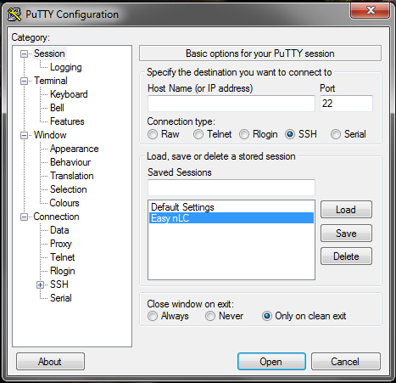
- The PuTTY window will open up prompting to login and then password:
Login as: hplc
hplc@172.16.0.104’s password: hplc

- On the command line, type: x11vnc -q -display :0

- Alternatively try the up arrow to reload previously used command and it should populate with the command line above.
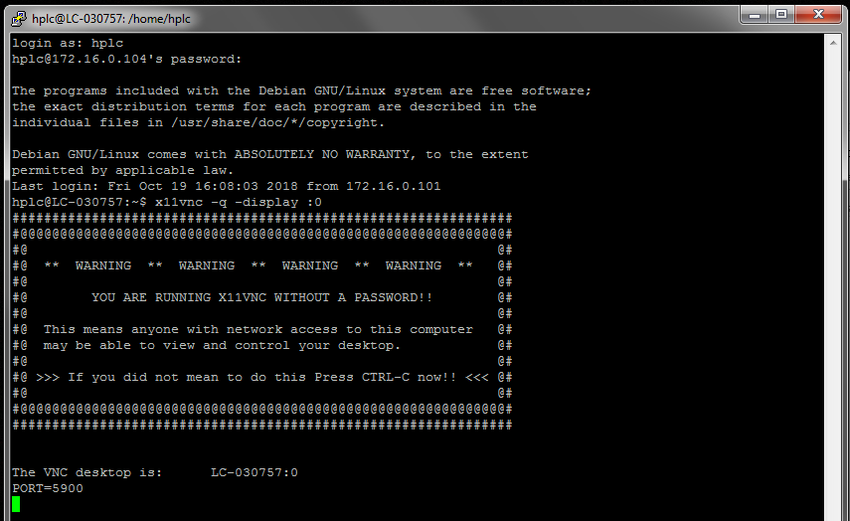
You can minimize this window without closing it.

- Now double click on the TightVNC icon (located on the desktop)
- Type: localhost::5901
- And hit “Connect”

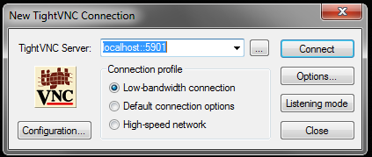

- Now the virtual display should open up and allow you to control the EASYnLC from the PC.

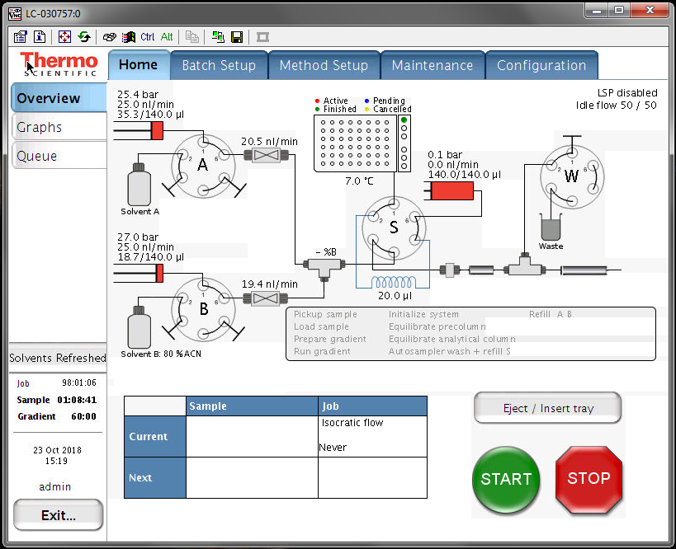

Changing the password in Putty

Open putty and login:
user: hplc
password (SW v 4.1): hplc
or
password (SW v 4.2): MasterKey


Note that the number 0 and capital O, as well as the number 1, small letter l and capital letter I look very similar. If you get an error when entering the key you may need to try to substitute them.
(Note if you wrote it down you can copy it and do a right mouse click in putty to paste it)

Note with SW v 4.2 the password “hplc” is too short, it has to be longer than that.

Once you logged in type “passwd” and hit enter
It will prompt you for the “(current) UNIX password”: enter the password/master key you just used to log in
Then it will prompt you to “Enter new UNIX password”: type the new password of choice it has to be at least 6 characters
Then it will prompt you to “Retype new UNIX password”: enter the new password again
It should confirm that the password updated successfully
