LC-MS setup

PPE (personal protective Equipment)
Do not use any of the equipment without the appropriate training. Always wear appropriate PPE when working in the lab, including goggles, lab coats and gloves. PPE is provided, ask if you cannot find the appropriate PPE or if PPE is missing. Always wear goggles when working with fused silica. Review MSDS and SOP’s before working with chemicals. Before working with the gas cylinders make sure you complete the EH&S “Compressed Gas Safety” online training (https://www.ehs.washington.edu/training/compressed-gas-safety-online).

Before you connect your trap and column
You need to provide your own trap and column (Note our fittings accommodate trap and column made with fused silica 360 µm OD).
Check our guide for packing traps and columns and list of consumables you should provide.
- Packing capillary columns (pdf)
- LC-MS commonly used consumables (xls)
Before you connect the column, check both the PEEK micro-tee and micro-cross for obstructions in the through whole. Remove all the fittings from both the tee and the cross and look at them under the microscope. The through holes should be wide open. If not use air in the can and blow some air through them and check again under the microscope. If you still see a blockage either grab a fresh micro-tee or cross or remove the blockage; try sonication in 50% methanol and/or use a wire to poke through the whole to remove the debris.

Connecting your trap and column
Our mass specs are equipped either with an EASYnLC UPLC system. Although UPLC systems rated to 1200 bar (17400 psi), the fittings we use are only rated to max 310 bar (4500 psi). If you wish to work with higher back pressure, you should provide your own fittings.

Micro-tee and micro-cross use instructions
Warning: Please take care when tightening the Micro-Fingertight fittings, making sure to only tighten sufficiently to prevent leaks from occurring. Due to the nature of some fused silica tubing, it is possible to damage the tubing if over tightened.
- Insert your tubing into green MicroTight tubing sleeve. Make sure your fused silica tubing is inserted far enough but does not extend past the end of the tubing sleeve.
- Insert your sleeved tubing through the PEEK female nut and through the black Micro Ferrule, as shown in the picture.
- Screw the assembled unit onto one of the available threaded ports on the micro-tee or micro-cross, making sure that the tubing is pushed firmly against the bottom ledge on the inside of the male port. Finger tighten securely.
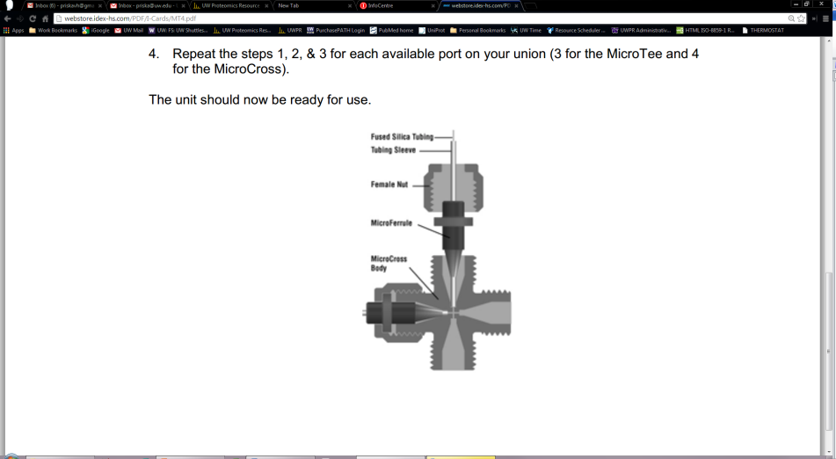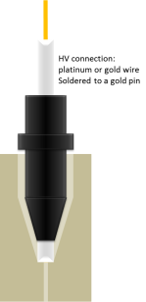

The micro-tee should be connected to the 25µm ID fused silica line coming from the pump (labelled “column”),
The trapping 75 µm ID waste line (labelled “waste”) should be connected to the micro-cross.

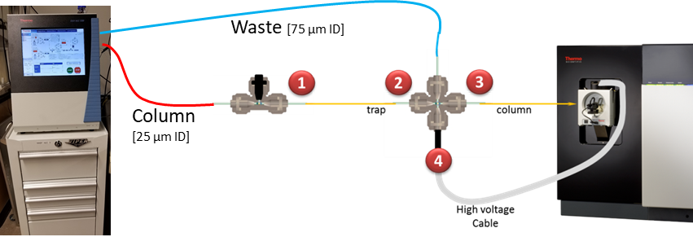

- Connect the open end of the trap to the micro-tee
Go to Maintenance/Scripts/
Under Category select: Prepare Name: Precolumn equilibration
Under Parameters select volume (e.g. 100 µl), flow rate (e.g. 2.5 µl/min) and/or max pressure (e.g. 250 bar)
Under Graphs select Pump A
Then hit start
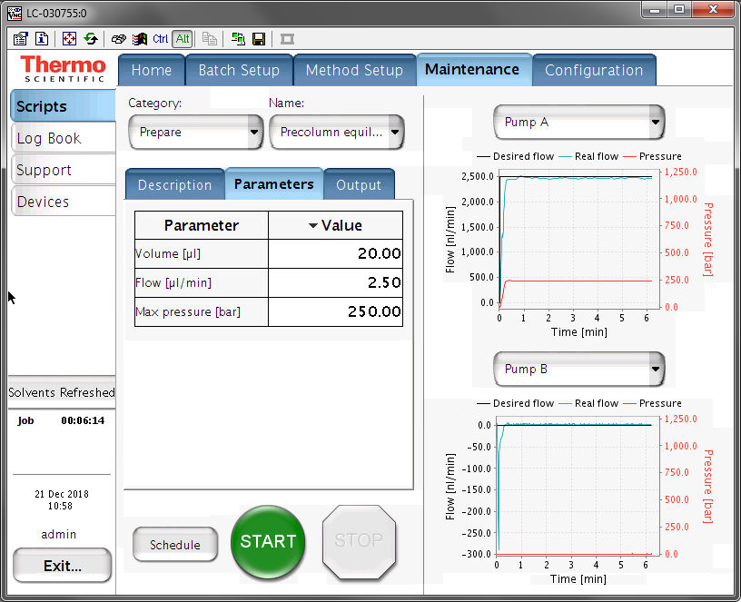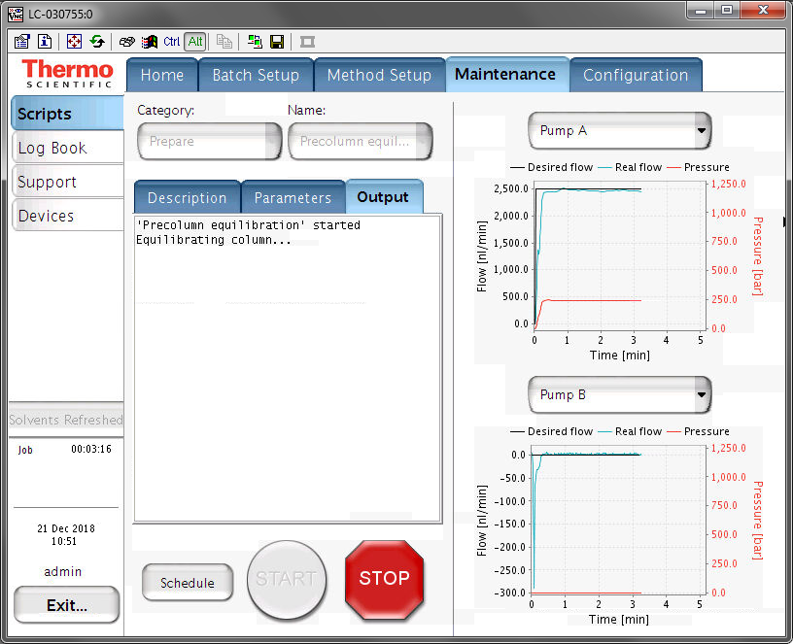
On the Home Page you can see the actual flower rates and backpressure as well.
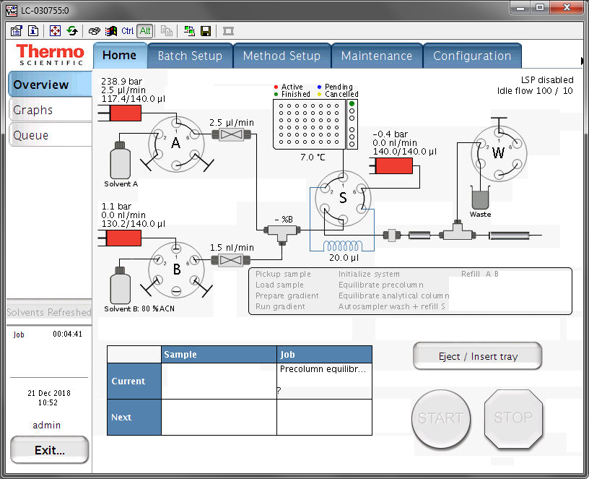

- Once you see a droplet forming at the fritted end of the trap, with the flowrate at 2.5µl/min connect the fritted end of the trap to the micro-cross and let it flow for a couple of minutes without the column connected. This is helpful if something elutes or some frit material breaks loose, so it won’t clog the column. Wait for the backpressure and flowrate to stabilize. You can let the pre-column equilibration while connecting the column.
- Connect the open end of the column to the micro-cross
Go to Maintenance/Scripts/
Click stop to end the precolumn equilibration
Under Category select: Prepare Name: Analytical column equilibration
Under Parameters select volume (e.g. 100 µl), flow rate (e.g. 0.3 µl/min) and/or max pressure (e.g. 250 bar)
Under Graphs select Pump A.
Hit start:
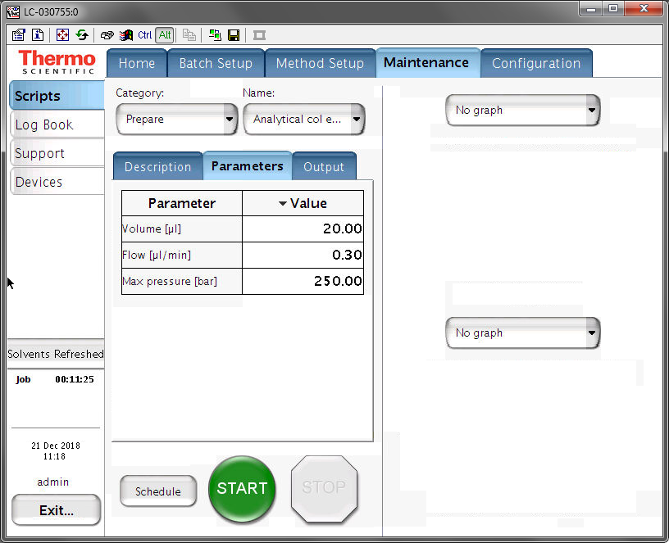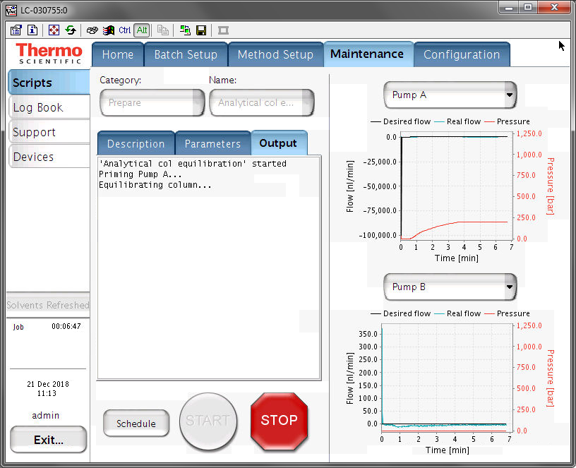
You will see the backpressure will start to increase but will not exceed 250 bars, instead it will regulate the flow rate. This allows the column to get equilibrated without over pressuring.
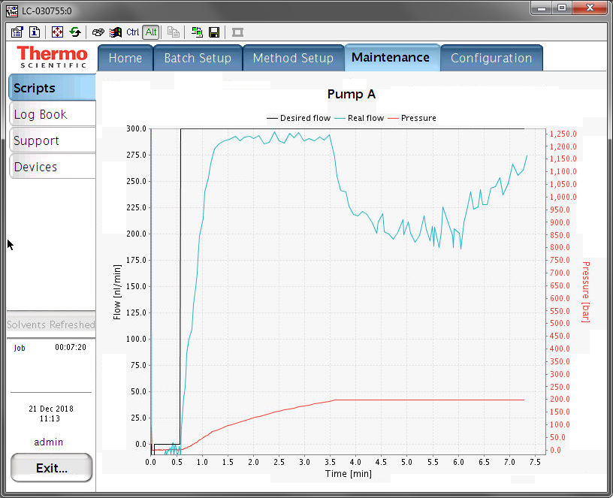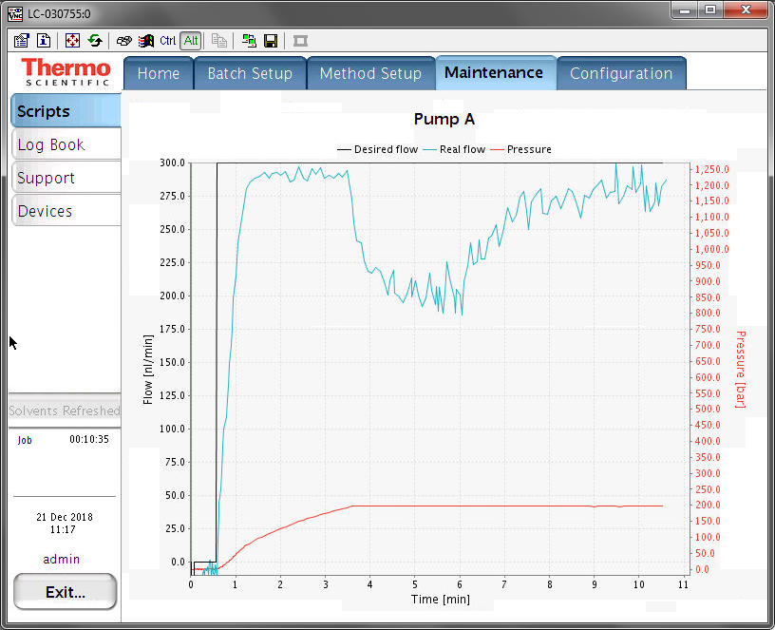
Wait for the backpressure to stabilize. The flow rate should be at 300 nl/min. Note the actual backpressure of the column.

- After about 10-20 min at stable backpressure, stop the flow and wait for the backpressure to drop, remove the column and cut it to the desired length. Make sure there is no void volume at the end of the column, minimizing the void between the trap and the column will minimize peak broadening.
- Reconnect the column to the micro-cross and restart the Analytical column equilibration, wait for the backpressure to stabilize, check for leaks and again note the backpressure with the final column length.
- Position the tip of the column in front of the ion transfer tube at about 3-5 mm distance. Be careful, the ion transfer tube is hot >300ºC.
- Make sure the instrument is in standby (the blue scanning light is off). Connect the high voltage connector to the pin on the micro-cross.

Adjust your ESI spray
With your column connected and the flow set to the desired rate, from the tune window start scanning the instrument.
Monitor the live spectrum for consistency in intensity, no spectra dropping out, no sputtering at the tip. Adjust the tip position and spray voltage until you get a consistent spray.
Typical NSI spray voltage is ~ 2.1 kV
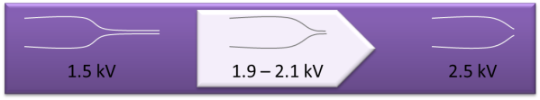
(The finer the spray tip the lower the voltage, as low as 1.5 kV. For blunt tips higher voltage may be needed, up to 2.4 kV)

Liquid droplet is forming at the tip:
If there was a liquid droplet at the tip of your column, it should disappear as soon as you start scanning the instrument. If it doesn’t, take a Kim wipe, twist one corner and gently wipe the droplet off, without touching anything or breaking the tip of your column.
If the droplet forms again, check and make sure the high voltage cable is connected. If not, turn the instrument into standby, connect the high voltage cable, and turn the instrument back on. If it still forms a droplet, check column positioning and/or spray voltage.

No peaks in the spectrum:
Check and make sure the high voltage cable is connected.
Check if there is a liquid droplet forming at the tip of your column.
If not turn the instrument into standby and monitor the tip of your column you should see a liquid drop form, if not check for leaks.

Once you have a stable spray, make sure the spray voltage in your method is set to the same voltage you just now determined to be best for your column, now you are ready to get started.

Spray voltage:
Remember to change the spray voltage in your methods.
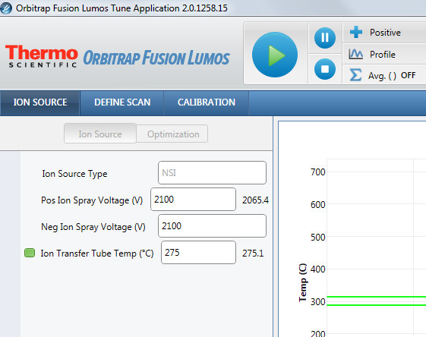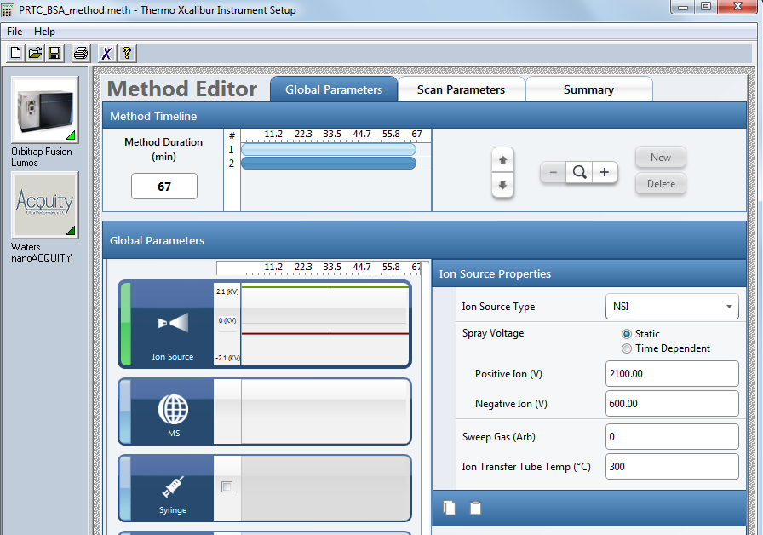

Start the first LC-MS run:
Always start by running a QC, you can choose your own QC or use the one provided by UWPR.
A QC assures that
- The column gets conditioned
- There are no leaks
- Your column/trap setup is performing properly
- The HPLC is performing properly (injection and gradient)
- The mass spec is performing properly (mass accuracy and sensitivity)

Here are the steps the instrument will go through during the acquisition:

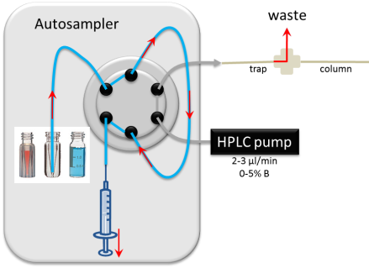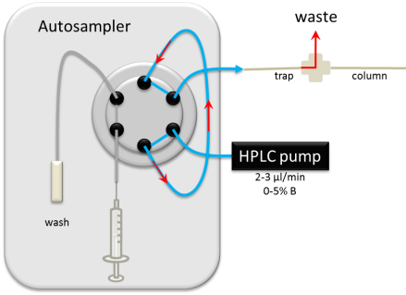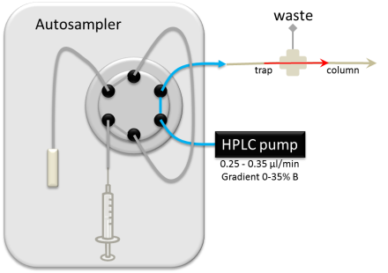
Gradient:
Sample elution
Loading/trapping:
Sample onto trap column
Sample pickup
Into sample loop

In AS position 1-V1 there should be a standard consisting of two peptides Angiotensin and Neurotensin, always check and make sure it’s there.
- AngioNeuro a simple peptide standard (xls)

Use the short gradient method provided by UWPR to run this standard.
In Xcalibur you may notice that the EASYnLC shows “Not Ready”
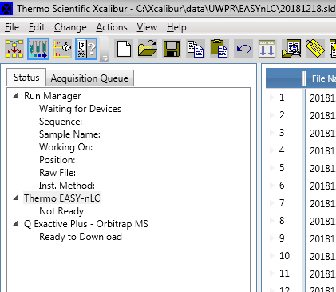
You will have to stop the current procedure (i.e. Analytical column equilibration) for it to become ready and allow you to start a run:
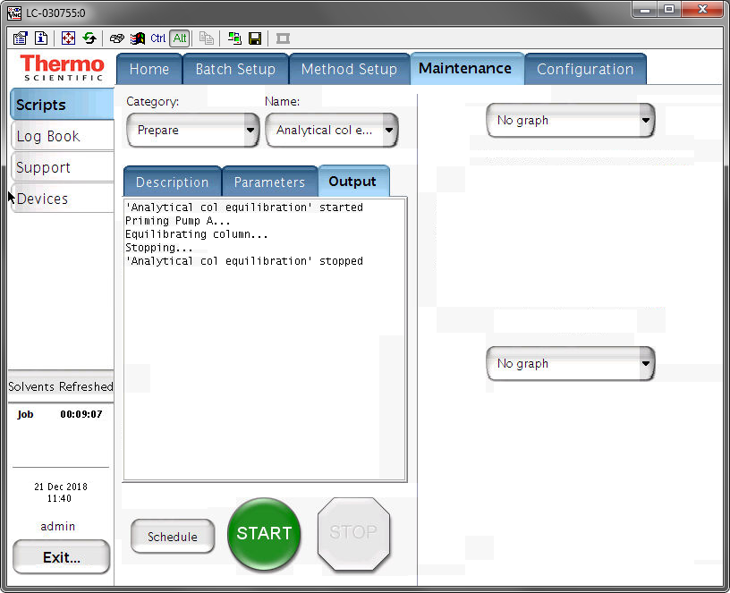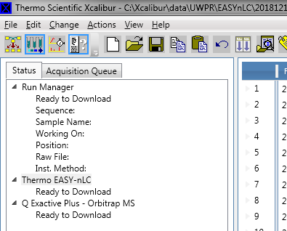

After you start the run, monitor the actions taken by the instrument:
- Both instruments should download the method, the HPLC will start running, and the mass spec should be “waiting for contact closure”
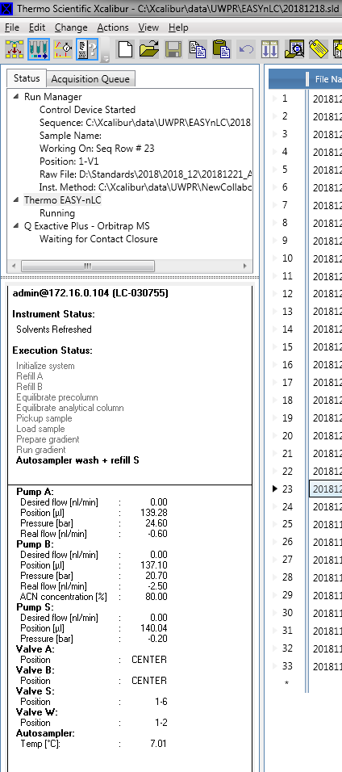
- It may run a flush air procedure to assure that there are no air bubbles in the system, that is normal.
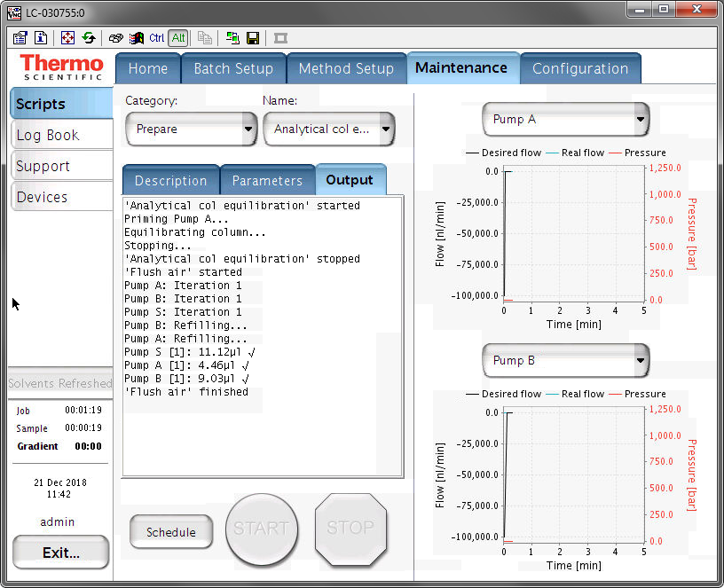
- The autosampler should go through the sample injection process (~ 3mins) and finally start trapping, i.e. sample loading onto the trap column.
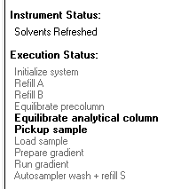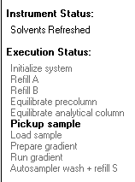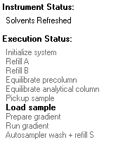
- After the loading is complete the mass spec acquisition will start

After the run is complete check the peak shape, separation, and intensity, and mass accuracy. There should be a good/recent reference AngioNeuro.raw file on the desktop.
It is normal for a brand new column to show slightly reduced intensities, this is due to unspecific irreversible binding of the peptides to the column/trap (part of column conditioning). It is also normal to sometimes see some additional peaks, typically from contamination from the column packing process.

Peaks are not separated at all or are tailing
Check for obstructions/blockage in the flow path, micro-cross and micro-tee.
Check for void volume between trap and column.
Try a second QC run.
Try a new trap and column.

Run your first sample
If your QC is satisfactory, start your first sample. Monitor instrument actions as described above. In addition monitor the back pressure during the trapping and during the gradient.

Trapping:
During the trapping the backpressure should be about what you saw during the pre-column equilibration and during the trapping of the QC run. It may increase a bit when your samples load onto the trap column. If it increases, too much your setup may start leaking. Contaminants in your samples (i.e. salt, lipids, detergents) can cause the backpressure to increase and clog the trap and analytical column and you may have to do additional cleanup steps.

Gradient:
The figure below shows a typical pressure trace during a 30 min gradient, 0-40% B, 35 cm column C18 100Å 5µm at 0.300 µl/min, note there is a delay between the point when the pump mixes the gradient to when it is visible in the pressure trace. This is because the pressure will change once the gradient reaches the column. This delay is a result of the void volume between the pump and the column. On our systems the delay is about 15-20 min (the actual gradient is in orange pump A flow, and dark blue pump B flow rate and the observed gradient/backpressure is red and blue pump A and B).
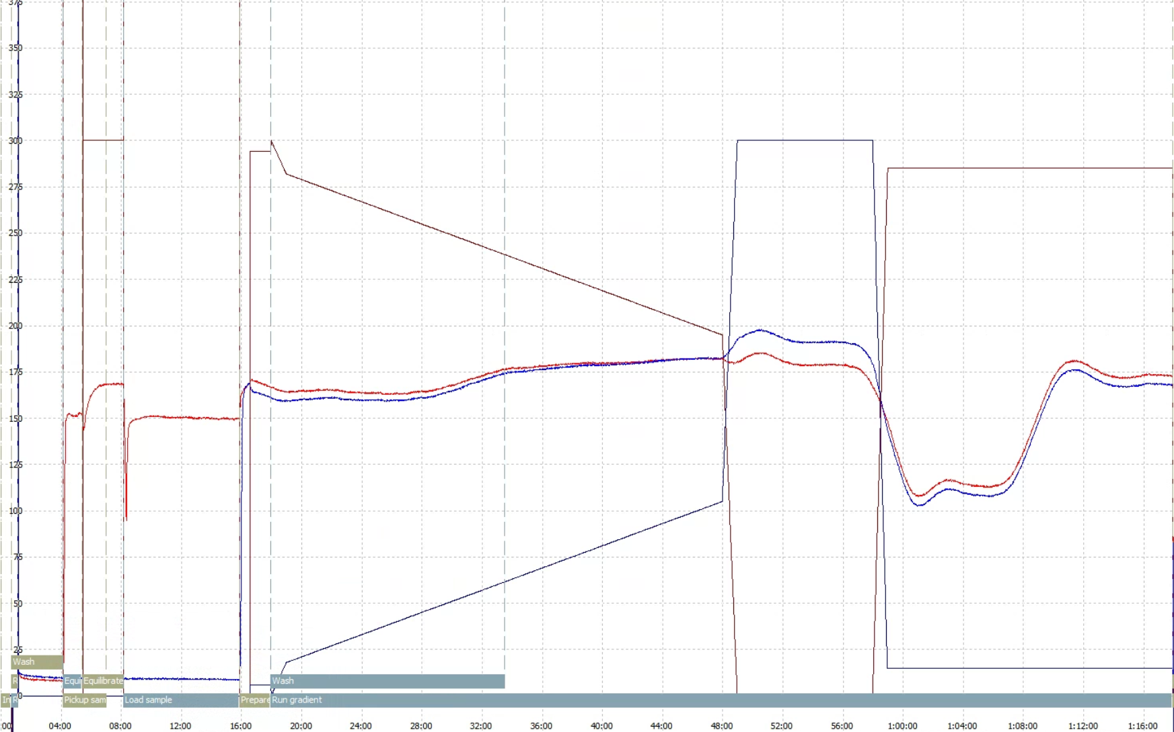
delay
100% B wash
95% A equilibraton
0-40% B gradient
Trapping

It is normal for the backpressure to drop at high % buffer B because of the viscosity of acetonitrile, but at the end of the equilibration, it should return back to the initial backpressure you established during the setup.
If your first sample ran satisfactory and the backpressure trace is similar to the QC, you should be good to go. If all your samples were prepared identically, chances are good that the system will analyze all of them with no problems.
If your sample causes the system back pressure to rise much higher than during the QC run, the system may over pressure or start leaking. If this is the case running your samples in an automated fashion is risky as you do not know when a leak/over pressure may occur.
A small increase in backpressure is normal, but if the backpressure increases after every sample and does not recover down to initial conditions, eventually it will overpressure or start leaking.

QC runs and blanks
How many QC runs should you run?
Ultimately that is up to you. Good practice would be to run a QC every 5 – 10 runs, to monitor system performance over time.
I like to line them up such that there is a finished QC run for me to look at first thing in the morning when I come in, so I can take action if needed.

Should you run blanks?
This really depends on your project, but here are some hints to help you decide:
The typical carry over on our systems from one run to the next is less than 1%.
For MRM runs we see about 0.5-1% of the most abundant peptides in the next blank run.
And for DDA we got 18000 peptide ID’s in the sample run (complex peptide mix on the QE), and got ~50-100 peptides in a subsequent blank run.

If carry over is a critical concern for your project, test it with your own sample. Run a blank and look for carry over.

LC-MS setup checklist | Note
Checked micro-cross and micro-tee through whole
Connect trap and checked trapping backpressure | Backpressure  Flow rate | bar  µl/min
Connect column and establish flow rate through column | Backpressure  Flow rate | bar  µl/min
Adjusted positioning and spray voltage to get stable spray and save the tune file
Change spray voltage in method (if necessary)
Change flow rate in methods if needed
QC run looks good
First sample run looks good

Legacy instruments:

Spray voltage on the LTQ-Orbitrap:
In Tune, adjust spray voltage and position the column tip until spray is stable (no drop outs, NL: stable), remember to save the tune file!
In the method select the correct tune file.
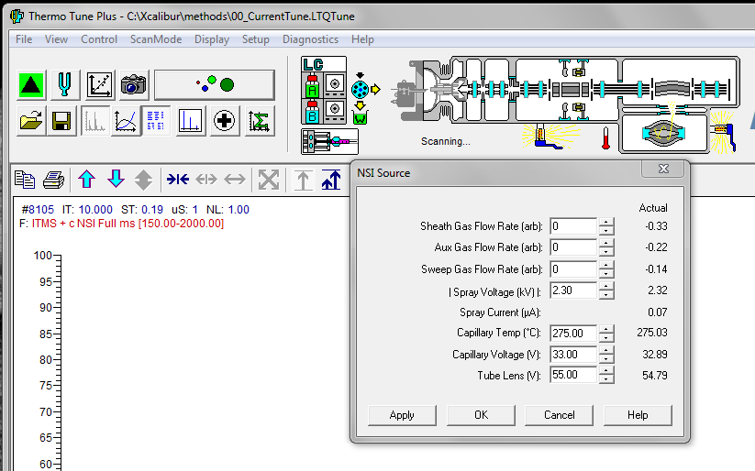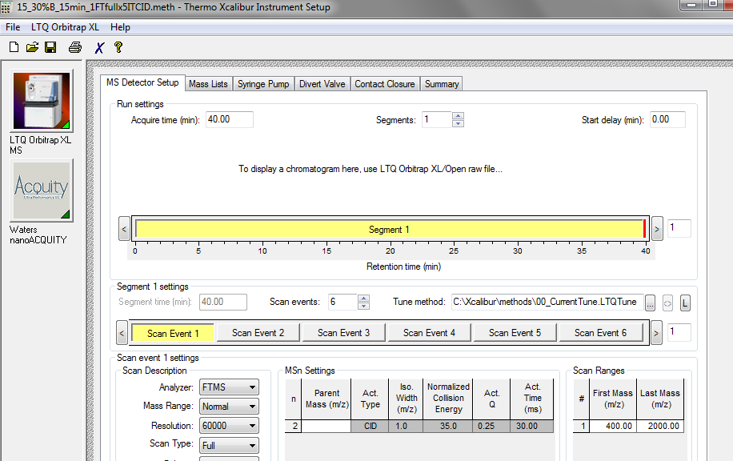

Spray voltage on the TSQ:
In Tune, adjust spray voltage and position the column tip until spray is stable (no drop outs, NL: stable), remember to save the tune file!
Remember to change the spray voltage in your method as well (EZ method only)
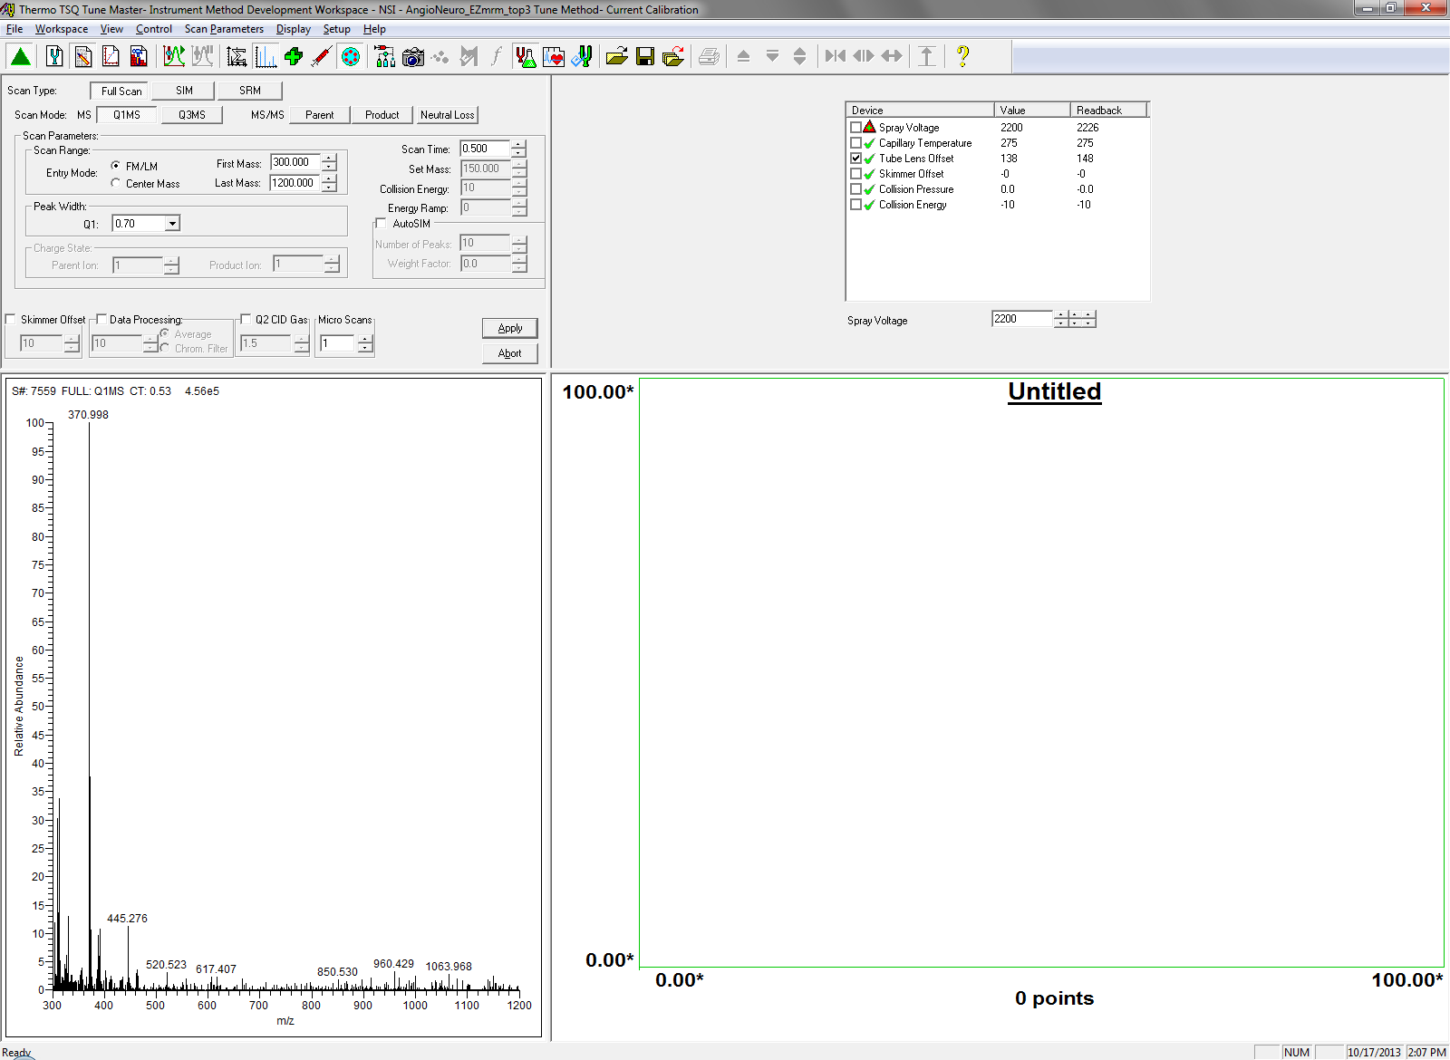

Spray voltage on the QExactive:
In Tune, adjust spray voltage and position the column tip until spray is stable (no drop outs, TIC variation <10%), remember to save the tune file!
