LC-MS setup VanquishNeo

Table of Contents
LC-MS setup VanquishNeo 1
PPE (personal protective Equipment) 2
Before you connect your trap and column 2
Connecting your trap and column 2
Micro-tee and cross use instructions 2
Adjust your ESI spray 5
Liquid droplet is forming at the tip: 5
If there are no peaks in the spectrum: 5
Spray voltage on the Fusion/Lumos/Exploris/Altis/Exploris480: 5
Spray voltage on the QExactive: 6
Load your samples: 6
Automatic Rack Type Identification 7
Setting the Rack Type Manually 7
Start the first LC-MS run 7
If the VanquishNeo does not start 8
Trapping 8
Gradient 9
After the run is complete 9
End of Run Equilibration 10
If peaks are not separated at all or are tailing 11
Run your first sample 11
QC runs and blanks 11
Should you run blanks? 11
Accessing the sampler to load samples during an acquisition 12

PPE (personal protective Equipment)
Do not use any of the equipment without the appropriate training. Always wear appropriate PPE when working in the lab, including goggles, lab coats and gloves. PPE is provided, ask if you cannot find the appropriate PPE or if PPE is missing. Always wear goggles when working with fused silica. Review MSDS and SOP’s before working with chemicals. Before working with the gas cylinders make sure you complete the EH&S “Compressed Gas Safety” online training (https://www.ehs.washington.edu/training/compressed-gas-safety-online).

Before you connect your trap and column
You need to provide column (Note our fittings accommodate column made with fused silica 360 µm OD). You can use the preinstalled commercial trapping column. If you wish to use your own trap you can use the following parts:
- PepMap™ Neo Trap Cartridge Holder, PEEK Tubing, & nanoViper™ Fittings (part # 174502, Fisher # 03-255-020)
- PepMap™ Neo Trap Cartridge (part # 174500, Fisher # 03255018)
To use home packed fused silica trap you need the following fittings:
- Two VHP MicroTight® Adapter 1/16" OD x 360 µm (Idex part # UH-634)
- Extra fittings: VHP One-Piece Fitting PK 360 (Idex part # UH-124)

Check our guide for packing traps and columns and list of consumables you should provide.
- Packing capillary columns (pdf)
- LC-MS commonly used consumables (xls)
Before you connect the column, check the PEEK mirco-tee or micro-cross for obstructions in the through whole. Remove all the fittings from both the tee and the cross and look at them under the microscope. The through wholes should be wide open. If not use air in the can and blow some air through them, and check again under the microscope. If you still see a blockage either grab a fresh tee or cross or remove the blockage; try sonication in 50% methanol and/or use a wire to poke through the whole to remove the debris.

Connecting your trap and column
Our mass specs are equipped either with a VanquishNeo or EASYnLC UPLC system. Although UPLC systems rated to 1500 bar or 1200 bar, the peek fittings we use are only rated to max 4000psi or 276 bar. If you wish to work with higher backpressure, you should provide your own fittings.

Micro-tee and cross use instructions
Warning: Please take care when tightening the Micro-Fingertight fittings, making sure to only tighten sufficiently to prevent leaks from occurring. Due to the nature of some fused silica tubing, it is possible to damage the tubing if over tightened.
- Insert your tubing into green MicroTight tubing sleeve. Make sure your fused silica tubing is inserted far enough but does not extend past the end of the tubing sleeve.
- Insert your sleeved tubing through the PEEK female nut and through the black Micro Ferrule, as shown in the picture.
- Screw the assembled unit onto one of the available threaded ports on the MicroTee or MicroCross, making sure that the tubing is pushed firmly against the bottom ledge on the inside of the male port. Finger tighten securely.
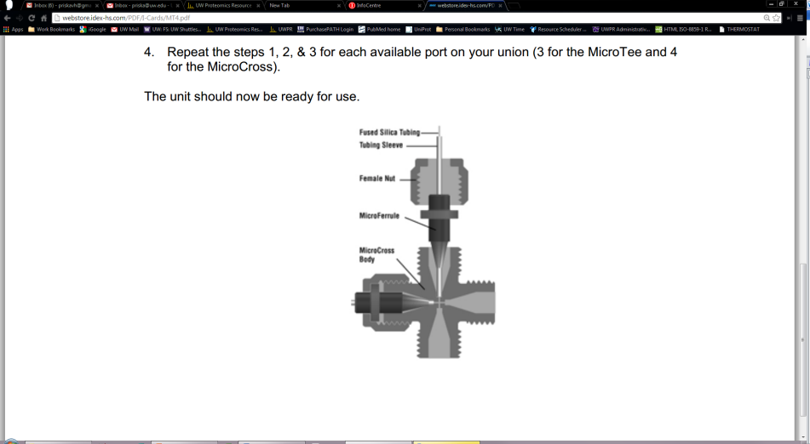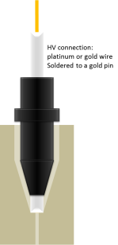

The micro-tee should be connected to the 25µm ID fused silica line coming from the pump (labelled “column”),

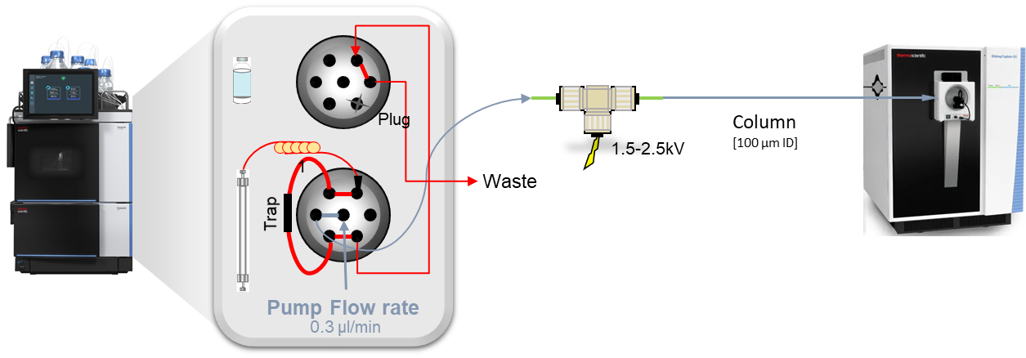

Connect the open end of the column to the micro-tee
Go to the web browser (Chrome or Brave) and go to 172.16.0.104 (there should be a bookmark in the bookmark bar)
Go to the scripts and select script A04 – Set Separation Column Specification and enter the appropriate specifications for your column and hit apply

If you make any changes make sure to update the column information in the methods (see below).
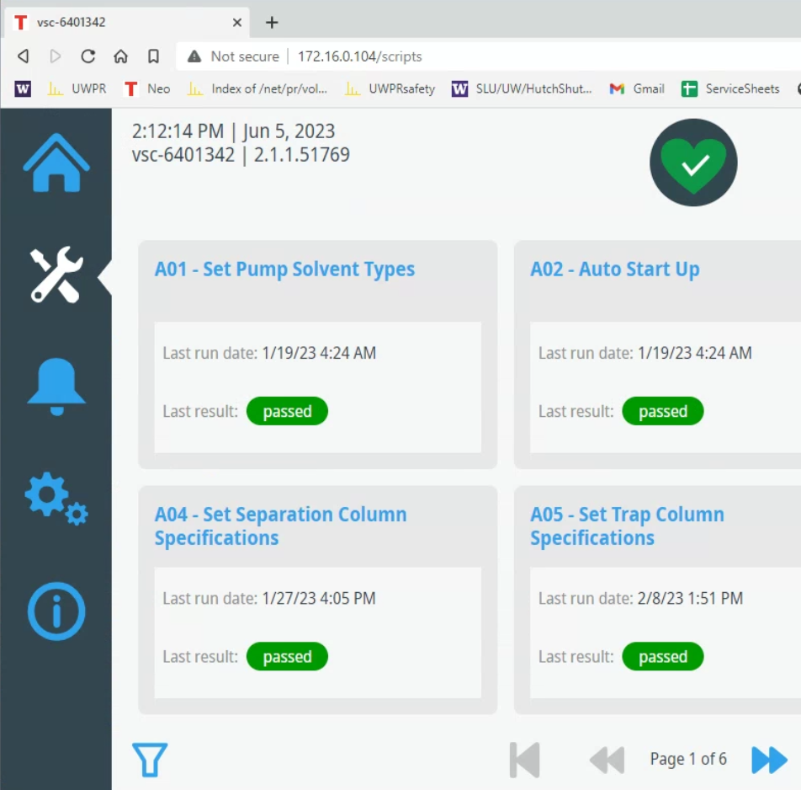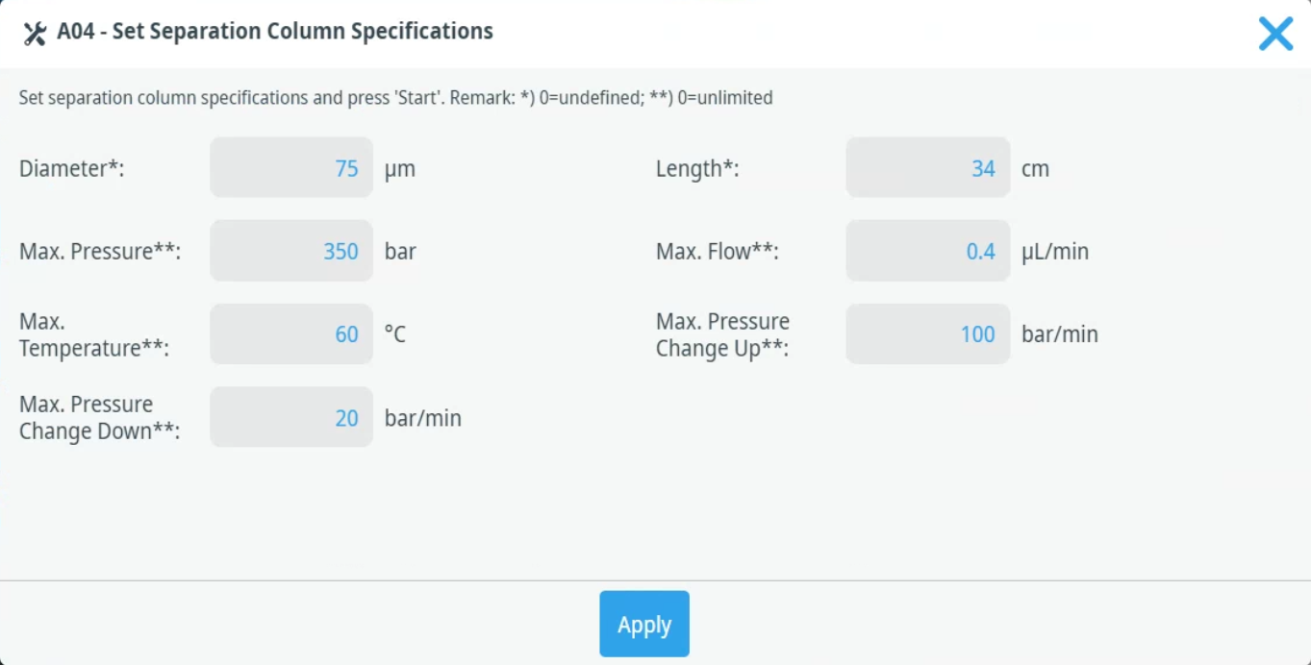

On the Home screen click on the pump
In the pop up window set the flow to On, the flow rate to the desired flow rate, typically 0.300 µl/min and the %B to 1-5%, then hit apply.
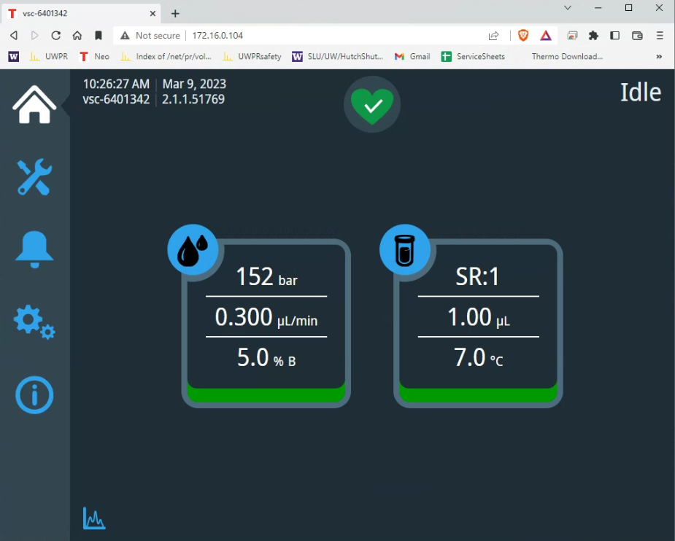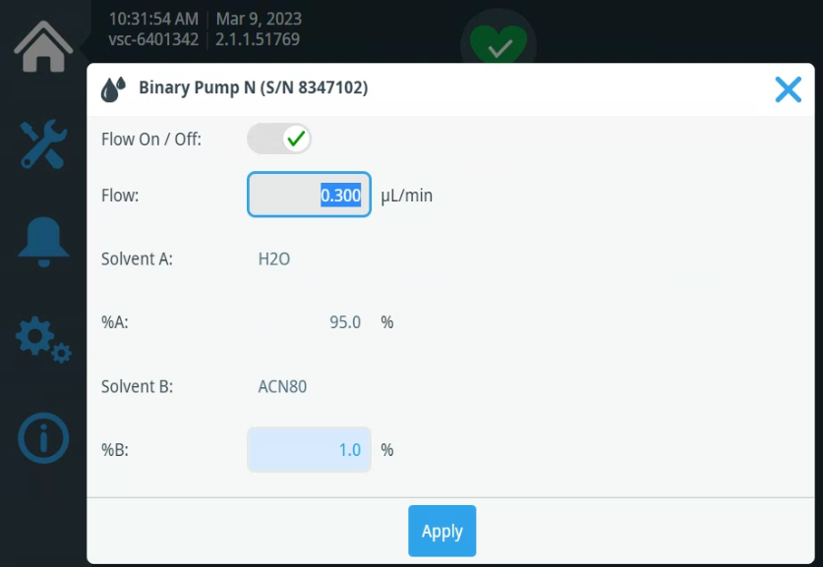
On the Home Page you can see the actual flowrates and backpressure, for a visual pressure trace click on the little graph symbol on the bottom left side of the home page. In the pop up you can select the trace you want to display, i.e. the pump pressure.
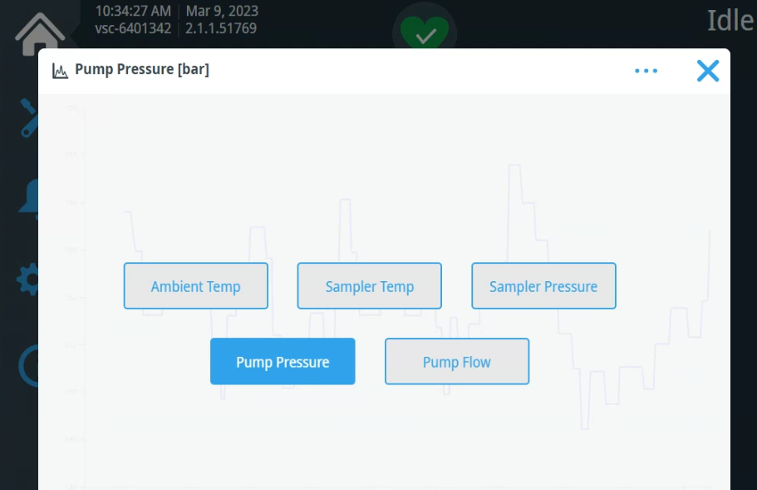

Wait for the backpressure to stabilize and note the pressure. In the first screenshot below, you see the pressure starting to increase and the stabilize at ~150 bar. Note the display will normalize to the highest/lowest value. In the second screenshot you see the zoomed in pressure once its stabilized.
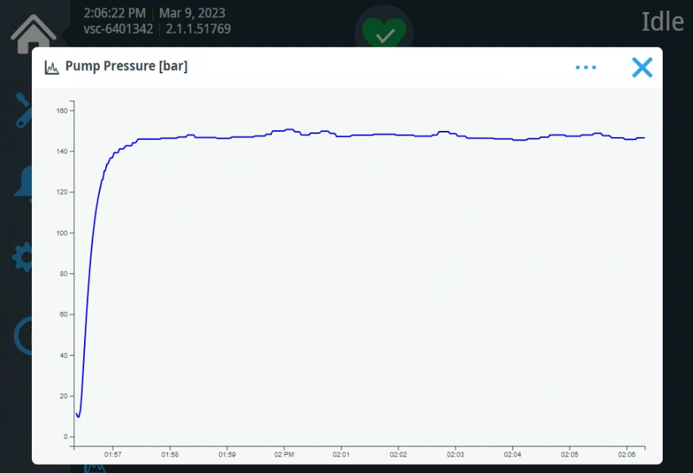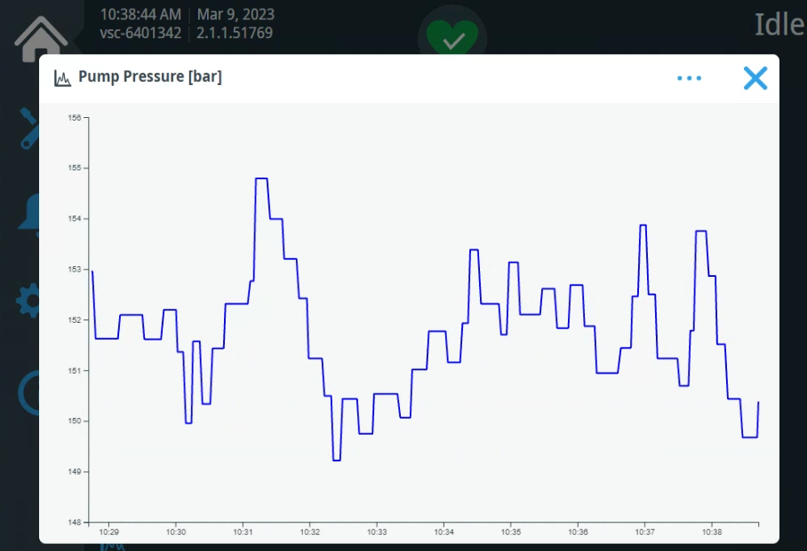

Open the methods you are going to use and click on the “Update Column Information” box:
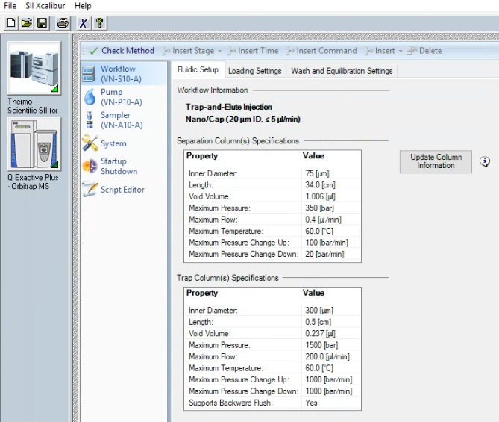

After about 10-20 min at stable backpressure position the tip of the column in front of the ion transfer tube at about 3-5 mm distance. Be careful, the ion transfer tube is hot >300ºC.
Make sure the instrument is in standby (the blue scanning light is off). Connect the high voltage connector to the pin on the micro-tee.

Adjust your ESI spray
With your column connected and the flow set to the desired rate, target backpressure <2000 psi,
from the tune window start scanning the instrument.
Monitor the live spectrum for consistency in intensity, no spectra dropping out, no sputtering at the tip. Adjust the tip position and spray voltage until you get a consistent spray.
Typical NSI spray voltage is ~ 2.1 kV
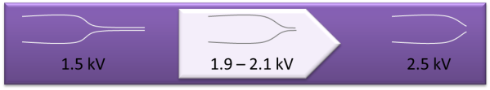
(The finer the spray tip the lower the voltage, as low as 1.5 kV. For blunt tips higher voltage may be needed, up to 2.4 kV)

Liquid droplet is forming at the tip:
If there was a liquid droplet at the tip of your column, it should disappear as soon as you start scanning the instrument. If it doesn’t, take a kimwipe, twist one corner and gently wipe the droplet off, without touching anything or breaking the tip of your column.
If the droplet forms again, check and make sure the high voltage cable is connected. If not, turn the instrument into standby, connect the high voltage cable, and turn the instrument back on. If it still forms a droplet, check column positioning and/or spray voltage.

If there are no peaks in the spectrum:
Check and make sure the high voltage cable is connected.
Check if there is a liquid droplet forming at the tip of your column.
If not turn the instrument into standby and monitor the tip of your column you should see a liquid drop form, if not check for leaks.

Once you have a stable spray, depending on the instrument you use, either save the tune file (TSQVantage, QEplus,) or make sure the spray voltage in your method is set to the same voltage you just now determined to be best for your column (TSQAltis, Fusion/Lumos, Exploris), now you are ready to get started.

Spray voltage on the Fusion/Lumos/Exploris/Altis/Exploris480:
In Tune, adjust spray voltage and position the column tip until spray is stable (no drop outs, NL: stable), 2100 V seems to work great with most of our columns. Make sure you confirm the voltage set in your methods.
There is no tune file, you need to remember to change the spray voltage in your methods.
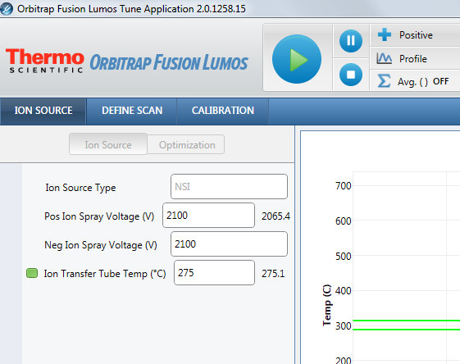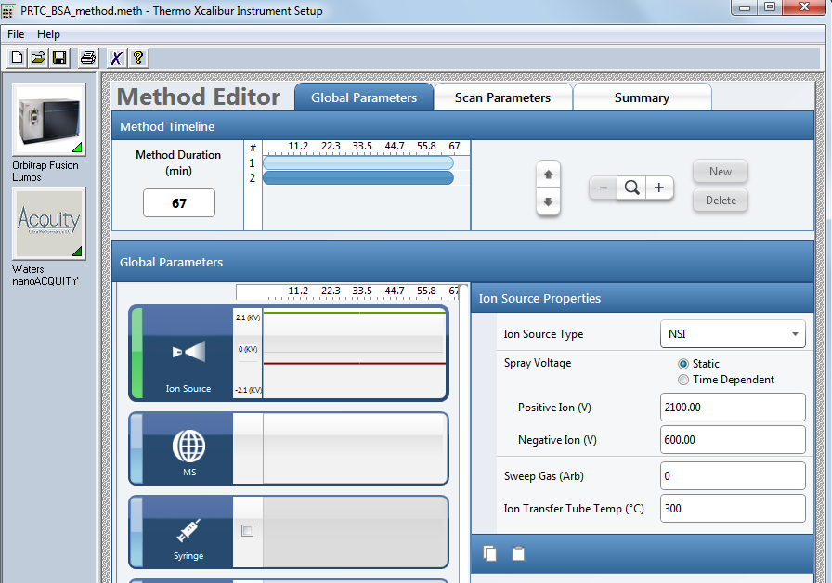

Spray voltage on the QExactive:
In Tune, adjust spray voltage and position the column tip until spray is stable (no drop outs, TIC variation <10%), remember to save the tune file!
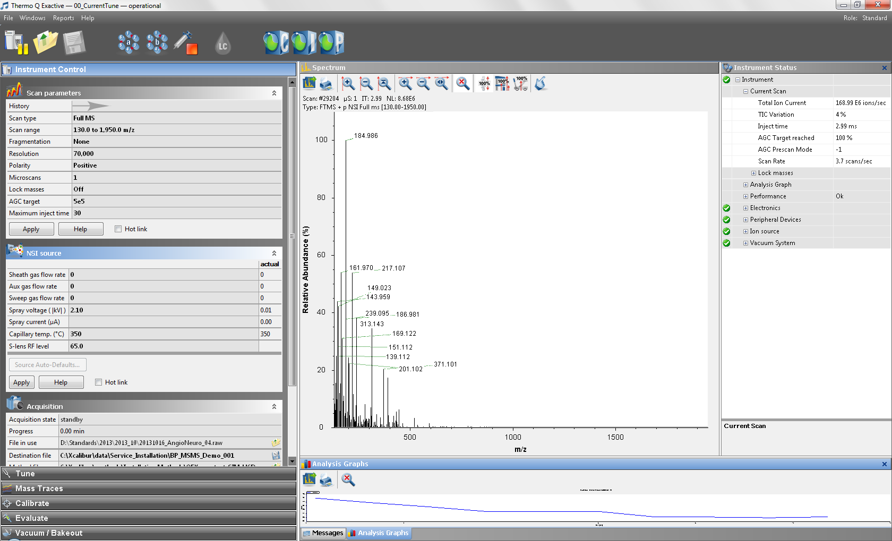

Load your samples:
Do not open the front doors when the LED bar is running blue: Parts of the autosampler are moving
If the doors are opened during needle and carousel movement, the autosampler stops the current movement of the needle arm
The needle does not puncture the sample container and does not draw sample
An acoustic signal alerts you that the doors are open
Load your samples in one of the trays, there are 4 trays. To move the tray go to the home page, click on the sampler and select the color of the tray you want to use:
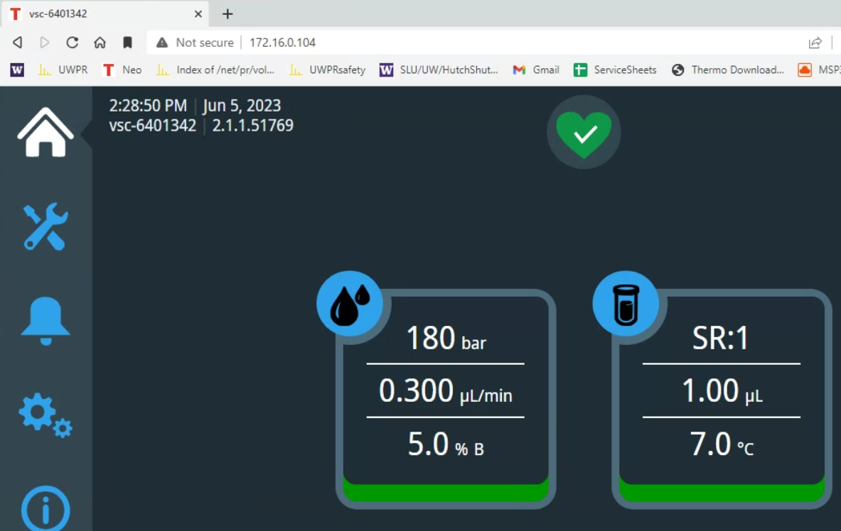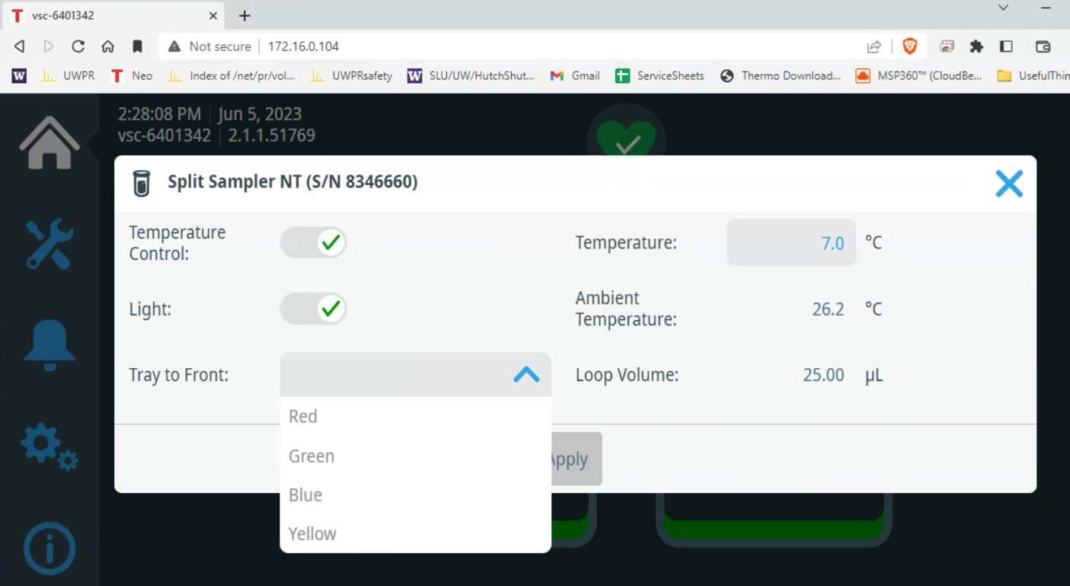
Alternatively, you can move the tray out of the direct control window:
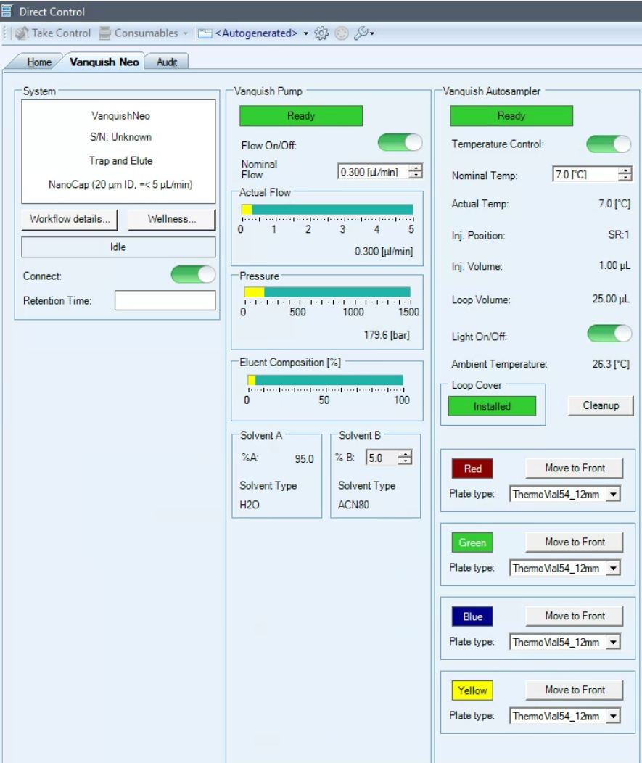

Automatic Rack Type Identification
If you use sample racks or well plates with Vanquish rack type barcode, the rack type and orientation is automatically identified during the inventory scan (e.g. Thermo Scientific™ WebSeal™ Well Plates, barcoded for Vanquish™ UHPLC Systems 10-190 ul V-shaped bottom, 60180P217B with Thermo Scientific™ WebSeal™ Sealing Tapes, Aluminum, Silicone, pressure sensitive, 60180M144)

Setting the Rack Type Manually
If you use sample racks or well plates without Vanquish rack type barcode, you must manually set the rack type for each segment on the Vanquish Neo ePanel in the chromatography data system. After loading the plate, the corresponding Plate type will show unknown. Use the pull down menu and select the plate type, e.g. WellPlate96. Note the orientation of the plate, A1 should be in the back left corner:
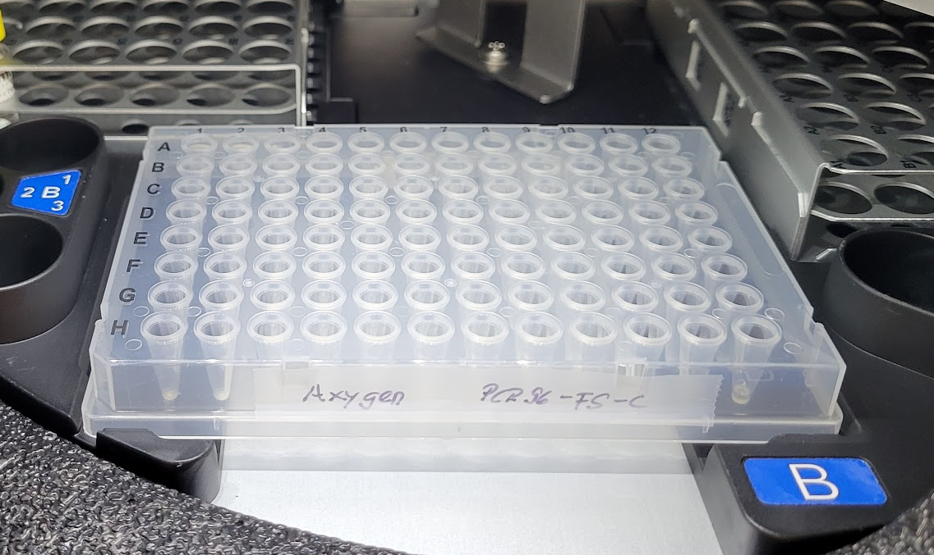

Start the first LC-MS run
Always start by running a QC, you can choose your own QC or use the one provided by UWPR.
A QC assures that
- The column gets conditioned
- There are no leaks
- Your column/trap setup is performing properly
- The HPLC is performing properly (injection and gradient)
- The mass spec is performing properly (mass accuracy and sensitivity)

In AS position SR1 (VanquishNeo) there should be a standard consisting of two peptides Angiotensin and Neurotensin, always check and make sure it’s there.
- AngioNeuro a simple peptide standard (xls)

Use the short gradient method provided by UWPR to run this standard. In Xcalibur Status make sure both the VanquishNeo and the mass spectrometer are in ready to download stage as seen below.
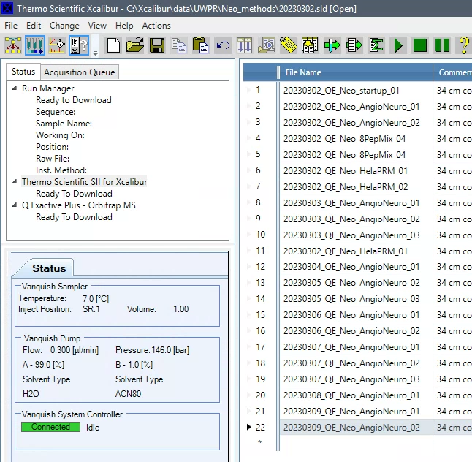

After you start the run, monitor the actions taken by the instrument:
- Both instruments should download the method, the HPLC will start running, and the mass spec should be “waiting for contact closure”
Under the Vanquish System Controller you’ll see the actions the HPLC is taking (sample pickup, sample loading and then running Separation, after the run it will equilibrate for a few minutes).
After the sample loading (trapping) is complete the mass spec acquisition will start
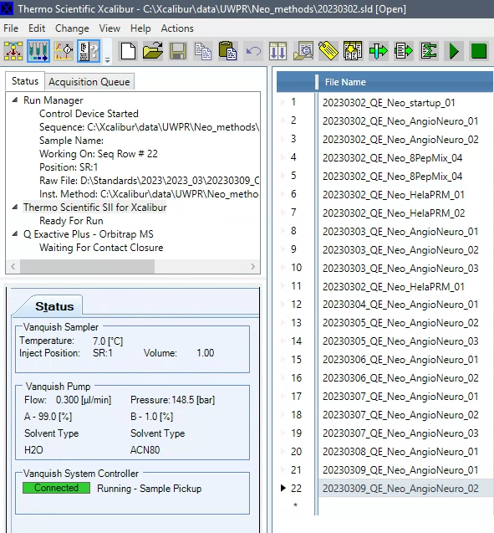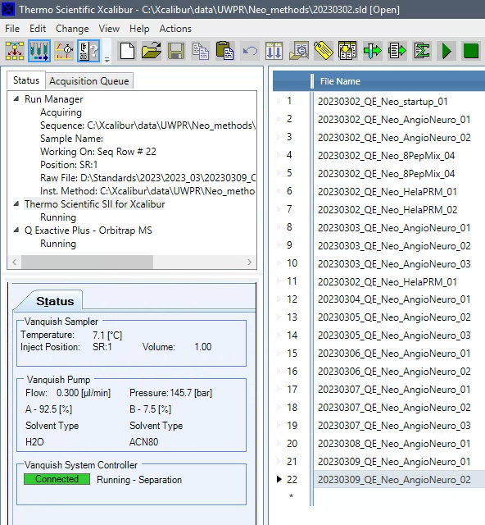

If the VanquishNeo does not start
Note if the VanquishNeo does not start, check the direct control window, you may have to Release Control
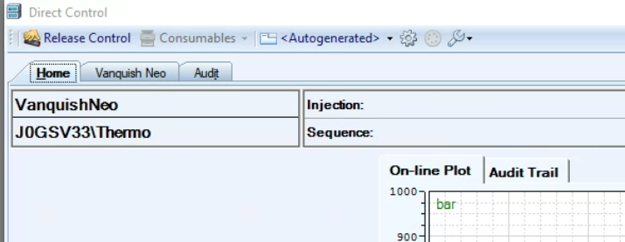

The following image shows a schematic of the auto sampler process of sample pickup, sample loading and running the gradient.
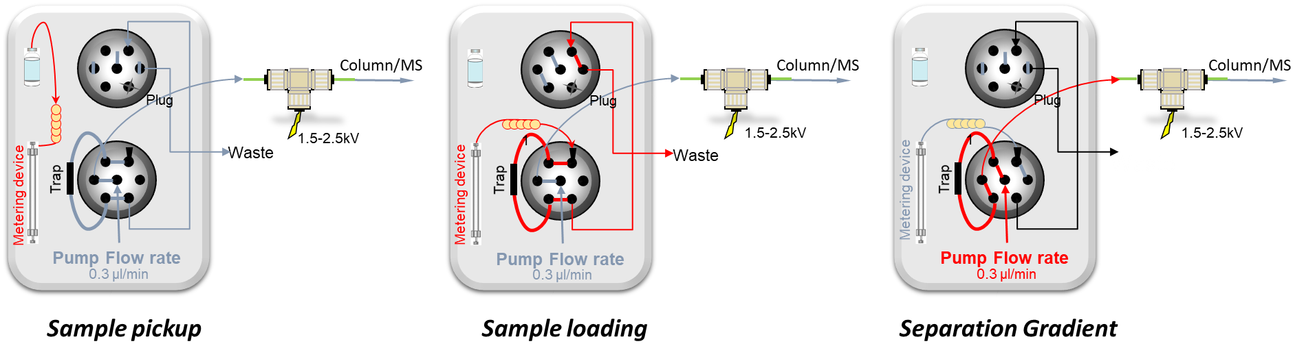
Sample loading
Into sample loop
Trapping:
Sample onto trap column
Gradient:
Sample elution

Trapping
During the trapping the flow is controlled/delivered via a metering device. With the commercial trap cartridge the flow rate can be set much higher (e.g. 60µl/min) than with the in house packed traps. This reduces the trapping time to just a minute or so. The commercial trap also allows for backflow, so the trap can be washed in both direction. The fused silica trap has an open end and can only accommodate flow in one direction.

Gradient
During the acquisition you can monitor the progress in the real time view:
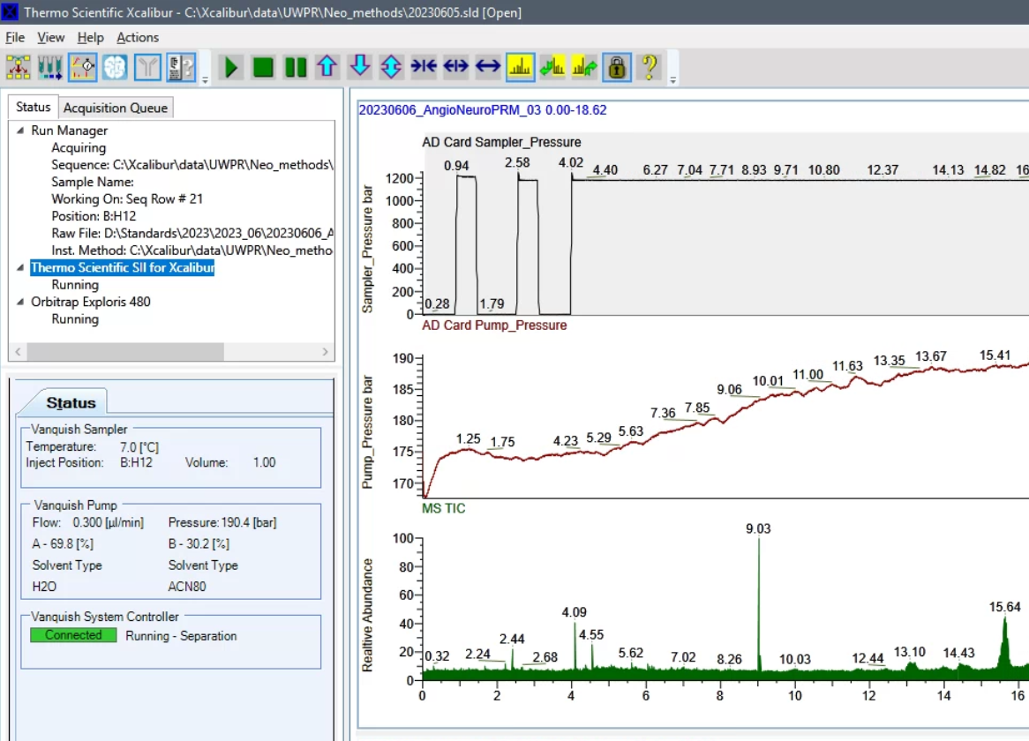

After the run is complete
After the run is complete, open the raw file in Freestyle to check the peak shape, separation, and intensity, and mass accuracy. There should be a good/recent reference AngioNeuro.raw file on the desktop.
It is normal for a brand new column to show slightly reduced intensities, this is due to unspecific irreversible binding of the peptides to the column/trap (part of column conditioning). It is also normal to sometimes see some additional peaks, typically from contamination from the column packing process.
To view the pump pressure trace in Freestyle go to Workspace Options/Chromatogram/Ranges then check the Display checkbox and select Detector Type A/D Card 2 for the pump pressure and A/D Card for the autosampler pressure trace:
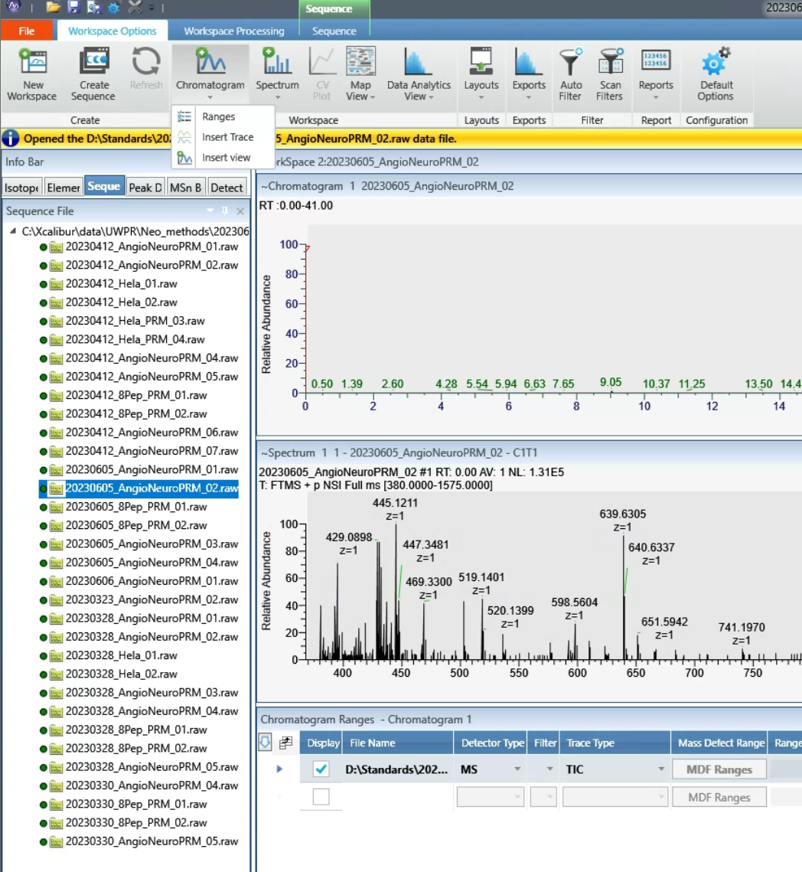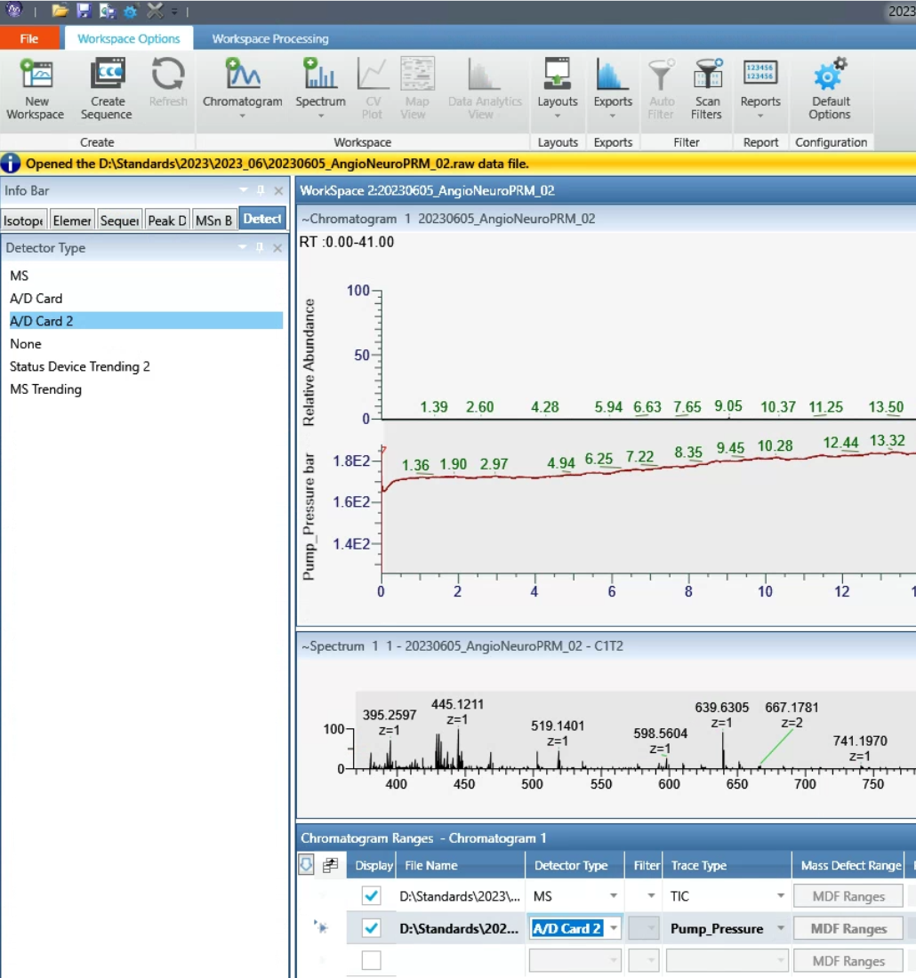

The figure below shows a typical pressure trace during a 30 min gradient, 6-35% B, 35 cm column C18 100Å 5µm at 0.300 µl/min, note there is a delay between the point when the pump mixes the gradient to when it is visible in the pressure trace. This is because the pressure will change once the gradient reaches the column. This delay is a result of the void volume between the pump and the column. On our systems the delay is about 2-3 min.
Note in Freestyle you can display the TIC and pump pressure see screenshot below. Under workspace Options expand the pulldown under Chromatogram and click on Ranges and Insert Trace
In the “Chromatogram Ranges” pane select “Detector Type” MS and A/D Card 2
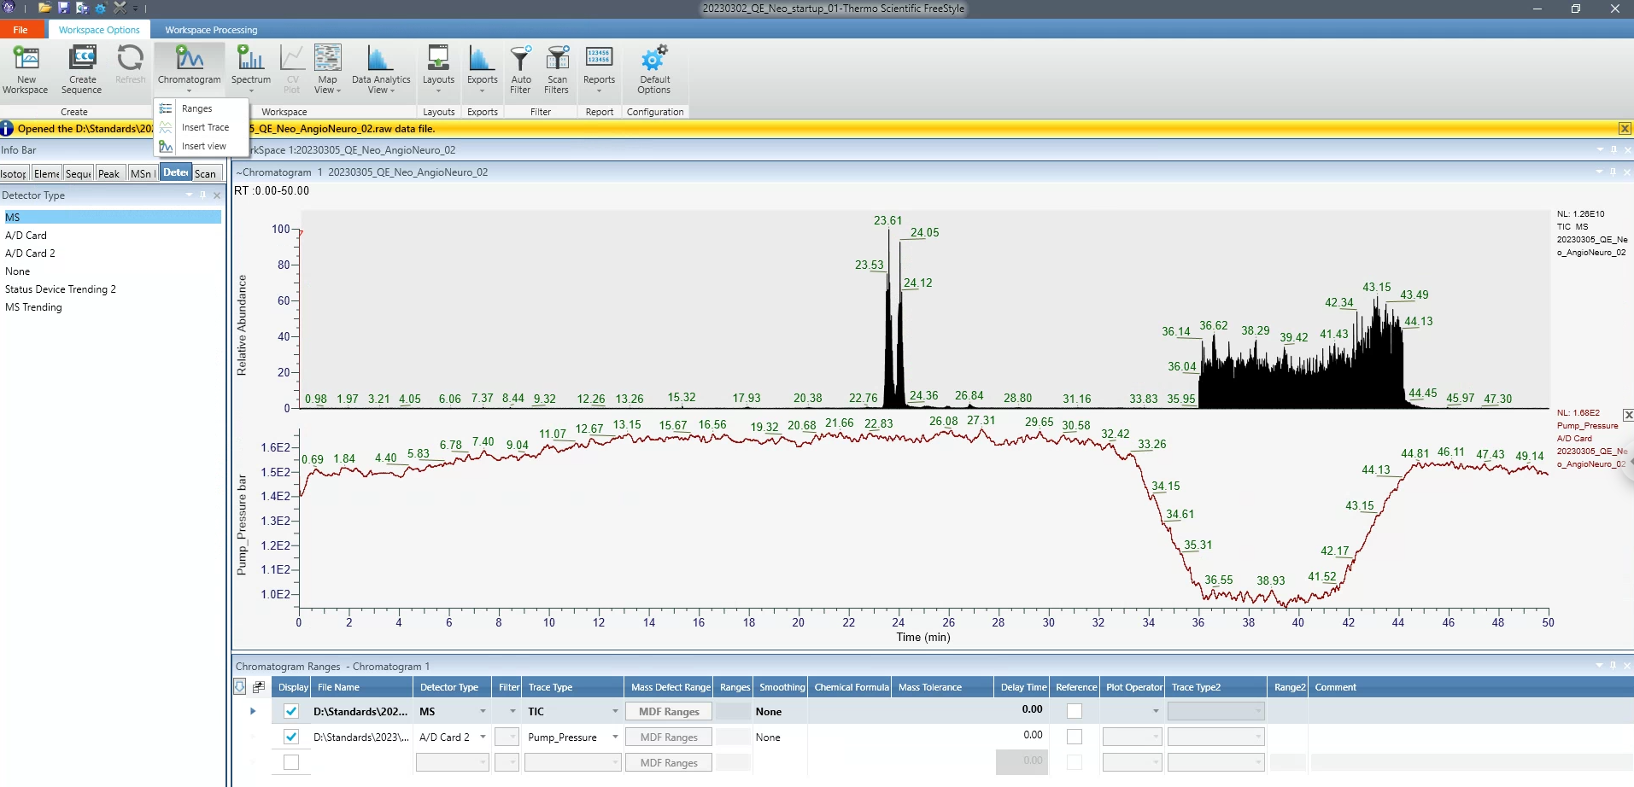
delay
95% A equilibraton
100% B wash
6-35% B gradient

It is normal for the backpressure to drop at high % buffer B because of the viscosity of acetonitrile, but at the end of the equilibration, it should return back to the initial backpressure you established during the setup.
If your first sample ran satisfactory and the backpressure trace is similar to the QC, you should be good to go. If all your samples were prepared identically, chances are good that the system will analyze all of them with no problems.
If your sample causes the system back pressure to rise much higher than during the QC run, the system may over pressure or start leaking. If this is the case running your samples in an automated fashion is risky as you do not know when a leak/over pressure may occur.
A small increase in backpressure is normal, but if the backpressure increases after every sample and does not recover down to initial conditions, eventually it will overpressure or start leaking.

End of Run Equilibration
Note the column equilibration is done after the acquisition is complete, so the system will not be ready for the next run immediately, you can see the status of the equilibration in the Direct Control pane, if there is another acquisition lined up it will start as soon as the column equilibration is complete (~5-10 mins depending on your column and method settings):
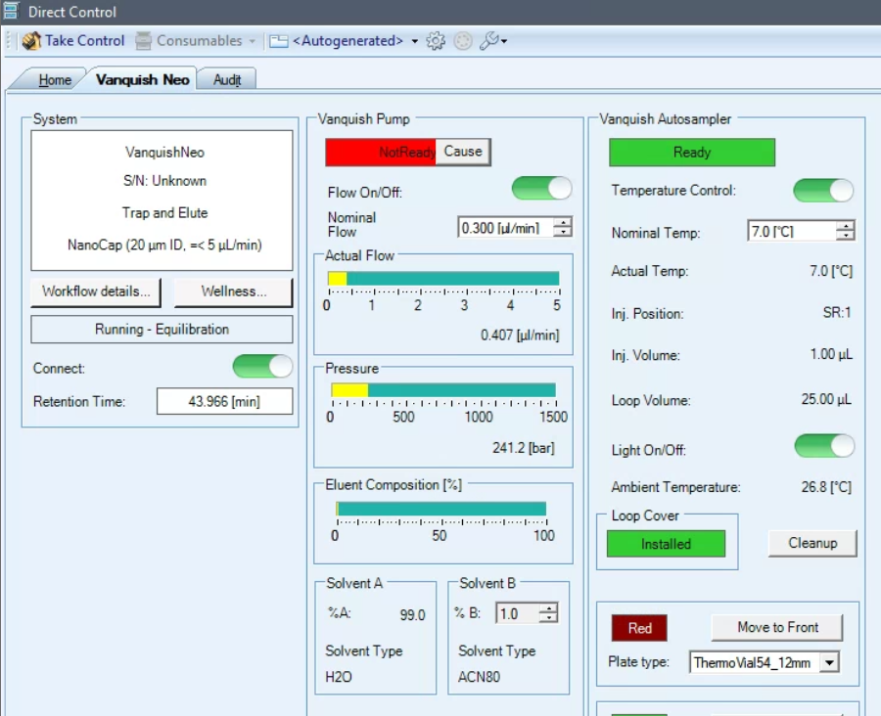

If peaks are not separated at all or are tailing
Check for obstructions/blockage in the flow path, micro-cross and micro-tee.
Try a second QC run.
Try a new column.

Run your first sample
If your QC is satisfactory, start your first sample. Monitor instrument actions as described above. Monitor the back pressure during the gradient. It should look similar to the QC run, if the backpressure increases during your sample acquisition you may need to do additional cleanup of your sample (spinning it down and transferring sample to a new vial, or spin column or zip tip cleanup to remove salts, detergents, lipids etc.)

QC runs and blanks
How many QC runs should you run?
Ultimately that is up to you. Good practice would be to run a QC every 5 – 10 runs, to monitor system performance over time.
I like to line them up such that there is a finished QC run for me to look at first thing in the morning when I come in, so I can take action if needed.

Should you run blanks?
This really depends on your project, but here are some hints to help you decide:
The typical carry over on our systems from one run to the next is less than 1%.
For MRM runs we see about 0.5-1% of the most abundant peptides in the next blank run.
And for DDA we got 18000 peptide ID’s in the sample run (complex peptide mix on the QE), and got ~50-100 peptides in a subsequent blank run.

If carry over is a critical concern for your project, test it with your own sample. Run a blank and look for carry over.

Accessing the sampler to load samples during an acquisition
Do not open the door while the autosampler is picking up and loading the sample, wait for the Vanquish Autosampler status to turn Ready (green).
Once it turns green you can open the door. To move a tray forward in the Direct Control window, click on “Take Control” and then click on Move to Front next to the tray color you want to move to the front:
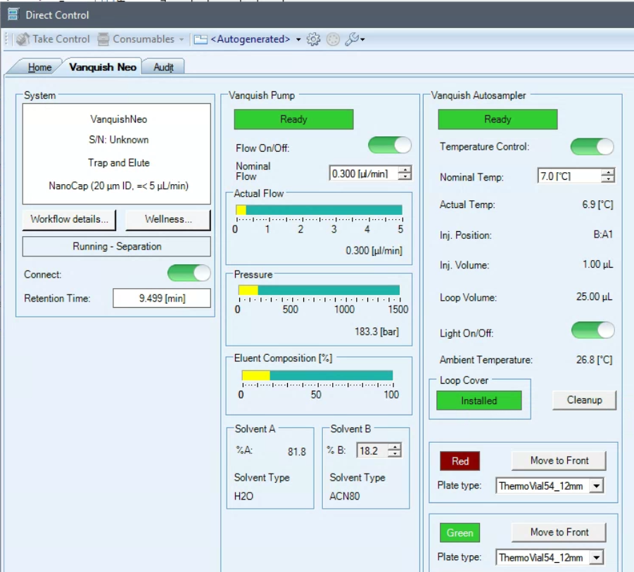
This will trigger a pop up warning:
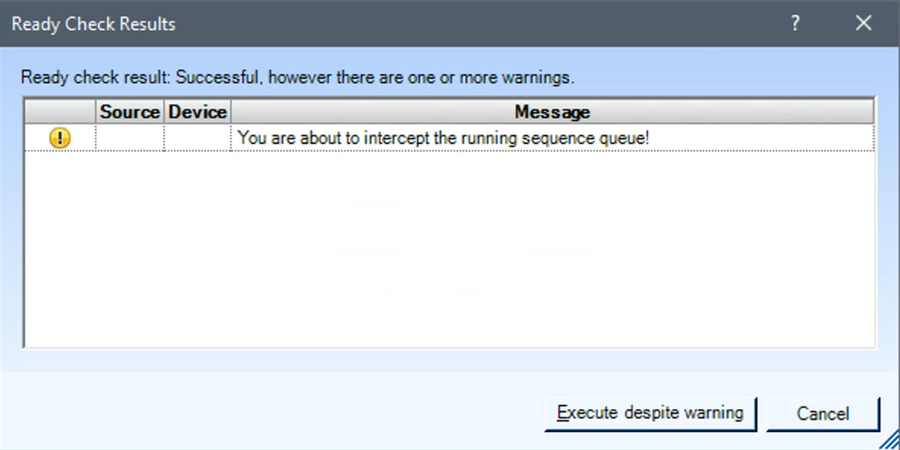
Click on Execute despite warning
Once you are done loading the samples, close the door and click on Release Control in the direct control window.

