VanquishNeo Method Setup
Note it is easiest to start with an existing method, like one of the standard methods we saved into your methods folder. Later in this document, we describe how to start from scratch or from a method that had a different HPLC system configured.
Table of Contents
VanquishNeo Method Setup 1
Workflow 2
Workflow: Fluidic Setup 2
Workflow: Loading Settings 2
Workflow: Wash and Equilibration Settings 3
Pump 3
Pump: General Settings to specify the Gradient 3
Sampler 4
Sampler: General Settings 4
Sampler: Advanced Settings 4
System 4
System: General Settings 4
Startup Shutdown 5
Startup Shutdown: Smart Startup 5
Startup Shutdown: Smart Shutdown 5
Startup Shutdown: Smart Standby 5
Script Editor 5
Starting with a method that had the EASYnLC configured 6
General settings 6
Fluidics setup workflow 7
General settings for the pump 7
General Settings for Sampler 8
Loading Settings for Workflow 8
Wash and Equilibration settings 9
Smart Standby 10
Mass spec run time 10

Workflow

Workflow: Fluidic Setup
Note, remember if the column settings changed, you need to update the methods with the new column settings!
To change the column information use the A03-Set Separation Column Specifications on the instrument touch screen.
In the method check the separation and trap column specifications, and if necessary update the information by clicking on “Update Column Information”:
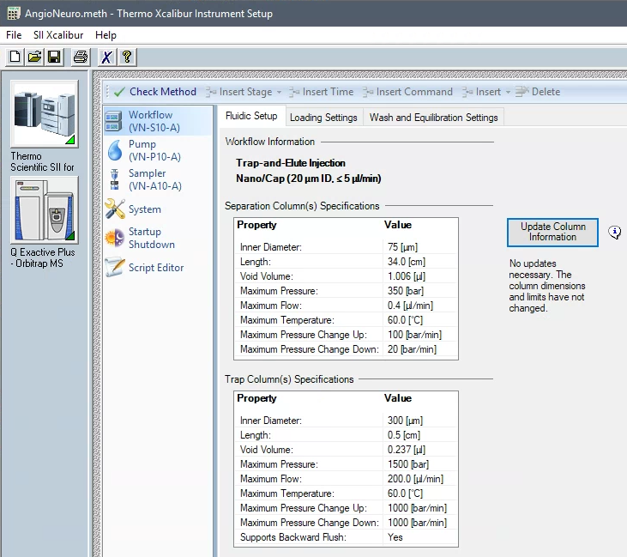

Workflow: Loading Settings
The PepMapNeo trap cartridge flow rate can be set at higher flow rates and backpressures than 100µm ID fused silica trap columns. You can specify the flow rate, the max pressure or combined (i.e. it will not exceed the target value specified)
You can specify the loading volume, or select automatic and it will calculate the loading volume based on the trap dimensions.

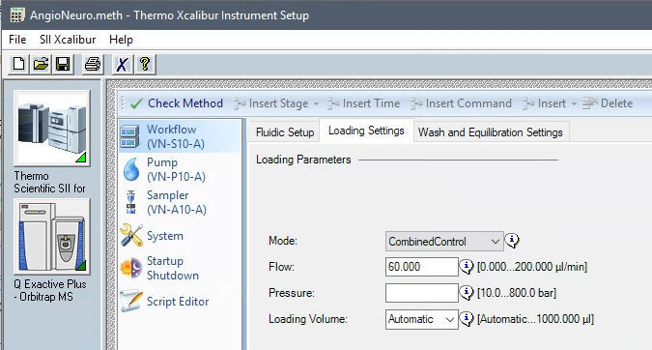

Workflow: Wash and Equilibration Settings
At the end of the acquisition, the system will wash and equilibrate the separation and trap columns based on the settings specified in this section:
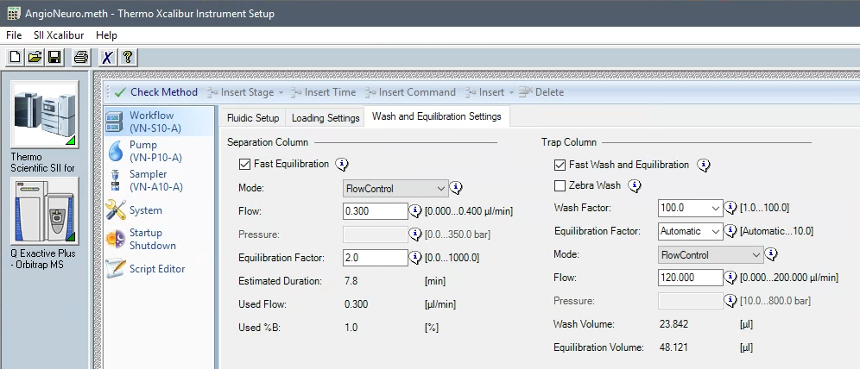

For the separation column, specify the desired Mode, Flow and Pressure. The equilibration Factor is number of column volumes used for the equilibration (calculated based on the column specifications), if you select flow control it will calculate and display the time needed to equilibrate the column.
For the Trap column set the wash and equilibration settings, fast wash is suitable for most applications. Note it calculates/displays the volume used for each the wash and equilibration.
Zebra wash uses alternating organic and aqueous solvents to wash the trap.
The Wash Factor specifies the volume of organic solvents used to wash the trap column, the factor is multiplied by the trap column volume plus the dead volume.
The Equilibration Factor specifies the volume of aqueous solvent used to equilibrate the trap column, the factor is multiplied by trap column volume plus the dead volume. Automatic = Equilibration Factor of 2 should work for most applications.
Specify the desired Mode, Flow and Pressure for the trap column equilibration.

Pump

Pump: General Settings to specify the Gradient
- Buffer A: 0.1 % Formic Acid in Water (Fisher Water with 0.1% Formic Acid (v/v), Optima™ LC/MS Grade, LS118)
- Buffer B: 0.1 % Formic Acid, 80% Acetonitrile in Water (Fisher Water with 0.1% Formic Acid (v/v), Optima™ LC/MS Grade, LS122500)
- Note Buffer B is 80% Acetonitrile, so keep that in mind when setting up the gradient.
- Most peptides elute between 10-30% Acetonitrile, or ~12.5-37.5 % B
- Here is an Example gradient we used for the AngioNeuro QC:
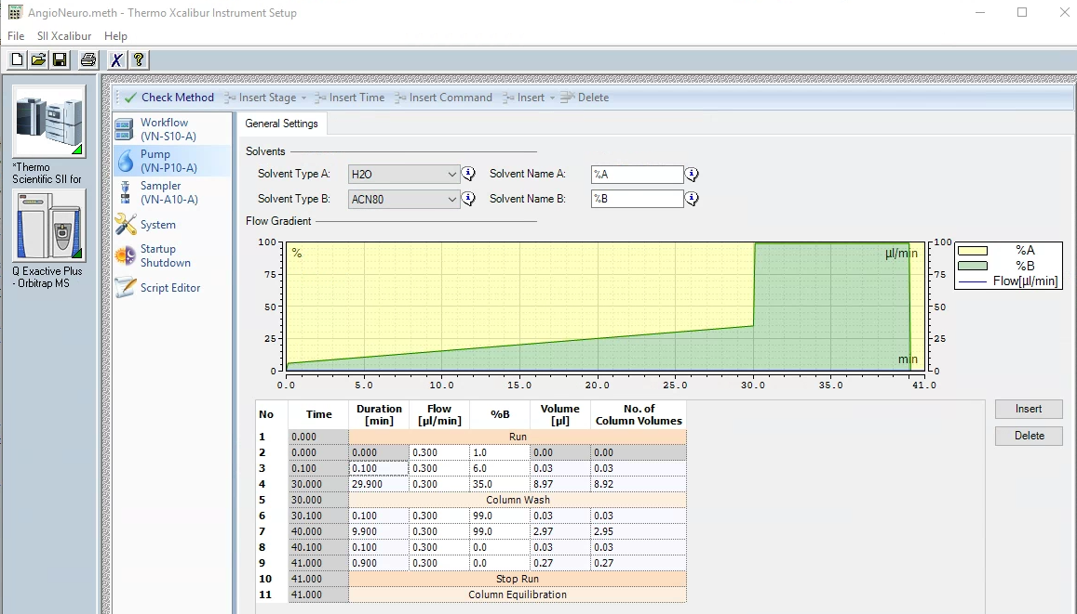

Sampler

Sampler: General Settings
Specify the names of the solvents used to wash the needle, metering device and wash port.
Specify to use temperature control and temperature of the sample compartment.
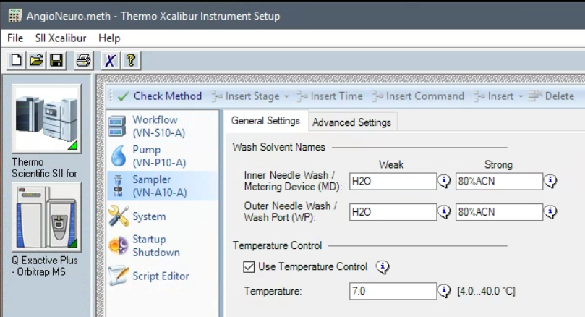

Sampler: Advanced Settings
Specify the Outer Needle Wash
Specify the direction the trap is flushed, note for open-ended traps like our homemade fused silica traps backwards flush is not an option.
Specify whether to use Air Gaps and the Air Gap Volume
Speed paramaters are optimal for the system and rarely need to be changed
Vial bottom detection, see figure below
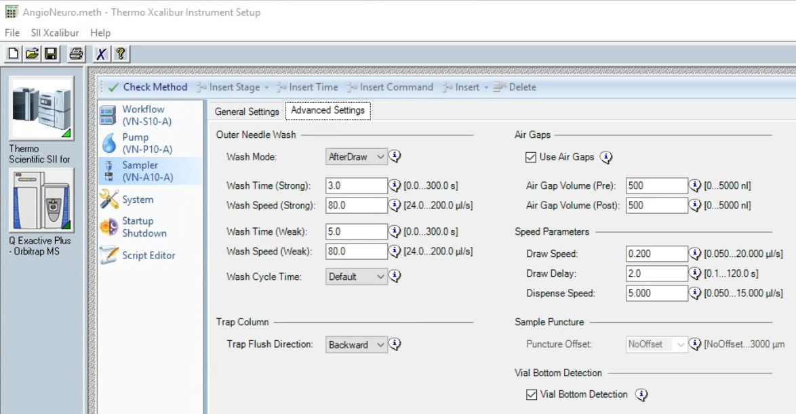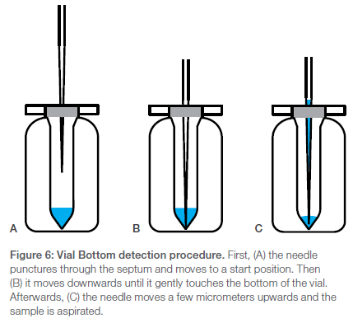

System

System: General Settings
Specify the run time and what channels to record.
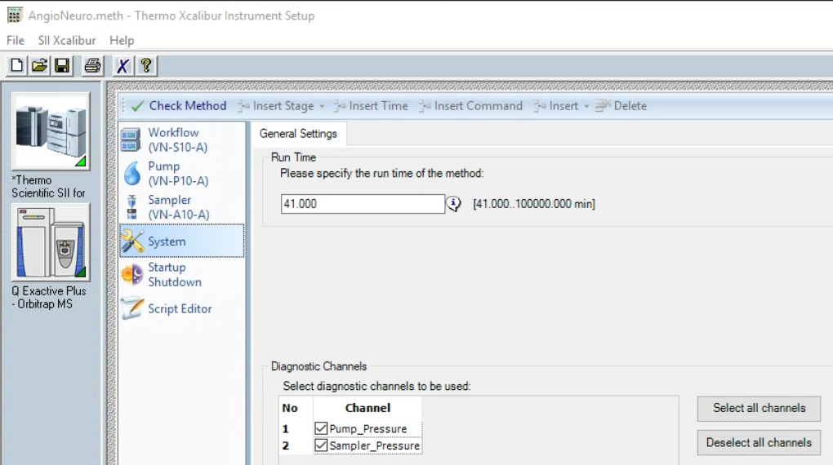

Startup Shutdown

Startup Shutdown: Smart Startup
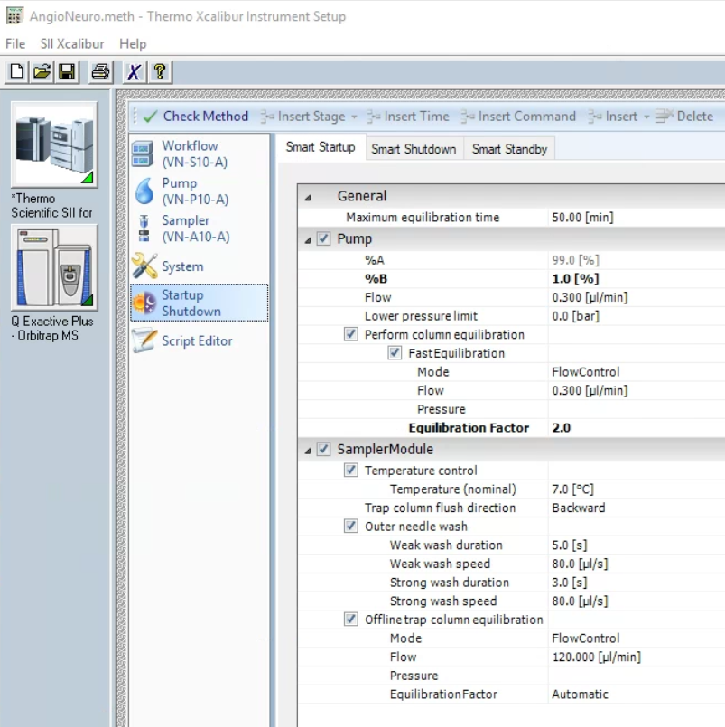

Startup Shutdown: Smart Shutdown
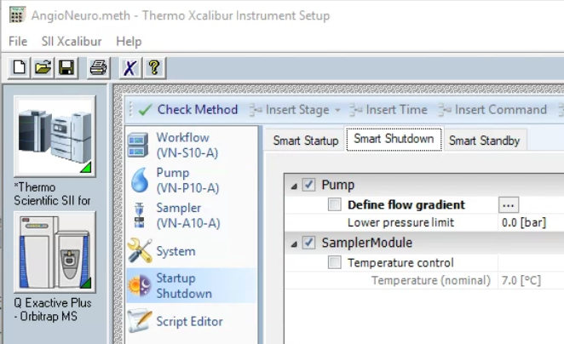

Startup Shutdown: Smart Standby
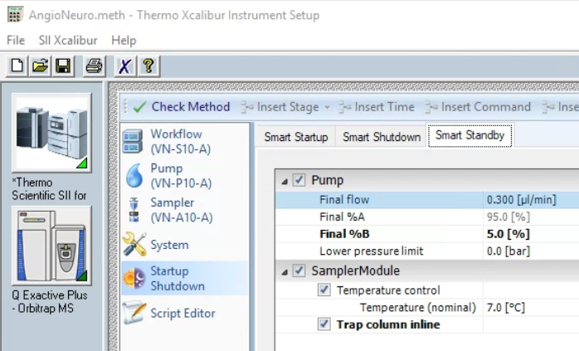

Script Editor
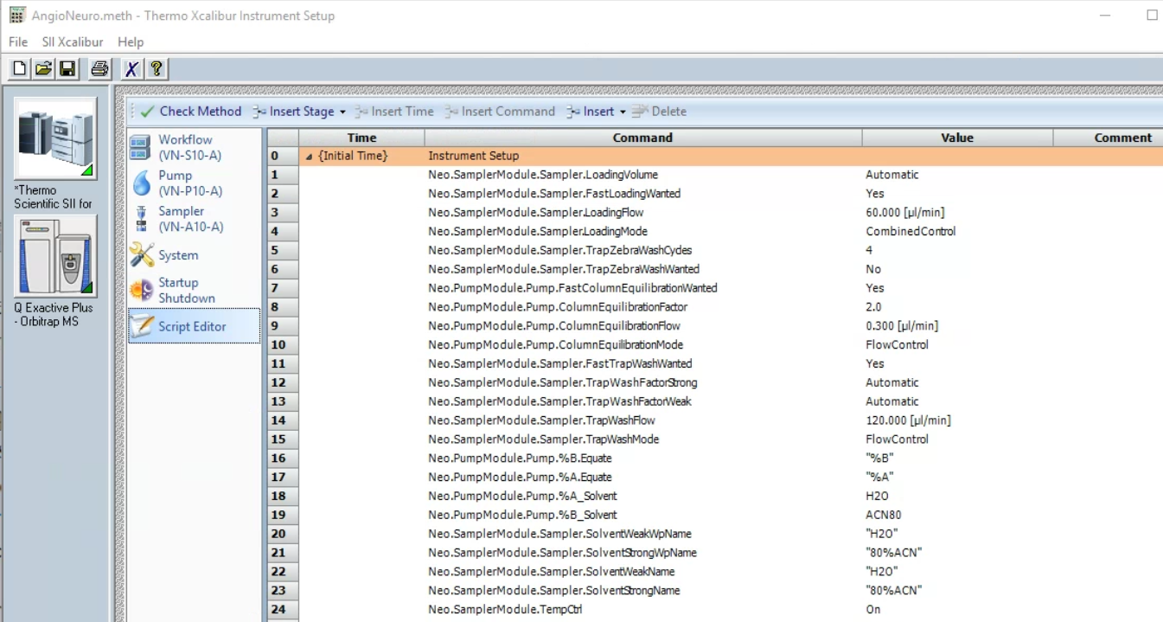

Starting with a method that had the EASYnLC configured
Open that method, you will get an error message:
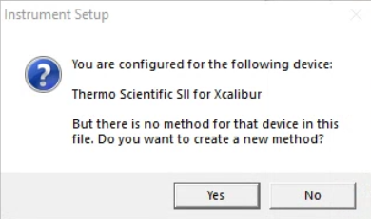click Yes.
If the method had been created with an older version of instrument control software you may get a second error message:
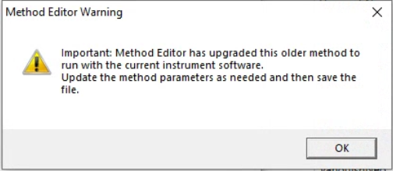click OK.

Once the method opens the method editor will step you through the setup of the Neo method:

Here is a link to a video from thermos that describes how to setup a method from scratch:
https://www.thermofisher.com/us/en/home/industrial/chromatography/liquid-chromatography-lc/hplc-uhplc-resources.html?item=Simple%20and%20Intelligent%20Method%20Creation

General settings
Here you should enter the overall acquisition time. (Note you will have to match that time for the mass spectrometer as well, as described a little later in this document), the diagnostics channels are checked by default, I always leave them on.
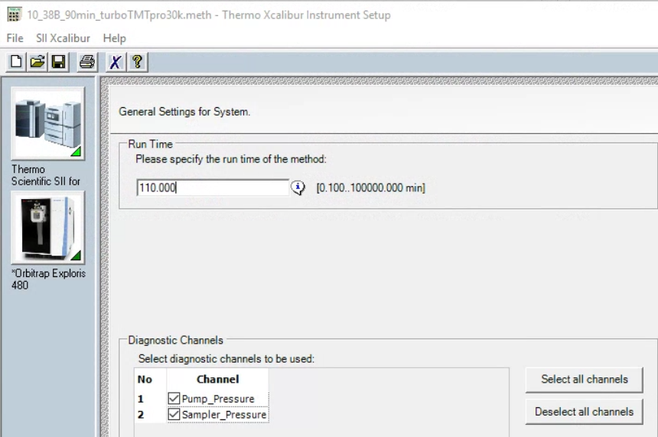Click Next.

Fluidics setup workflow
This shows the workflow currently configure for the Neo, it will display the current column specifications that were imported into the method.
Note if you change the column specifications you need to open the methods and update them.
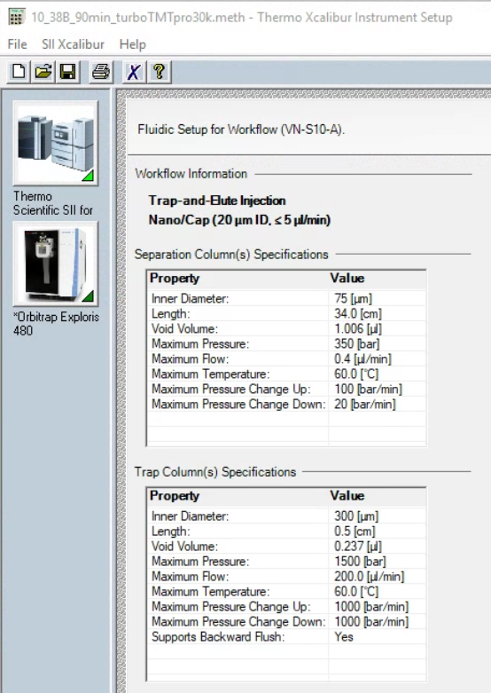Click Next.

General settings for the pump
Here you need to enter the gradient information, do a right mouse click to fill down a value, or enter/remove a row.
Make sure your total time matches the time entered above and also matches the mass spectrometers time.
Enter the flow rate, the duration and %B for the gradient as well as the column wash.
Note the system automatically eqilibrates the column after the run, so you could end at a high organic wash. We prefer to give it a couple of minutes at 100%A.
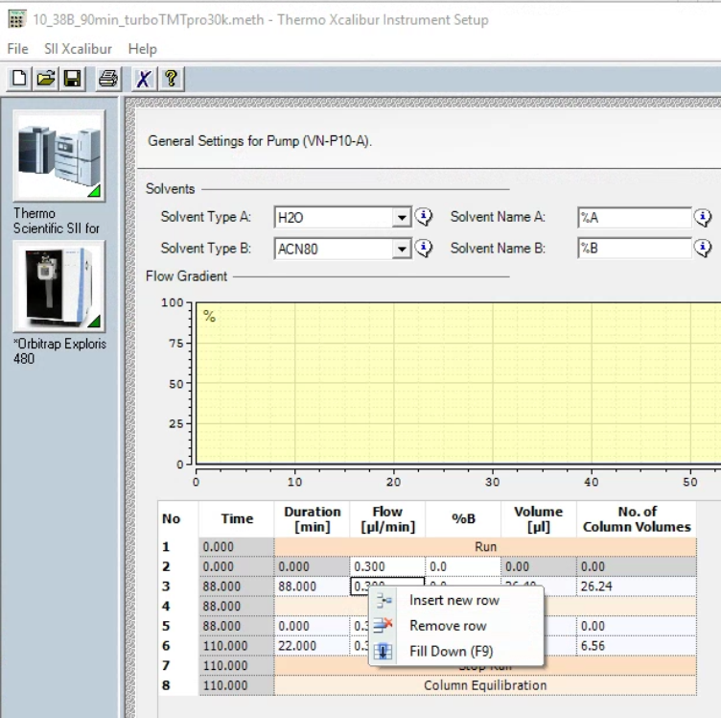

Check the visual of your gradient and wash and make sure it’s the way you want it, e.g. like in the image below.
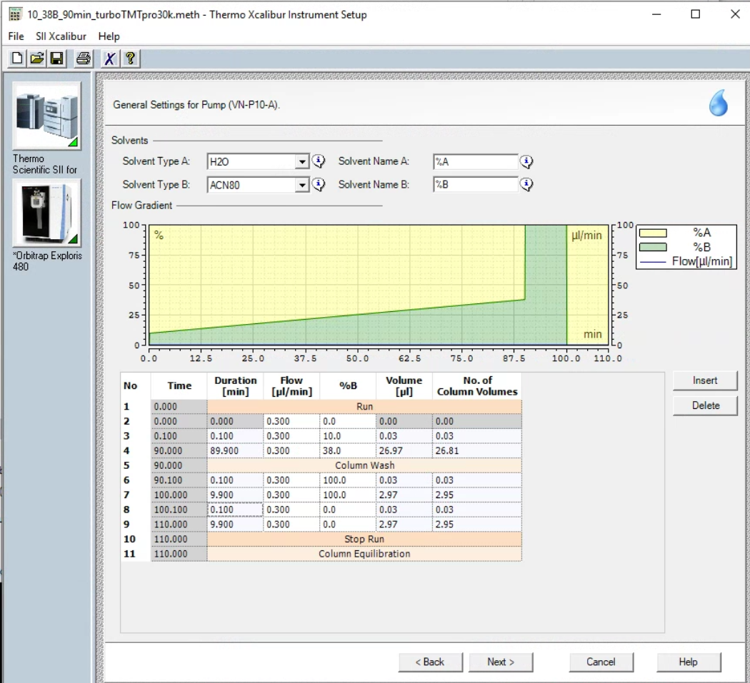Click Next.

General Settings for Sampler
Here we use the default parameters.
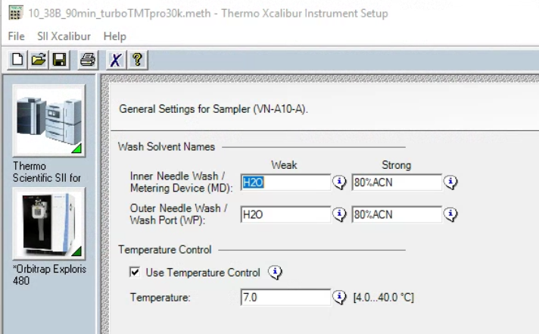Click Next.

Loading Settings for Workflow
The settings in this section depends on your trap configureation. If you use the PepMax cartridge you can load a relatively high flow rates. We have been using 60µl/min for loading and the automatic loading Volume. With our home made trap we use 2-4µl/min.
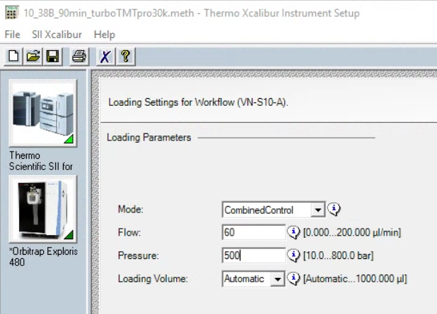 Click Next.

Wash and Equilibration settings
For the separation column we use the fast equilibration at 0.3 µl/min and equilibration factor of 2. If you use flow control it calculated the time needed for the equilibration at the end of the acquisition.
For the PepMap trap column with use a wash factor of 100 and automatic equilibration factor. For the home made trap we use a wash factor of 8 and automatic equilibration factor. Again, it calculates/displays the volumes used for the wash and equilibration of the trap column based on the trap column specifications.
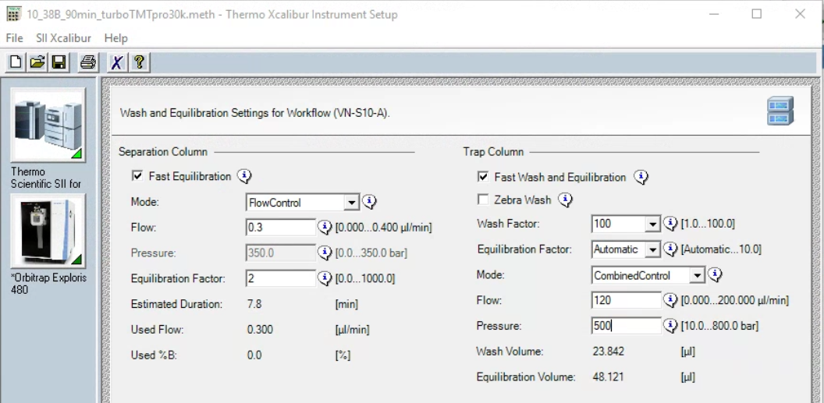 Click Next.

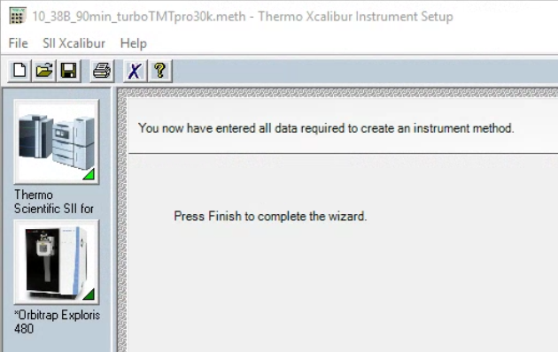 Click Finish.

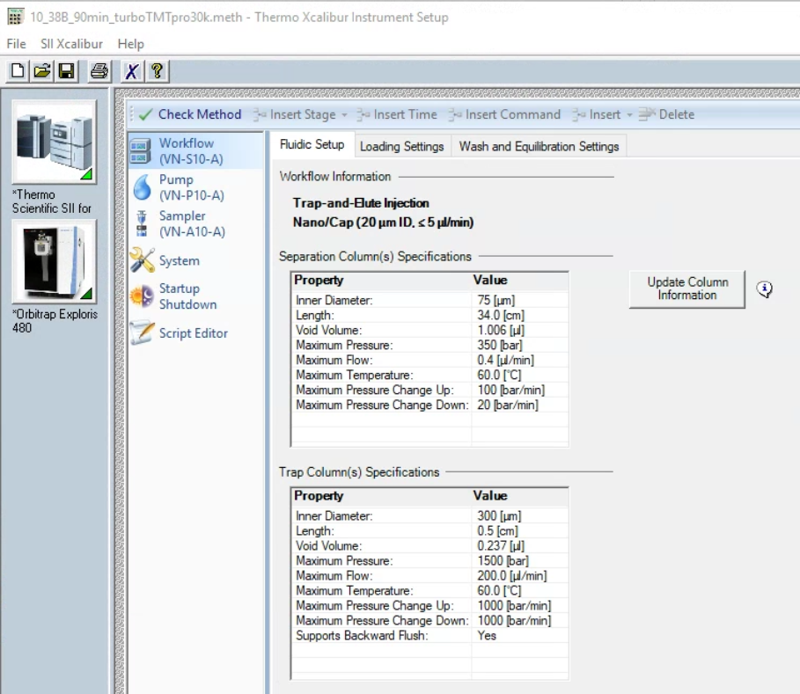

Smart Standby
In standdy we like to have the flow continue through the trap column at 5% B. Note you have to check “Advanced Settings” to see all the settings.
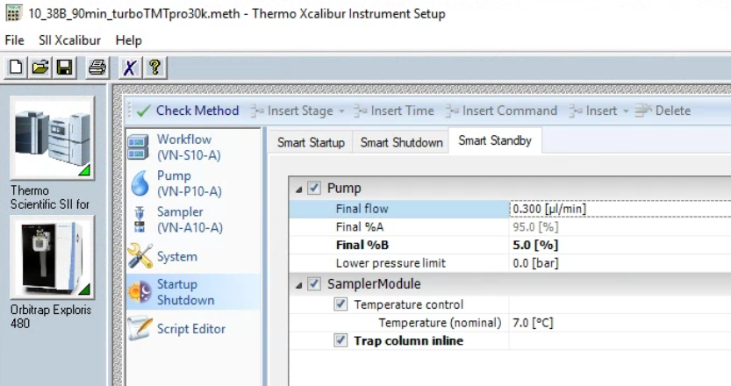 Click Next.

Mass spec run time
Now that you’re all done with the HPLC method you need to remember to adjust the mass spec run time. Also double check all the mass spec settings are all correct.
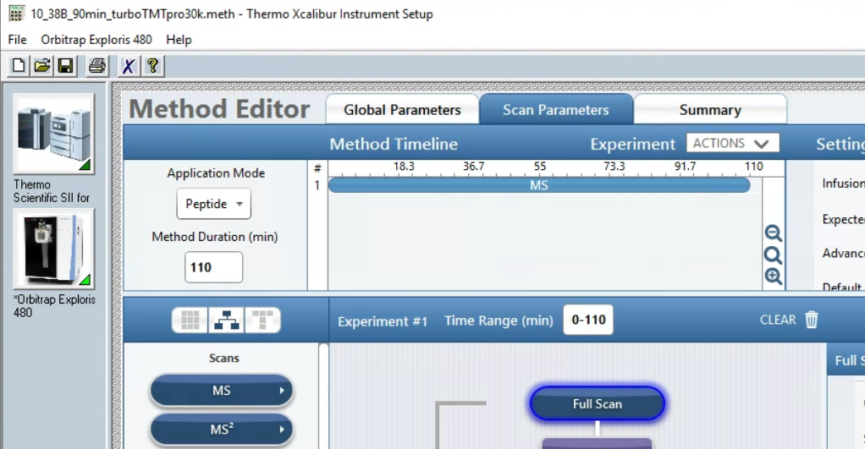 Save the method.

