LC-MS setup VanquishNeo

Table of Contents
LC-MS setup VanquishNeo 1
Installing software for the VanquishNeo 2
Installing SII for Xcalibur 2
Installing the VanquisNeo driver 2
Configuring the VanquishNeo 2

Installing software for the VanquishNeo
You will need to download the latest version of software from the Thermo download portal:
https://thermo.flexnetoperations.com/control/thmo/login
you will need SII for Xcalibur and VanquishNeo driver
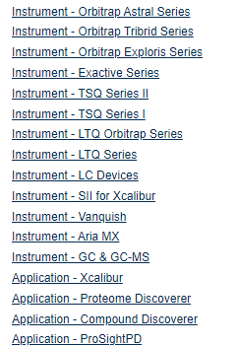

Installing SII for Xcalibur
Read the latest Installation Guide, make sure you have the latest versions of software (Xcalibur, instrument software) you need for this version of SII.

If you are upgrading from an earlier version of SII, remove it from the configured devices in the Instrument Configuration window.
You may have to uninstall the older version of SII, before upgrading Xcalibur and the mass spec driver (if needed)

Then install SII for Xcalibur and follow the prompts, you’ll have to reboot the PC a couple times.

Installing the VanquisNeo driver
After installing SII for Xcalibur, install the VanquishNeo driver, follow all the prompts.

Configuring the VanquishNeo
With the VanquishNeo connected, open Instrument configuration
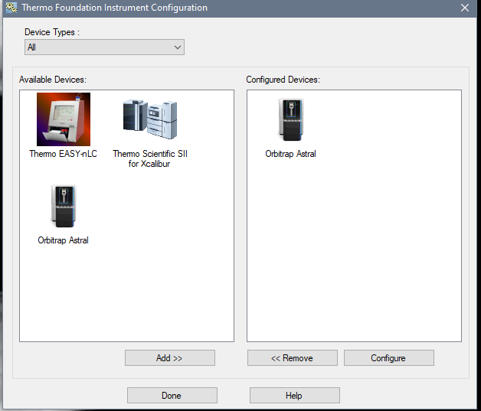

Select SII for Xcalibur and add it to configured Devices:
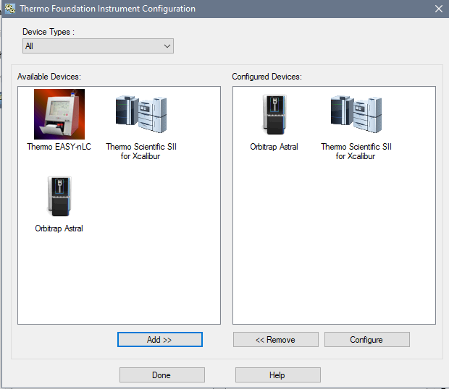

Select SII and hit Configure, wait for the pop up window:
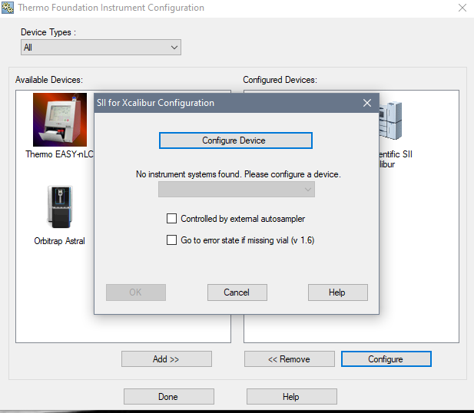

Click on Configure Device and wait for the Chromeleon Configuration Manager to open:
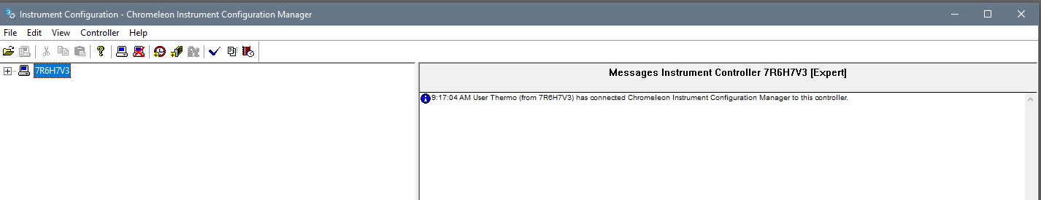

Right mouse click and select “add new Instrument”, in the pop up name it VanquishNeo
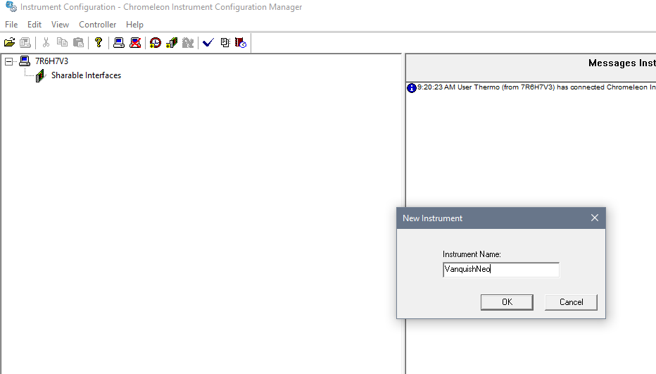

Hit OK:
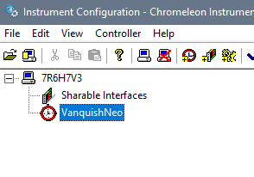
Right mouse click and select “add module”, in the popup on the left side select “HPLC: Vanquish” and on the right side select “Vanquish Neo System”:
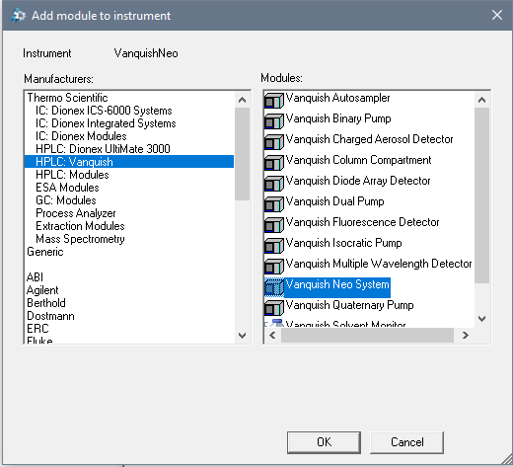

In the “Vanquish Neo System Configuration” pop up window, enter the IP address of the VanquishNeo, you can look it up on the Neo screen:
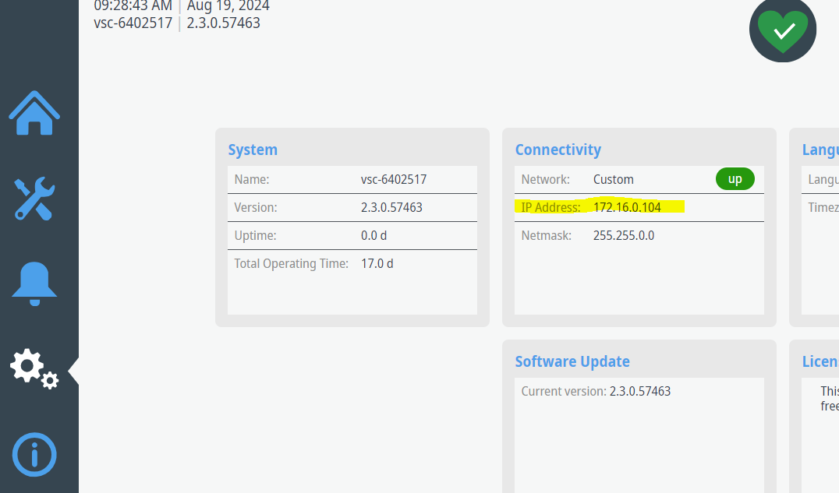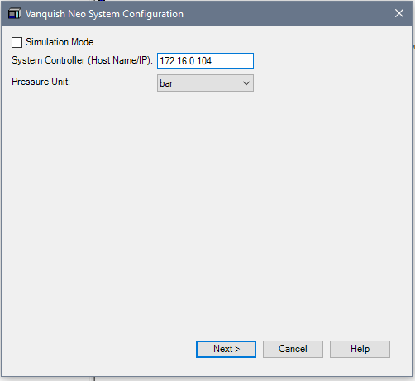

Hit next and it will reach out and find the neo
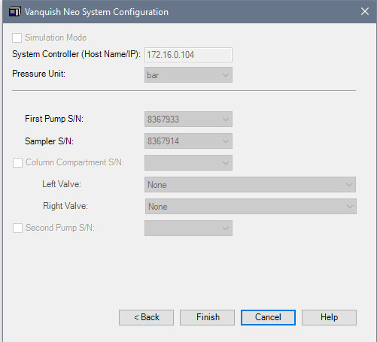

If you get this error, reboot the VanquishNeo and the computer and try adding the module again, you should see the messaged on the right side like in the screen shot below:
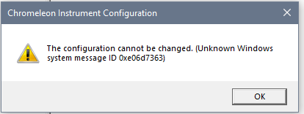

Once you configure the VanquisNeo you should see a bunch of updates in the right panel:
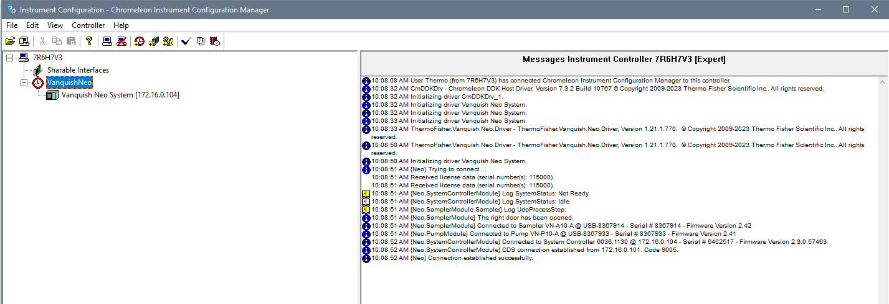

Then save the configuration:
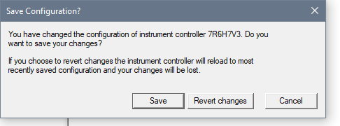

You should see the following:
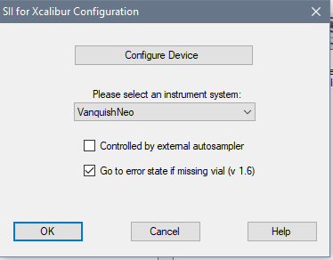

Reboot the PC and open inst config,select SII and it ok, close inst config
Wait for it to close then open Xcalibur, note the light indicators on the Neo should turn green. Sometimes it requires a reboot of the Neo and the PC for it to connect. In the Xcalibur Status pane you should see SII Connected:

