How to setup a PRM assay on the Fusion and FusionLumos (SW v 3.1)

Inclusion List
First you need a list of peptides representing the proteins you want to monitor/quantify. You can use prior DDA data, databases or theoretical peptides.
Generate an inclusion list including:
- Mono-isotopic precursor m/z
- charge state (z)
- For scheduling you’ll need the start and end times,
- you can also include the peptide sequence in the comment field if you wish

You can use skyline to generate the list for you. Follow their tutorials. Note you’ll likely use Skyline to analyze your data, so you might as well use it to generate your inclusion list.
https://skyline.gs.washington.edu/labkey/wiki/home/software/Skyline/page.view?name=tutorial_targeted_msms

Instrument method
If you wish you can add a full scan in addition to the PRM scan. This allows you to integrate the precursor mass as well.
Make sure the full scan mass range covers the m/z range of the inclusion list.
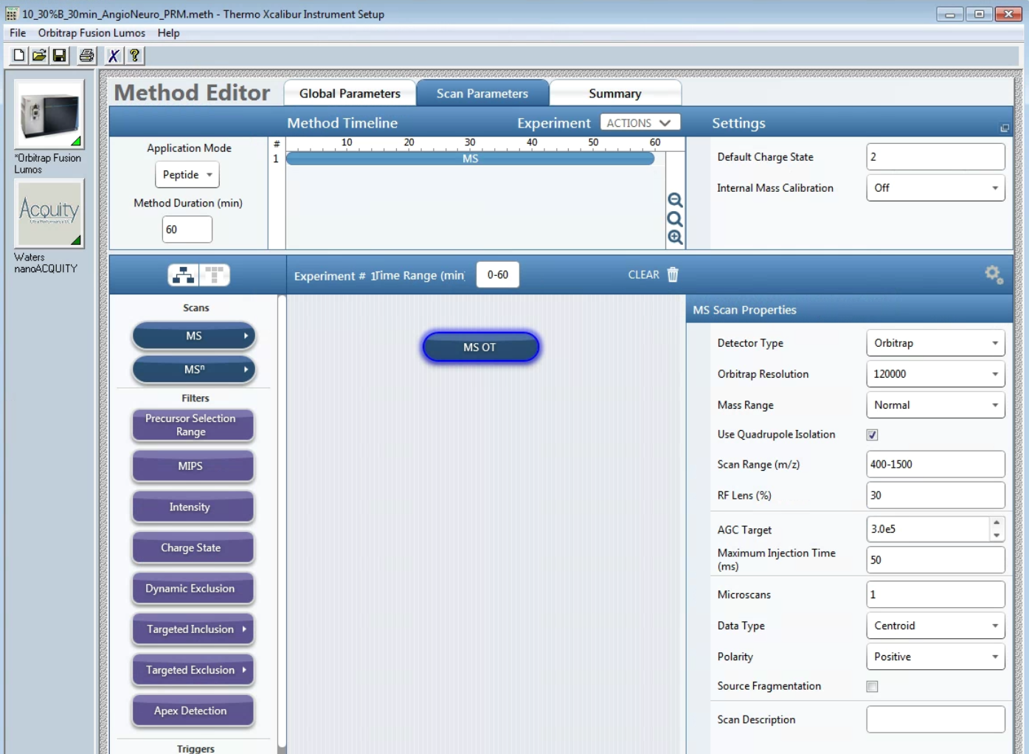

Now add a second experiment and drag or double click the MS^{n} module over. It will show up as “tMS² OT CID”
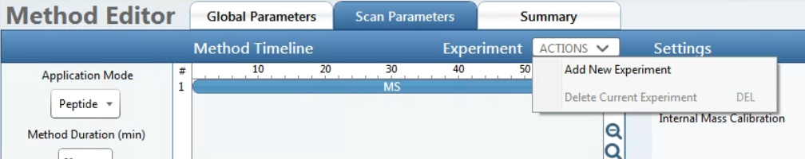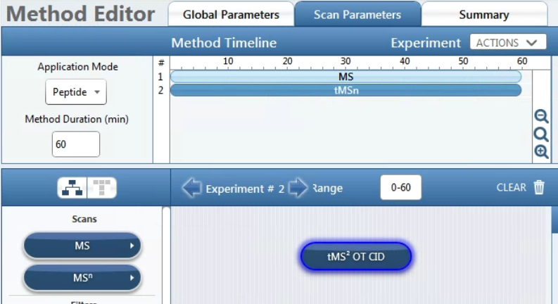

Change all the MSn scan properties and update the inclusion list. This is a screen shot of a common PRM method we use.
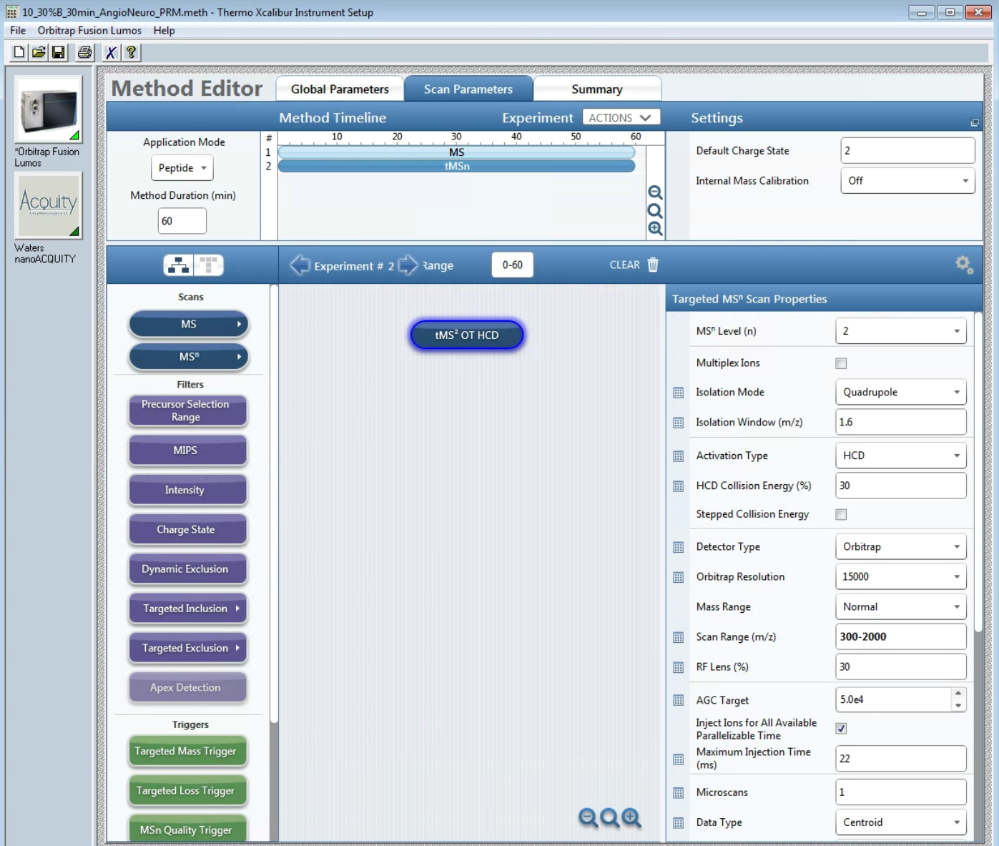
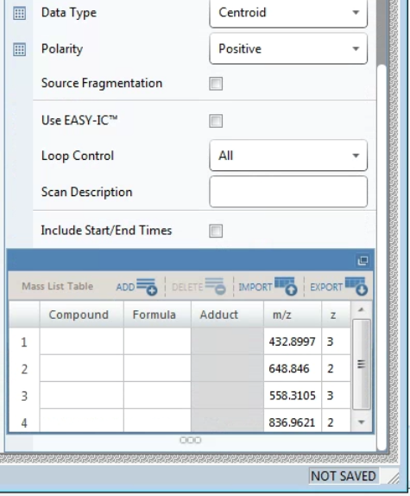

Multiplex Ions: Ion multiplexing performs sequential isolation of multiple ions for simultaneous analysis.
In tMS2 multiplexing, the MS uses the quadrupole to sequentially isolate each targeted ion and fragments them as they enter the IRM. The MS creates the first group of fragment ions in the IRM where they remain as it creates the next group, simultaneously storing them in the IRM. When the IRM contains the fragments from the defined number of multiplexed ions, the MS transports them into the ion trap or the Orbitrap for simultaneous mass analysis.
Note: For tMS2, the AGC target value is the total number of ions for all precursors combined. Each precursor injects for an equal amount of time.
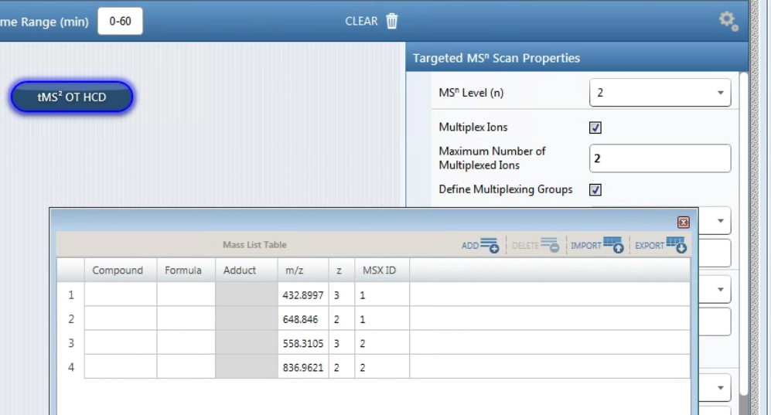

Isolation Mode (Quadrupole or Ion Trap): Although ion trap isolation is more sensitive, quadrupole isolation is faster and is done in parallel with analysis, giving the highest instrument duty cycle.

Isolation Window (m/z): On the Fusion/Lumos the isolation window is centered around the precursor mass and ranges one-half of the isolation window to either side of the precursor mass (on the Fusion/Lumos the isolation offset is 0, note the QE allows to set an offset). A value that is too low results in loss of sensitivity because not all of the ions in a mass peak and/or the neighboring isotopic peaks are isolated. A value that is too high may cause interference from neighboring peaks from different peptide species.
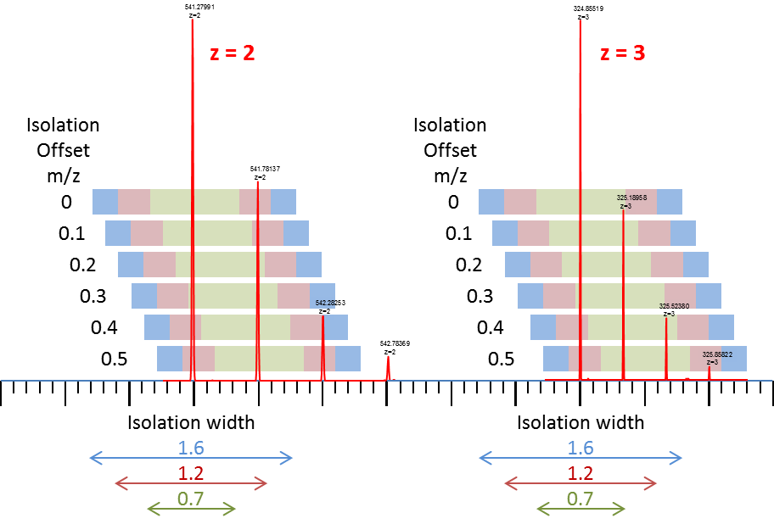

Activation Type: Select how the precursor ion is activated for fragmentation (that is, CID, HCD, or ETD [for instruments with the ETD option]).
Use HCD to obtain fragment ion spectra similar to the triple-quadrupole fragmentation process. Specify the normalized accelerating voltage (as a percentage) that the MS uses to accelerate ions into the IRM, where fragmentation occurs (default: 30).
For CID activation type specify the percentage of RF amplitude to fragment the ions (default: 35).

Stepped Collision Energy (available with quad isolation with HCD): With stepped collision energy, the MS injects isolated precursor ions into the IRM in three steps, each with a different HCD collision energy. The MS then mass analyzes all three groups of ions in a single scan. Stepped collision energy increases the probability that at least some of the precursor ions experience the optimum collision energy for fragmentation. For example, if the collision energy is 35% and the step is 5%, the injections are 30, 35, and 40%.

Detector Type: Select the type of mass analysis that the MS uses for the current scan from these options:
- Ion Trap: When you need high sensitivity.
- Orbitrap: When you need high resolution and mass accuracy

RF Lens (%): 60 for the Fusion, 30 for the Lumos

AGC Target: Specify the automatic gain control target value for mass analysis. Increase the AGC target to increase sensitivity, but a value that is too high might affect mass accuracy. Decrease the AGC target to speed up fill times, but too low a value will affect sensitivity.

Inject Ions for All Available Parallelizable Time: Select to allow the AGC target to be exceeded if there is available parallelizable time.

Maximum Injection Time (ms): Specify the maximum injection time (in milliseconds) for AGC.
The IRM fills with ions until it reaches the AGC target and then the MS transfers the ions to the ion trap or Orbitrap.
For maximum speed the max injection time should not exceed the scan time of the previous scan (parallelization).
OT resolution | “free” fill time
15000 | 22
30000 | 54
50000 | 86
60000 | 118
120000 | 246
240000 | 502
500000 | 1014

Loop Control: allows you to specify the number of scans or the amount of time for each scan cycle (loop) before the MS performs the next experiment (full scan in our case), prescan, or both.
This feature is useful for a long mass list. It ensures that the AGC prescans run at regular intervals (once per experiment) for accurate injection times. Each scan cycle consists of one prescan followed by either N targeted scans or as many scans that can run during the specified cycle time. The scan cycle repeats through the mass list from where it last left off. With this feature, you can add another experiment (for example, a full scan) without needing to split up the targeted list.
The options are as follows:
- N: Run each cycle on the next N targeted scans. (Specify the number of spectra for each scan loop.)
- Time: Run each cycle for the specified time. (Specify the cycle time (in seconds) for each scan loop.)
- All: Run each cycle on the full list of spectra.
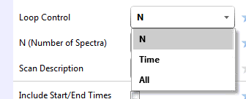
In our example we have 30 m/z values in our list and want to do one full scan followed by 30 PRM scans. We selected Loop Control of N and set the number of Spectra to 30. (alternatively we could have selected “All”).

If you scroll down you’ll see the inclusion list, if you click in the upper right corner of the list it will maximize the window as you see in the next screen shot:
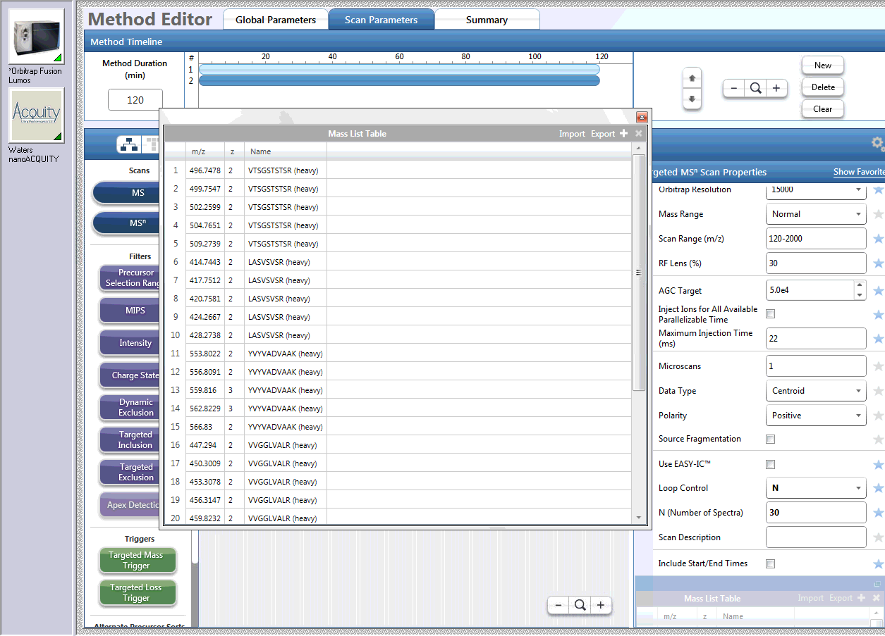
Click here to maximize the Mass List

Mass List Table:
You can enter all the values manually or you can export a template to csv and copy/paste your list.
To export a template, enter a couple of values (I usually enter the m/z and z in the first row only).
Then click on “Export” and give it a path and file name to save the template as a csv file.
Open that file in Excel and edit as needed save and close it. Note you need to close the csv file in order to import into the method editor.
You’ll need to enter monoisotopic masses for the peptides of interest and the charge state and polarity.

Note you can add additional settings to the table, to customize the PRM scan for each individual precursor. Simply click on the little square next to the scan parameter you want to add:
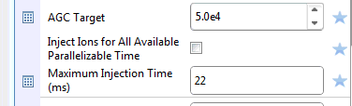

The most common ones we use are the AGC target and the ion time. In order to increase the sensitivity, increase the AGC target and/or max ion time for very low abundant peptides.
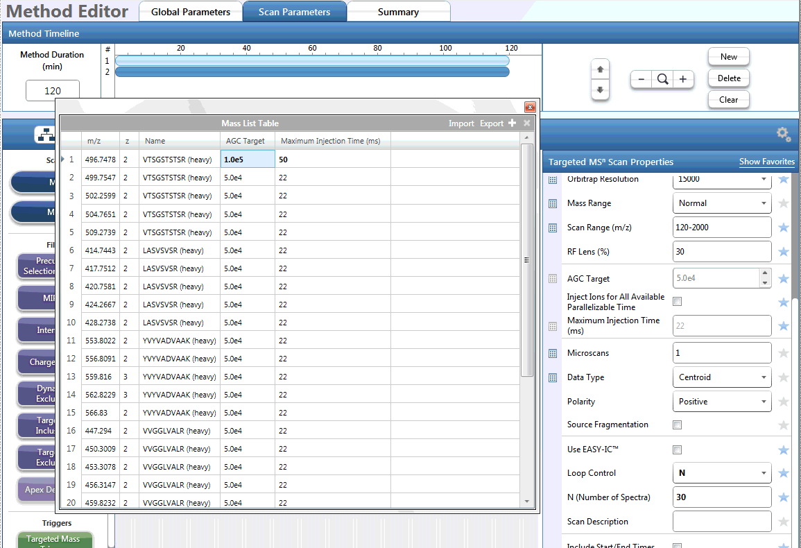

If you want to schedule the monitoring you can include start / end time as well, otherwise the targets will be monitored the entire time of the acquisition.

How many peptides can be monitored?
Max scan speed with 15000 resolution is 20 Hz (according to Thermo), so you can monitor up to 20 peptides per second. If the chromatographic peak width is 30 seconds and you want to monitor a peptide about 10 times across the chromatographic elution, your total cycle time should be about 3 seconds (30/10). So 20 Hz * 3 seconds = 60 peptides at any given time. Typically, we get about a scan speed of 18.5 on our Fusion/Lumos.
Cycle time  [sec] |  | Scan speed (15k res.)  [Hz] |  | # of precursors |  | Points across 30 sec peak
1 | * | 20 | = | 20 | = | 30
2 | * | 20 | = | 40 | = | 15
3 | * | 20 | = | 60 | = | 10
4 | * | 20 | = | 80 | = | 7.5
5 | * | 20 | = | 100 | = | 6
6 | * | 20 | = | 120 | = | 5
7 | * | 20 | = | 140 | = | 4
8 | * | 20 | = | 160 | = | 3.5
9 | * | 20 | = | 180 | = | 3
10 | * | 20 | = | 200 | = | 3

To monitor more peptides you need to schedule them using the start and end times in the inclusion list.

The table below contains approximate scan rate for the different resolution settings:
 | Fusion/Lumos |  |  |  | QExactivePlus
Resolution at m/z 200 | "Free" injection time [ms] | Approx. scan speed [Hz] | Transient length [ms] | Resolution at m/z 200 | "Free" injection time [ms] | Approx. scan speed [Hz]
15 000 | 22 | 18/20 | 32
30 000 | 54 | 15 | 64 | 17 500 | 50 | 13
50 000 | 86
60 000 | 118 | 7.5 | 128 | 35 000 | 110 | 7
120 000 | 246 | 4 | 256 | 70 000 | 240 | 3
240 000 | 502 | 2 | 512 | 140 000 | 500 | 1.5
 |  |  | 1064 | 280 000 | 1000 | <1
>450 000 | 1014 | <1 | 1024

You can check the scan speed for your particular method, just open the raw file in qual browser and zoom in, if you acquired a full scan just look at the time difference between full scans and calculate the scan speed base on the number of scans you had setup to run (full scan plus number of PRM/DIA scans):
In first example from our QEplus it’s about 12.8 Hz (our inclusion list has 30 precursor masses plus one full scan).
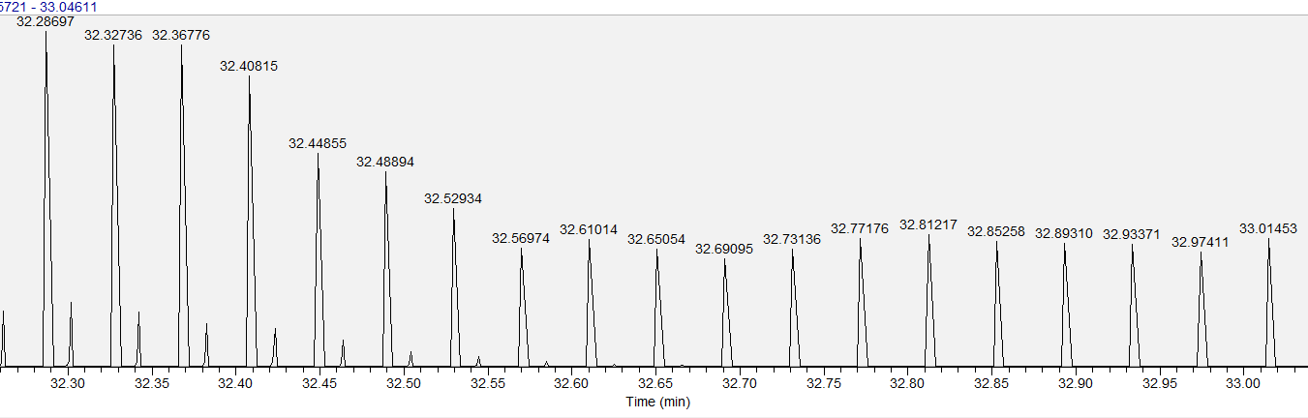

In the example from our Fusion (SW v 1.2) it’s about 18.57 Hz (our inclusion list has 30 precursor masses plus one full scan).
MS1: OT 120k resolution, AGC 2e5, IT 20 ms
PRM: OT 15k resolution, AGC 5e3, IT 20 ms, HCD NCE 25
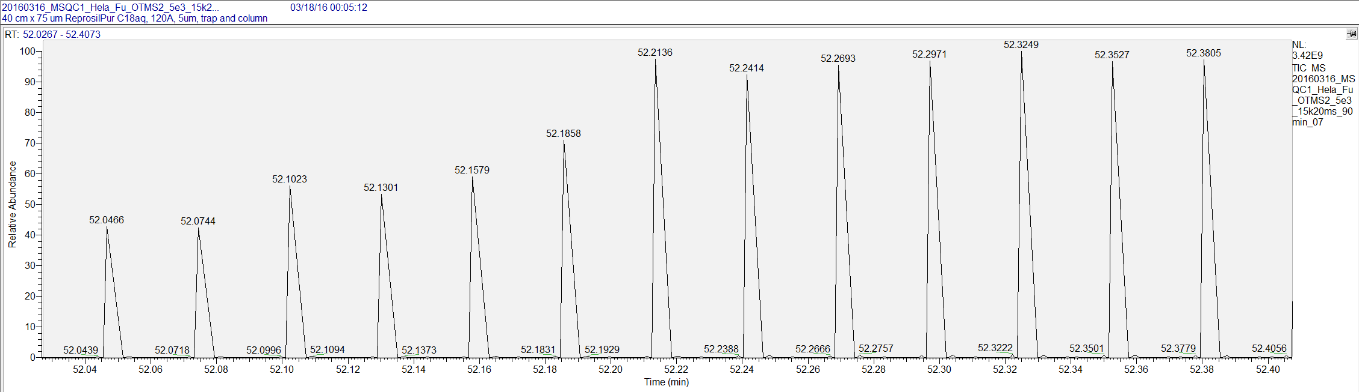
We tried a few different settings on our Fusion (SW1.2):
PRM OT 15k resolution, AGC 5e3, IT 20 ms, HCD NCE 25: 18.57 Hz
PRM OT 15k resolution, AGC 1e4, IT 20 ms, HCD NCE 25: 18.41 Hz.
PRM OT 30k resolution, AGC 1e4, IT 50 ms, HCD NCE 25: 11.63 Hz
PRM IT (ion trap) with rapid scan rate 18.41 Hz

Scan Speed on our Fusion Lumos (SW1.2)
PRM OT 15k resolution, AGC 5e3, IT 20 ms, HCD NCE 25: 18.24 Hz
PRM OT 15k resolution, AGC 1e4, IT 20 ms, HCD NCE 25: 18.36 Hz
PRM OT 15k resolution, AGC 5e4, IT 20 ms, HCD NCE 25: 18.27 Hz
PRM OT 30k resolution, AGC 5e3, IT 50 ms, HCD NCE 25: 11.64 Hz
PRM IT (ion trap) with rapid scan rate 18.14 Hz

