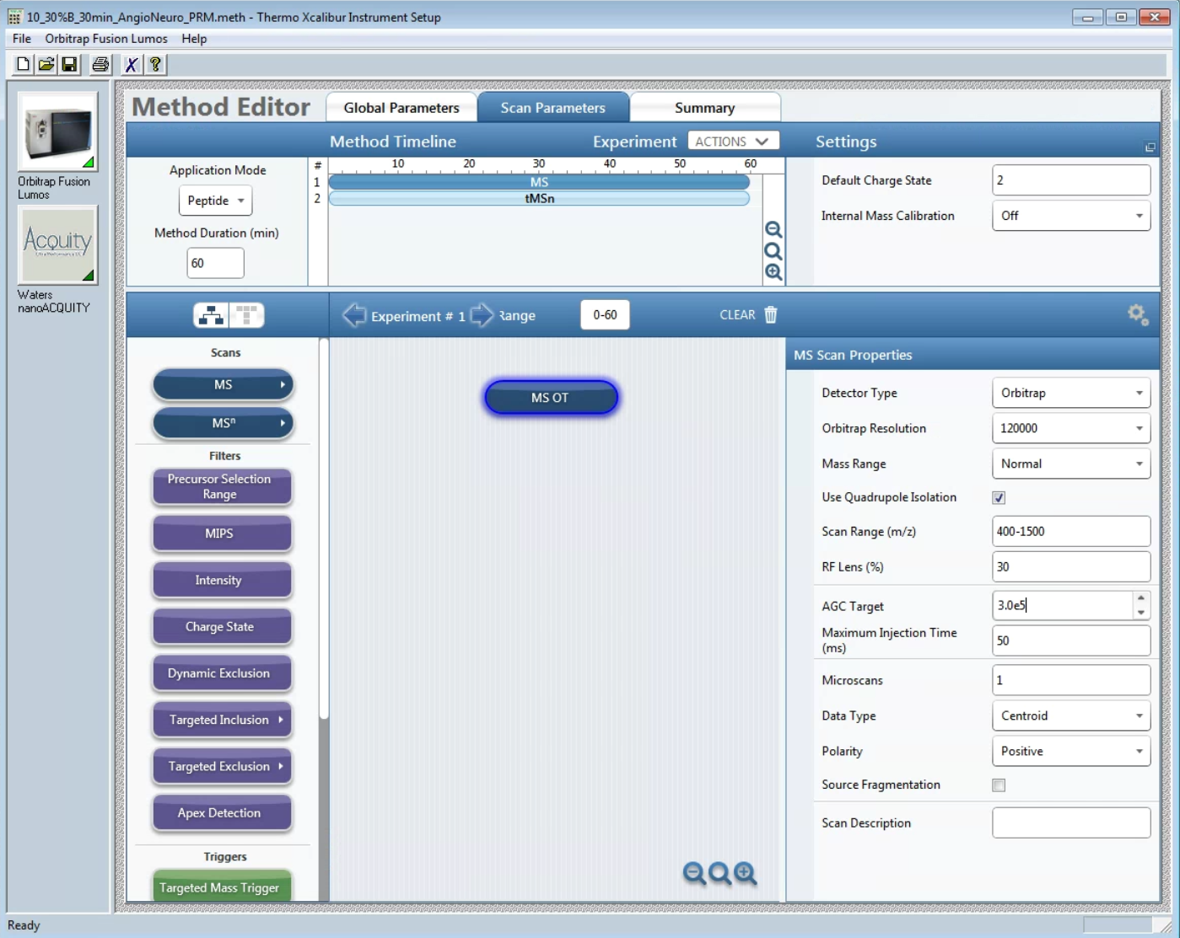
Full scan is optional, but you can integrate the peak of the full scan in skyline and get additional quantitative information.
Make sure the full scan range covers the m/z range of the PRM precursors you are monitoring

