QEplus – nanoAcquity Contact closure failure

Instruments: QE plus with nanoAcquity
Symptom: After a few days/weeks the contact closure would be on and start the acquisition immediately after starting a run.
Workaround: we changed the contact closure out on the nanoAcquity from the back of the autosampler to the back of the binary pump (BSM), and then set the contact closure signal out in the method. This worked flawlessly for years.

Move the contact closure wire:
Move the green contact closure plug from the back of the AS to the back of the BSM and connect the wires to port 8 and 9 from the top, labeled Switch 1 Out:
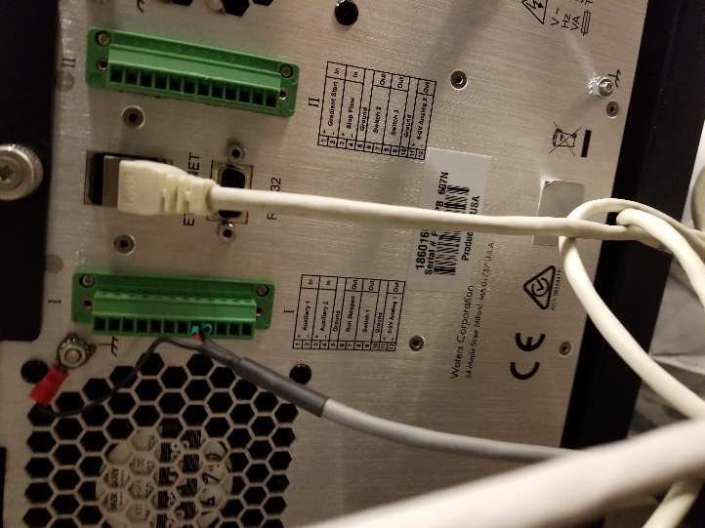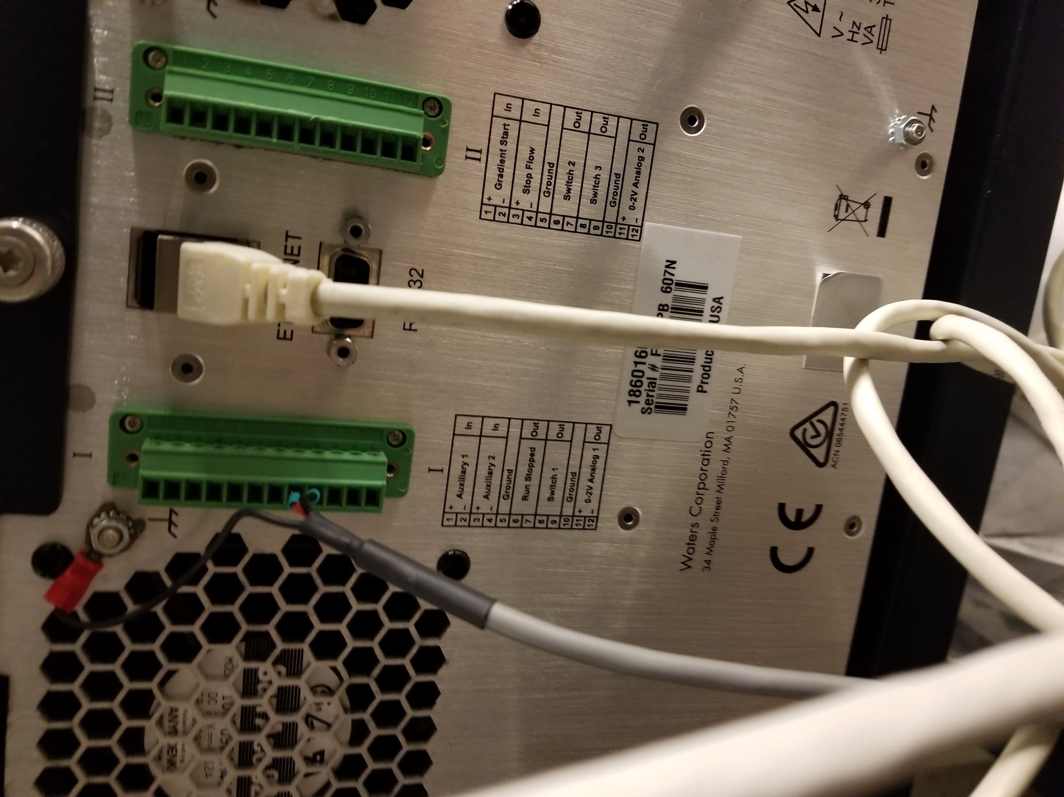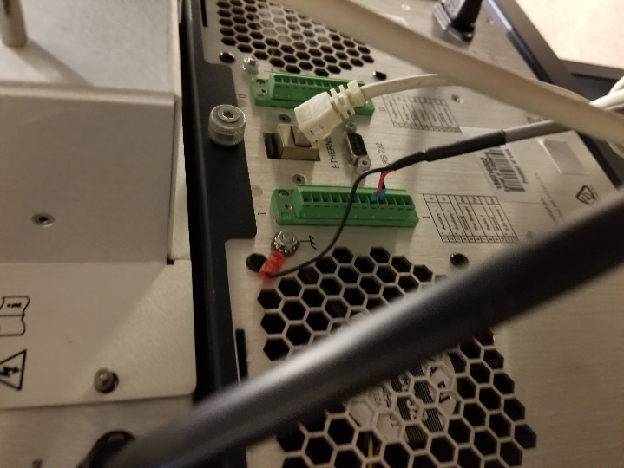

Then make sure to set the contact closure in the method, see next page:

Setup Contact Closure in your method:
Open your method, select Waters nanoAcquity/ACQ-nBSM/Events

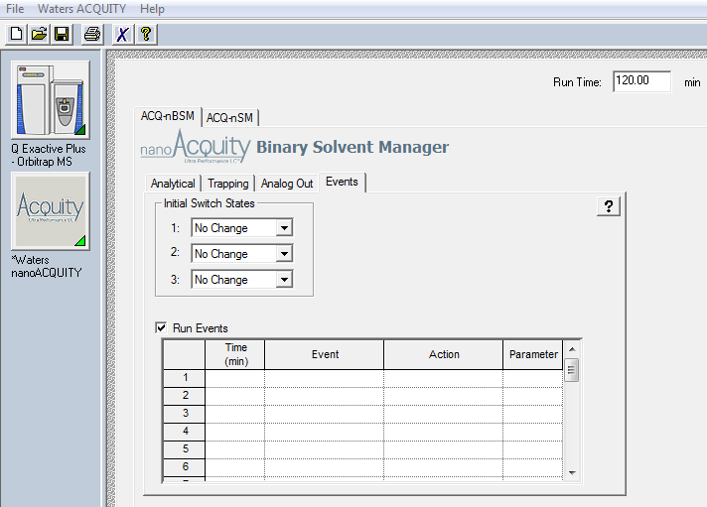

- Change initial Switch status 1: to Off
Note this is for Switch 1 Out, if you look at the photos above you’ll see a Switch 2 and Switch 3 out on the second plug II
- Check Run Events (it should be checked by default)
- Then configure the table as follows:
- Add time 0.01 Switch 1 Off
- Add time 0.05 Switch 1 On
- Add time 0.1 Switch 1 Off
- Save the method

It should look like this:
