Important:
Setup Contact Closure in your method:
Open your method, select Waters nanoAcquity/ACQ-nBSM/Events
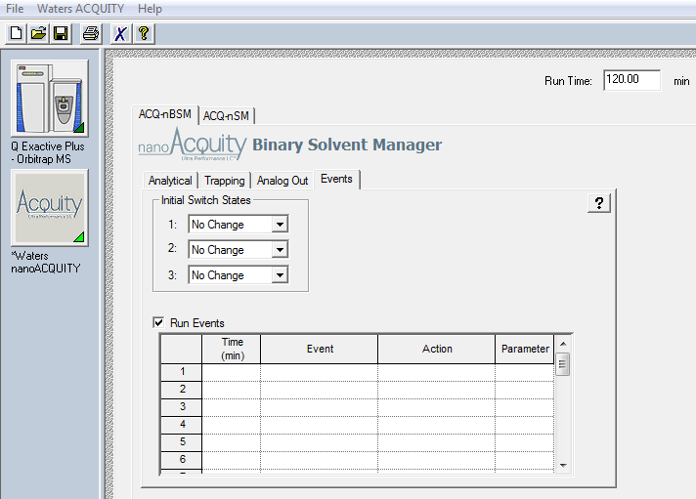
- Change initial Switch status 1: to Off
- Check Run Events (it should be checked by default)
- Add time 0.01 Switch 1 Off
- Add time 0.05 Switch 1 On
- Add time 0.1 Switch 1 Off
- Save the method
