Win10 LTSB 2016 upgrade on Thermo TNG systems

If you read this you probably know that Win 7 support ends January 2020 and that you need to upgrade your instruments PC to Win10 LTSB 2016

The easiest way to upgrade is most likely to have Thermo help you upgrade and/or buy a new PC from Thermo and have them install it for you.
Of course, this comes at a price, so you may have to try doing it yourself or you just disconnect the PC from the web. Several folks have asked me about this so I decided to prepare this document to help you make a decision how to deal with this.

Note about nanoAcquity: As of today, 11/20/2019 there is no software available from Thermo that will work with the nanoAcquity on Win10. Their latest version of Xcalibur 4.3 and LC-devices 3.2 SP1 (which claims to support nanoAcquity) does not work. The nanoAcquity will disconnect every 1-2 days and you will see a “server failed” error in the Xcalibur status page. Same for the Waters M-class. Thermo has known about this for over a year now.. I’ll update this if they come up with a fix.

In this document I use screen shots from our Altis which is connected to an EASYnLC. The Lumos and Fusion will install very similarly.

Table of Contents
Win10 LTSB 2016 upgrade on Thermo TNG systems 1
Install Win10 LTSB 2016 2
Windows 10 settings 3
Windows update settings 3
Group Policy Editor 3
Turn off automatic restart: 4
Defer Windows Updates 5
Desktop Wallpaper 5
Microsoft products update settings 5
Power settings 6
Configure the Ethernet card for the instrument 7
Windows Firewall settings 8
Turn on windows features 9
System Image 9
Install Thermo instrument software 10
Xcalibur and Foundation 10
LC Devices 10
Instrument software 10

Install Win10 LTSB 2016
If you have a spare PC or can afford a new PC and extra Ethernet card that is a great way to go, you can load everything and keep your orginal PC in case you run into problems and need to recover. (You should get the min requirements from Thermo, but something like the Optiplex XE3, i7 8th gen, 16 GB or more, 1TB hard drive, with a second 1 TB hard drive).
If not I would strongly recommend making a system image backup onto the D drive. I always backup and delete all the raw files and other unnecessary files before I start and before making the image backup.

- Before you begin make a backup copy of the calibration file, then run all the calibration checks and calibrate the ones that fail.
The cali file is located here: C:\Thermo\Instruments\TNG\TSQAltis\3.1\System\MSI\TNGCalFile.xmb
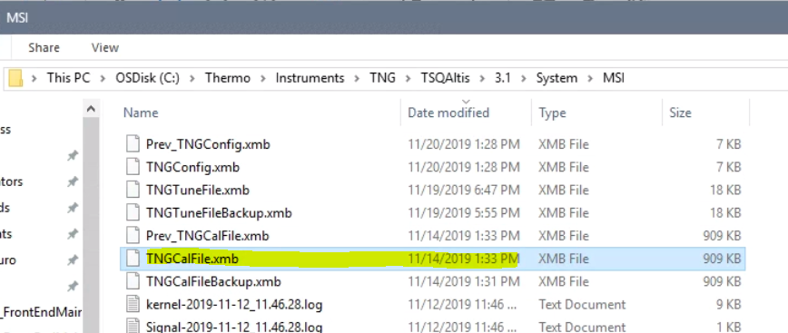
- Backup/copy all the data and files and delete them from the C drive.
- Create an image backup to the D drive.
- Backup/copy the calibration files.. I usually copy the whole “System” folder to the D drive and to our server...
C:\Thermo\Instruments\TNG\TSQAltis\3.1\System
This folder can be large so alternatively you can just copy the MSI folder, which contains the cali file
C:\Thermo\Instruments\TNG\TSQAltis\3.1\System\MSI
Note the Fusion and Lumos are the same, just says Fusion or Lumos instead of Altis
- Open instrument configuration and remove all configured instruments
- Install Win10 LTSB2016
- during the install it’ll ask you to “get going fast” select “customize” and turn off all options
- then when asked how to connect, create a local account.
- Install Sophos (UW uses Sophos for virus protection)
- Install Office
- Install Adobe reader
- Install WinSCP and Putty (if you use those)
- Do all the updates

Windows 10 settings

Windows update settings
To prevent win10 from doing automatic updates and rebooting etc we have to edit the Local Group Policy Editor.
Here is a link to a site describing this:
https://www.tenforums.com/tutorials/8013-enable-disable-windows-update-automatic-updates-windows-10-a.html

Group Policy Editor
Click on the magnifying glass next to the windows icon on the bottom left side of the task bar and search for “group policy” and it will come up with Edit group policy
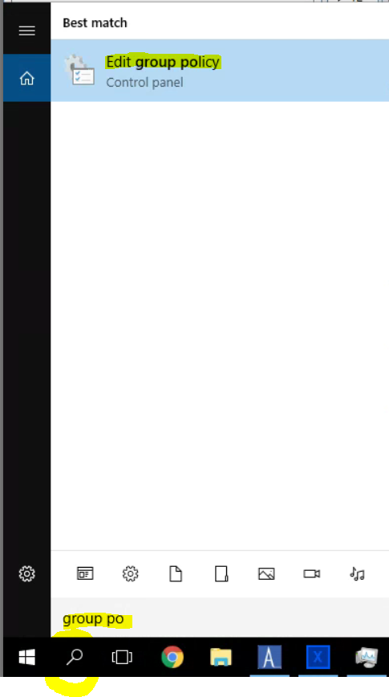
Click on it to open the Local Group Policy Editor. In the left pane expand:
Computer Configuration/Administrative Templates/Windows Components/

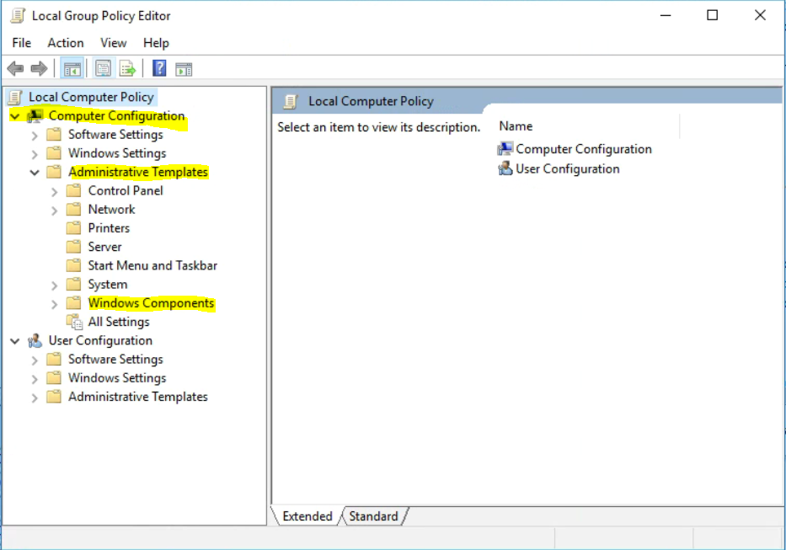

Scroll to the bottom and select Windows Updates
In the right pane select “Configure Automatic Update” and then “Edit Policy setting”
Set the automatic updating to 3-Auto download and notify for install
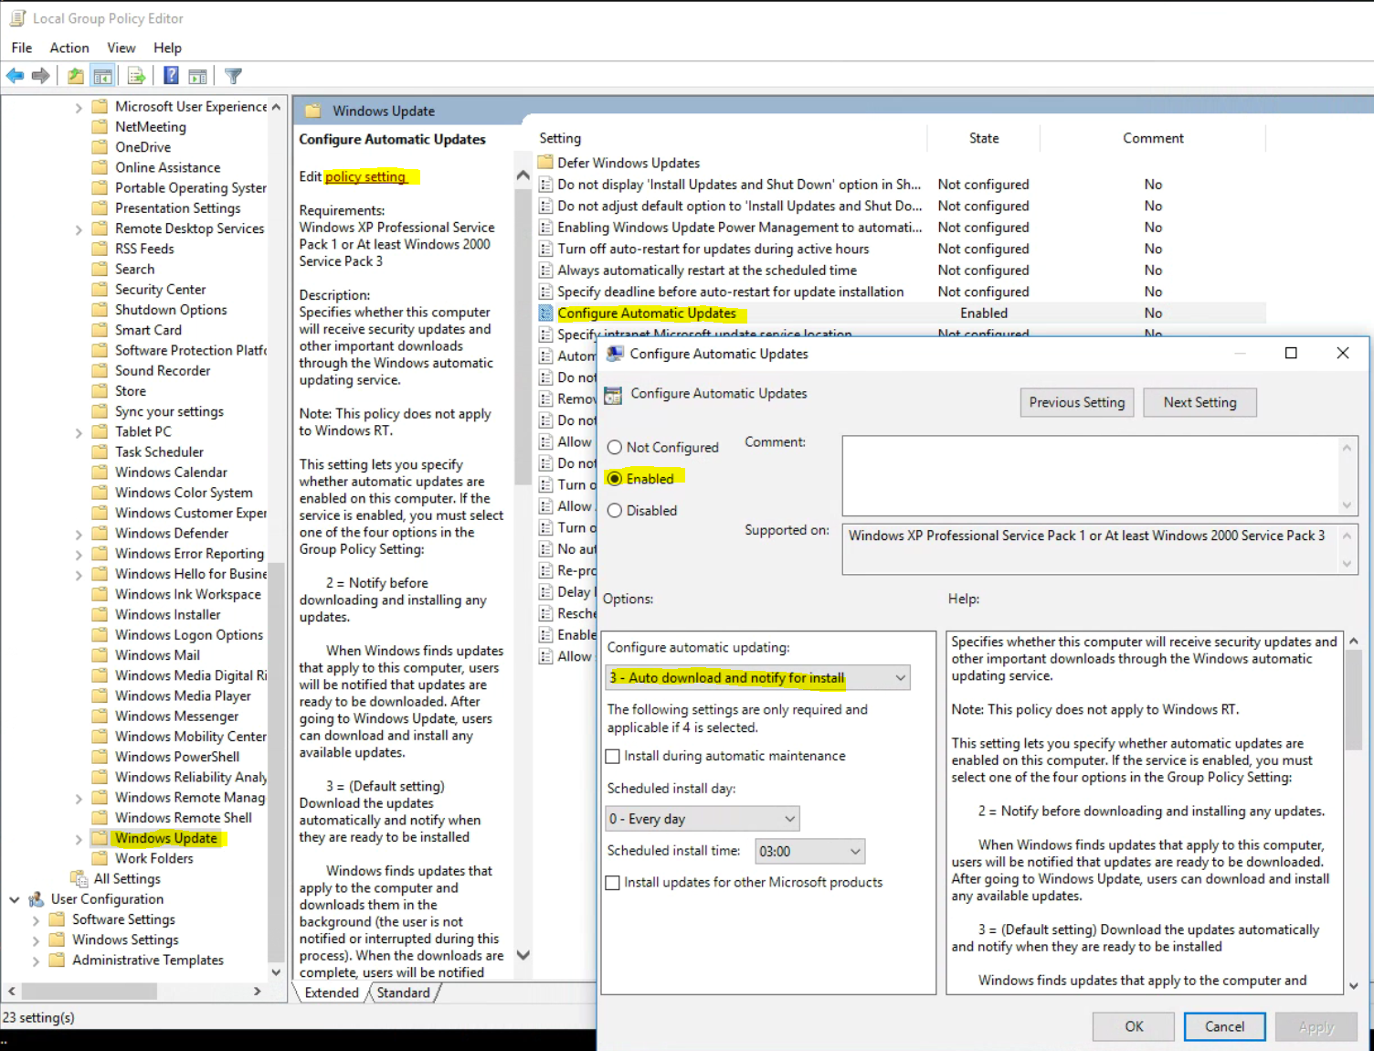

Turn off automatic restart:
Click on “No auto-restart with logged on users for scheduled automatic updates” and select “Edit policy setting”:
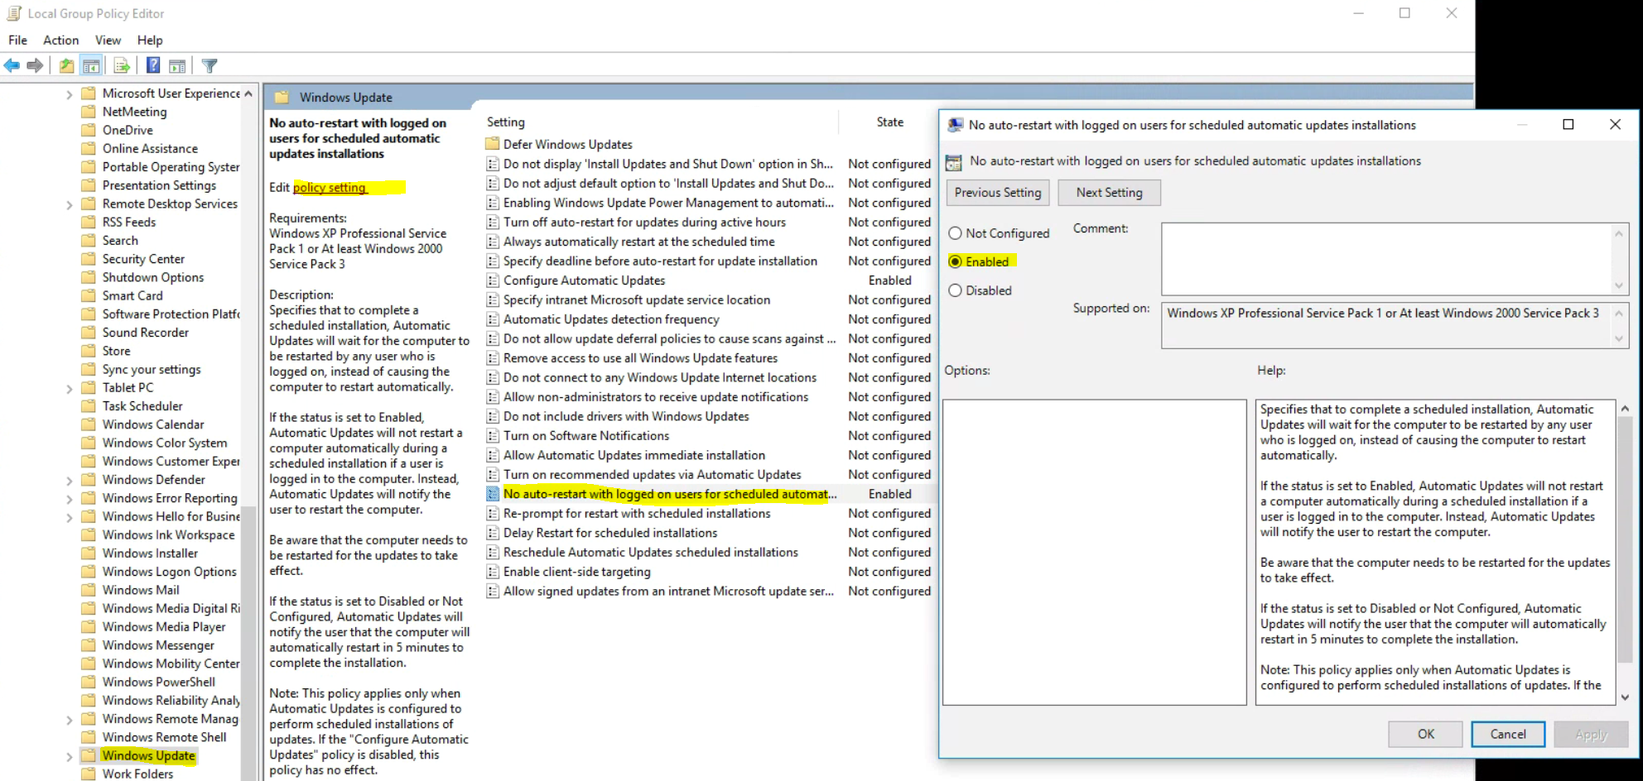

Defer Windows Updates
Select when feature Updates are received, select “Current Branch for Business”
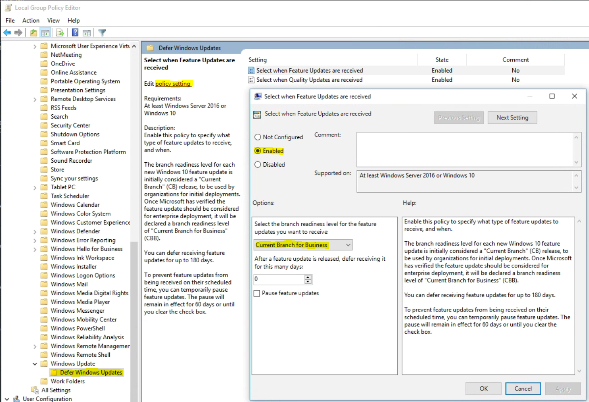

Desktop Wallpaper
If your desktop wallpaper is locked i.e. if you can’t change it, it may be set in group policy as well, disable it to be able to choose your own wallpaper.
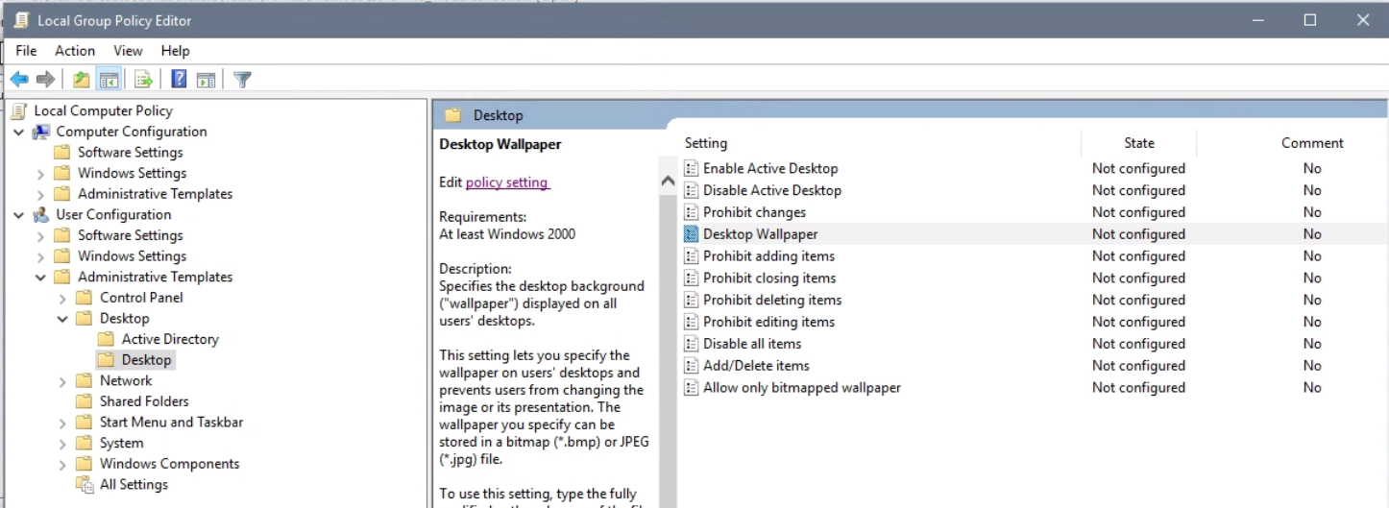

Microsoft products update settings
To get Microsoft products updates set the that option on under
Settings/Update & Security/Advanced options:
check “Give me updates for other Microsoft products when I update Windows”
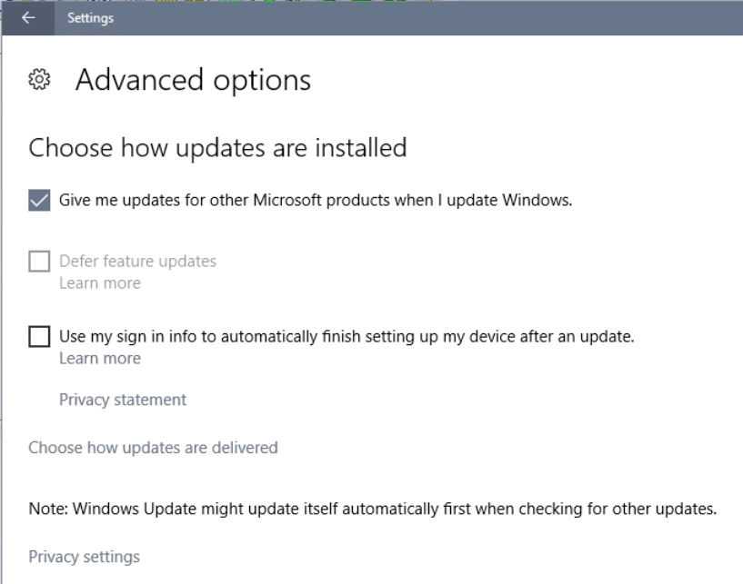

Power settings
To keep the PC from turning off the hard drive I set the following power settings
Go to Control Panel/Power Options
The “High performance” plan may be hidden, if so click on show additional plans, and select “High Performance” and then “Change plan settings”
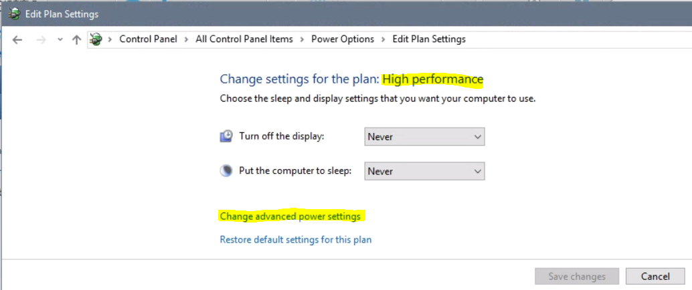
Got to “Change advanced power settings” and set the following:

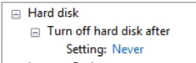
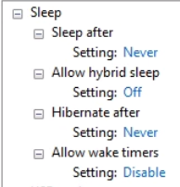
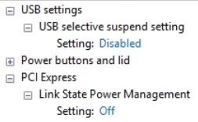

Configure the Ethernet card for the instrument
If this is a new PC and you need to install a card, power the PC off, unplug it, open up the side panel and install the card. Reconnect and power up the PC. It will likely find the card and install the drivers. If not you should have gotten a driver CD with it or you can find it online from the manufacturer. Save the driver onto your desktop, then go to Control Panel/Device Manager and under Network adapters find your new card, right mouse click and select Update Driver Sofware. Then Browse my computer and navigate to the folder where you saved the drive and hit ok.
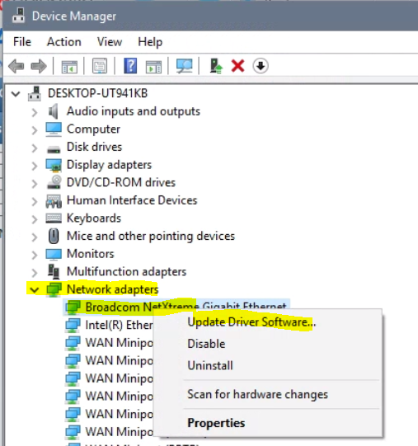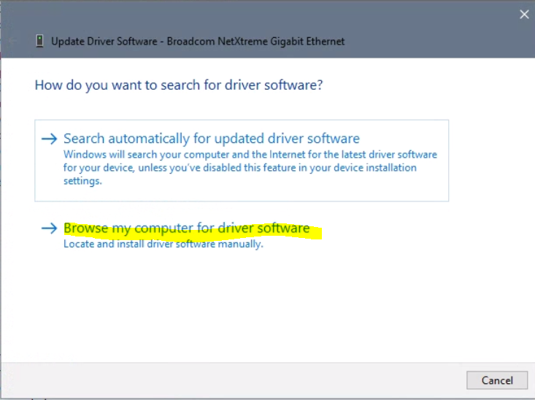

Go to “Control Panel\Network and Sharing Center” and on the left side of the window select “Change adapter settings”. In a new window you should see two cards (maybe three, e.g. we have a third one for the nanoAcquity). If you don’t know which one is the instrument card just unplug the mass spec Ethernet cable from the back of the PC and it will show as disconnected, rename it to instrument and plug it back in.
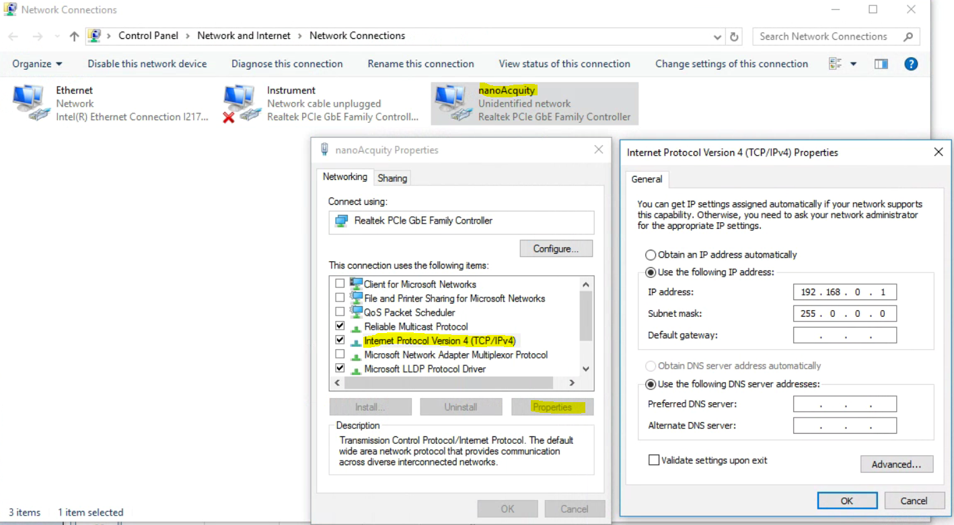

Do a right mouse click on the instrument card and select “Properties”
Now select Internet Protocol Version 4 (TCP/IPv4) and click on “Properties”
Click on “use the following IP address:”
Specify the IP address: 172.16.0.101
and Subnet mask: 255.255.0.0
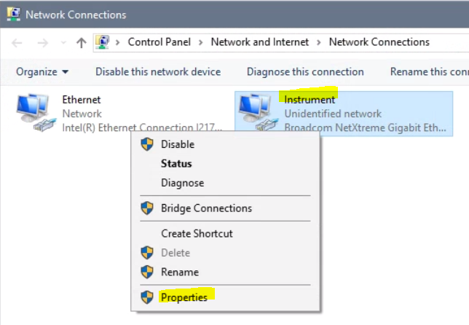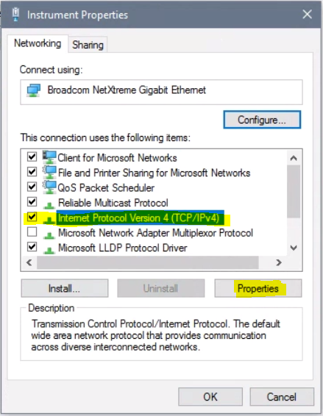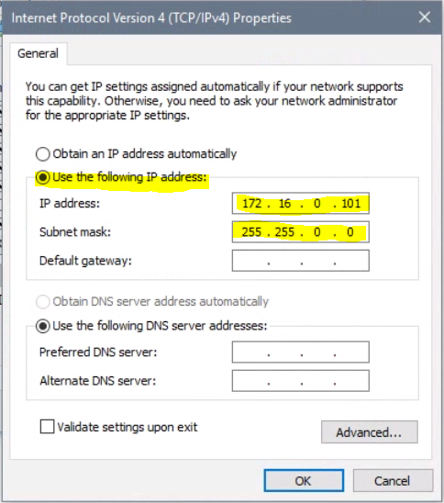

Now set the Power management as shown in the screen shot below:
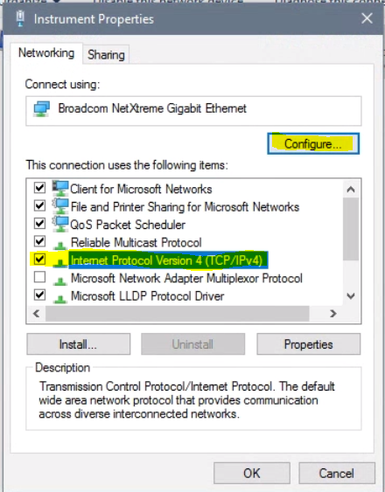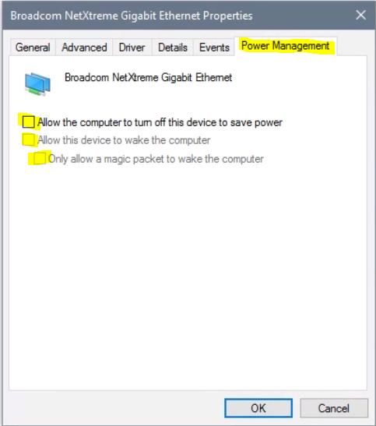

nanoAcquity Ethernet card settings:
Click on “use the following IP address:”
Specify the IP address: 192.168.0.1
and Subnet mask: 255.0.0.0


Windows Firewall settings
Go to Control panel/Windows Firewall and select “Advanced settings”
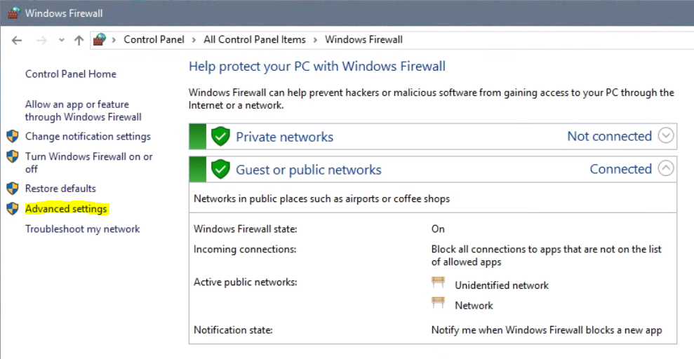

Select “Windows Firewall Properties” and then next to Protected network connections: select “Customize” and uncheck the instrument and the nanoAcquity if present, but leave Ethernet checked.
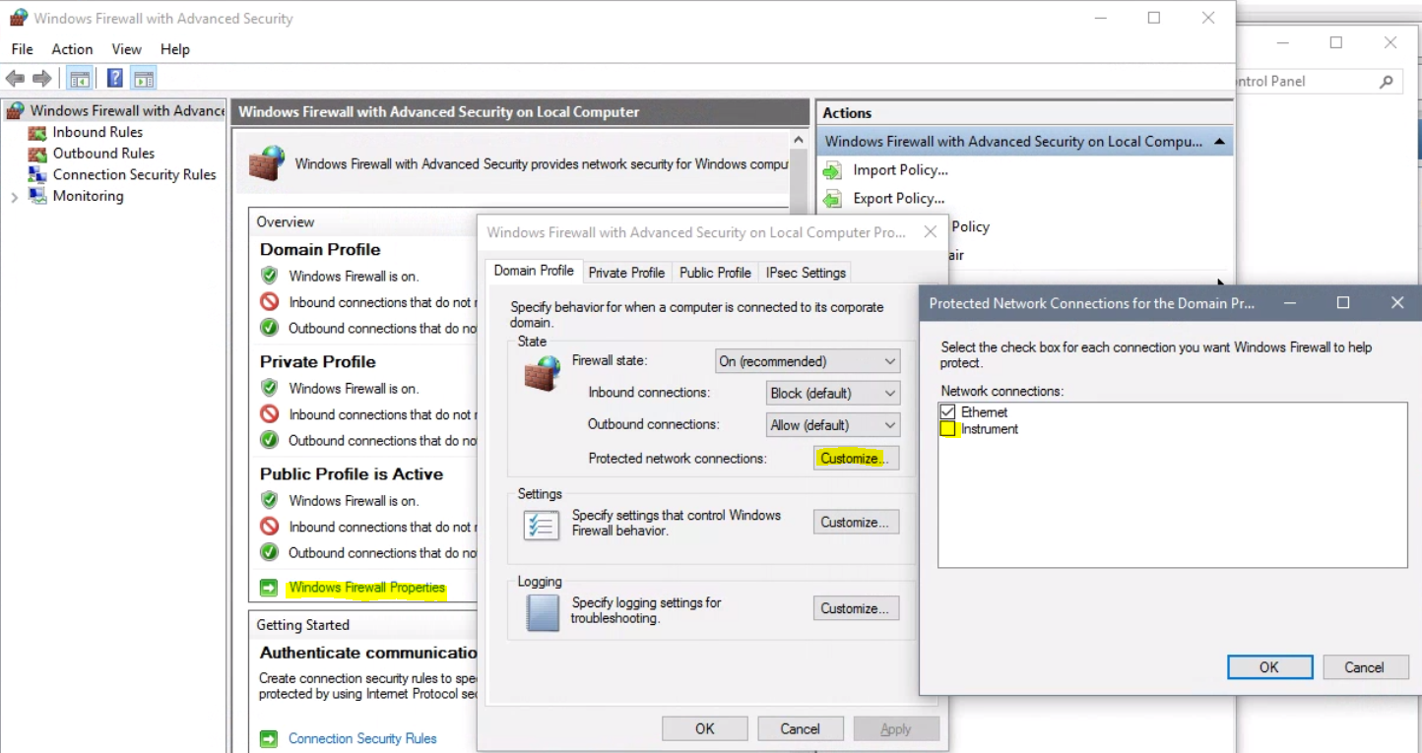

Turn on windows features
Search for windows features or go to Control Panel/Programs and Featurs and select “Turn Windows features on or off”
Select: .NET Framework 3.5 ((includes .Net 2.0 and 3.0) and hit ok, it will download the necessary files
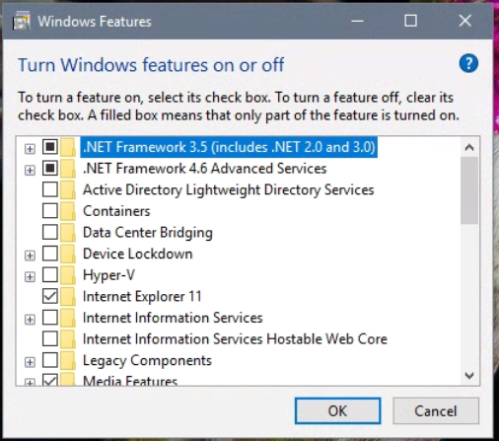

And then under .NET Framework 4.6 Advanced Services
Select ASP .NET4.6 and Message Queuing (MSMQ) Activation
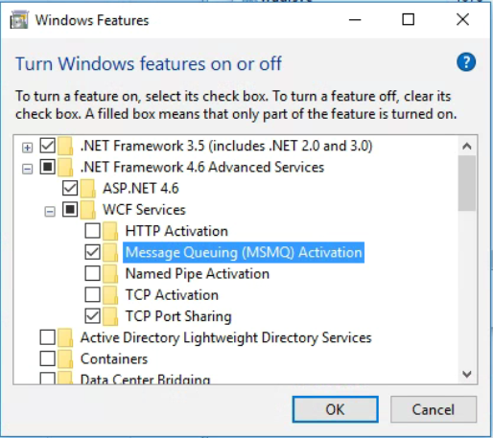

System Image
Now is a really good time for a system image backup

Install Thermo instrument software
You should have all the software, but if not you should be able to register and download it from this site:
https://thermo.flexnetoperations.com/control/thmo/login

Xcalibur and Foundation
If you downloaded the .zip file, extract all
Then go to the release notes
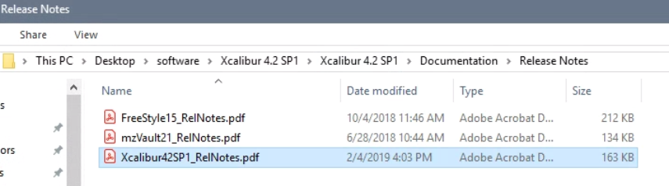
In there you’ll find min system requirements and some instructions how to install the SW.
Install Xcalibur first by double clicking on the “ThermoLauncher.exe”.
If you haven’t installed Adobe reader yet, you can do that now.
Then select Xcalibur, will automatically install Foundation if it is not present and then Xcalibur. It will also install Freestyle.
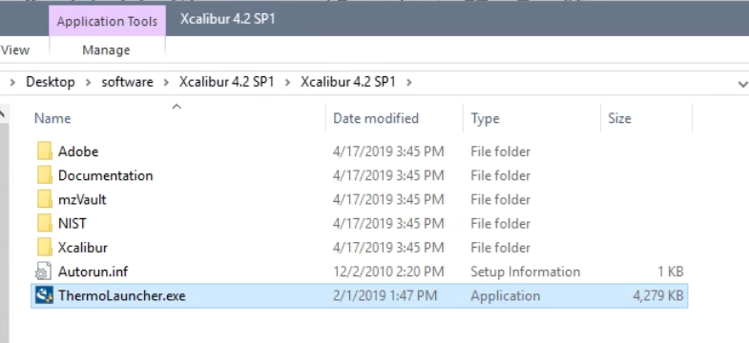
Note it will prompt for a reboot and continue the install after the reboot.
After it’s installed I usually reboot one more time.

LC Devices
Same for the LC-Devices, download the latest version, extract all and read the readme file:
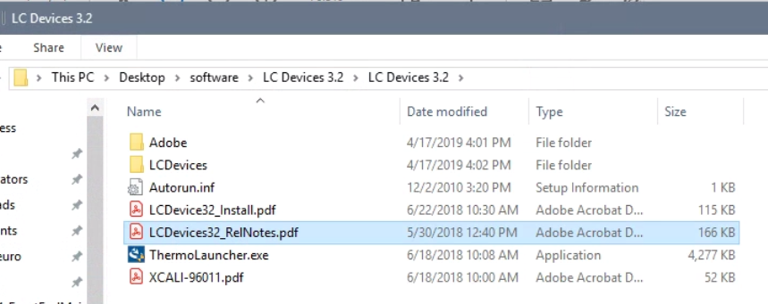

Install LC Devices by double clicking on the “ThermoLauncher.exe”
During the install, select the instrument you want to install, e.g. EASYnLC or Waters nanoAcquity
Do a reboot.

Instrument software
Download the latest version, extract all and read the readme file.
You may find that the system folder is still present even after the Win10 upgrade:
C:\Thermo\Instruments\TNG\TSQAltis\3.1\System
You can try installing the software, but it may give you an error that the System folder from an older version is present.
If so move it to a different location or rename it. And try again.
Now install the instrument software by double clicking the installer:
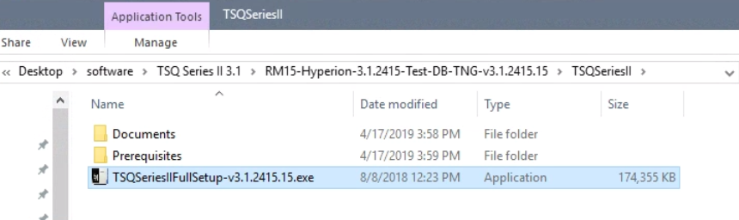

During the install make sure you select the correct options for your instrument (e.g. FAIMS, ETD and Internal calibrant etc).
Now copy the the original TNGCalFile.xmb into the folder and replace the existing one: C:\Thermo\Instruments\TNG\TSQAltis\3.1\System\MSI\TNGCalFile.xmb
And the TNGConfig.xmb into the folder and replace the existing one: C:\Thermo\Instruments\TNG\TSQAltis\3.1\System\MSI\TNGConfig.xmb

Now open instrument configuration and add the instrument and LC system and hit done.
Reboot the PC and reset electronics on the instrument if necessary.
If you upgraded to a newer version software for the Fusion/Lumos run the upgrade procedure as described in the release notes and installation instructions. Note last time I did it, I found the syringe pump turned off during the “Upgrade with Calmix” procedure and it failed part of the upgrade, so I restarted the syringe pump and ran it again. It would now skip the part that already passed and run the remaining procedures.

For the install of the EASYnLC virtual display see https://proteomicsresource.washington.edu/instruments/EASYnLC.php

