Win10 LTSC configuration on Thermo system PC’s

The easiest way to upgrade is most likely to have Thermo help you upgrade and/or buy a new PC from Thermo and have them install it for you.
Here are some settings we had to change to make the PC compatible with our lab.

In this document, I use screen shots preparing our Dell Optiplex XE4 for our Astral.

Table of Contents
Win10 LTSC configuration on Thermo system PC’s 1
Lock screen settings 2
Change automatic lock screen when inactive 3
Windows Defender preventing software installation 4
View all configured group policy items 5

Lock screen settings
On our PC we were not able to customize the lock screen, in order to make this available go to the “group policy editor” (i.e. search for group policy editor in the search bar) and allow the prompt.

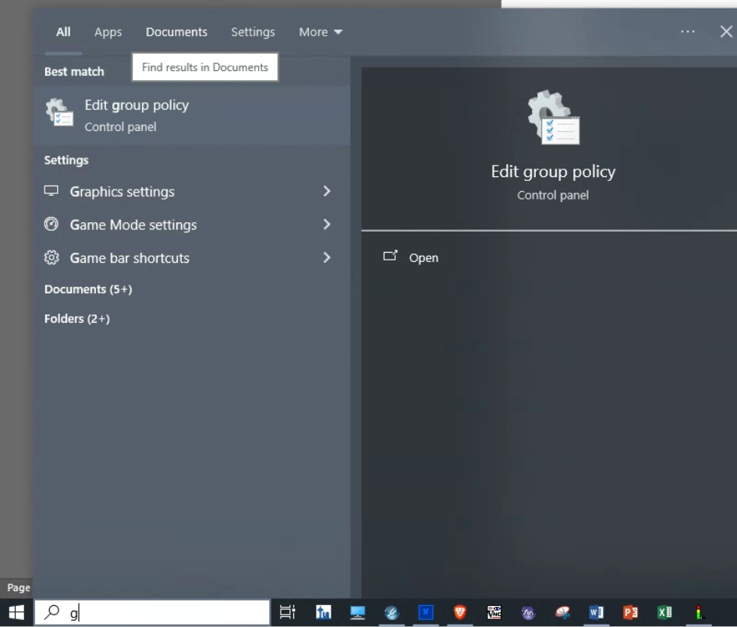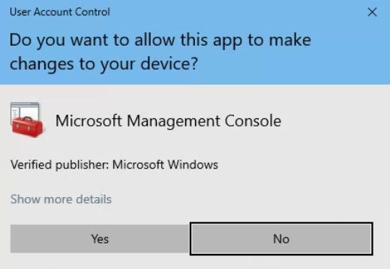

Under “User Configuration” open “Administrative Templates” and click on “All Settings”:
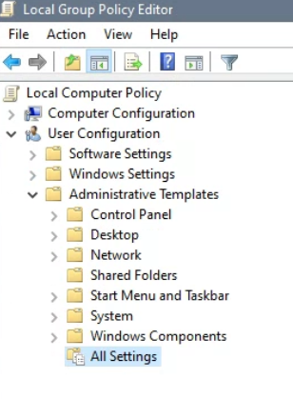
On the right side find “Configure Windows spotlight on lock screen” do a right mouse click and select “edit”.
Change it to not configured. Go back to the lock screen and you should now be able to customize it.

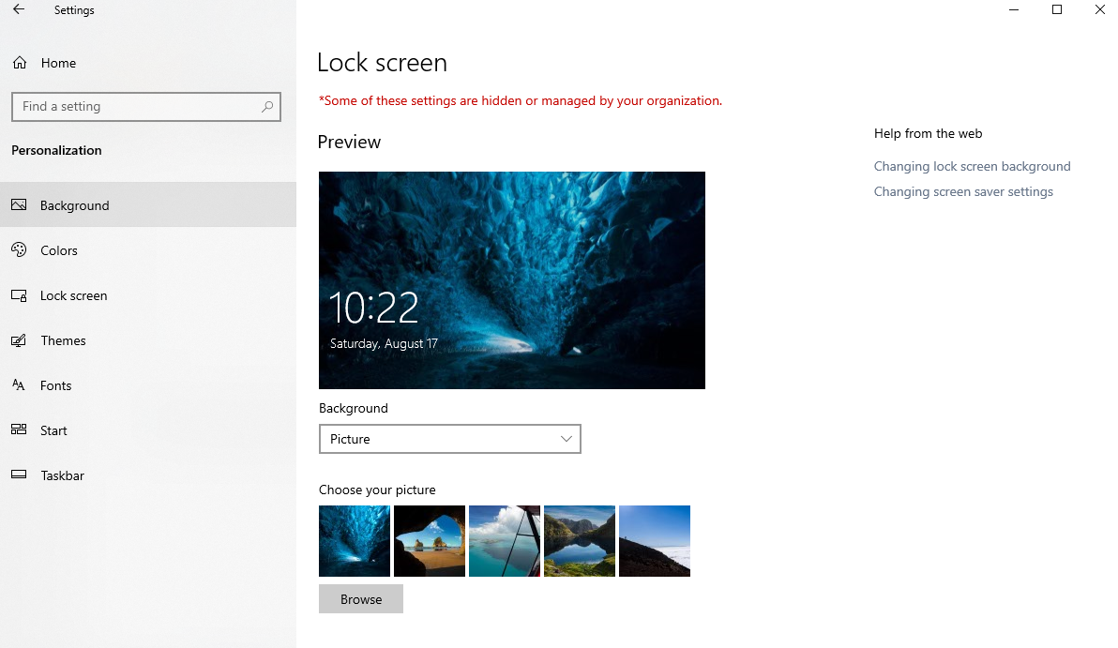
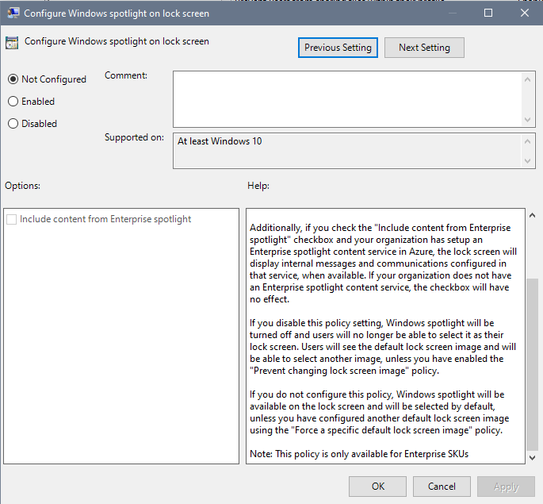

Change automatic lock screen when inactive
Our PC would constantly (after 3 mins of inactivity) go to the lock screen during inactive times, forcing us to enter the pass word to log back in. To change that go to group policy editor as described above.
Navigate to Computer Configuration/Windows Settings/Security Settings/Local Policies/Security options/
On the right side find Interactive logon: Machine inactivity limit
Do a right mouse click and select edit, change the time to 0 seconds.
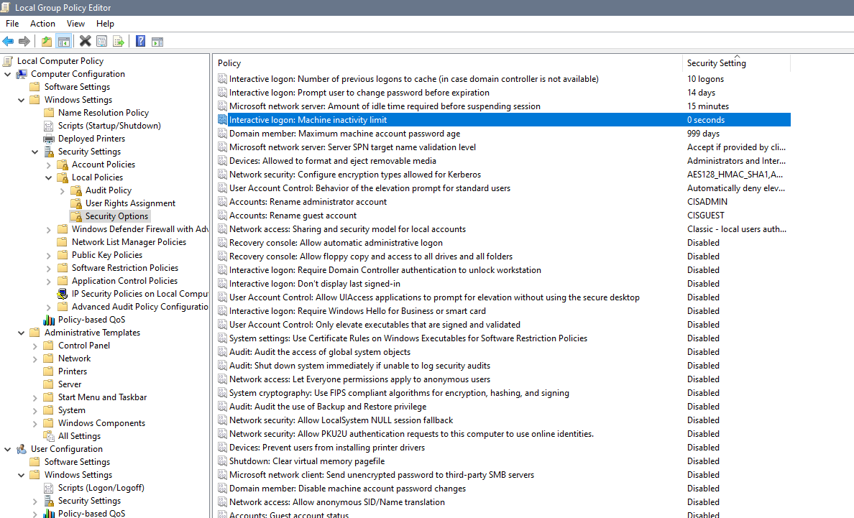

Now if you go back to your sign in option you will see “require sign-in” never:
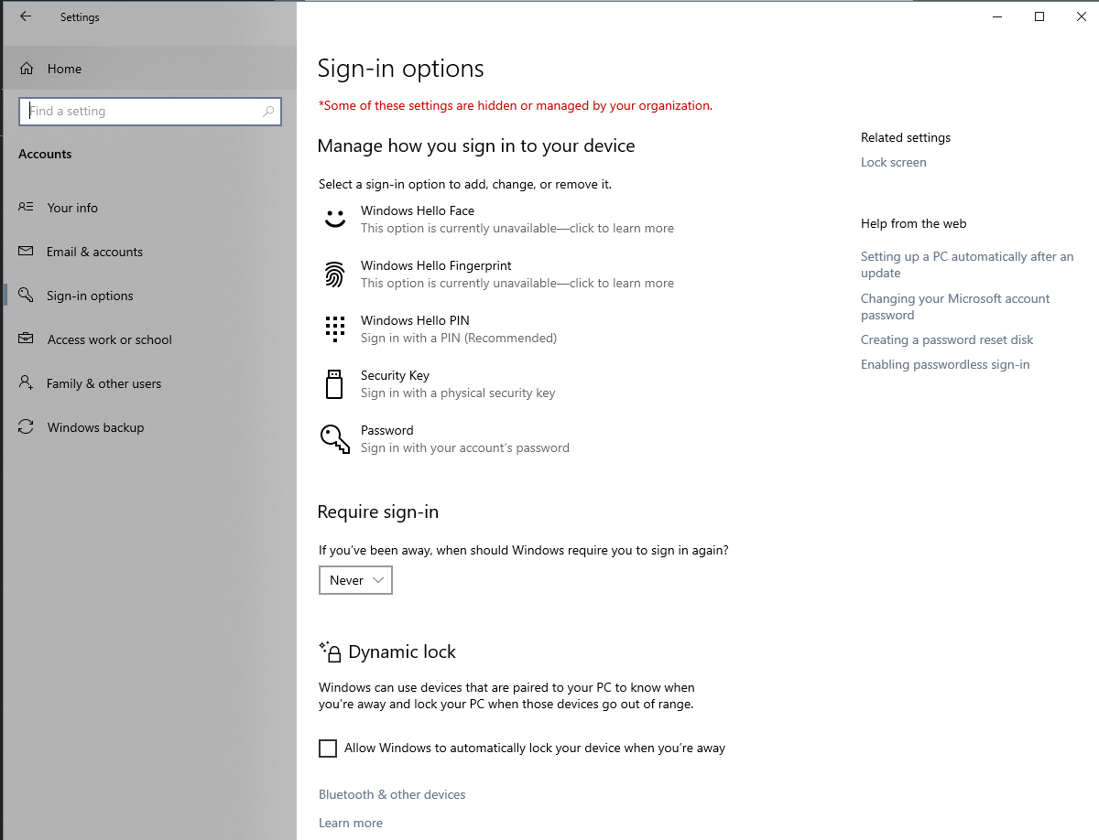

Windows Defender preventing software installation
When trying to install LC-devices Windows defender would pop up and not allow the installation.
To fix that go to group policy editor as described above.
Navigate to Computer Configuration/Administrative Templates/All settings
On the right side find Configure Windows Defender Smart Screen
Change the policy from “Warn and prevent bypass” to “Warn”
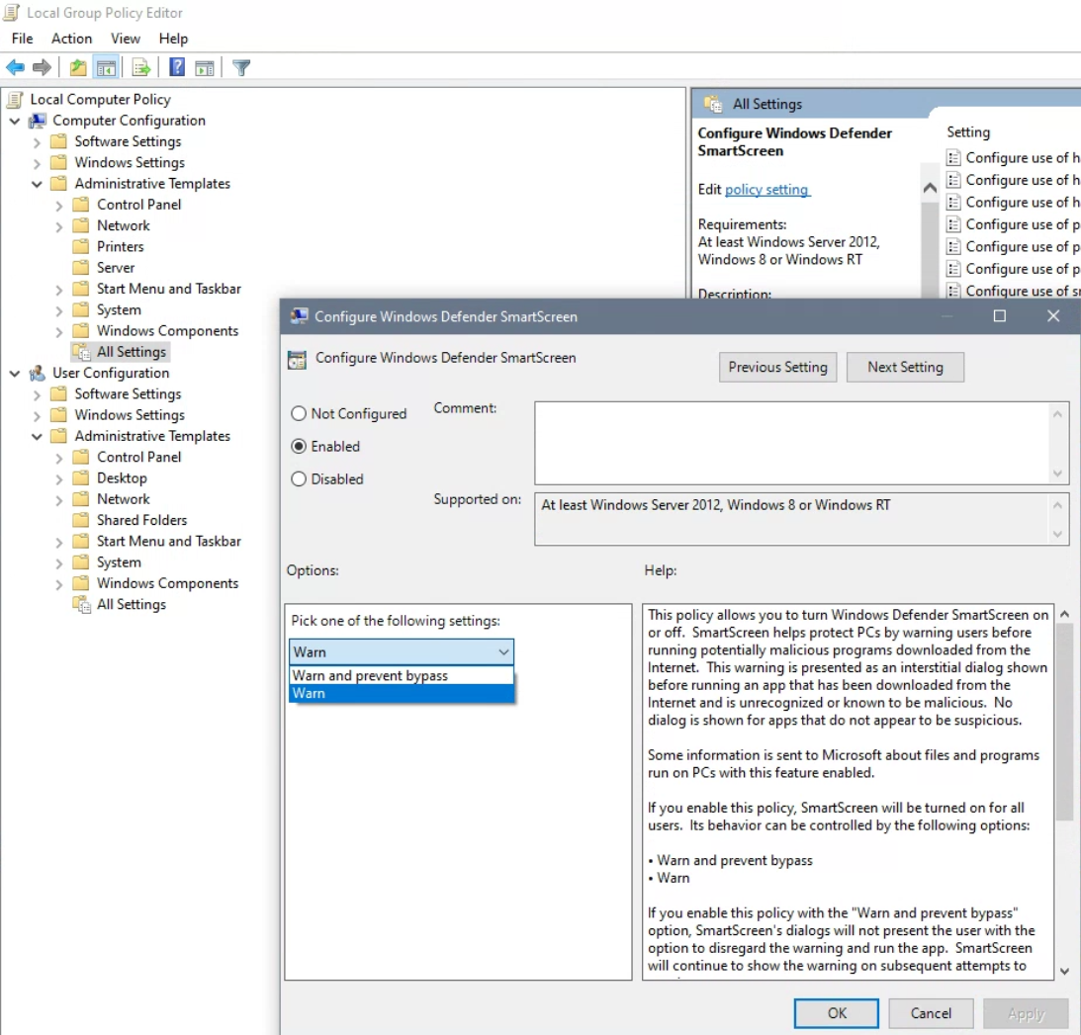

View all configured group policy items

If you would like to to view all the configured policy items, go to group policy editor
navigate to Computer Configuration/Administrative Templates
on the right side pane do a right mouse click, select “View” and then “Filter Options” on the pop up window:

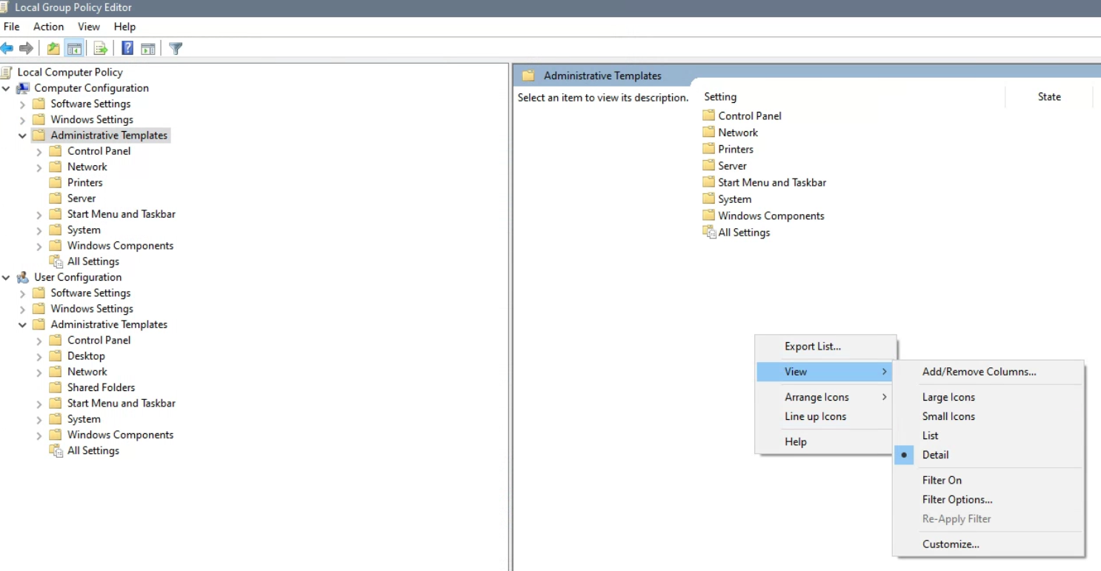

Now choose the filter options and hit ok:
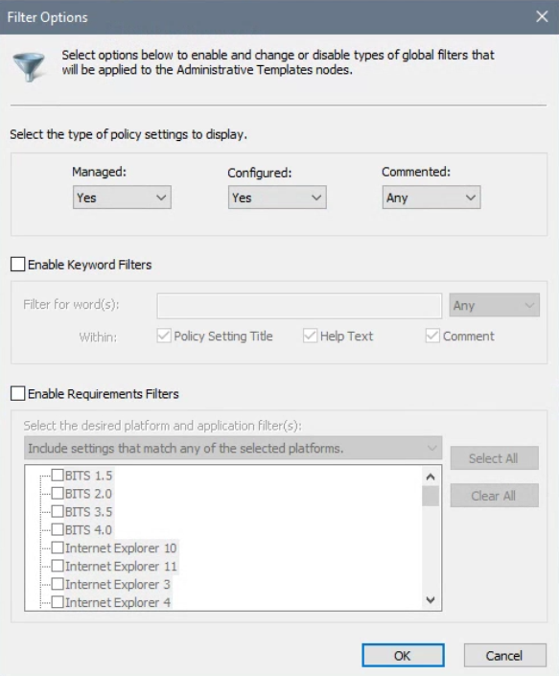

Now if you go to “All Settings” you will see all the configure group policy items.

