UWPR Pressure Cell

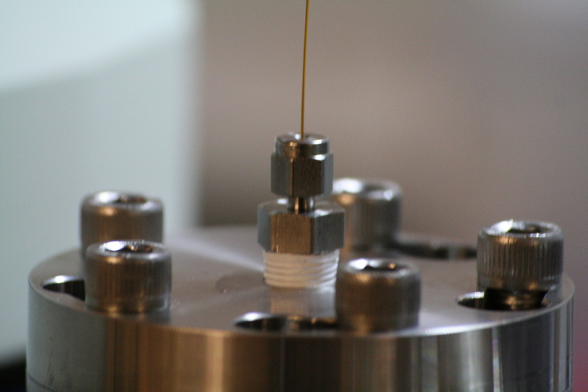

Pressure cells are designed to pack/load microbore capillaries, such as polyimide coated fused silica. They can be used to pack columns and pre-columns (traps) with a slurry of beads or to load samples onto packed traps or columns.
We routinely use 360 µm OD capillaries with 50-150 µm ID’s to pack columns and traps with 3-5µm beads of various chemistries (C18, SCX…).

There are a couple of good movies at benchfly.com that show how it’s done.

How to pack a capillary column | http://www.benchfly.com/video.php?video=96
How to Bomb-load Capillary Tips or Frits for LC/MS | http://www.benchfly.com/video.php?video=104
How to pull a capillary tip for LC/MS | http://www.benchfly.com/video.php?video=102

The documents on this site are intended to help you setup your own packing station and pack/load columns. You can order the machined parts from emaichineshop.com (or any other machine shop) or order a premade pressure cell from one of the commercial sources (some of them are listed in the documents).

Packing_Capillary_Columns.pdf

UWPR_Pressure_Cell_for_packing_capillary_columns.pdf
UWPR_Pressure_Cell_Material_List.xls

Download the free CAD drawing software from http://www.emachineshop.com/ to view the files below:
UWPR_PressureCellLid.ems
UWPR_PressureCellBody.ems
UWPR_PressureCellBody_smallChamber.ems

Please send any feed back to priska@uw.edu

