02/18/20

Nida Janulaitis

MolSim 115 HW 5

Number 2:

**NPT**

Temperature vs. Time

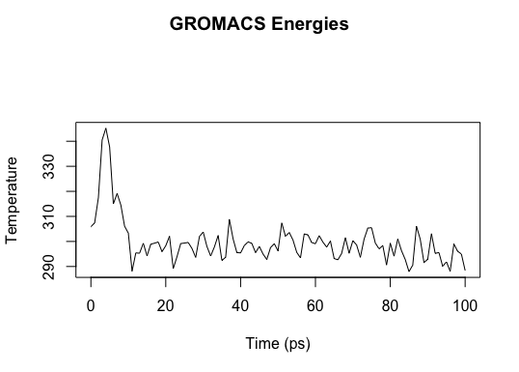

Pressure vs. Time

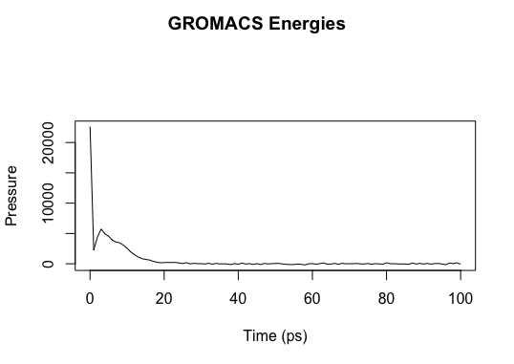

It looks like the system starts at a high pressure for some reason and then the pressure goes to zero because the system explodes for some undetermined reason.

NVT equilibration

Temperature vs. Time

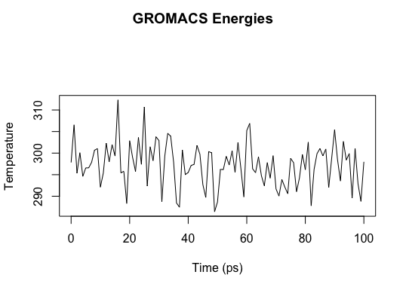

Pressure vs. Time

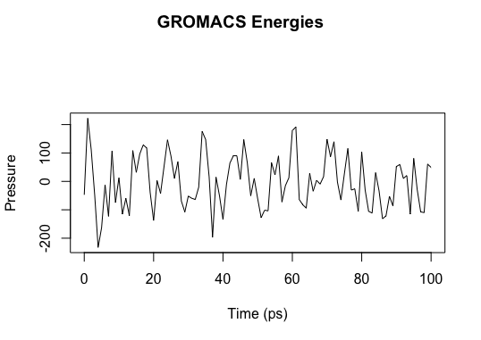

Looks like for this system the pressure and temperature just tend to fluctuate around an average that doesn’t seem to change very much.

NVT production

Temperature vs. Time

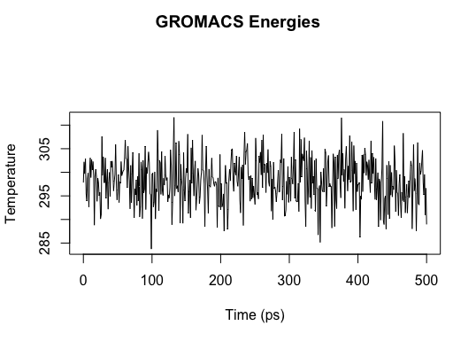

Pressure vs. Time

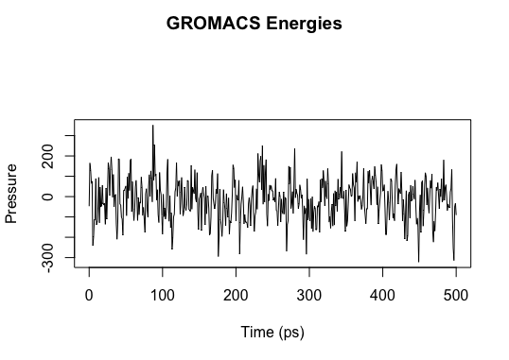

For the production run here the fluctuations are much more detailed, the average seems to stay pretty stable.

Number 3:

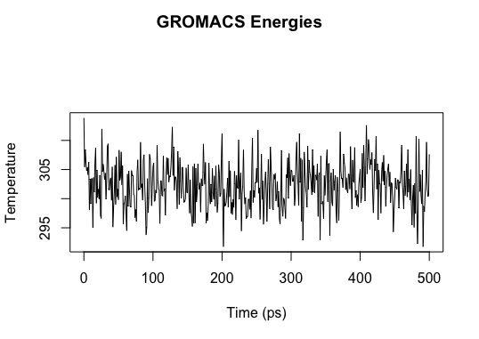

Number 4:

NVE with initial velocity= yes

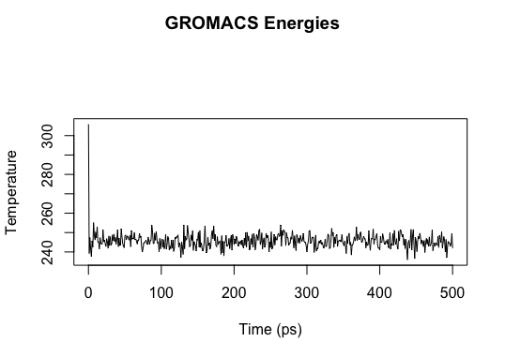

With a given initial velocity the temperature has a very quick convergence to what seems like a pretty stable value around which it fluctuates.

NVE without initial velocity (velocity=no)

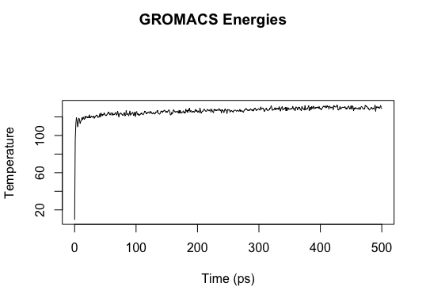

Without the initial velocity, the temperature starts low and spikes then slowly tends to increase and, presumably, converge over time. The fluctuations seem much smaller for this run but it could just be a result of a slightly larger y-axis scale.