2/19/20

Nida Janulaitis

MolSim – HW6: VMD

Part 1: download a PDB and render 3 unique images

Chosen molecule: Insulin

Image 1

Image 2

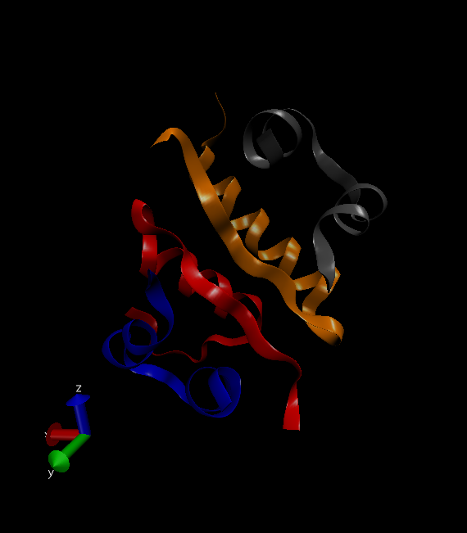

Image 3

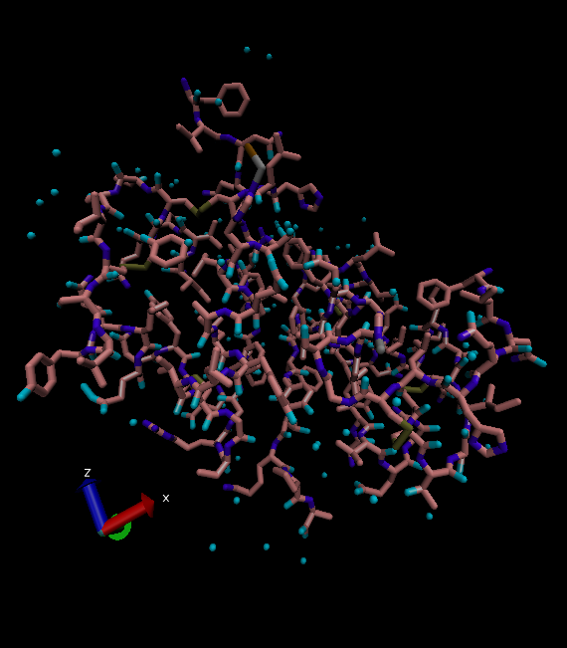

Part 2: write own tcl script that loads preset VMD settings

Script 1: Creates a visualization state like that of image 1

mol modstyle 0 0 NewRibbons 0.350000 12.000000 7.360000 0

mol modcolor 0 0 ColorID 1

mol color ColorID 1

mol representation NewRibbons 0.350000 12.000000 7.360000 0

mol selection all

mol material Opaque

mol addrep 0

mol modstyle 1 0 Surf 1.400000 0.000000

mol modstyle 1 0 Surf 1.400000 0.000000

mol modmaterial 1 0 Transparent

mol modcolor 1 0 ColorID 27

Tested on coronavirus:

Script 2: Creates a visualization state like that of Image 2:

mol modstyle 0 0 NewRibbons 0.350000 14.000000 7.360000 0

mol modcolor 0 0 Chain

mol modmaterial 0 0 Glossy

Tested on Coronavirus

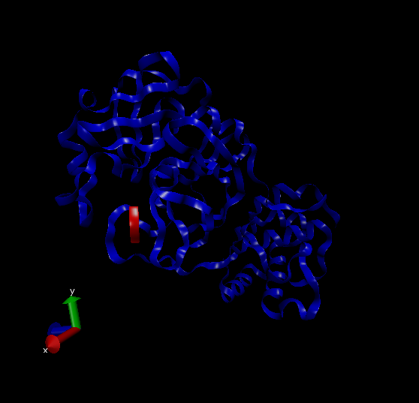

The scripts do work but it is good to note that if script 2 is run after script 1, it will not look the same because the surface is not deleted in script 2 so either need to add a command or run from a “clean” (just loaded) molecule visualization.