03-12-20

Nida Janulaitis

MolSim 115: HW 8

1. Render images

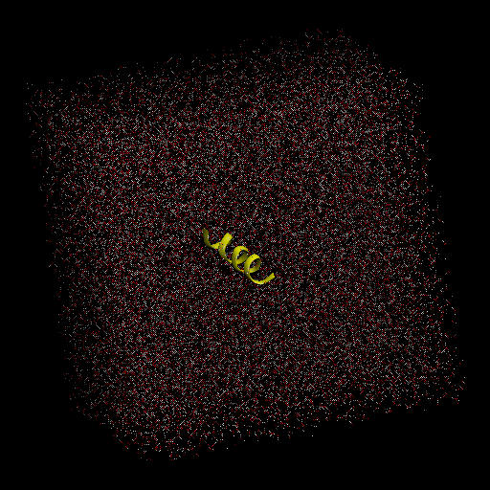

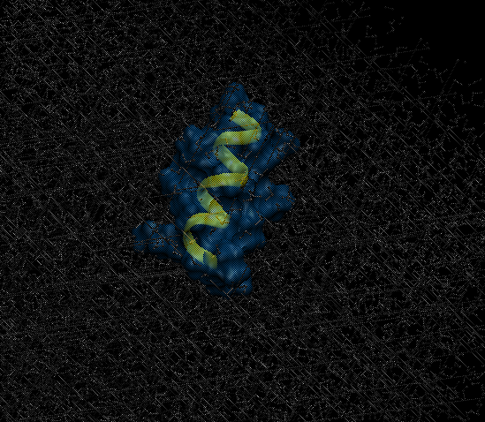

1. Yes, the protein does have a secondary structure: an alpha-helix.
2. Radial distribution functions. I think the first gsol-sol(r) peak corresponds to more tightly packed water at a radius of about 1 angstrom.

Bonus: I think plot ii is the result of block averaging i because I don’t think the range of tau should be shortened by block averaging i. Not sure about block size.