03-19-20

Nida Janulaitis

MolSim 115: Final Project

**Part 1: Forcefields**

Started with pdb2gmx to convert the downloaded .pdb to a .gro file and generate topol.top.

Used editconf to add a 3x3x3 nm box.

Used solvate to solvate the molecule.

Used grompp and genion and a simple ions.mdp file to add ions to neutralize the system.

**Part 2: Simulation Parameters**

Ran an energy minimization using grompp, mdrun and a simple em.mdp file appropriate for the AMBER99SB-ILDN forcefield.

Equilibrated system in an NPT ensemble by creating an npt.mdp file and specifying it to run over 1 ns at 1 bar and 300 K using a Berendsen barostat and a velocity rescale thermostat.

Part 2 Plot 1: Temperature vs. Time

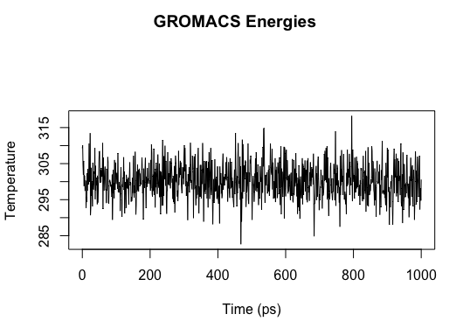

Part 2 Plot 2: Pressure vs. Time

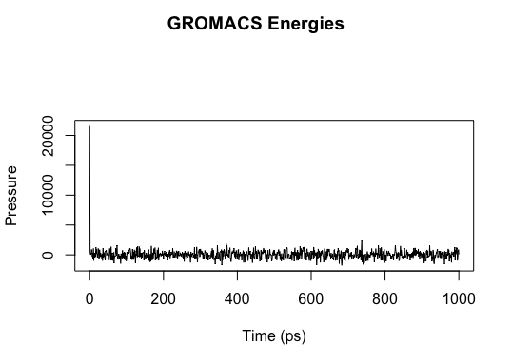

The two plots above indicate that the system has equilibrated because the temperature and pressure are not changing much and are fluctuating around fairly constant average values (300 K and 1bar, as specified).

**Part 3: Parallel Computing**

The equilibrated system from above was run over 1 ns of NPT at 1 bar and 300 K, as above, using different CPU settings. The number of nanoseconds computed per day was recorded for five different CPU settings.

|  |  |  |
| --- | --- | --- |
| MPI ranks (np) | OMP Threads (ntomp) | ns/day |
| 2 | 1 | 36.153 |
| 4 | 1 | 44.075 |
| 6 | 1 | 90.105 |
| 2 | 2 | 41.671 |
| 4 | 4 | 149.609 |

Part 3 Plot 1: Scaling Plot

The data indicates that you get significantly more ns/day by using 6 ranks versus 2 and you get more ns/dy when using 4 ranks and 4 threads but the benefits are less significant once you start adding that many resources. Because the benefits of using 4 ranks and 4 threads is still fairly large, I think this is the most efficient CPU setup, but I think any added resources would no longer be worth adding because it’s likely the increased cost will no longer be worth the benefits.

**Part 4: Trajectory analysis**

The equilibrated system from above was then run in an NVT ensemble for 10 ns at two different temperature conditions: 500 K and 273 K. The temperature, pressure, RMSD, and water density of the systems were then analyzed.

|  |  |
| --- | --- |
| **Legend** | |
| **Red** | **500 K** |
| **Blue** | **273 K** |

Part 4 Plot 1: Temperature vs. Time

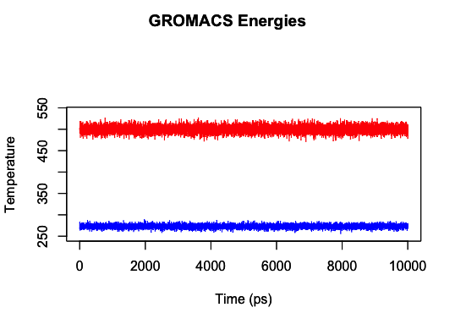

This plot is consistent with what is expected, the run at 500 K is fluctuating around that value and the same goes for the run at 273 K.

Part 4 Plot 2: Pressure vs. Time

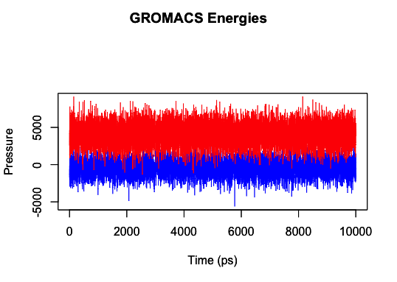

The pressure seems to be fluctuating a lot but around similar and consistent values, there was no pressure coupling in this run but an NPT ensemble was previously run. It make sense for the lower temperature to exhibit a slightly lower pressure, as shown here.

Part 4 Plot 3: RMSD

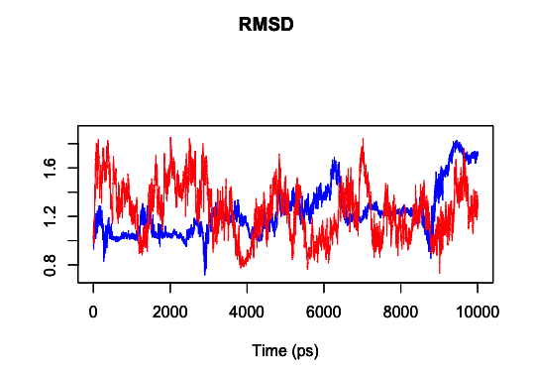

It looks like the RMSD is fairly stable, although it does look like it could have been run a little bit longer to make sure the structure fully stabilizes. Ideally, equilibration would be run for an infinite amount of time.

Part 4 Plot 4: Water Density

There is a larger fluctuation of the water density at lower temperatures, this may be because the molecules are moving slower and therefore can form a more distinct gradient.

**Part 5: VMD/Vizualization**

Used trjconv command to center the protein in the box.

(gmx_mpi trjconv -f nvt_500.trr -s nvt_500.tpr -center -pbc res -o center_3.xtc)

Final Frame of Trajectories

At 273 K:

At 500 K:

The two renderings above are very interesting because you can see clear differences in the final structure of the protein when it is at 273 K versus 500 K. As expected, the protein seems to be less folded at the higher temperature and the secondary structure is much less distinct. At 273 K, an alpha helix is clearly observed; whereas, at 500 K, a clear alpha helix is not present.