Important Definitions and Terms

OPM basics

The OPM database is the first comprehensive resource for membrane-associated peptides and proteins with known structures whose arrangement in membranes can be reliably assessed by the PPM 2.0 method, which is based on the evaluation of free energy of transfer of molecules from water to the anisotropic lipid environment. We also provide a web tool, PPM server, which enables the user to evaluate the membrane binding energy and parameters of spatial arrangement in the lipid bilayer of proteins not yet included into the OPM database.

OPM is highly accessed with more than 435 000 unique visits since its first release (from 4000 to 10 000 first time visitors and from 500 to 1200 returning visitors each month). The availability of the OPM database contributes to basic scientific research advances including understanding of the physics of protein–membrane interactions, determining the role of protein–lipid interactions in molecular transport, signal transduction, membrane transformations, formation of multi-proteins functional units and comparative analysis of mechanisms of insertion and translocation of proteins from different families into or across membranes. We are dedicated to incorporating new data in a timely manner as long as funding support is available.

Paper: <https://www.ncbi.nlm.nih.gov/pmc/articles/PMC3245162/>

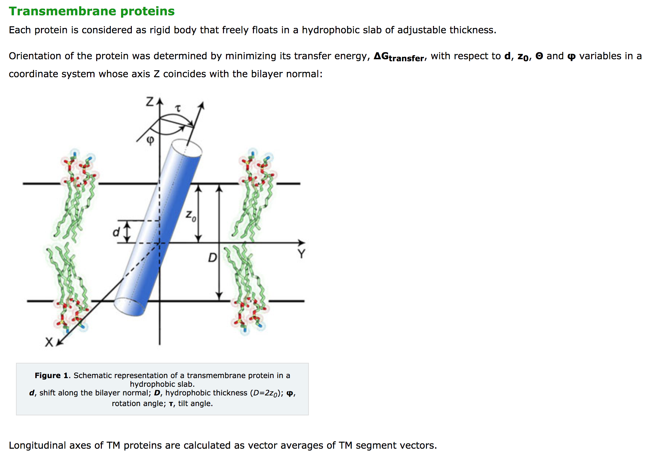

Accuracy

