**Introduction**

User interface is the main component of a web application that user interacts. To design user interface, UI designers have to do a heavy lift. There are several steps before the actual html code is developed. First the handmade sketch is drawn. Then the sketch is need to convert to a wireframe. So a designer draws a wireframe using a wireframing software. Then the wireframe is converted to a prototype using another software like ‘Photoshop’. Then only we can generate the html using that prototype. As you can see this lot of time and effort. What if he can bring UX designer’s imagination from sketch to html design without converting the sketch into wireframe or prototype? What if the he UI designer has so little to do? So “Magicurve” is the solution we are looking for.

Magicurve, a user friendly tool which converts handmade sketch to html using image processing and certain AI technologies. There are many tools that generates html from the prototype, but the developers starts shouting the output because they generate a crappy set of code that developers cannot start work on. So we intend to output a basic but professional standard code that can be used for further developing. And also this tool will use the built-in web camera of the user’s laptop as the input for the desired output, and also some basic customizations on the fly (Of course we can always edit the generated code).

**Background Motivation**

Web interface development is the process and practice of developing web application. When we think about technologies those are used in web application development, there are two main categories programming for creating web applications. Those categories are client side scripting, coding and server side scripting, coding. User interface designing is the main task of client side developing in web development process. It mainly focuses on the user’s experience and interaction. Developing UI involves different kind of developers and they need different skills and developing, designing experiences as well as knowledge to complete this process successfully with meeting relevant goals. Not only that this process may expensive and costly than other steps.

When we consider about user interface creation of web application development process, basically it contains three main steps. Firstly, UX designers have to draw a sketch of the web page. Then it needs to convert into graphic with PSD or any other image format. Finally they try to develop web page using markup language such as html by looking created psd graphic prototype. But sometimes this process may take lots of time and waste time because of the bad designing of the user interface. It will also cause to decrease user interaction for web page. So Magicurve is rapid developing solution with minimum steps of creating user interface than above described traditional process.

As the main UI designer of the Innovative-e (pvt) Ltd, Mr. Qasid Mukthar says there are tools like Adobe Muse, Axure or even Photoshop , “they generate HTML from what’s designed, but the HTML they render, if isn't used correctly generates a crappy set of code which breaks the moment you start dev on top of it”. So it’s very important that what every tool that we are intent to build should generate the code with good syntax.

Another problem is that most of the developers does not have a good eye for the design. So no matter how much harder they develop the business logic, the software fails because of the user interface. So for individual contractors needs a tool that can generate UI with a little help from a designer. Or they can use this tool to test out different layouts with in milliseconds of time can come up with the best layout they can use. And if we consider about multiplatform mobile developing frameworks like apache Cordova or Ionic, the developer can use this tools to generate all the screens and controls at place in no time. And as we are now using project management techniques like Scrum, the requirement change very rapidly. So this tool will help to adopt to those changes faster.

With the knowledge we are going to gain knowledge on image processing and AI technologies at our level four subjects it’ll be very interesting to use our knowledge at this challenge, and come up with a profession level tool that can have good business value.

**Problem in Brief – Scope**

*You may rename the heading to reflect the problem that you address. For example, the heading can be: Major issue – Communication gap. Since the previous section pointed out several problems, here briefly write the specific problem that you are going to address.*

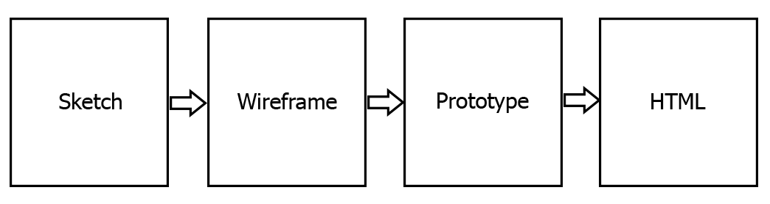

**Aim**:

The aim of this project is to develop a user friendly tool for rapid development of web application interfaces by generating html code automatically from sketch input with use of image processing techniques and certain AI technologies.

**Objective**:

There are set of general objectives of our project.

* Study of the rapid development of web interfaces with saving time.
* Study of technologies such as image processing techniques and other AI techniques that can solve the problem.
* Design a tool that can generate rapid html designs using a provided sketch image.
* This tools should be able to manipulate all the controls one by one.
* Ability to recognize the controls changes if the same sketch is revised.
* Contrast between different versions of the same sketch.
* Error handling.
* Evaluation of the proposed solution.
* Preparation of the final documentation.

**Magicurve, Image processing for UI designing.**

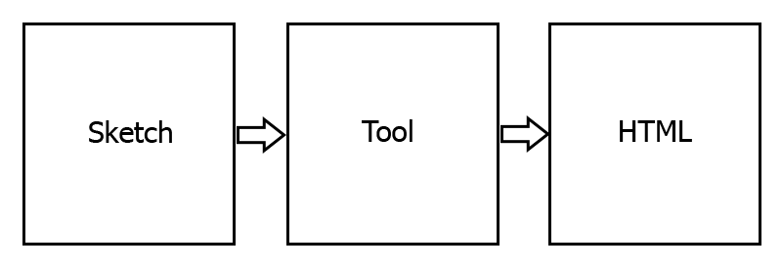

**“**Magicurve” as we have named, it will be a magical thing for developers. The basic input for this tool will be a simple sketch which will be drawn as the figure 1.1. And we will use image processing for recognizing drawn lines and curves. And for mapping the recognized shapes to html controls we’ll be using AI technologies (expert systems). And certain AI techniques will be used for error handling.

Ex: - Recognize square even the length of the four sides are not precisely equal.

We’ll be defining some notations for the user to input as the accuracy of the output should be higher as much as possible. And we are going to use the aid of fellow architecture faculty’s students who are very good at UX/UI designs to gather required number of samples for the AI data processing. And we’ll develop the tool’s accuracy up to 95%.

The tool will not be accurate 100%. So we are going to give a popup at each control, one at a time to customize selected html attributes. And the tool will be able to contrast between output and the desired output. And it will be able learn from users suggestions. We are planning to build this tool as a web application so that we can reach worldwide users and improve the tool from their feedback.

**Resource Requirements**

Hosting space with Google app engine and opencv support.

*Computer with 1GB RAM and 2GHz or more processing power*

*Internet connectivity*

*Web camera*

**Reference**

*This is the list of reference. A sample for the list of reference is given below in this document. Note all what you listed under list of reference must necessarily be cited inside the body of the text. In project proposal, references are generally cited in the sections of Introduction and Background & Motivation.*

**Appendix**

*It is better to include a plan of actions as an appendix. This may be cited in the section on Proposed Solutions. This is a list of activities together with intended dates for their completion. In order to decide on the time scale, you must refer to the project duration prescribed by the Faculty. The list of activities must be defined as per the Objectives of the project.*

|  |  |
| --- | --- |
| [1] | M. Q. Muktar, Interviewee, *Issues in ui automation tools.* [Interview]. |
| [2] | B. Kohan, "Guide to Web Application Development," 2014. [Online]. Available: http://www.comentum.com/guide-to-web-application-development.html. |
| [3] | "User Interface Design," [Online]. Available: http://en.wikipedia.org/wiki/User_interface. |