Assessment

Introduction to UX

|  |  |
| --- | --- |
| *Name* | Ervin Samsonov |
| *Student number*  *Attempt* | 18051545  Module 1 |
| *Academic year* | 2018 |

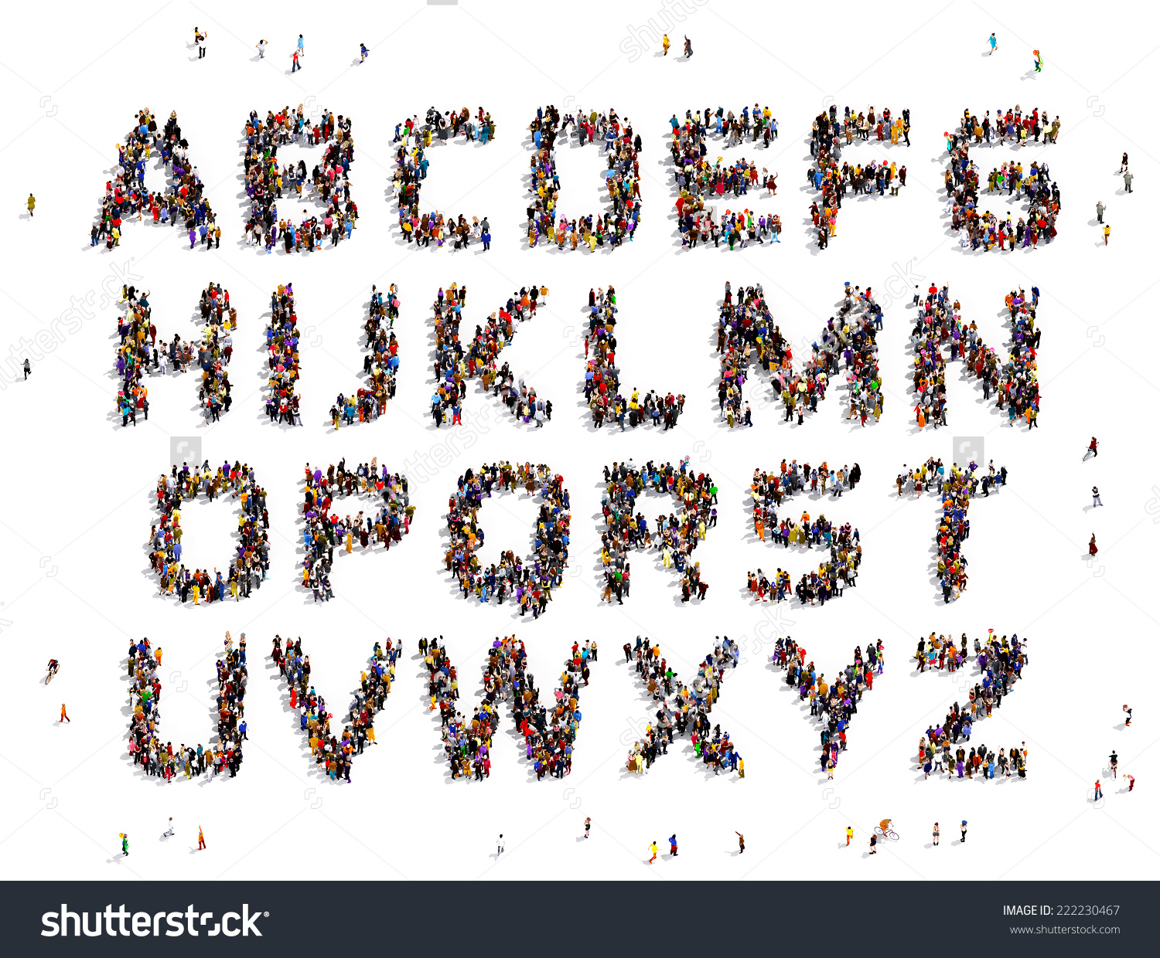

**USER EXPERIENCE DESIGN**



Faculty of IT & Design

Contents

1 Introduction 2

1.1 The product Smart-ID 2

1.2 The user Bank users 2

1.3 The context Logging in the bank account and making payments 2

2 Critiquing Usefulness 3

2.1 Usefulness of Smart-ID 3

3 Critiquing Usability 4

3.1 Usability factor 1 Easy-of-use 4

3.2 Usability factor 2 Leanability 4

3.3 Usability factor 3 Efficiency 4

4 Critiquing Engagement 5

4.1 Engagement factor 1 Aesthetics 5

4.2 Engagement factor 2 Stimulation 5

4.3 Engagement factor 3 Adaptivity 5

5 Critiquing Meaning 6

5.1 Meaning factor Security 6

6 Conclusions 6

6.1 Overall quality of the User Experience 6

6.2 Great UX design(ers) 7

7 Literature 8

# Image result for smart-idIntroduction

## The product Smart-ID

### What is the purpose of this product for the user?

Easy, safe and fast way of logging into your bank account.

### What are the functions and features the product offers to fulfil its purpose?

It generates random number sequence and sends it to your bank. After that you need to confirm your authorization in the app itself using your own password which you created when registered. Using your Smart-ID account is made secure thanks to these PIN codes. These are the codes you choose while registering your account in order to authenticate e-services and sign documents and transactions.PIN1 code is at least 4 digits long and used to get access to e-services.PIN2 code is at least 5 digits long and needed to sign documents or confirm actions such as bank transactions. If someone has access to your device and tries to guess your PIN codes, your account will be locked each time your PIN has been entered incorrectly three times in a row. Application works in Latvia, Lithuania and Estonia.

### How does the user interact with the product (and the system)?

User need to install Smart-ID application on his phone and register in the system. Then link your Smart-ID account to bank account. It generates random number sequence and sends it to your bank. After that you need to confirm your authorization in the app itself using your own password which you created when registered.

## The user Bank users

### How would you describe a typical user of this product?

Person who often use internet banking and makes payments and lives in Latvia, Lithuania or Estonia.

### What (be, do, motor) goals does this user have related to the product?

More safe, easy and fast logging into bank account and make a payment.

### What are relevant characteristics of the user that influence how they use and experience the product? Explain how

User is busy, likes to save time, likes to feel safe about his money. Lives in Latvia, Lithuania or Estonia.

If user is busy person who likes to save as much time as possible , then he will be happy to use this application, because in comparison to code-cards Smart-ID can save his time up to three minutes for 1 logging with payment. And user will feel safe about his money because there is no way of hacking his account anymore.

## The context Logging in the bank account and making payments

### In what situations (use DETAILS) would the user use this product?

I will explain by using example:

Tom now is using Smart-ID to log in his Swedbank internet account. He is owning a small architecture firm and often need to make a payments to different people using internet banking. Earlier he needed to use pin-cards (card with 60 various 5-digit numbers) for logging into bank account and making payment. It took about 3 minutes for every payment and you always needed to make sure you did not forgot your pin-cards. But when Smart-ID was added he spent mush less time for making any payments. If it was 3 minutes now it is only about 1 minute or even less. So Smart-ID helps him to save time and relieves from always taking pin-cards with him.

### What characteristics of the context influence the user experience? Explain how

Fast, safe and easy logging into your bank account. You do not need to use code-cards, which can be stolen. You do not need to remember your long password, only 4-digit code. You do not need to search code-cards and search on them needful code wasting your time.

# Critiquing Usefulness

## Usefulness of Smart-ID

### How well does the product fulfil its purpose?

[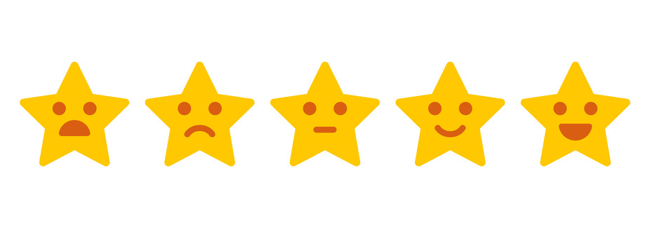](https://www.google.nl/url?sa=i&rct=j&q=&esrc=s&source=images&cd=&cad=rja&uact=8&ved=0ahUKEwjPt5-rmt7UAhWNb1AKHffNDCMQjRwIBw&url=https://phys.org/news/2016-12-recommendingthree-internet-age.html&psig=AFQjCNEyni3tIhLq0xlW7-SYP5mD4BkMsg&ust=1498658980945790)

### Explain your rating referring to the user needs

User needs – fast, easy, safe and accessible way of logging into bank account and making payments. Smart-ID gives you way of fast and easy login – only enter 4-digit code into application on your device. Smart-ID provides safe way – only you know your code, only you have your phone and without in it is impossible to make a payment or login. But it is accessible only in Latvia, Lithuania and Estonia so my grade is 4.

### In what situation is the product most useful for the user? Explain

Person lives in Latvia, Lithuania or Estonia. Works somewhere where needs to make a lot of transfers and payments using internet bank. So it is necessary to do all his work fast and his or firm bank account must be safe. Smart-ID makes your payments faster for 3-5 minutes then when using code-cards, it is more safe too.

# Critiquing Usability

## Usability factor 1 Ease-of-use

### How do you explain this usability factor (in general) to others?

Ease of use means how good you can use the product intuitively – without any instructions.

### How do you rate your product on this factor? (circle a star) [Afbeeldingsresultaat voor rating](https://www.google.nl/url?sa=i&rct=j&q=&esrc=s&source=images&cd=&cad=rja&uact=8&ved=0ahUKEwjPt5-rmt7UAhWNb1AKHffNDCMQjRwIBw&url=https://phys.org/news/2016-12-recommendingthree-internet-age.html&psig=AFQjCNEyni3tIhLq0xlW7-SYP5mD4BkMsg&ust=1498658980945790)

### Explain your rating using product, user and context characteristics

Smart-ID does not have any advertising into the application so you always see only important information. Also design of application is very minimalistic and do not contains any unnecessary functions. All steps shows you what you are doing so you will not get confused. So my grade is five.

## Usability factor 2 Learnability

### How do you explain this usability factor (in general) to others?

Learnability means how easy it is for user to learn how to use something.

### How do you rate your product on this factor? (circle a star) [Afbeeldingsresultaat voor rating](https://www.google.nl/url?sa=i&rct=j&q=&esrc=s&source=images&cd=&cad=rja&uact=8&ved=0ahUKEwjPt5-rmt7UAhWNb1AKHffNDCMQjRwIBw&url=https://phys.org/news/2016-12-recommendingthree-internet-age.html&psig=AFQjCNEyni3tIhLq0xlW7-SYP5mD4BkMsg&ust=1498658980945790)

### Explain your rating using product, user and context characteristics

There is an interactive guide how to use it. Application has hints so even if you forgot how to do something you always can see hints and remember how to use it. When you use if for the first time you will see guide according all your steps, because of this grade is five.

## Usability factor 3 Efficiency

### How do you explain this usability factor (in general) to others?

Efficiency means how much effort you need to make and how much resources to spend for reaching your goal.

### How do you rate your product on this factor? (circle a star) [Afbeeldingsresultaat voor rating](https://www.google.nl/url?sa=i&rct=j&q=&esrc=s&source=images&cd=&cad=rja&uact=8&ved=0ahUKEwjPt5-rmt7UAhWNb1AKHffNDCMQjRwIBw&url=https://phys.org/news/2016-12-recommendingthree-internet-age.html&psig=AFQjCNEyni3tIhLq0xlW7-SYP5mD4BkMsg&ust=1498658980945790)

### Explain your rating using product, user and context characteristics

Smart-ID is very efficient application. It can save about 3 minutes every time you make a payment or trying to enter to your bank account and you do not need to search something or remember many digits so it is indisputable five.

# Critiquing Engagement

## Engagement factor 1 Aesthetics

### How do you explain this engagement factor (in general) to others?

Aesthetics means how beautiful something is.

### How do you rate your product on this factor? (circle a star) [Afbeeldingsresultaat voor rating](https://www.google.nl/url?sa=i&rct=j&q=&esrc=s&source=images&cd=&cad=rja&uact=8&ved=0ahUKEwjPt5-rmt7UAhWNb1AKHffNDCMQjRwIBw&url=https://phys.org/news/2016-12-recommendingthree-internet-age.html&psig=AFQjCNEyni3tIhLq0xlW7-SYP5mD4BkMsg&ust=1498658980945790)

### Explain your rating using product, user and context characteristics

Smart-ID can be count an aesthetic one. It is very minimalistic with nice looking background, which does not interfere reading text, and without any extra functions or advertisement. There is no any specific design so grade is four.

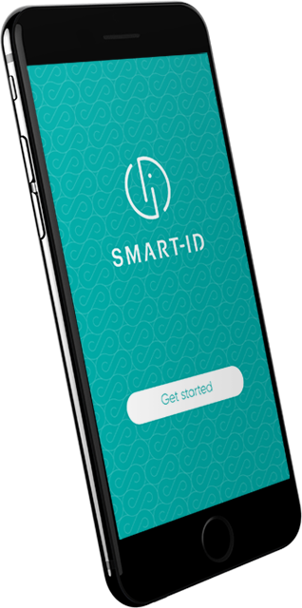

## Engagement factor 2 Stimulation

### How do you explain this engagement factor (in general) to others?

Stimulation means how you are showing your interest and enthusiasm in doing something.

### How do you rate your product on this factor? (circle a star) [Afbeeldingsresultaat voor rating](https://www.google.nl/url?sa=i&rct=j&q=&esrc=s&source=images&cd=&cad=rja&uact=8&ved=0ahUKEwjPt5-rmt7UAhWNb1AKHffNDCMQjRwIBw&url=https://phys.org/news/2016-12-recommendingthree-internet-age.html&psig=AFQjCNEyni3tIhLq0xlW7-SYP5mD4BkMsg&ust=1498658980945790)

### Explain your rating using product, user and context characteristics

Smart-ID only helps you to make payments and do it faster so you will not feel stimulated by it so hard that you will feel enthusiasm or excitement in making payments. However, if you are often doing payments and working with bank then this application can stimulate you to use it because it makes the whole process much easier than it was. Therefore, my grade is three.

## Engagement factor 3 Adaptivity

### How do you explain this engagement factor (in general) to others?

Adaptivity means how something can adapt to your needs and how it can be used in different situations.

### How do you rate your product on this factor? (circle a star) [Afbeeldingsresultaat voor rating](https://www.google.nl/url?sa=i&rct=j&q=&esrc=s&source=images&cd=&cad=rja&uact=8&ved=0ahUKEwjPt5-rmt7UAhWNb1AKHffNDCMQjRwIBw&url=https://phys.org/news/2016-12-recommendingthree-internet-age.html&psig=AFQjCNEyni3tIhLq0xlW7-SYP5mD4BkMsg&ust=1498658980945790)

### Explain your rating using product, user and context characteristics

Unfortunately, Smart-ID has very poor adaptivity. First of all, it can be used only in Latvia, Lithuania and Estonia. This list of countries will grow, but for now, it is only three. Smard-ID does not have any flexible settings – only possibility of changing language. In addition, it works only on IOS and Android devices though most devices are on Android or IOS platform. It cannot be used without internet connection. Therefore, adaptivity is not about Smart-ID and my grade is two.

# Critiquing Meaning

## Meaning factor Security

### Why does this factor fit this product (for the intended user group)?

Application makes all actions with passwords and codes encrypted so your password cannot be stolen or hacked by someone. Even if you will lose your phone no one will be able to discover your codes and passwords. You always get a notifications when trying to log in so when someone will try to log into your account you will immediately know it. In case of forgetting your own code you can contact your bank and rebind your Smart-ID account with changing codes.

### How does this product cause the user to experience this meaning?

The user bank account will never get hacked and money will never be stolen. You always know when you or someone else try to log into your account.

### How might this product and its meaning impact the user’s life?

User might feel more easy about his money on his bank account, maybe stop paranoid about security of his money.

# Conclusions

## Overall quality of the User Experience

### Do you think your product is usable to the user? Why / why not?

Yes, I think my product is usable for the user. Because it is usable for me and lot of people I know, most of people in Latvia who use internet banks are using Smart-ID and because this application has perfect usability and helps a lot. It saves your time by making all process from logging in to making a payment faster, application is pretty easy and you do not need much time to study how to use it. Most important – Smart-ID is very efficient.

### Do you think your product is engaging to the user? Why / why not?

I think my product is not very engaging for users. It looks pretty nice, but it is application designed for facilitating another process so you will not be engaged or stimulated by it because it is only auxiliary thing.

### Do you think your product is meaningful to the user? Why / why not?

I think it depends on the user. For someone who like to save time or want to feel more safe about his money – my product will be very meaningful, but if person is indifferent to things like security or efficiency, then it will not be very meaningful. However, for most of Smart-ID users this application is meaningful and helps a lot.

### What is your overall judgement of the UX quality of your product and the experience it offers the user?

Smart-ID was designed for certain functions – to make a way you login into your bank account and make a payment more secure, faster and easier. Smart-ID fully accomplish this task and moreover has some pros like good learnability and aesthetics.

## Great UX design(ers)

### What is good UX design to you?

For me good UX design it is when product, which you designed fully and correctly, fulfils the given goal and moreover is nice to use.

### What do you think it takes to be a great UX designer?

First of all, you need to have all necessary skills for designing. Good UX designer might be able to make a good research of his client needs, must be creative, but remember that he if he is designing for another person than it is not about his preferences, but about his client. Good UX designer must be purposeful with great communicating skills and must have skills of teamwork.

# Literature

<https://www.investopedia.com/terms/e/efficiency.asp>

<http://www.givegoodux.com/learnability-5-principles-interaction-design-supercharge-ui-3-5>

<https://measuringu.com/measure-learnability/>

<https://www.wqusability.com/articles/more-than-ease-of-use.html>

<https://www.interaction-design.org/literature/topics/ease-of-use>

<https://uxdesign.cc/design-principle-aesthetics-af926f8f86fe?gi=64f5dcf42b3f>

<https://www.collinsdictionary.com/dictionary/english/adaptivity>

<https://www.researchgate.net/publication/257048076/download>

Materials from the blackboard <https://blackboard.hhs.nl/webapps/blackboard/content/listContent.jsp?course_id=_72275_1&content_id=_2494075_1&mode=reset>