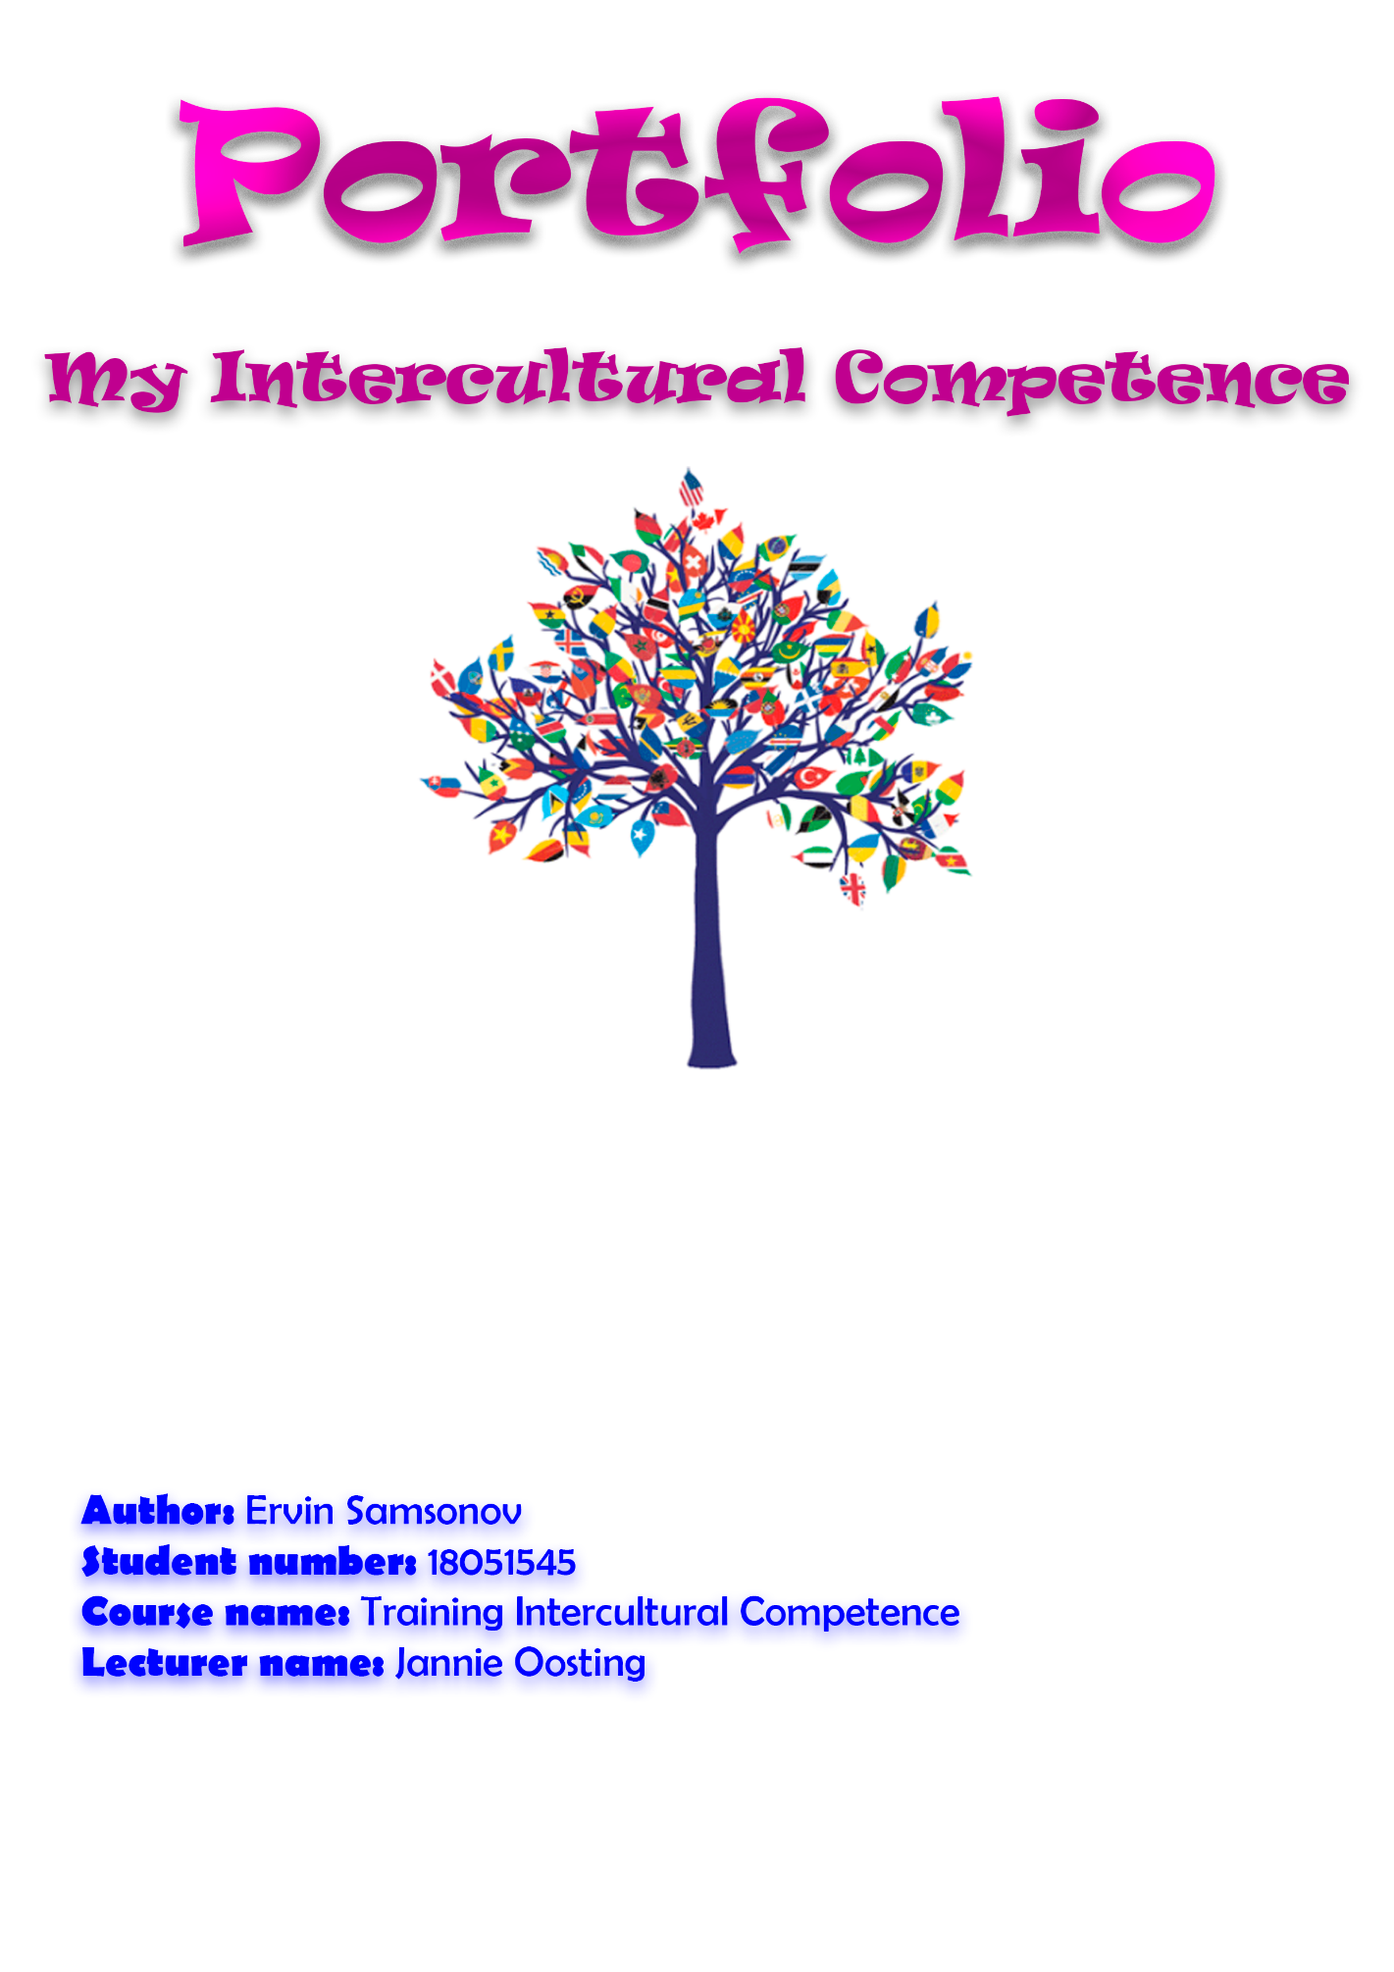

**Portfolio**

**My Intercultural Competence**

**Name client:** *Jannie Oosting*

**Name author:** *Ervin Samsonov*

**Student number:** *18051545*

**Course name:** *Training Intercultural Competence*

**Lecturer name:** *Jannie Oosting*

**City:** *The Hague*

**Date:** *12.10.2018*

**Version:** *1.0*

Table of contents

**Chapter** 1 - **Introduction** **4**

**Chapter 2 -** **Intercultural biography** **5**

**Chapter 3 -** **Communication style** **7**

**Chapter 4 -** **International communication barriers** **8**

**Chapter 5 -** **Intercultural dimensions Hofstede** **9**

**Chapter 6 -** **Learning goals** **10**

**Chapter 7 -** **Achievements** **11**

**Chapter 8 -** **Conclusion** **1****3**

**Attachment 1 - DNA flower** **1****5**

**Attachment 2 - Communication scale** **1****6**

**Attachment 3 – Hofstede’s Dimensions table** **1****8**

**Attachment 4 - Feedback** **1****9**

# Introduction

**Situation:**

Ervin Samsonov – student of The Hague University of Applied Sciences, who studies at User Experience Design and have a course Training Intercultural Competence, created this work.

I was born in 1998 in the Latvia where I lived until coming for studying in Netherlands.

It was an assessment given to me by my lecturer Jannie Oosting at the start of the year.

**Purpose of the report:**

To reflect on my intercultural competence and improve it.

**Target group\readers:**

My TIC course lecturer - Jannie Oosting.

**Subject matter of the portfolio:**

My intercultural competence, it’s advantages and disadvantages and ways to improve it.

**Assignment:**

I will write following chapters:

* *Intercultural biography*
* *Communication style*
* *Intercultural communication barriers*
* *Intercultural dimensions of Hofstede*
* *Learning goals*
* *Achievements*
* *Conclusion*

# Intercultural biography

My name is Ervin Samsonov. I was born in Latvia in 1998. My parents were already quite old when I appeared – my father was forty five and mother forty two years old. They lived together in Latvia for twenty years before my birth. My mother came to Latvia from Ukraine for studying in university when she was twenty. As for my father – he was born in Latvia and lived there the biggest part of his life. Now they both still live in Latvia and hope that I will be alright in new country. They hope that I will study well and settle in Netherlands. As for me – I hope that one day they will be able to move to Netherlands as well.

I already said that my mother was from Ukraine and my father from Latvia. My mother is fully Ukrainian knowing all about own culture, but she needed to study more about Latvian culture when moved to new country. Despite of fact that my father was born in Latvia he is only half Latvian and the other half Russian. That is because his father was Russian and stayed in Latvia after World War Two. So only because of parents I was affected already by three cultures. Though Ukrainian culture have a lot of similarity with Russian culture and because of that it will be easier if I will combine both of this cultures in my further explanation. Also it is very important to say that Latvia once was country occupied by Russia so nowadays in Latvia, especially in the main city - Riga, there live about 50% Russian speaking people of all city population. Of course they need to study Latvian language and culture though many do not study it. Because of that if you want for instance start working as a waiter – it is almost necessary to know Russian. Based on this it is clearly seen that mainly I was affected by Russian culture.

Though not only Russian culture influence me, of course Latvian culture too, but not so much. In Latvia there are many Russian schools where people learn in Russian and I was in one of those schools. At the same time I started going to boxing trainings where my coach was Latvian same as the whole group of other children. However, most time I spend in school with my classmates so as I said – Russian culture affected me much more. Also language which used my family was Russian too. Because of this I knew more about news from Russia than from Latvia. I am watching Russian social media – for instance YouTube and TV-programs. I am using mostly Russian social network and knew history no worse than Latvian which I learned in school for twelve years.

Throughout my life I met a lot of people living in different countries and with some we even become a friends. For example my best friend now lives in Belorussia and I am trying to help him move to Europe. Big part of my life takes chatting with other people through internet. I will not describe how much internet gives to me, it is enough to know that I am become a friends with people from Belorussia, Chez-Republic, Ukraine, Russia, Uzbekistan, Romania, Germany, Sweden and Norway. With most of them I communicate in English and Russian.

Besides of communicating with people using internet I travelled a lot to Germany because my parents have there old school friends. And I think that this intercultural experience made the biggest impression on me. There is a big difference between Latvia and Germany besides fact that Latvia is also Europe country. The biggest one that impressed me the most is difference in attitude of people to each other. In Germany most people are smiling when staring at you, all refer to you politely and for instance refer to child as to adult. I can continue this list very long, but the thing is that from that time I started to think of moving to other country.

I fully understood that this is difficult to change countries, to adapt. But I acknowledge the risks and now I am here. However, I can move to another country, but I cannot move my cultural identity. I am Russian and sometimes I regret this. Some people just hating Russians some thinks about Russians as about nation of alcoholics, rude and quick-tempered people. The most horrible thing - partially they are right. My nation drinks the most and stereotypes about quick-tempered Russians are true too. Well, not all Russian people are like that and I am one of these people, however sometimes we feel uncomfortable watching other impolite colleagues. Finally, now I live in Netherlands and I will try my best to learn about culture of this country and adapt to it.

I am very surprised how useful the course TIC is because with it I can not only understand my own culture value, but became more confident in other cultures. Chapter 1 and 7 which I read helped me a little to overcome cultural shock. This course is very interesting and I hope I will learn many new things and finally became good at communicating with people from other countries with different cultures.

# Communication style

Mostly I communicate with people low context. Despite the fact that I was born in Russian family and lived in Latvia. However, it does not mean that I am not able to communicate with people in high context, of course I can and I do so. It is just my preference – when it is possible and suitable I will prefer to use low context. For instance with my family I use mainly medium context because in my family we used to talk in such way. In school I am always using low context as the easiest and fastest way to exchange information. Even though when I am with my best friend we always talk in high context. To sum up, I think that I am able to communicate with all – high, medium and low profile and it will be easy for me to find a correct way in communication with different people.

In my culture most of people are medium mono- and polychromic. They can communicate both of low and high context, it does not matter to do one thing at a time or many, most people in my culture are adapting to situation. And I am as the others from my country – it depends on situation. Sometimes I will fully focus mine attention on one task and avoid any interruptions, but next time I will chatting while doing my homework and eating at the same time. So I am in the middle between monochronic and polychronic and I think this will not be a problem to cooperate with both type of people.

I am very picky about question of my personal space. I can not say this about my whole culture – this is only mine sense of personal space. I feel comfortable when people standing near to me are in 1 arm length far. I do not panic when someone gets closer, but if it is possible I always remind person with who I am speaking that it is normal if I am standing a bit far – I just feel better when we are at 1 arm length distance and it is not because I do not want to speak.

For me it is hard to use slow messages when I want to talk or chat to someone. Because from my childhood I used to fast messages like SMS, later messengers. Expressing feelings for me is faster through emoji and even in dialogues face to face I use shorten words to explain my thought faster. Maybe it starts because we do not have much free time and often chat while doing something else.

Accumulate all this information I found that I am – person who uses low context more often then high context, but can use both of it. I am medium mono- and polychromic, but mostly in depends on situation. My personal space is about 1 arm length what is a bit more than normal in Netherlands and mostly I use fast speech because I used to it.

# International communication barriers

After lesson I found some interesting things to think about. However, I actually knew most of information I got. We talked about racism, differences in cultures, stereotypes and my view of this point always was steady and open – I treat all people as equal to me without exceptions like if you are from eastern counties you are worse than others. Since childhood I have been brought up with understanding that all people are equal in their rights. I am observing people with who I am interacting though. Because in different cultures there are different concepts of politeness therefore I always will try to understand how to correctly behave myself with this or that person. Now I am cooperating with my classmates, and there is no problems so far and I hope would not be any. I just ask them to say directly if there will be any problems or misunderstandings and clearly explain to others some things about myself. For instance, I am not very talkative person and it is normal for me to listen much more than talk.

It is difficult to remember much situations where I hit the communication barriers. When I lived in Latvia where Muslim population is very low I got all news and information about them through television though it was full of stereotypes and lies. I was lucky because met one Muslim girl who lived near to me and we became a friends so I changed my opinion about Muslims and learned a lot of new things about their culture. I believe that my only limitation in attitude is lucking information about another cultures and to improve that, I only need to get more information through reading about their culture, asking them to tell me about them. Of course, I will try hard to accomplish this.

# Intercultural dimensions Hofstede

**Power distance:**

Latvia’s score on Hofstede’s Dimensions of culture is 44. When I worked as shop-assistance in Latvia I had boss who was much older than me. However he always act like he is also the normal person though he emphasized that he is your boss.

**Individualism | Collectivism:**

Latvia’s score on Hofstede’s Dimensions of culture is 70. We are taught that we must solve our own problems ourselves and ask for help only if there is a real need. While studying in school Latvian kids do not like to cooperate with others because we are competing for better grades.

**Masculinity**

Latvia’s score on Hofstede’s Dimensions of culture is 9. I fully disagree with that because Latvia is post-soviet country where hard divisions in society by gender. Most of women stay at home with kids and are a housewife, but men must earn money.

**Avoidance of uncertainty:**

Latvia’s score on Hofstede’s Dimensions of culture is 63. We really do not like uncertainty. At work I often got clear instructions what I need to do and most of people became worried if something going not by a plan.

**Long term orientation:**

Latvia’s score on Hofstede’s Dimensions of culture is 69. We are planning most of things in long-term. For instance we start planning our whole life from university to work at age 15. We calculate most of ours expenses, but do not reach fanaticism in that.

**Indulgence (Restraint):**

Latvia’s score on Hofstede’s Dimensions of culture is 13. Latvia has very restraint culture. For us it is weird if you will just smiling to other people at street. We do not like show to others our feelings that is true.

# Learning goals

**How intercultural competent I am?**

There is a big difference in my intercultural competence before I started studying TIC course and now. I learned many useful skills and get a lot of new information about how to deal with different cultures though I feel there is still many space to improve my intercultural competence. I am sure it would not be a problem to work and cooperate with people from abroad with another culture, but there is no way to say that I am a professional in it. I need more practice, in my opinion it is a key.

**What are my objectives?**

My only objective is to became a professional in my field of work, to be able to communicate with people from any part of the world and work hard to accomplish all my dreams.

**My learning goals**

* Break through communication barrier.
* Improve my knowledge of different cultures.
* Became more patient to people with different code of conduct.

**My buddy:** Daniela Kamenecka

In her feedback she said that my work is easy to read, but I have some typos and I need to go through text once again and check it. Also she noticed that I need to add the ways how I adapt to people from other cultures in chapter – My Communication Style.

**What did I do with feedback:**

Firstly, I thank Daniela for her feedback. Then I opened my work and scanned it for mistakes and corrected them. After that I checked chapter My Communication Style, checked what I need to write in it and found that I really missed some data. I fixed this chapter. Feedback was useful.

# Achievements

**My personal gains regarding intercultural competence:**

The most important thing I obtained is competence in communication with people. No matter from which culture, I can feel that there is a right way to communicate with them. I gained knowledge about different ways and styles of communication, of person’s communication preferences definition and now I know how not to harm people if I do not know their morals. Also important is that now I can easier talk to other people. Because I became more competent!

**Example:**

When I started studying at UXD course and first time came to lesson I was very shy and scared. I just wanted to run away and it was difficult for me to talk with someone. For this reason some people might think that I do not like them though it is not true. However, now I improved a lot and even find a good friends. I can speak to others without being afraid and this is great achievement for me.

**Extend to which I achieved my learning goals:**

My learning goals were:

* Break through communication barrier.
* Improve my knowledge of different cultures.
* Became more patient to people with different code of conduct.

I can say that I fully achieved first and last goal. I improved my knowledge of different cultures though. However, it is something that cannot be done in a few month, you can improve your knowledge of cultures all your life.

The most impact was activities on lessons TIC lessons. We did a lot of group work which required cooperating with other students so I was forced to talk with them. Other courses also gave me this experience, but TIC as an addition I learned a lot of useful information about the right way of talking to other people.

I was very pleased and surprised when I saw that even if our group do not know each other well, if you ask for help – someone necessarily will respond. And this helped me quite well, I started to feel more calm.

**My contribution to activities of the class:**

I cannot say that I did a lot for the class. The most important is that I did not make it worse. However, I often answer on other people questions in our WhatsApp group and whenever possible try to help others.

**Conclusion:**

I improved a lot. I started to feel competent in conversations, I am not shy or scared anymore. I think that I achieved my goals and thanks TIC lessons and my group for that!

# Conclusion

**Main subject of my portfolio:**

My intercultural experiences.

**Objective of this portfolio:**

To reflect on my intercultural experiences. Evaluate my previous intercultural experience, understand my communication barriers, what I need to improve and what I need to learn. After this – start improving my intercultural skills.

**The extent to which I reached my goals:**

I almost reached my goals. I cannot say that I reached them fully because one of my goal “Improve my knowledge of different cultures” is something that can be improving all your life. I can say that I improved my knowledge of different cultures a lot and now I am not so afraid of communicating to others. However, many things still can be improved so I will keep working hard!

**How competent I am feeling right now:**

Unfortunately, I am not feeling as professional User Experience Designer or professional in Intercultural Communication. I think two-month experience is not enough for me. Nevertheless, at the same time I feel that I am growing up quickly and soon I will be able to say that I am young professional. However, now I feel competent in communicating with my classmates and this is great achievement for me!

My competence in cooperating with my classmates can be clearly seen. I gave an example in chapter 7: *“When I started studying at UXD course and first time came to lesson I was very shy and scared. I just wanted to run away and it was difficult for me to talk with someone. For this reason some people might think that I do not like them though it is not true. However, now I improved a lot and even find a good friends. I can speak to others without being afraid and this is great achievement for me.”*

**My further activities I am going to undertake:**

In the future I would like to gain more knowledge about how perform different cultures and most important to get more experience in communicating with them. I would like to know more about their code of conduct, their views and even religions. Also I will continue to study and creating my way of becoming a professional.

**To do all of that I will:**

* Continue going to lessons and trying to participate in all class and outside class activities.
* Learn more about cultures from movies and books.
* Continue to talk with my classmates.
* Talk more to people not from my course.
* Reflect on my intercultural competence skills and increase them.

**To sum up:**

I hope I will achieve all my further goals. It was interesting for me to do this work – I learned a lot of new information, I improved my intercultural competence a lot and I hope it was not too boring to read my portfolio ☺

# Attachment 1

*DNA flower*

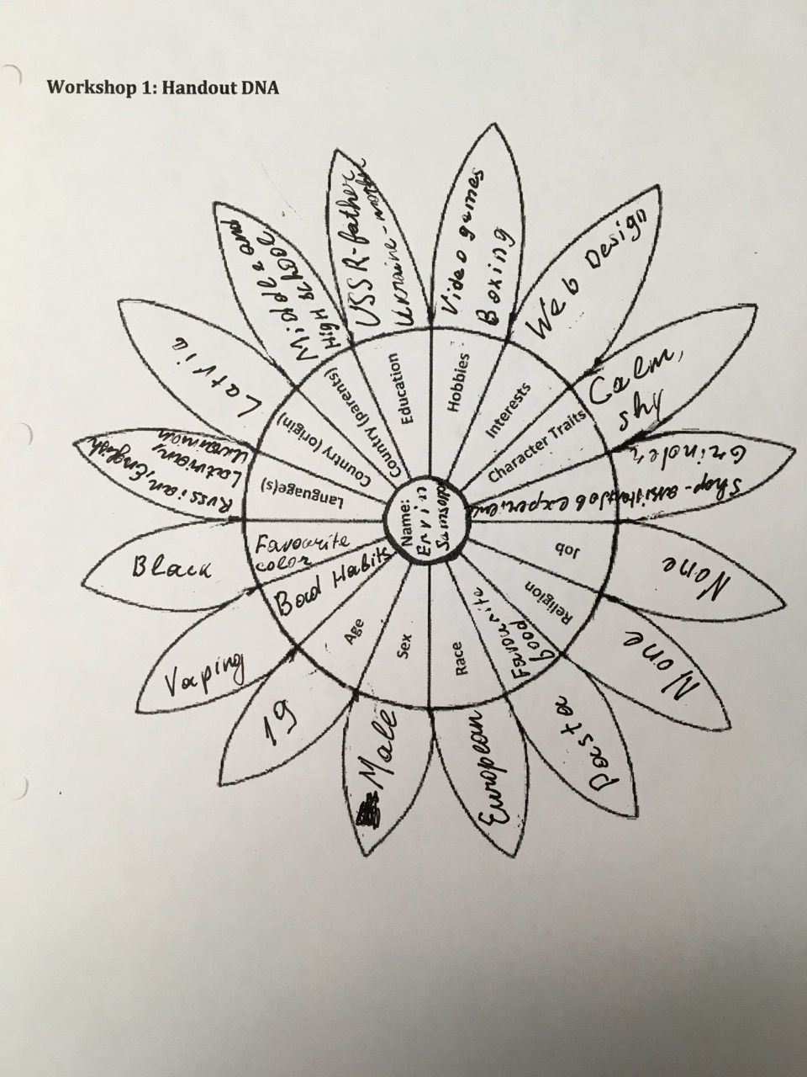

# Attachment 2

*Communication scale*

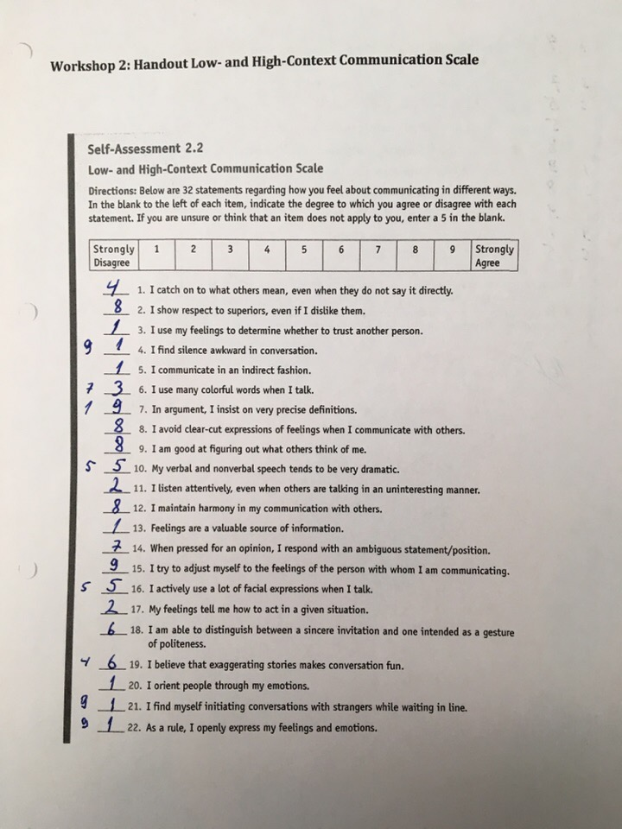

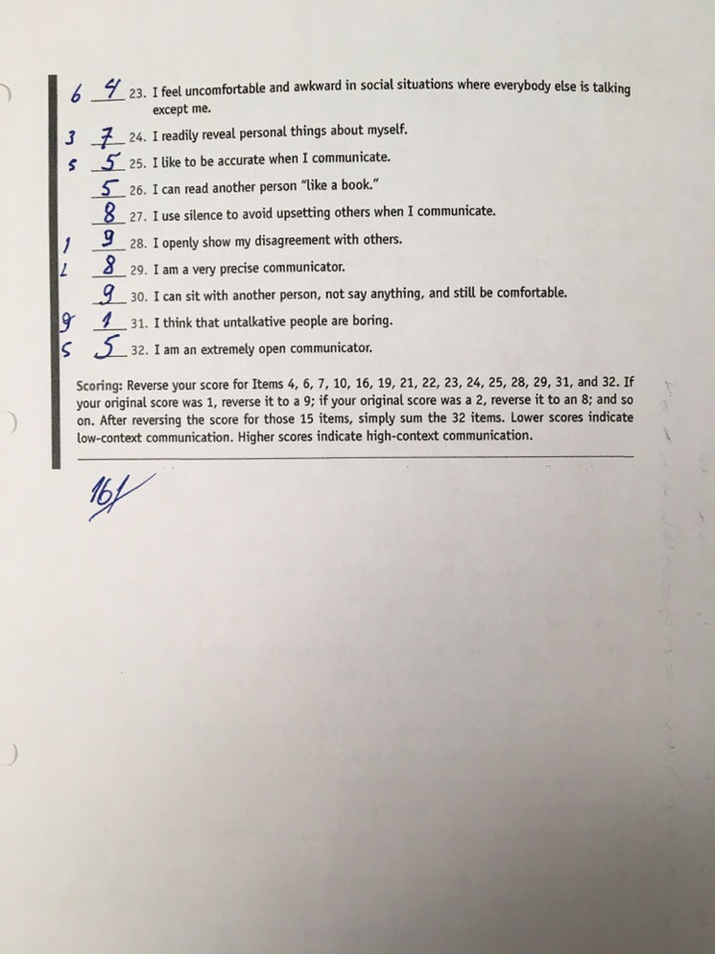

# Attachment 3

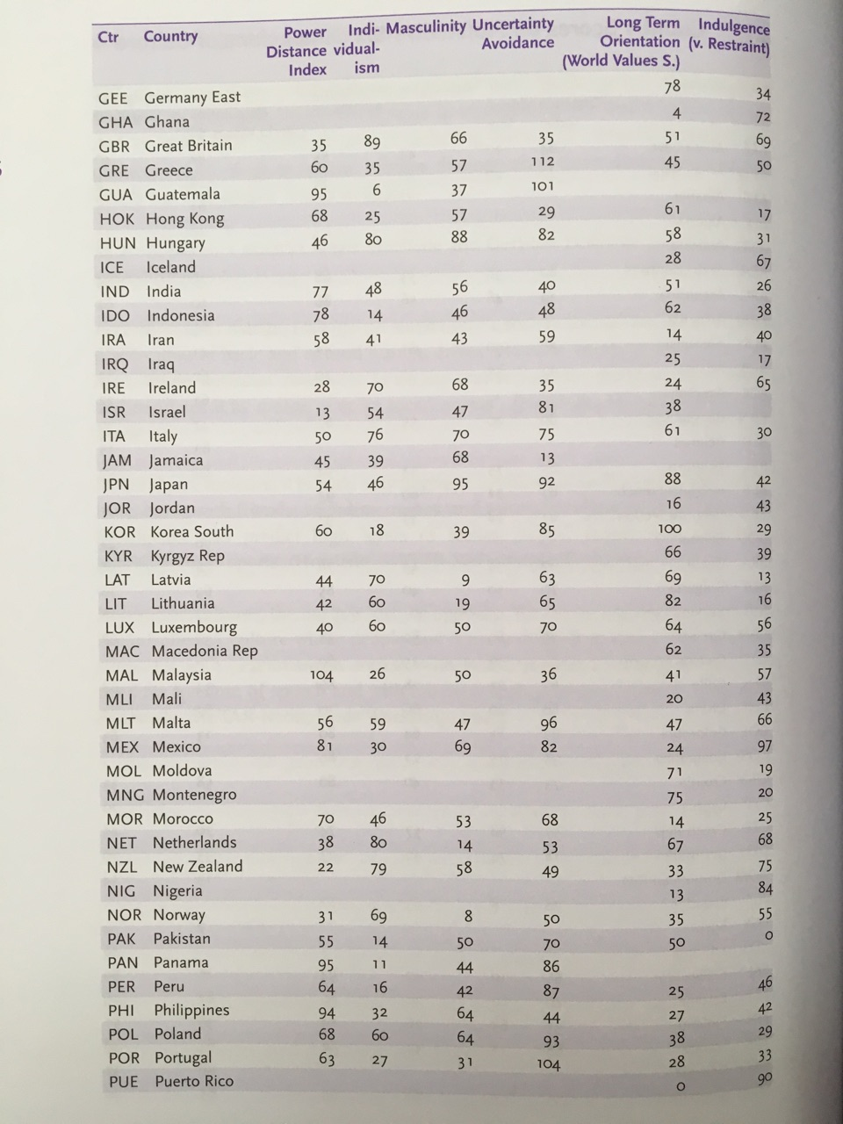*Hofstede’s Dimensions table*

# Attachment 4

*Feedback*

*Daniela Kamenecka*:

“Your work was very nice -straightforward and easy to read. However, I found some typos, so i suggest you go through your text once again. And, maybe, look again at the table with what to write in chapter My Communication Style, because you need to add the ways you adapt to people with other styles and in which situations to do that. Everything other is just fine :)”

