**Credentials:  
Name: Umar Khan  
Class: BESE – 6 (B)  
Registration: 128752  
Lab08**

**Purpose:**The purpose of the lab was to test different techniques of entering large sums of data into a database to observe the time taken by each technique to determine which technique serves us best in entering large data. Each technique had their own complexity.

**What We Have Done:**What I have done is that I have produced a table that correlates between different techniques and the time taken to enter the same amount of data in Milliseconds time, I have taken screenshots for each method as well as the source code has been attached with this document. There is one extra java class by the name of TableDropper that performs the renewal of the table to make sure the table is fresh when entering data into the database to make sure that the external factors like such don’t effect the time data.

|  |  |
| --- | --- |
| **Method** | **Time** |
| Statement(Non-Batched, Auto= False) | **1604 ms** |
| Statement(Non-Batched, Auto= True) | **1374 ms** |
| Statement(Batched, Auto= False) | **1083 ms** |
| Statement(Batched, Auto= True) | **905 ms** |
| Prepared Statement(Non-Batched, Auto= False) | **1132 ms** |
| Prepared Statement(Non-Batched, Auto= True) | **1045 ms** |
| Prepared Statement(Batched, Auto= False) | **374 ms** |
| Prepared Statement(Batched, Auto= True) | **273 ms** |

**Outcomes:**Prepared Statement in general is better than Statement while entering large sums of data but the complexity of coding in Prepared Statement is a bit higher than using the simple Statement, The variations in the AutoCommit and Batched are as such:  
1. AutoCommit True is better than AutoCommit False in all Cases.  
2. Batched Execution is much better than Non-Batched Execution in case of large sums of data.  
3. Prepared Statements Coupled with batch are the best way to enter large sums of data, the time difference is quite noticeable.

**Pictures:**

**Statement, Non-Batched with AutoCommit = Flase: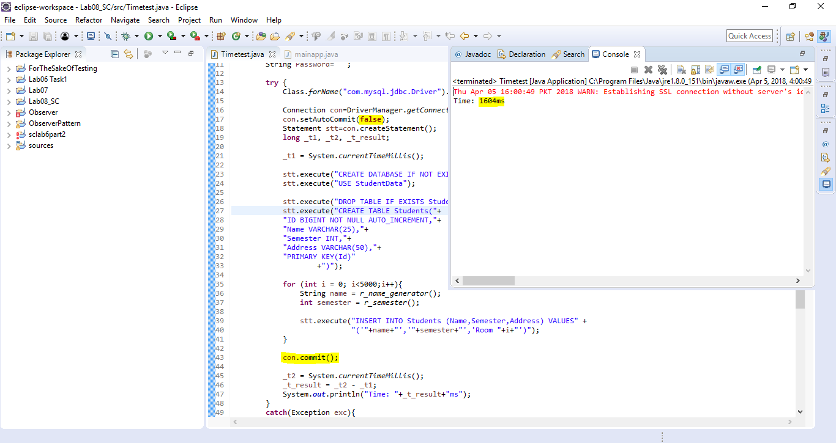Statement, Non-Batched with AutoCommit = True:** 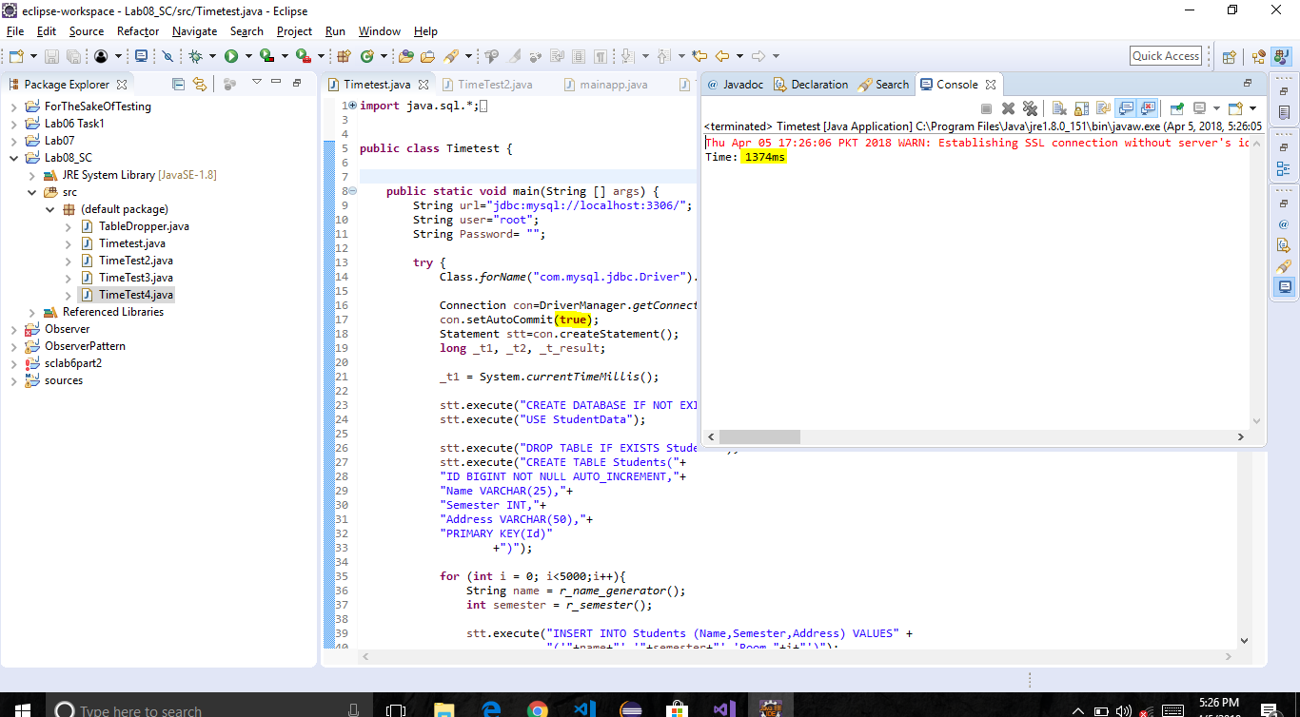

**Statement, Batched with AutoCommit = False:**  
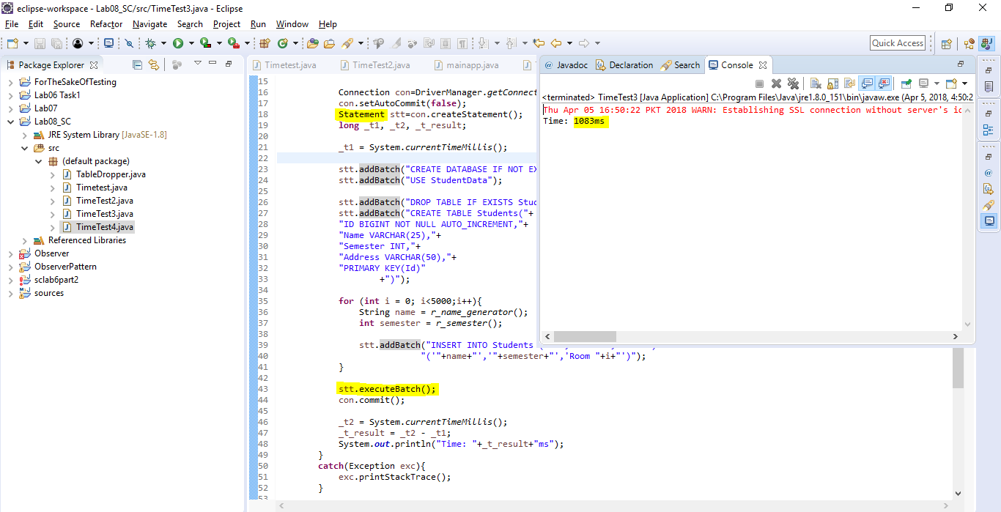 **Statement, Batched with AutoCommit = True:**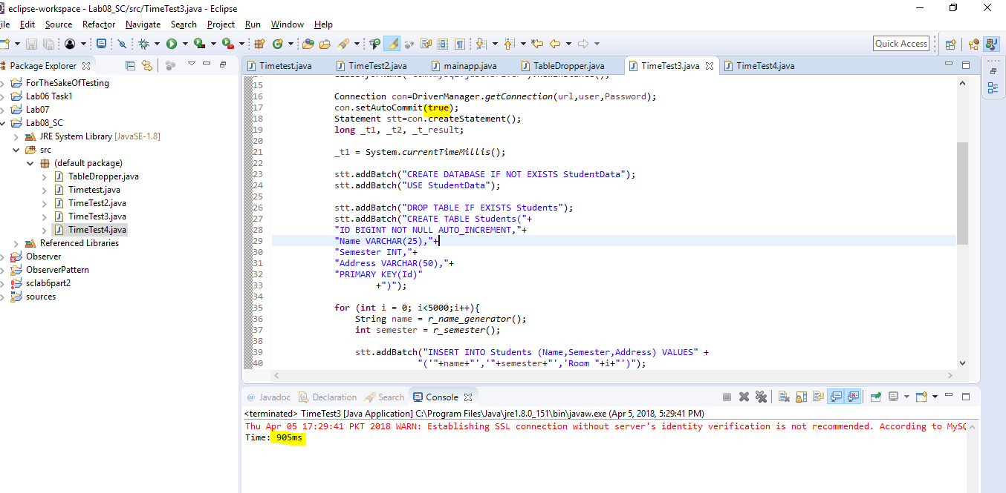

**Prepared Statement, Non-Batched with AutoCommit =False:** 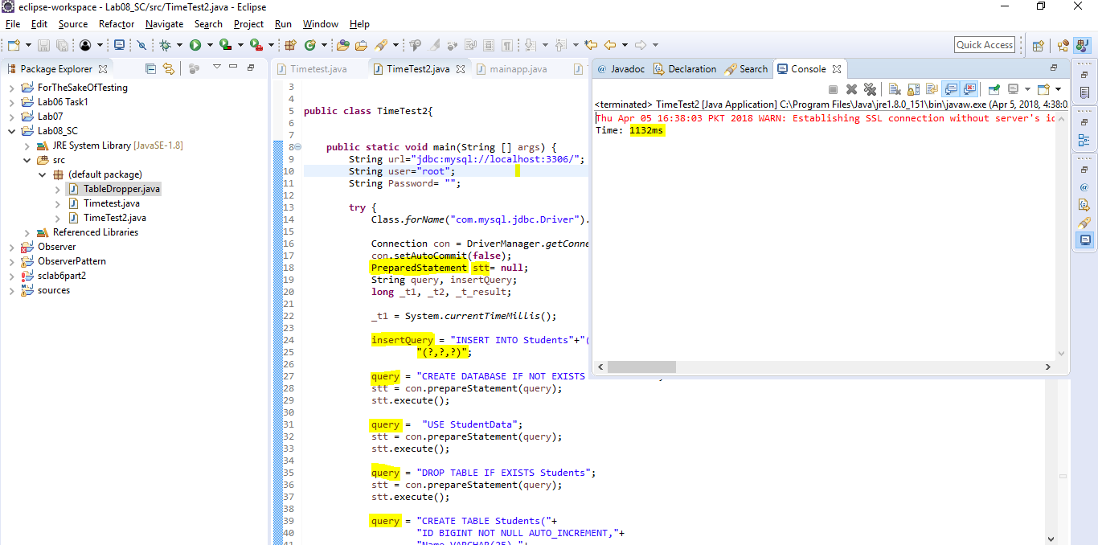  
**Prepared Statement, Non-Batched with AutoCommit = True:** 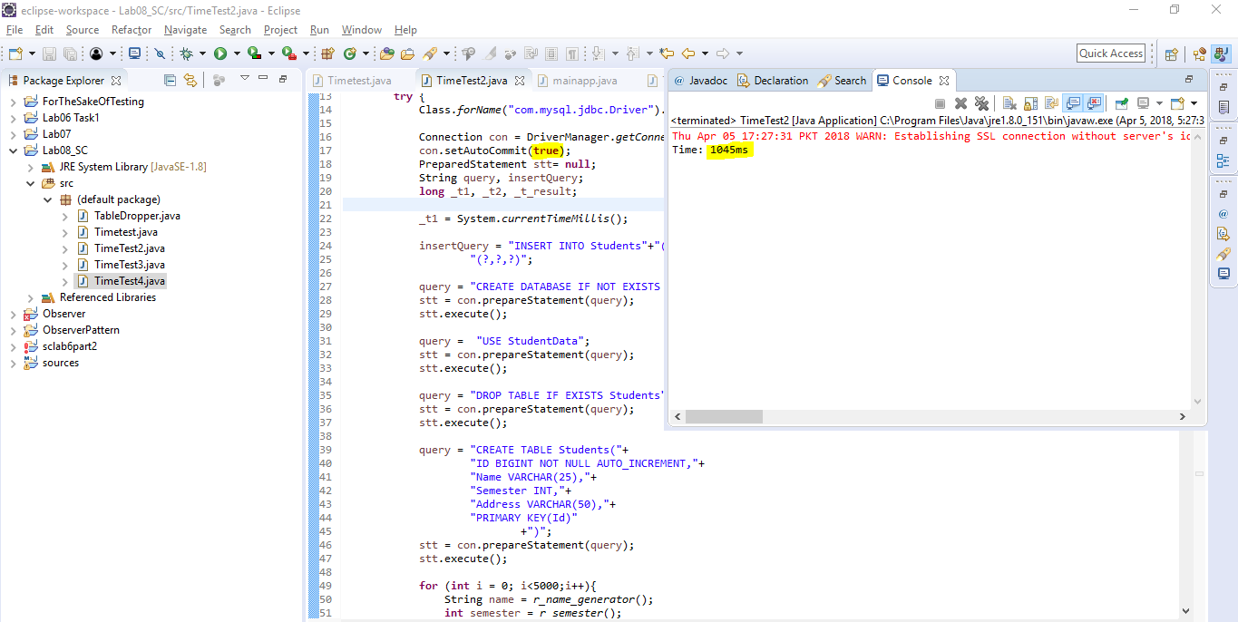

**Prepared Statement, Batched with AutoCommit =False:**   
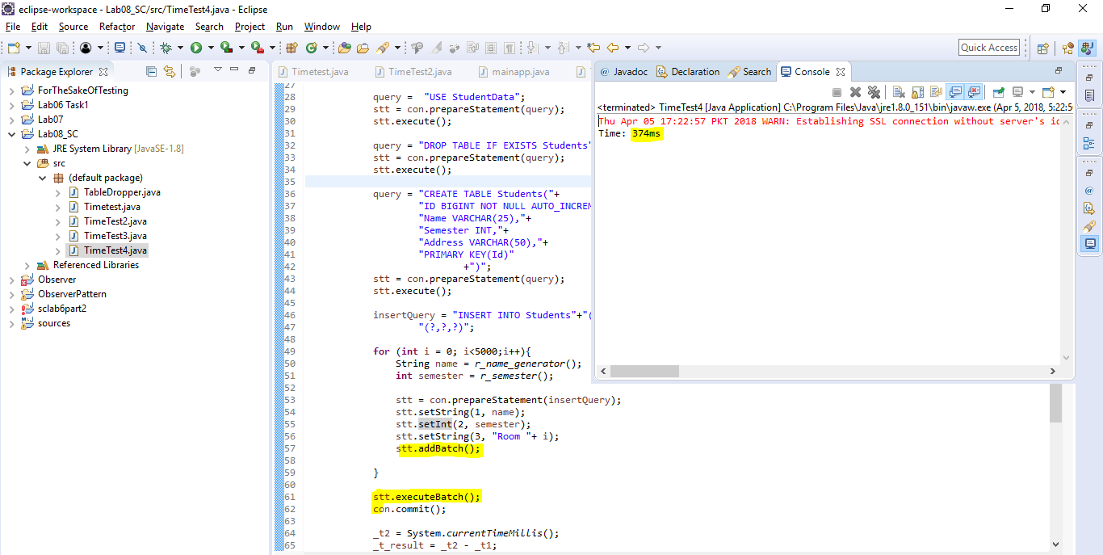  
**Prepared Statement, Batched with AutoCommit = True:** 