**Umar**

**Introduction**  
I've used abalone dataset. The reason I used this dataset is that

* it has enough number of training examples
* the data is already in numerical form

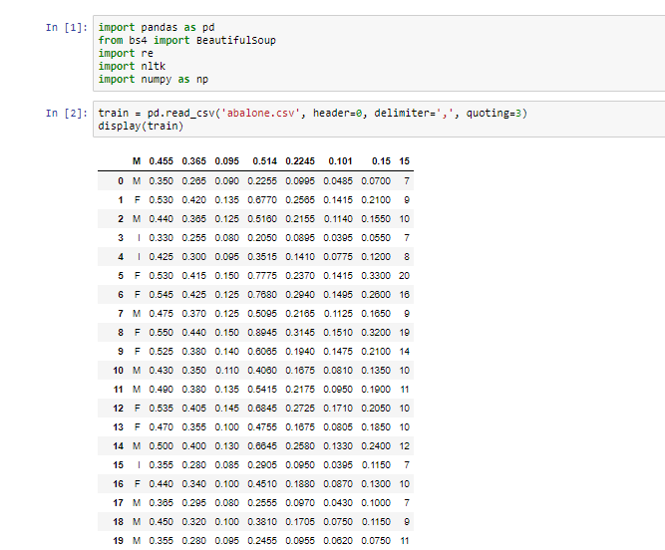

**Algorithms**

I've used

* Support Vector Machines
* Multilayer Perception(Neural Network)
* Least Angle regression

As our problem is regression problem, So I've used these algorithms as they work better for regression problems.

**Code**

Code file is in the folder

**Results**

As these are regression problems so I've used mean squared error function to compute cost. Minimum cost is better

* Support Vector Machines Cost: 8.81
* Multilayer Perception Cost: 7.13
* Least Angle Regression Cost: 4.77

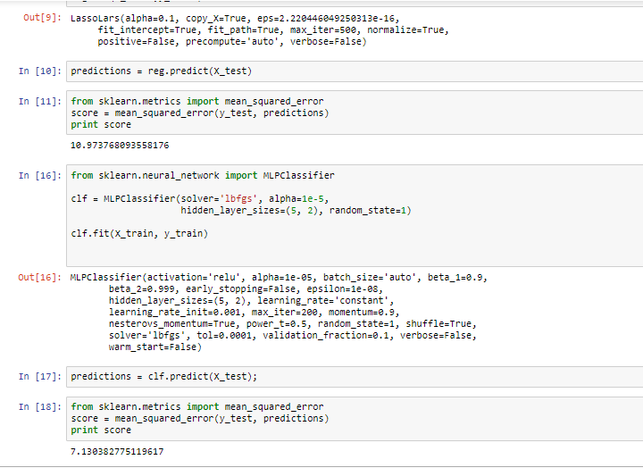

The minimum cost comes with Least angle Regression. Parameters are chosen based on trial and error method.

**Summary**

Just testing out a few things to learn how to choose algorithms to best fit our needs.  
oh and I found a cheat sheet on sci kit learn, check it out

