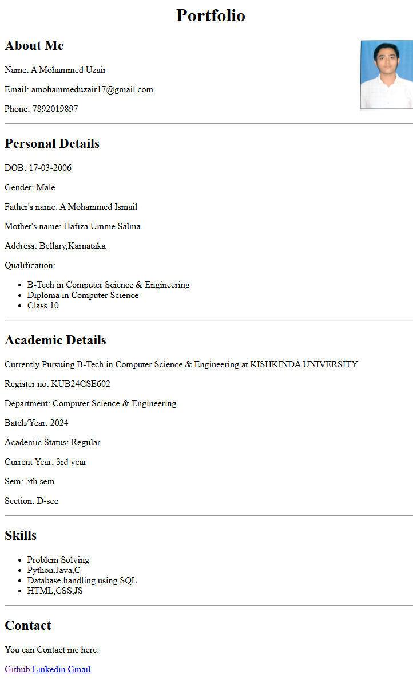

**Source Code:**

<html>

<head>

<title>My Portfolio</title>

</head>

<body>

<header>

<center>

<h1>Portfolio</h1>

</center>

</header>

<section>

<img src=uzair.jpeg width="100" align="right"/>

<h2>About Me</h2>

<p>Name: A Mohammed Uzair</p>

<p>Email: amohammeduzair17@gmail.com</p>

<p>Phone: 7892019897</p>

</section>

<hr>

<section>

<h2>Personal Details</h2>

<p>DOB: 17-03-2006</p>

<p>Gender: Male</p>

<p>Father's name: A Mohammed Ismail</p>

<p>Mother's name: Hafiza Umme Salma</p>

<p>Address: Bellary,Karnataka</p>

<p>Qualification:</p>

<ul>

<li>B-Tech in Computer Science & Engineering</li>

<li>Diploma in Computer Science</li>

<li>Class 10</li>

</ul>

</section>

<hr>

<section>

<h2>Academic Details</h2>

<p>Currently Pursuing B-Tech in Computer Science & Engineering at KISHKINDA UNIVERSITY</p>

<p>Register no: KUB24CSE602</p>

<p>Department: Computer Science & Engineering</p>

<p>Batch/Year: 2024</p>

<p>Academic Status: Regular</p>

<p>Current Year: 3rd year</p>

<p>Sem: 5th sem</p>

<p>Section: D-sec</p>

</section>

<hr>

<section>

<h2>Skills</h2>

<ul>

<li>Problem Solving</li>

<li>Python,Java,C</li>

<li>Database handling using SQL</li>

<li>HTML,CSS,JS</li>

</ul>

</section>

<hr>

<footer>

<h2>Contact</h2>

<p>You can Contact me here:</p>

<a href="https://www.github.com/UZAIR78920">Github</a>

<a href="#">Linkedin</a>

<a href="https://amohammeduzair17@gmail.com">Gmail</a>

</footer>

</body>

</html>

