DemandSense Bus Project Plan
  - Intent based public transport demand estimation
SWE 305 Software Project Management
We plan to deliver an eight-week mobile prototype that estimates relative public transport demand from authenticated app interactions. This plan defines the work, responsibilities, schedule, estimation basis, costs, risks and acceptance evidence needed to deliver that prototype.
Document information | Value
Document date | 1 November 2026
Version and status | 0.1 Proposed baseline for team review
Project manager | Umut Arda Ekiz
Planned duration | 8 weeks | 40 working days
Calculated completion | End of working day 38 | 2 days of schedule reserve
Planned effort | 313 person-hours including coordination
Planning meeting | 3 November 2026, 11:00 to 14:00, in class
Plan submission | 6 November 2026, 21:00, GitHub repository and SABİS

Planning basis
The project purpose, team membership, eight-week duration and functional scope follow the Project Charter dated 12 October 2026. Individual assignments, work estimates, development method, technology selection and detailed technical rules below are planning proposals for team review.
Week 1 is the first agreed implementation week. Its calendar start date must be confirmed before the baseline is adopted. The charter date does not by itself establish the implementation start date. The class meeting and plan-submission dates above are fixed assignment dates, separate from the relative delivery schedule.
All costs are in TRY. The 200 TRY per person-hour rate is an explicit classroom valuation assumption, not a market quotation or a payment commitment. Cash expenditure and the value of student effort are reported separately.

Contents
Section | Page
1 Project purpose and scope | 2
2 Development method and technical approach | 3
3 Team responsibilities and work breakdown | 4
4 Activity register part one | 5
5 Activity register part two | 6
6 Schedule and milestones | 7
7 Network activity diagram | 8
8 Critical path analysis | 9
9 Effort and cost estimation | 10
10 Risks constraints and dependencies | 11
11 Quality delivery and decisions | 12

1 Project purpose and scope
DemandSense estimates interest in selected bus lines and stops before boarding. Meaningful views and direct tracking actions are compared with a historical activity reference for the same line and time period. Users see quieter than usual, normal, or busier than usual demand.
The result is relative app activity. It does not establish exact passenger counts, vehicle occupancy percentages or real-world prediction accuracy.

Scope boundary
Included | Excluded
Mobile sign-in, pilot lines and stops, line details and demand categories | Live municipal integrations, vehicle sensors and physical hardware
Backend API, PostgreSQL data, weighted events and a 15-minute cooldown | Exact passenger numbers or validated occupancy percentages
Historical references, synthetic scenarios and a small protected test panel | City-wide production rollout and large field trials
Automated checks, setup guide, test evidence and a final demonstration | Route recommendations and sensor-data fusion

2 Development method and technical approach
Proposed method: iterative Agile delivery using a Kanban board and a weekly review. Each week the team selects ready work, implements a usable increment and reviews integration results. WBS and dependency calculations provide the baseline; actual results are checked against that baseline each week.
An item is ready when its acceptance condition, API or data dependencies and owner are clear. It is done when its exit condition is met, relevant automated checks pass, a peer has reviewed the change and the documentation is updated. The activity register budgets the effort required for these steps.

Proposed technology baseline
Component | Proposed selection | Reason within the project
Mobile | Flutter | One mobile codebase for the prototype
Backend | Python with FastAPI | API, scoring and synthetic-data workflows in one language
Authentication | JWT access tokens and hashed passwords | Associate events with authenticated users
Persistent storage | PostgreSQL | Users, lines, stops, events and baseline records
Short-lived control | Redis | Atomic cooldown keys and request counters
Demonstration | Local environment | Avoid reliance on paid hosting or municipal access
These selections narrow the alternatives listed in the charter. They remain proposed choices until the team confirms them; no live municipal feed is required.

Proposed operating rules
- A stop view qualifies after at least 3 seconds and contributes +1. Direct line tracking contributes +3. The server verifies event fields and records the authoritative event time.
- Cooldown key: authenticated user, target type and target ID. An atomic Redis operation accepts only the first event for that target during the next 900 seconds. Different event types for the same target share the cooldown. At exactly 900 seconds, a new event is eligible.
- Aggregate accepted events in a rolling 15-minute line window. Each stop-view event must carry a selected line ID so a shared stop is not counted against several lines.
- Proposed baseline: mean score in matched 15-minute periods for that line. If current score divided by a positive baseline is below 0.80, show quieter; from 0.80 through 1.20, show normal; above 1.20, show busier.
- If the baseline is missing or zero, show insufficient reference data. Use synthetic historical samples for demonstration. Window definitions, thresholds and cooldown semantics require team confirmation because the charter leaves these details open.

3 Team responsibilities and work breakdown
The charter names the manager and six team members. The responsibilities below are a proposed allocation; initials identify owners in the activity and cost registers. An owner is accountable for the complete work package and coordinates any peer assistance within its budget.
ID | Team member | Proposed responsibility | Hours
UE | Umut Arda Ekiz | Project manager | 41
FT | Faruk Turnalı | Mobile development | 56
AS | Ali Caner Sezer | Authentication and backend integration | 52
HG | Ahmet Hilmi Güler | Database and API design | 40
HY | Hüseyin Yılmaz | Scoring and baseline logic | 32
YB | Yusuf Büyüktaş | Simulation and system testing | 48
MD | Muhammet Ali Damgacı | Test panel and documentation | 44

Work breakdown structure
WBS | Deliverable group | Leaf work packages
1 | Project management | 1.1 Scope and acceptance A; 1.2 Coordination U
2 | Design | 2.1 UX B; 2.2 Data model and contracts C
3 | Backend services | 3.1 Authentication D; 3.2 Line and stop data E; 3.3 Events G; 3.4 Demand API J
4 | Mobile prototype | 4.1 Screens F; 4.2 Integration M
5 | Demand estimation | 5.1 Weights and cooldown H; 5.2 Baseline comparison I
6 | Simulation tools | 6.1 Generator K; 6.2 Test panel L
7 | Validation | 7.1 Access tests R; 7.2 Boundary tests S; 7.3 System tests N; 7.4 Corrections O
8 | Delivery | 8.1 Setup notes T; 8.2 Final evidence P; 8.3 Demo Q
The leaf packages cover the planned scope. Summary groups do not add hours or cost. U is ongoing coordination effort rather than a predecessor task; all other leaf packages appear in the dependency network. Technical activities include local implementation checks, while group 7 covers cross-component validation and recorded acceptance evidence.

4 Activity register part one
Durations are elapsed working days; effort is person-hours. Monetary values use 200 TRY per hour. Predecessors are finish-to-start with no lag. Dates are calculated relative to working day 0, the start of Week 1.
ID WBS | Work package and exit condition | Owner | Time | After | TRY
A  1.1 | Scope and acceptance criteria  Exit: Scope, rule decisions and acceptance checklist recorded | UE | 2 d  6 h | None | 1,200
B  2.1 | Mobile UX and screen flow  Exit: Sign-in, line, stop and demand screen designs reviewed | FT | 3 d  12 h | A | 2,400
C  2.2 | Data model and API contracts  Exit: Entities, endpoint contracts and event schema versioned | HG | 3 d  12 h | A | 2,400
D  3.1 | Authentication and sessions  Exit: Protected endpoint accepts valid sessions and rejects invalid ones | AS | 4 d  16 h | C | 3,200
E  3.2 | Database and line stop APIs  Exit: Repeatable migrations and seeded line and stop endpoints work | HG | 4 d  16 h | C | 3,200
F  4.1 | Mobile screens with mock data  Exit: Main screens work with loading, empty and error states | FT | 6 d  24 h | B | 4,800
G  3.3 | Interaction ingestion API  Exit: Authenticated events validated and timestamped by server | AS | 3 d  12 h | D, E | 2,400
H  5.1 | Weights and cooldown  Exit: Weights and atomic 15-minute repeat suppression implemented | HY | 4 d  16 h | G | 3,200
I  5.2 | Historical baseline comparison  Exit: All categories and insufficient-reference fallback implemented | HY | 4 d  16 h | H | 3,200
J  3.4 | Demand results API  Exit: Demand endpoint exposes category and reference metadata | AS | 2 d  8 h | I | 1,600

5 Activity register part two
Durations are elapsed working days; effort is person-hours. Monetary values use 200 TRY per hour. Predecessors are finish-to-start with no lag. Dates are calculated relative to working day 0, the start of Week 1.
ID WBS | Work package and exit condition | Owner | Time | After | TRY
K  6.1 | Synthetic data generator  Exit: Seeded scenarios include 20 distinct simulated users | YB | 5 d  20 h | E | 4,000
L  6.2 | Admin and test panel  Exit: Protected panel can trigger scenarios and inspect results | MD | 5 d  20 h | G | 4,000
M  4.2 | Mobile API integration  Exit: Real sign-in, browsing, events and categories work together | FT | 5 d  20 h | F, J | 4,000
N  7.3 | End to end scenario testing  Exit: Acceptance scenarios executed with saved evidence | YB | 4 d  16 h | M, K, L, R, S | 3,200
O  7.4 | Defect correction and regression  Exit: Blocking defects fixed and regression suite passes | AS | 4 d  16 h | N | 3,200
P  8.2 | Final documentation and evidence  Exit: Setup guide, test report and limitations complete | MD | 2 d  8 h | O, T | 1,600
Q  8.3 | Demonstration and release  Exit: Version tagged and demonstration delivered | UE | 1 d  3 h | P | 600
R  7.1 | Access and abuse tests  Exit: Authentication, rate limits and concurrent repeat tests pass | HG | 3 d  12 h | H | 2,400
S  7.2 | Scoring boundary tests  Exit: Threshold, cooldown and baseline boundary fixtures pass | YB | 3 d  12 h | I, K | 2,400
T  8.1 | Setup guide and API notes  Exit: Clean local setup and API examples documented | MD | 4 d  16 h | L | 3,200

Ongoing coordination package U
WBS 1.2 is owned by UE and spans all 40 working days: 32 hours, valued at 6,400 TRY. It includes weekly planning, board maintenance, risk reviews, integration follow-up and delivery coordination. This effort is counted once in team totals and is excluded from the technical critical-path calculation.

6 Schedule and milestones
The proposed calendar has eight weeks and five working days per week. Each member is assumed to have up to 4 project hours per working day. The resource profile contains no simultaneous assignments above this limit, including the manager’s 0.8 hour daily coordination allowance. Actual availability and holidays must be checked when calendar dates are assigned.
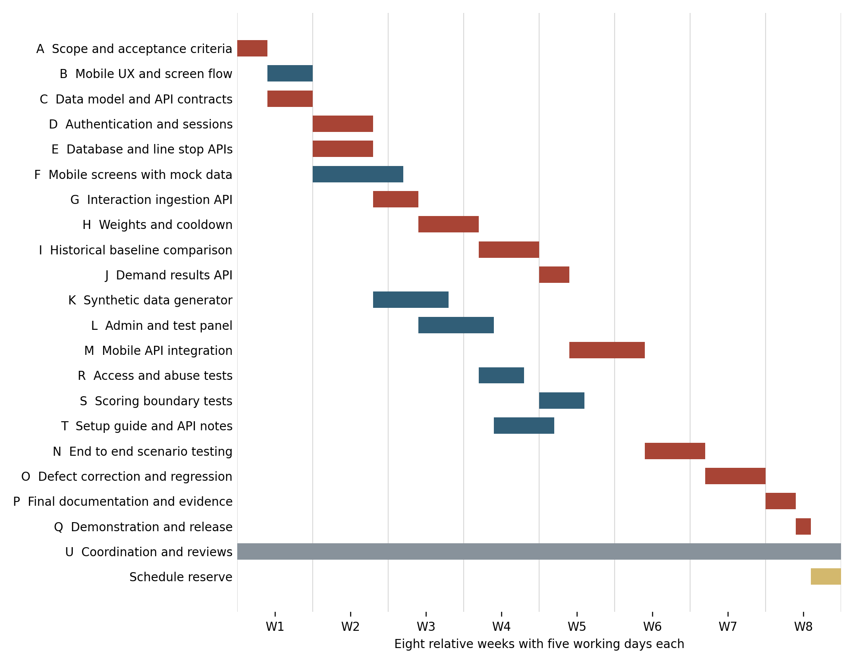
Red bars indicate zero-float activities. Blue bars indicate activities with float. Gray is coordination; gold is the two-day project reserve after the calculated finish.
Checkpoint | Target | Evidence
Scope and design | End W1 | A, B and C complete
Core API and event ingestion | During W3 | D, E and G complete
Scoring and reference logic | End W4 | H and I complete
Connected mobile increment | During W6 | J and M complete
Scenario validation | During W7 | N complete after R and S
Final release | During W8 | O, P and Q complete by day 38

7 Network activity diagram
Each node is an activity ID and its duration in working days. Arrows show finish-to-start dependencies. Red edges and pale red nodes identify critical branches. Full names and exit conditions are in the activity register. U is ongoing coordination and is not a technical dependency.
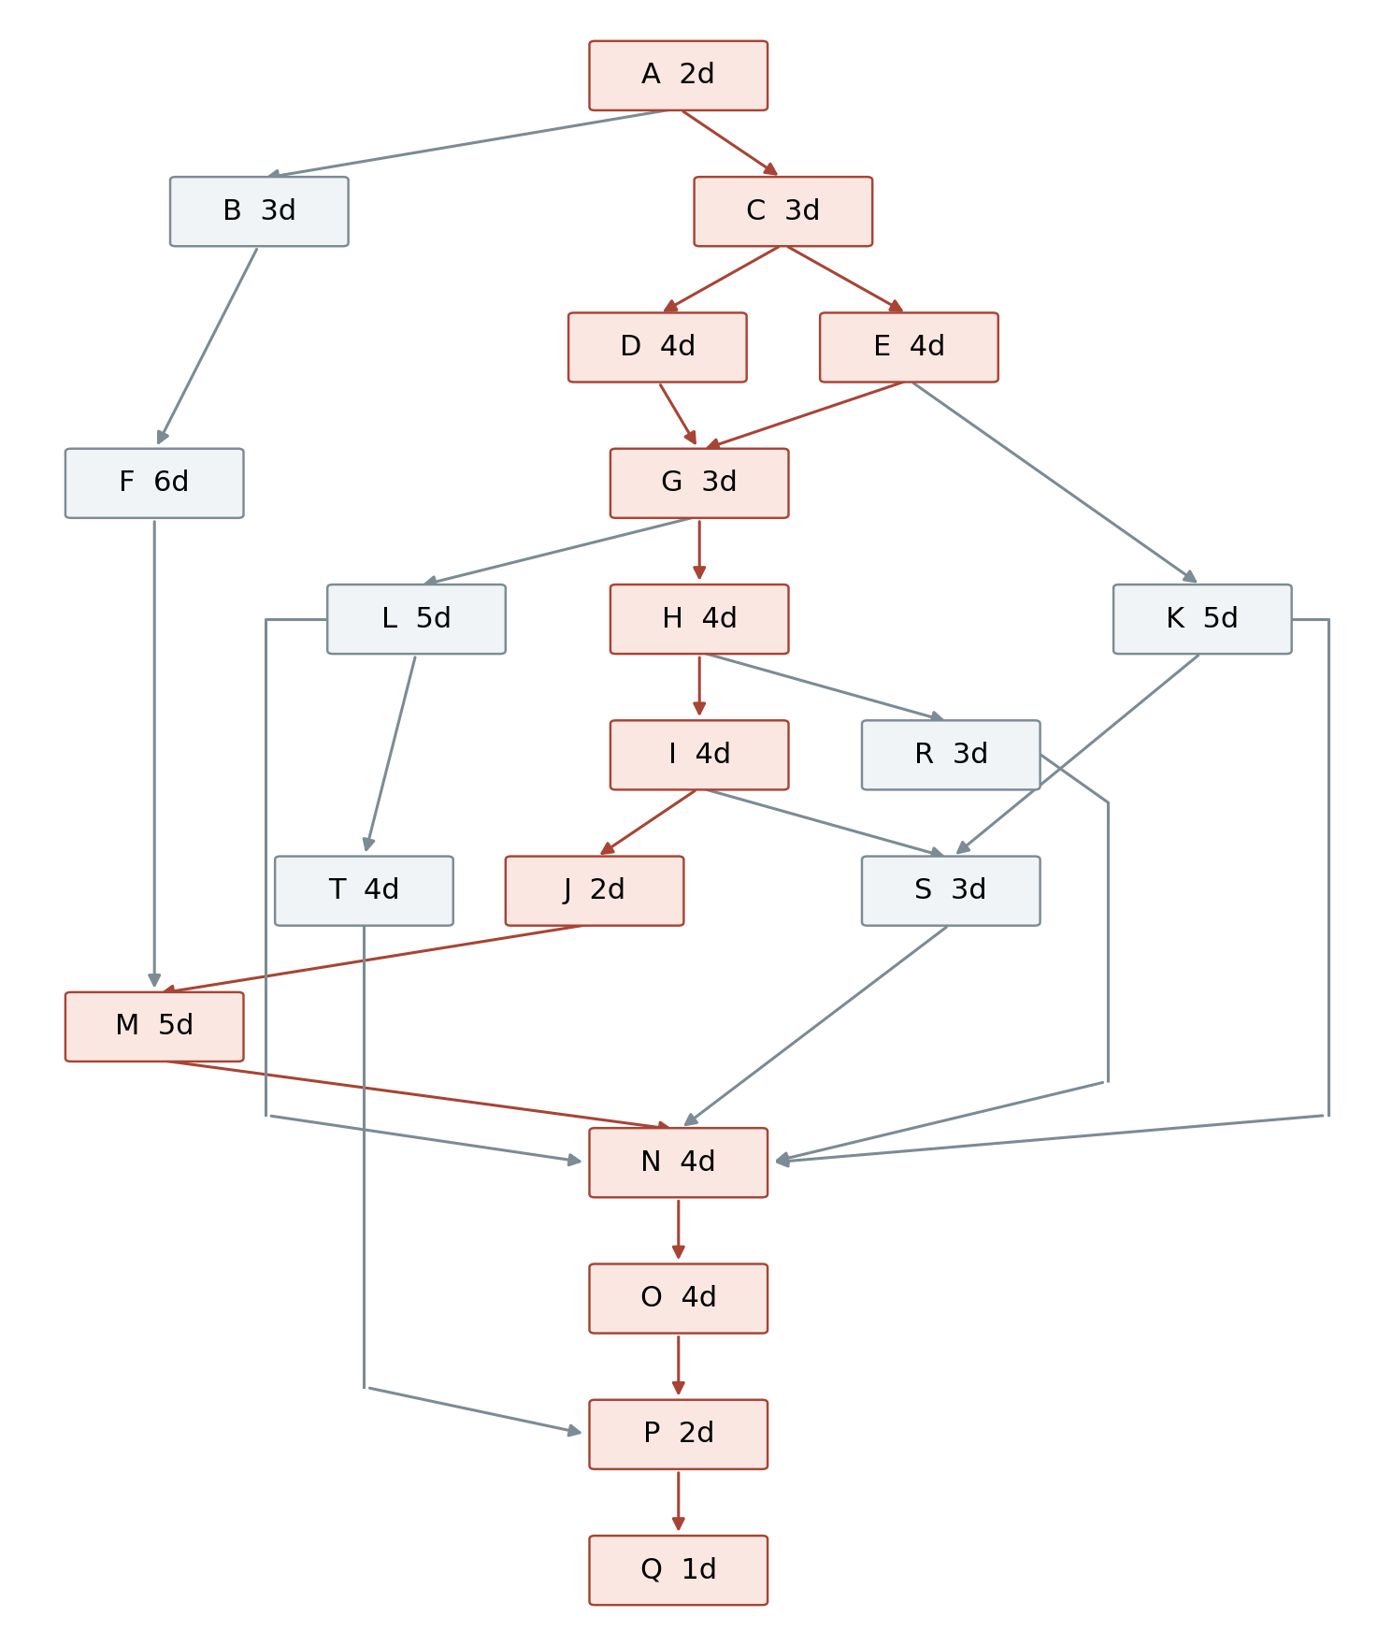
Both authentication D and line/stop services E must finish before event ingestion G. Final scenario testing N waits for the mobile integration, synthetic data, panel, access tests and boundary tests. Documentation P waits for corrected software O and setup notes T.

8 Critical path analysis
The critical path method uses a forward pass for earliest start and finish, then a backward pass from the calculated finish at day 38. Total float is latest start minus earliest start. A zero-float task will delay the calculated completion if it slips without recovery. The separate day 38 to 40 reserve protects the eight-week target.
ID | Days | ES | EF | LS | LF | Float
A | 2 | 0 | 2 | 0 | 2 | 0
B | 3 | 2 | 5 | 13 | 16 | 11
C | 3 | 2 | 5 | 2 | 5 | 0
D | 4 | 5 | 9 | 5 | 9 | 0
E | 4 | 5 | 9 | 5 | 9 | 0
F | 6 | 5 | 11 | 16 | 22 | 11
G | 3 | 9 | 12 | 9 | 12 | 0
H | 4 | 12 | 16 | 12 | 16 | 0
I | 4 | 16 | 20 | 16 | 20 | 0
J | 2 | 20 | 22 | 20 | 22 | 0
K | 5 | 9 | 14 | 19 | 24 | 10
L | 5 | 12 | 17 | 22 | 27 | 10
M | 5 | 22 | 27 | 22 | 27 | 0
R | 3 | 16 | 19 | 24 | 27 | 8
S | 3 | 20 | 23 | 24 | 27 | 4
T | 4 | 17 | 21 | 31 | 35 | 14
N | 4 | 27 | 31 | 27 | 31 | 0
O | 4 | 31 | 35 | 31 | 35 | 0
P | 2 | 35 | 37 | 35 | 37 | 0
Q | 1 | 37 | 38 | 37 | 38 | 0

Two critical paths
A → C → D → G → H → I → J → M → N → O → P → Q
A → C → E → G → H → I → J → M → N → O → P → Q
Each path totals 38 working days. D and E are parallel branches of equal duration and both are required by G, so both branches are critical. Task duration is elapsed time, not person-hours. The network assumes the proposed resource availability and the explicit dependencies shown above.
Day 0 is the start boundary. Day 38 is the end of the 38th working day.

9 Effort and cost estimation
Bottom-up estimation is used: estimate each WBS leaf package, assign an owner and sum the hours. Duration is estimated from the work, dependencies and the proposed availability cap of 4 hours per working day. CPM determines the earliest completion; weekly actual hours and remaining estimates will update the forecast. These are planning estimates, not measurements from completed work.
For each activity, assigned-member cost equals its budgeted person-hours multiplied by 200 TRY. The activity registers show each leaf cost; the table below reconciles those values by member, including U. No separate cost is added for the WBS summary groups.
Member | Assigned activities | Hours | Labor TRY
Umut Arda Ekiz | A, Q, U | 41 | 8,200
Faruk Turnalı | B, F, M | 56 | 11,200
Ali Caner Sezer | D, G, J, O | 52 | 10,400
Ahmet Hilmi Güler | C, E, R | 40 | 8,000
Hüseyin Yılmaz | H, I | 32 | 6,400
Yusuf Büyüktaş | K, N, S | 48 | 9,600
Muhammet Ali Damgacı | L, P, T | 44 | 8,800
Total | All WBS leaf work | 313 | 62,600

Cash budget
Item | Minimum TRY | Maximum TRY | Basis
Development tools and local environment | 0 | 0 | Existing equipment and free tools
Optional hosting | 0 | 1000 | Planning allowance, no supplier quotation
Testing and miscellaneous allowance | 0 | 500 | Charter allowance; spending tracked by manager
Total cash expenditure | 0 | 1500 | No labor payments included
Base labor value: 313 hours × 200 TRY = 62,600 TRY. Total planned economic value including cash allowances is 62,600 to 64,100 TRY. The cash funding requirement remains 0 to 1,500 TRY because student effort is valued for planning rather than paid.
The 16 hours in O explicitly budget defect correction. The final two working days are a schedule reserve and have no additional committed work or labor cost. If that reserve is used for new effort, the manager must update the activity hours and forecast cost before accepting the revised baseline.

Estimate control
Owners record actual hours and remaining work weekly. Any forecast beyond day 40, cash above 1,500 TRY or a change to an agreed acceptance rule is reviewed by the manager and team; course requirements are clarified with the instructor when needed. Optional features are deferred before core acceptance scope is reduced.

10 Risks constraints and dependencies
Likelihood and impact use Low, Medium and High ratings. Owners check these risks at the weekly review. Responses below extend the risks already identified in the charter.
ID | Risk | Likelihood / impact | Owner | Response and trigger
R1 | Few or unrepresentative users | High / High | YB | Use seeded scenarios; label indicators as relative app demand. Trigger: insufficient pilot data.
R2 | Casual taps appear intentional | High / Medium | HY | Apply the 3-second gate and weighted signals. Check short-view and accidental-action fixtures.
R3 | Repeated or concurrent score inflation | Medium / High | AS | Use authenticated identity, atomic cooldown and rate limits. Test simultaneous duplicate requests.
R4 | Weak, missing or zero reference | Medium / High | HY | Use adequate synthetic history and explicit insufficient-data output. Test zero and missing values.
R5 | Integration or schedule delay | Medium / Medium | UE | Agree contracts early and integrate weekly. Replan if a critical task slips or reserve is forecast to run out.
R6 | Reduced member availability | Medium / High | UE | Confirm availability weekly, transfer a documented task and defer optional work when capacity drops.
R7 | Environment or Redis failure | Medium / Medium | HG | Version setup steps and seed scripts. Reject or defer scoring while cooldown control is unavailable; show an error.

Constraints and assumptions
Delivery is limited to eight weeks, seven people, a small pilot dataset and a 0 to 1,500 TRY cash budget. There is no guaranteed municipal API access, labeled occupancy dataset or representative live user sample. The proposed availability cap is 20 hours per person per week; actual exam periods and holidays may reduce it.
The plan assumes access to ordinary development computers, a shared GitHub repository, a mobile test device or emulator, and working local PostgreSQL and Redis instances. Route definitions and historical activity can be synthetic. These assumptions support a demonstration, not validation of live prediction accuracy.

Dependencies
Internal dependencies are defined by the activity register and network. The main external dependencies are repository access, agreed technical decisions, test equipment and instructor feedback. Hosting is optional and does not block the local demonstration. The municipality is a potential future stakeholder, not a confirmed project partner.

11 Quality delivery and decisions

Acceptance evidence
ID | Required check | Evidence
AC1 | A user signs in, browses pilot lines and stops and sees relative demand | Recorded end-to-end scenario and demo
AC2 | A 2.9-second stop view adds 0; a 3.0-second view adds +1; direct tracking adds +3 | Automated rule fixtures with expected totals
AC3 | Duplicates for the same user and target are suppressed before 900 seconds; a new event at 900 seconds is eligible | Boundary and concurrent-request tests
AC4 | 20 distinct simulated users can change the category with configured reference data | Seed, reference values, scores and category before and after
AC5 | Quieter, normal and busier results pass; ratio boundaries 0.80 and 1.20 and missing baseline are covered | Automated category tests against proposed rules
AC6 | Unauthorized access is rejected and configured rate limits are enforced | API tests including invalid sessions and limit responses
AC7 | A clean local setup works and installation notes, test evidence and limitations are delivered | Setup rehearsal, final repository tag and presentation

Communication and release control
Owners update the GitHub board and report blockers as they arise. The manager runs one weekly planning and risk review, records decisions in the repository and checks the integrated increment. Changes require a peer review and passing relevant checks. The final package includes mobile and backend code, migrations, seeded scenarios, test-panel code, setup instructions, test results and demo material.

Decisions before adopting the baseline
Confirm the implementation start date and member availability; accept or revise the proposed role assignments and stack; agree the aggregation window, thresholds, shared-stop attribution and cooldown semantics; and confirm the classroom labor-rate assumption. The manager records the resulting decisions and recalculates affected tasks, dates and costs.

Plan submission checklist
Bring this plan draft to the 3 November meeting. Incorporate feedback, verify diagram and cost consistency, and upload the same final plan document to the team GitHub repository and SABİS by 6 November 2026 at 21:00. The submission requirement applies to the plan document; the prototype follows the agreed eight-week implementation schedule.

Source documents
SWE 305 Software Project Management, Project Plan assignment, 2 pages. DemandSense Bus Project Charter, dated 12 October 2026, 3 pages. Project scope and membership follow the charter; the detailed plan is a proposed elaboration.

