Beaten by Eighteen Features: A Capability-Controlled Test of Privileged Self-Access
Ubayd Hattas
Jaswin Chinthala

Beaten by Eighteen Features: A Capability-Controlled Test of Privileged Self-Access
Ubayd Hattas — Computer Science, Statistics & Data Science, University of Cape Town
Jaswin Chinthala — Electrical Engineering, University of Cape Town
With Apart Research · Digital Minds Research Sprint, Track 3 (Introspection & Self-Report Reliability), 14–16 August 2026
This is the judge-facing submission report. The full technical record — all methods, tables, verification, provenance, cost and appendices A–K — is 10_report.md. Every number here is in it.

Abstract
Model-welfare work runs on self-report, so what matters is not whether a model can predict its own outputs but whether it beats an equal-or-lower-cost outside observer reading the same text. Asked which of two replies it would produce, Hermes-3 discriminated its own from a same-base sibling's: balanced accuracy 0.719, hit − false alarm +0.437. But a one-feature "pick the longer reply" rule scored 0.808 on exactly those pairs, and an 18-feature supervised classifier identified the author at 0.831 under a different procedure. Length explains only part: where the cue points away from Hermes's own reply, it still discriminates (+0.381). A capability-controlled crossed 2×2 — four stimulus constructions on one shared 200-prompt pool, 24 cells, 9,269 trials — shows no positive raw self-advantage on the target column, while the originally preregistered interaction is positive on the leakiest set (+0.089) and is not uniquely diagnostic. Self-prediction is possible here; privileged self-access is not thereby demonstrated. We release a surface-leakage gate and a response-bias check.

1. The question, and why self-prediction alone cannot answer it
People — including researchers — treat an AI's self-report as if it knows something special about itself. Preference elicitation, distress signals and most practical model-welfare methodology run through self-report. If a model's report about itself carries no epistemic advantage over what a comparably capable outsider could infer from the same text, those methods are measuring something other than what they claim, and both over- and under-attribution of moral significance get likelier.
So the question is not can a model predict its own behaviour — it can. It is whether that prediction is privileged. We adopt Song, Lederman, Hu & Mahowald's (2025) operational criterion: a process is introspective only if it is more reliable than an equal-or-lower-cost process available to a third party. Above-chance self-prediction meets that criterion only once the cheap third party has been built and beaten.
Two confounds block a clean black-box test, and this project ran into both. Capability: in every practical configuration the "self" predictor is also the strongest model in the comparison, so Self > Other cannot distinguish "well-fit to its own output distribution" from "simply the better classifier." Surface leakage: a hidden property is only interesting if the model recovers it from something an outsider cannot cheaply read off the text — and our pilot found the property was recoverable almost entirely from style. Rather than treat that as a failed pilot, we made leakage the independent variable.

2. Method
Models. Roles were fixed by a preregistered lineage ladder and verified by API call before selection: M = meta-llama/llama-3.1-70b-instruct and N = nousresearch/hermes-3-llama-3.1-70b — two post-trainings of one pretrained base (the Hermes card states Base model: meta-llama/Llama-3.1-70B) — plus F = mistralai/mistral-small-3.2-24b-instruct, a different organisation, base and architecture family. All three are pinned to one provider at fp8: if M-as-generator and M-as-self-predictor were served at different quantizations, "same weights" would be literally false.
Hidden property. A source prompt is an advice dilemma in which respecting a person's stated preference and protecting their long-term welfare point to different recommendations. A generator answers each prompt twice, once under each of two persona clauses differing only in a values ordering. A trial shows a predictor one text plus both clauses verbatim, order counterbalanced, and asks for a single-letter forced choice. Every predictor gets identical information; the only channel open to the generating model and closed to the others is "I know how I would enact this clause." Ground truth is constructed, not elicited — the label lives in a directory the prediction code structurally cannot import, enforced by a test.
The capability-controlled crossed design. Each of M and N generates a column of texts; each of M, N and F predicts both columns. An additive predictor-level competence effect appears in both of M's cells and cancels in the interaction (M→M − N→M) − (M→N − N→N). A unit test asserts that a pure capability effect returns zero.
The surface baseline (condition D). D is a logistic regression on 18 structural features — length, sentence count, type-token ratio, hedge rate, modal rate, sentiment balance, second-person rate and similar — with no bag-of-words features, so it reads style and not topic, and 5-fold cross-validated grouped by source prompt, so two texts sharing a prompt land in the same fold and topic cannot be memorised. D is never a point on the similarity axis; it is the operationalisation of Song et al.'s equal-or-lower-cost third party, fit per target column.
Four constructions on one shared pool. The crossed design ran on 200 main source prompts × 2 personas per column for four persona/scaffold constructions spanning the leakage axis: 24 cells, ≈400 items per cell, 9,269 scored trials, zero malformed. Main prompts are disjoint from the pilot prompts used to select the sets. Inference is an item-level bootstrap resampling source prompts, not texts, since the two personas from one prompt are not independent.
The self-prediction probe (amendment A8). Every VO-C prompt has an M-authored and an N-authored answer under the same persona clause. Each model is given the dilemma, that clause, and both replies — its own and the sibling's, order counterbalanced — and asked which reply it would produce. Nothing is recalled; this is Binder et al.'s prediction framing, not a memory question.
Provenance. The design was frozen as a preregistration in 02_design_audit.md (15 decision rows, confirmed 2026-08-15, before any main-experiment call). Nine amendments A1–A9 carry dates and reasons and were confirmed by both authors on 2026-08-16, after the results were known; confirmation is not preregistration, and the load-bearing cases are flagged in §8.

3. Result 1 — apparent persona prediction tracks surface style
Five persona pairs × two generator columns = ten column-results, 80 items each, all bought under a feasibility band fixed before the pilot ran (Self 60–80% and D ≤ 58%, per column). Every column failed, and every original-scaffold column failed on D — while Self sat inside the 60–80% band in five of six. The models could read the persona; what they could not do was read it without an 18-feature style classifier reading it too. Across the ten columns corr(Self, D) = +0.71, and D matches or beats the model in six of ten columns; VO-A's N column is the clearest case, D 0.766 against Self 0.610.
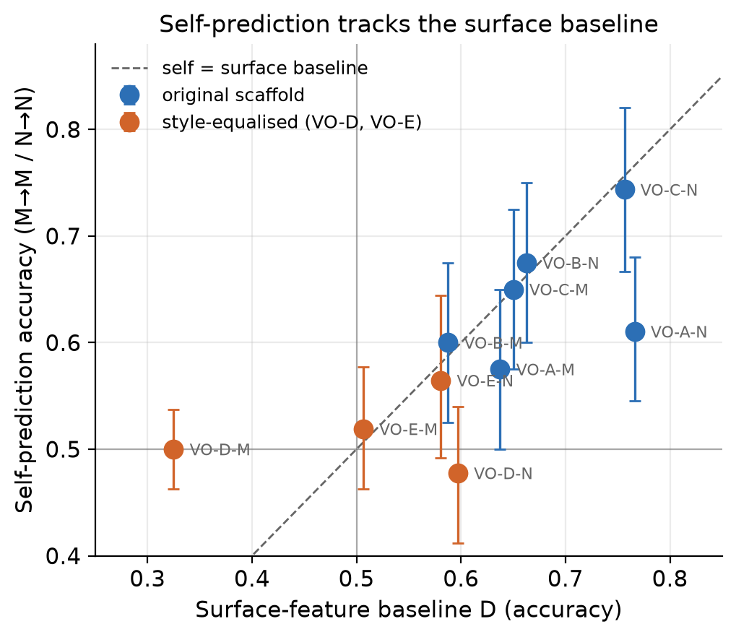
Figure 1. Self-prediction accuracy against surface-baseline accuracy, one point per persona pair × generator column (n = 10). Points at or below the diagonal are columns where a stylometric baseline matches or beats the model at reading the model's own persona.
Closing the leak removed the signal — and more besides. VO-D's scaffold fixes the response at four sentences / 85–105 words in a fixed skeleton and instructs the generator not to hedge. On the M column D fell to 0.325, below chance, and Self fell with it, to 0.500. VO-E (amendment A5) changed exactly one sentence of that scaffold and reproduced the collapse (Self 0.519, D 0.506).
This is our largest limitation, and we found it ourselves, after the fact. The equalising scaffolds did not only flatten style; they also converged what the two personas recommended. Content-word overlap of sentence 1 — the sentence reserved for the recommendation — is 0.364 (VO-D) and 0.343 (VO-E) against 0.082–0.107 for the three original-scaffold pairs, while whole-text overlap is unchanged at 0.17–0.21; in a hand-checked sample of 25 VO-D prompts, roughly four in five gave the same recommendation under both clauses. No manipulation check was preregistered and none was run before the main run; these overlap figures were computed ad hoc from the logged texts afterwards. Where both personas recommend the same course the hidden label is close to arbitrary with respect to content, so no predictor could exceed chance there by any route. VO-D/VO-E are therefore not a clean causal isolation of style: the surface-classifiable distinction and the behavioural distinction fell away together, and we claim no mediation.

4. Result 2 — the crossed design
Table 1. Four stimulus constructions, ordered by mean surface baseline. Prompt-clustered bootstrap CIs. Cell-level accuracies for all 24 cells are in the full report, Appendix H.
Set | D (M col / N col) | Raw self-advantage on M's column (M→M − N→M) | Capability-controlled interaction
VO-D (style-equalised) | 0.551 / 0.536 | +0.000 [−0.015, +0.015] | −0.006 [−0.033, +0.021]
VO-B (original) | 0.647 / 0.753 | +0.000 [−0.033, +0.035] | +0.005 [−0.040, +0.050]
VO-A (original) | 0.664 / 0.751 | +0.020 [−0.015, +0.056] | −0.030 [−0.079, +0.018]
VO-C (original, leakiest) | 0.693 / 0.845 | −0.033 [−0.058, −0.008] | +0.089 [+0.048, +0.131]
On the raw M-target contrast, no construction shows a positive self-advantage whose interval excludes zero. The single significant value on that contrast is negative. On VO-C's M column the self model is the worst of the three predictors of its own output — M→M 0.603 [0.572, 0.635] below N→M 0.636 [0.604, 0.668] and F→M 0.628 [0.596, 0.661] — so Llama is beaten on its own text by a 24B model from another organisation. M is simply the weakest classifier of the three: N and F beat it on both columns.
The originally preregistered estimand is positive on the leakiest set, and we do not bury it. VO-C's interaction is +0.089 [+0.048, +0.131], and the same pattern appears with F as the reference predictor. Read at face value that is a capability-controlled self-advantage — the one number in this study that points the Binder way. It does not uniquely establish privileged access, for a reason internal to the estimator: the interaction cancels an additive predictor-level competence effect but not a predictor-by-column difference, and VO-C exhibits exactly such a difference. Moving from column M to column N, F gains +0.135 and N gains +0.130, while M gains only +0.041; the interaction is positive because M under-performs on N's column, not because it over-performs on its own. The most economical reading is M's differential weakness as a style-reader — a diagnosis, not an adjudication. We neither claim this number nor claim to have explained it away; it is the result a larger, better-powered design would need to resolve.
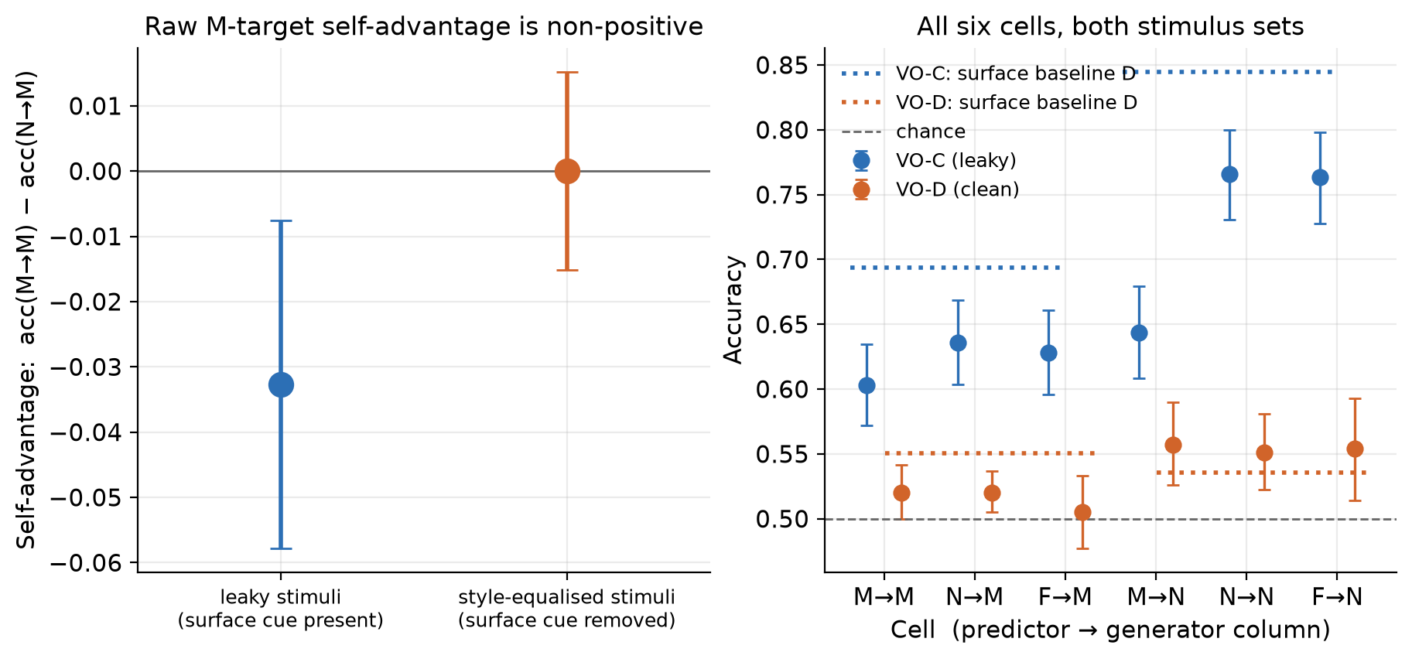
Figure 2. The leakage manipulation. Left: the raw self-advantage acc(M→M) − acc(N→M) for the leaky and style-equalised sets, prompt-clustered CIs. Right: all six cells for both sets, with the surface baseline drawn in — on the leaky set it sits above every language model, including the self cell. Read the style-equalised bars with §3 in hand.
Three scope limits travel with this table. First, VO-D's null carries less weight than it looks: both its estimates exclude the applicable SESOI (row P5: 5 pp for a simple contrast, 8 pp for the interaction at the achieved n), but §3 shows the personas had largely stopped recommending different things, so the flatness is not evidence about self-access. Second, these are four constructions on a shared 200-prompt pool, not four independent prompt samples — a defect in the pool would propagate to all four. Third, the achieved sample size is below the preregistered floor: row P4 set a target of 1,000 items per cell with a floor of 500; the main run used 200 source prompts for ≈400 per cell, and VO-D's N column retained 323 after a pre-declared exclusion. No amendment authorised the reduction and no reason is recorded, so none has been invented. The cost is precision; the intervals above are the intervals that n supports.

5. Result 3 — self-prediction, and a cheaper observer
The persona property leaves one question open: does the style-equalised null mean "no privileged access" or merely "no readable signal for anyone"? Authorship settles the second half. The information is plainly there: a surface classifier fit to author discrimination on VO-C texts — 18 features, grouped cross-validation — identifies the author 83.1% of the time across 791 texts.
Two self-recognition framings failed to elicit anything: in a forced choice M answered "A" on 99.0% of trials and N "B" on 98.7%, and in a single-text framing both answered "no" to 100% of 791 texts. Both are elicitation failures, not measurements — the apparent ~50% is what counterbalanced order mechanically produces from a constant answer, and reporting accuracy alone would have published a clean-looking null that is entirely an artifact. Amendment A8 re-ran the probe as self-prediction.
Table 2. Self-prediction on VO-C texts, split by which slot the model's own text occupied — which converts a counterbalanced forced choice into a signal-detection problem, since discrimination (hit − false alarm) is zero for a model answering by position alone. Intervals are 95% prompt-clustered bootstrap and are post hoc. The last two rows are external comparators, not model scores.
 | Llama-3.1-70B (M), n = 387 | Hermes-3-70B (N), n = 391
Raw accuracy | 0.460 | 0.714
Share answering "A" | 0.897 — just under the 0.90 degeneracy threshold fixed in advance in A8 | 0.32
Correct when own text was A / B | 0.845 / 0.048 | 0.537 / 0.900
Discrimination (hit − FA) | −0.107 [−0.166, −0.048] | +0.437 [+0.349, +0.519]
Balanced accuracy | 0.447 | 0.719 [0.675, 0.762]
Comparator (post hoc): length-only rule, same pairs | — (see below) | 0.808 [0.768, 0.847]
Comparator: 18-feature classifier, single-text authorship | 0.831 | 0.831
Hermes-3 predicts its own output above chance. Balanced accuracy 0.719 with discrimination +0.437 is not a position artifact: Hermes is right 90.0% of the time when its own text is in slot B and 53.7% when in slot A, so despite a clear B-preference it separates the two texts far better than any constant strategy could. Llama-3.1 shows none: discrimination −0.107, slightly anti-correlated. Its 89.7% "A" rate sits just under the threshold fixed in advance, so the degeneracy rule did not formally fire; we report the margin rather than round it up. Self-prediction here is a property of a particular model, not of "language models".
A cheaper observer beats it overall. Hermes's own reply is the longer of the two in 316 of 391 pairs (median 227 words against Llama's 180), so "pick the longer reply" — one feature, fit to no labels, costing nothing — scores 0.808 on exactly the pairs Hermes was asked about. That comparator is matched item-for-item, so a paired test is meaningful: paired difference +0.095 [+0.036, +0.155] in the rule's favour, and of the 135 pairs where the two disagree the rule is right on 86 and Hermes on 49 (exact McNemar p = 0.0018). The 18-feature classifier's 0.831 also exceeds 0.719, but it is supervised single-text labelling against Hermes's zero-shot pairwise forced choice — a different evaluation procedure, so 0.719 versus 0.831 is a comparison against a criterion and no test is run between them. The length rule and the intervals in this section are post hoc: found during a post-experiment review, computed from already-collected texts.
But length does not explain Hermes's residual. On the 75 pairs where Hermes's own reply is not the longer one — where a pure length strategy is actively wrong — Hermes still discriminates at +0.381 [+0.188, +0.566], with accuracy 0.653 against 0.728 where length agrees. Smaller, and clearly positive.
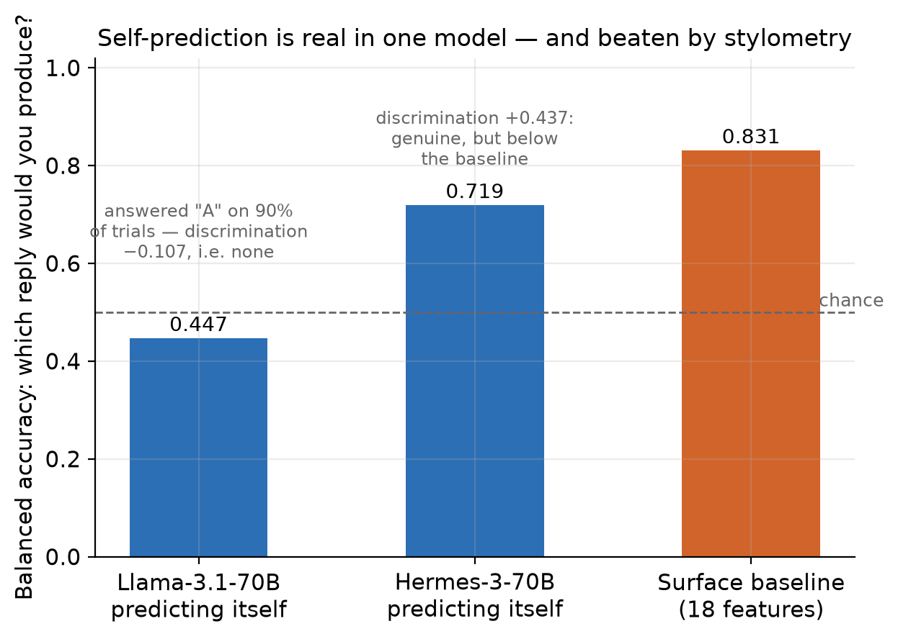
Figure 3. Self-prediction under Binder et al.'s framing, scored as balanced accuracy so a model answering by position alone cannot score. Hermes-3 discriminates (0.719; +0.437); Llama-3.1 does not (0.447; −0.107). The surface classifier's 0.831 is drawn as a cost criterion, not a matched score — it is a different, supervised procedure — and the bare length rule reaches 0.808 on Hermes's own pairs (post hoc; not shown).

6. Discussion
Self-prediction is possible here; privileged self-access is not thereby demonstrated. Hermes-3 exhibits positive, interval-bounded self-prediction discrimination, and we are not walking that back. But the criterion adopted before data collection asks whether the model beats an equal-or-lower-cost third party reading the same text, and on this probe it does not: a one-feature rule that never inspects model identity predicts the same outcome better overall.
Cheap external observers matter more than they are usually made to. On the persona property the 18-feature classifier matched or beat the model in six of ten pilot columns and, on the leakiest main set, sat above every language model including the self cell. Any paradigm reporting above-chance self-prediction without fitting a surface-feature classifier on the same stimuli, per condition, cannot by itself distinguish self-knowledge from style-reading — a threat inherited by every experiment that infers introspection from prediction of a hidden property.
And yet something model-specific survives. Where the length cue points away from Hermes's own reply, Hermes still discriminates at +0.381. Learned self-preference, an idiosyncratic style not captured by length, and genuine behavioural self-modelling all predict that pattern, and this design separates none of them. We call it what it is — a model-specific residual with an unresolved mechanism — and neither "privileged access" nor "mere style".
What this does not show. Not that models lack self-knowledge — our style-equalised condition could not show that, because there the signal is unreadable for every predictor and the personas had largely stopped recommending different things. Not that self-prediction is always stylometry, and not that the positive interaction has been explained away. It does not refute Binder et al., who finetune both models on ~30k examples, nor speak to Lindsey's activation-level results, which need access we lack.

7. Methodological contribution
Two checks changed what this study ran and what it concluded. Both are released as one file, tools/surface_leakage_gate.py — numpy only, no dependency on the rest of the repository.
The surface-leakage gate asks one question before a main run is paid for: can a trivial style classifier recover my hidden property from the same stimuli? The grouping by source prompt is the part most easily got wrong and is not optional — if two texts sharing a prompt land in different folds, the classifier memorises the topic and the baseline inflates.
The response-bias check catches a predictor answering by position rather than content: under a counterbalanced forced choice a model that always answers "A" scores about 50%, indistinguishable in an accuracy column from a clean null. We hit this twice — both self-recognition framings, and Llama-3.1's 89.7% "A" rate.
from surface_leakage_gate import gate, response_bias
if not gate(texts=texts, labels=labels, groups=prompt_ids).passed: # groups = source-prompt id
... # default threshold 0.58 — your stimuli leak
if response_bias(answers).degenerate: # answers e.g. ["A", "A", "B", ...]
... # default: any single answer above 90% of trials
Passing the gate is necessary but not sufficient, and we know that from our own use of it: a low score licenses only "these 18 features do not recover it," never "no cheap cue remains", and VO-D passed the gate while still being uninformative. The estimate is also noisy at pilot n — the same VO-D design scored 0.325 on 80 items and 0.551 on ≈400. It is a candidate diagnostic with no external validation beyond this study, not a validated benchmark: use it to reject leaky stimuli, and treat a pass as the beginning of the argument.
Recommendation. For behavioural self-prediction and introspection studies, report a grouped cross-validated surface-feature baseline on the same stimuli, and the predictor's answer distribution, before interpreting any above-chance result as privileged access.

8. Critical limitations
- The style-equalising manipulation was not clean, and no manipulation check was run before the main data (§3). VO-D/VO-E converged what the personas recommended as well as how they wrote, so that condition cannot separate "no privileged access" from "the property was no longer behaviourally expressed." This is the largest threat to the leakage interpretation, and we found it by post-hoc inspection of our own texts.
- The primary estimand was substituted after the pilot (amendment A4), with the stimulus sets selected on their surface-baseline values, and the direction predicted for the new primary contrast was wrong. Both estimands are reported, and the one A4 replaced is the one that is positive on VO-C.
- Achieved n is below the preregistered floor (§4): target 1,000/cell, floor 500, actual ≈400, and 323 in VO-D's N column. No amendment authorises the reduction and no reason is recorded, so none has been reconstructed.
- One lineage, one hidden property, prompting only, at one pinned quantization, with a weakly established similarity axis (calibration Δ = +2.1 pp, CI spanning zero).
- Behavioural evidence only. We make no claim about introspection, internal states, sentience or moral status; the ceiling is same-weights behavioural self-modelling, and prediction happens in a fresh session, so nothing here bears even on same-episode memory.
- The §5 intervals and the whole length analysis are post hoc (amendment A9), computed after the experiment from already-collected data and outside A8's declared plan — diagnostic, not confirmatory.
- The comparators are asymmetric. The 18-feature classifier is supervised and labels single texts; the models answer zero-shot on a pairwise choice. We argue the comparison is the right one for the hypothesis — a model with privileged access to its own output distribution should not need labelled examples of its own writing — but a reader who disagrees should weight the length rule, which is matched item-for-item.
- Amendments are confirmed, but confirmation is not preregistration. Rows P1–P15 were confirmed 2026-08-15 before any main-experiment call; A1 and A3–A9 were confirmed by both authors on 2026-08-16, after the results were known, with every original status line preserved. Two provenance items remain open and are disclosed as open: who screened the VO-D/VO-E clause pairs and when, and the reason for the sample-size step-down.

9. Future work
Our own data leave one question open: what is the model-specific residual that survives control of cheap surface cues, and can a behavioural test be built in which a positive privileged-access result would be identifiable? This is a decision tree, not a schedule.
Stage 1 — dissociate self-preference from self-prediction. Re-run the A8 probe on the same pairs under two questions: which reply would you produce against which reply is better on the stated criterion. A residual as large under the quality question reads as self-preference or a general authorship signal; one specific to the prediction framing is the more discriminating outcome. Stimuli need a hidden property with a behavioural manipulation check run before main collection.
Stage 2 — retrospectively audit existing claims. Where published data permit, apply the released checks to existing behavioural introspection and self-prediction results and ask how many survive controls this cheap. It needs no new model runs and tests whether the framework generalises beyond our stimuli.
Stage 3 — stronger causal tests, conditional. Only if a residual survives Stage 1 and audited effects do not dissolve: a training-relationship ladder against our one-lineage limit; open-weight activation steering or an independently planted property, so ground truth is verified rather than assumed; and an incremental-validity test of whether a self-report carries information beyond an observer's features. If Stage 1 dissolves the residual, that is the result and Stage 3 does not run.

Author contributions
Ubayd Hattas led the experimental design and statistical reasoning: the crossed 2×2 capability control and its interaction estimand, the calibration probe, the prompt-clustered bootstrap and paired comparisons, the statistical specification of the surface baseline, the quantitative interpretation, and the analysis code implementing those estimators.
Jaswin Chinthala led the literature grounding, the hidden-property task design and the pilot feasibility judgment, and led the engineering and data collection: the pinned OpenRouter client with its pre-request budget guard, the generation and prediction runners, checkpointing and append-only logging, the reproducibility tooling and repository infrastructure, and the figure and presentation engineering.
Both authors framed the research question, developed the persona clause pairs and stimulus scaffolds at project level under preregistered rows P10/P13, took the experimental decisions recorded as amendments A1 and A3–A8, and share the interpretation, discussion, limitations, final manuscript, presentation and final review. Both confirmed A1 and A3–A9 on 2026-08-16.

Code, data and cost
Repository: https://github.com/UbaJaz/Digital_Minds_Research. Every API call is logged append-only with returned model id, pinned and returned provider, token counts, computed cost, timestamp and prompt hash; stimuli are frozen with content hashes. Generation used temperature 1.0 and provider seed reproducibility is unverified, so the logged texts — not re-sampling — are the reproducible artefact. Total spend $3.12 of a $10 ceiling. Full record: 10_report.md; preregistration and amendments: 02_design_audit.md; post-hoc audit: notes/A9_post_hoc_audit.md.

References
- Binder, F. J., Chua, J., Korbak, T., Sleight, H., Hughes, J., Long, R., Perez, E., Turpin, M., & Evans, O. (2025). Looking Inward: Language Models Can Learn About Themselves by Introspection. ICLR 2025. arXiv:2410.13787
- Song, S., Hu, J., & Mahowald, K. (2025). Language Models Fail to Introspect About Their Knowledge of Language. COLM 2025. arXiv:2503.07513
- Song, S., Lederman, H., Hu, J., & Mahowald, K. (2025). Privileged Self-Access Matters for Introspection in AI. arXiv:2508.14802
- Lindsey, J. (2026). Emergent Introspective Awareness in Large Language Models. Anthropic. arXiv:2601.01828

