When COVID 19 touched the African shores, WHO predicted high fatality rate mainly due to lack of infrastructure and healthcare facilities. But Africa startled everybody and fought strong. When compared to most of the continents, Africa stood its ground against COVID, and fights strong to this day.

I decided to analyze the data for myself to make sense of what has transpired since January 2020, at a Global level and compare it to the situation here in South Africa. Here is the summary:

We have seen America leading the chart followed by Asia.

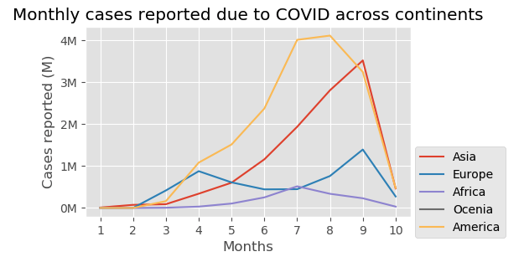

Europe has fewer cases when compared to Asia, but we see high mortality rate and a drastic rise in number of deaths due to COVID, and only after April the curve has declined.

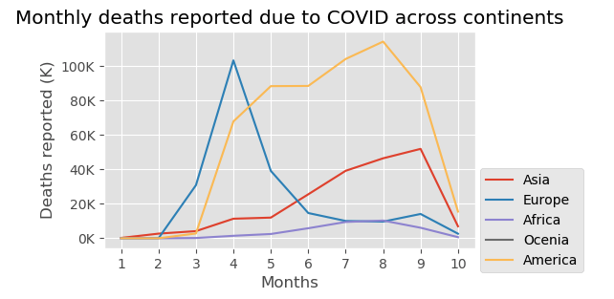

When we compare deaths due to COVID globally, we see America and Europe leading the charts, followed by Asia. Also the fact that Europe and Asia come close, shows that Europe after April has managed to get a handle on keeping the numbers low. While as in Asia from April the number of deaths have been increasing.

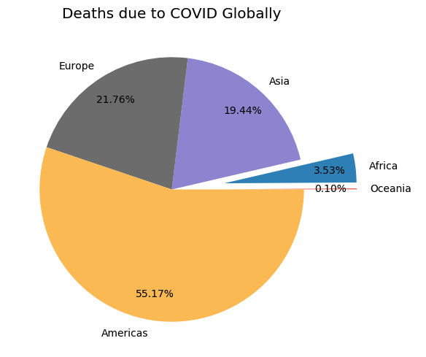

List of top 10 countries with highest COVID cases: USA tops the list followed by India and Brazil.

South Africa is at number 10.

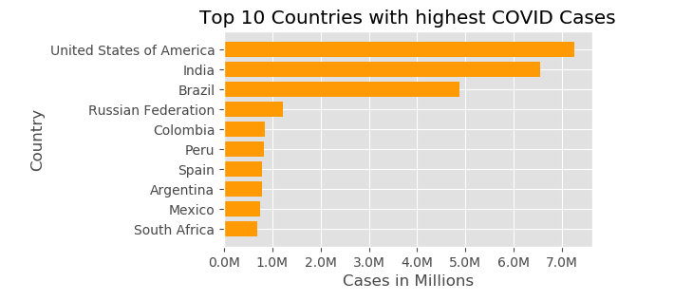

What is interesting to note here is that, even though UK didn’t feature in top 10 countries with highest COVID cases, it actually does come up as one of the countries with highest number of deaths due to COVID. Also most of the countries here are either from America or Europe.

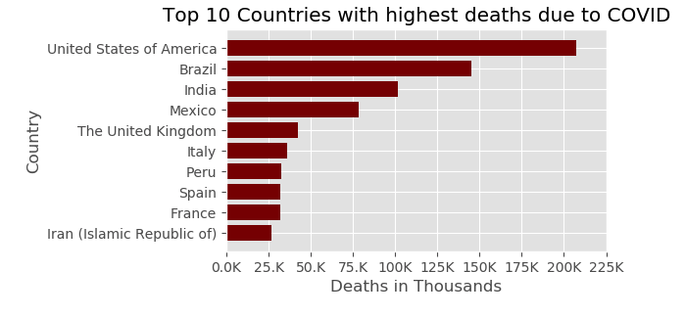

New Covid cases in South Africa were steadily increasing and now are on decline since July.

