- Write a program to implement removal of recursion for – Finding maximum from array.
#include <iostream>
using namespace std;

int main() {
int n;
cout << "Enter number: ";
cin >> n;

int arr[n];

cout << "Enter elements: ";
for (int i = 0; i < n; i++)
cin >> arr[i];

int max = arr[0];

for (int i = 1; i < n; i++)
if (arr[i] > max)
max = arr[i];

cout << "Maximum = " << max;

return 0;
}
Output:
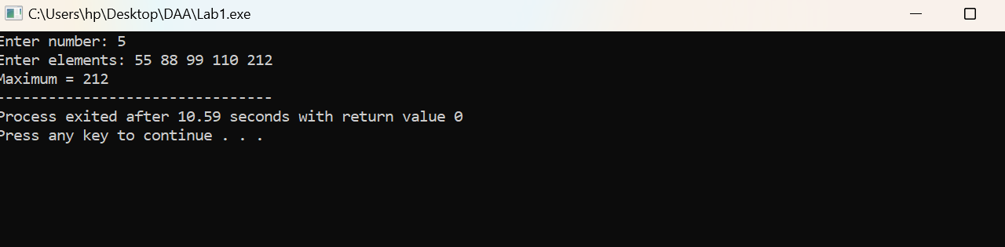

- Write a program to implement removal of recursion for – Binomial Coefficient B(n,m)= B(n-1, m-1)+B(n-1,m), B(n,n)=B(n,0)=1
#include <iostream>
using namespace std;
int main() {
int n, m;
cout << "Enter n and m: ";
cin >> n >> m;
if (m < 0 || m > n) {
cout << "Invalid input";
return 0;}
int C[n + 1][m + 1];
for (int i = 0; i <= n; i++) {
for (int j = 0; j <= m && j <= i; j++) {
if (j == 0 || j == i)
C[i][j] = 1;
else
C[i][j] = C[i - 1][j - 1] + C[i - 1][j];
} }
cout << "Binomial Coefficient = " << C[n][m];
return 0; }
Output:
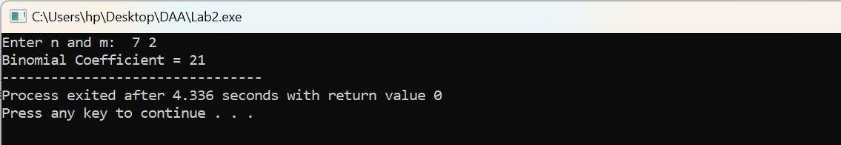

- Write a program to implement removal of recursion for – Searching element from array.
#include <iostream>
using namespace std;
int main() {
int n, key;
cout << "Enter number of elements: ";
cin >> n;
int arr[n];
cout << "Enter array elements: ";
for (int i = 0; i < n; i++)
cin >> arr[i];
cout << "Enter element to search: ";
cin >> key;
int pos = -1;
for (int i = 0; i < n; i++) {
if (arr[i] == key) {
pos = i;
break;
}}
if (pos != -1)
cout << "Element found at position " << pos + 1;
else
cout << "Element not found";
return 0;
}
Output:
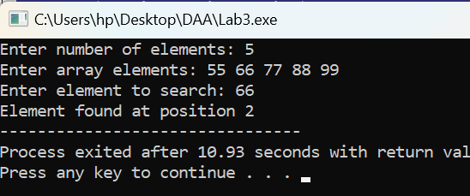

4. Write a program for creating Max/Min. heap using INSERT.
#include <iostream>
using namespace std;
void insert(int h[], int &n, int x, bool maxHeap) {
h[++n] = x;
int i = n;
while (i > 1 && (maxHeap ? h[i] > h[i/2] : h[i] < h[i/2])) {
swap(h[i], h[i/2]);
i /= 2;
}}
int main() {
int h[100], n = 0, x, choice, size;
cout << "1. Max Heap\n2. Min Heap\nChoice: ";
cin >> choice;
cout << "Enter number of elements: ";
cin >> size;
for (int i = 0; i < size; i++) {
cin >> x;
insert(h, n, x, choice == 1);}
cout << "Heap: ";
for (int i = 1; i <= n; i++)
cout << h[i] << " ";
return 0; }
Output:
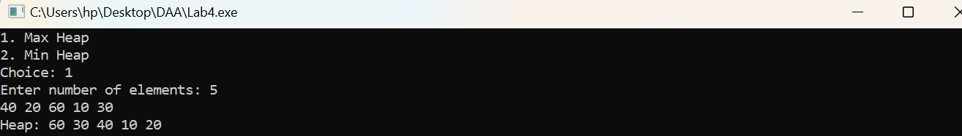
- Write a program for creating Max/Min. heap using ADJUST/HEAPIFY.
#include <iostream>
using namespace std;
void heapify(int h[], int n, int i, int max) {
int x = i, l = 2*i, r = 2*i+1;
if (l <= n && (max ? h[l] > h[x] : h[l] < h[x]))
x = l;
if (r <= n && (max ? h[r] > h[x] : h[r] < h[x]))
x = r;
if (x != i) {
swap(h[i], h[x]);
heapify(h, n, x, max);
}}
int main() {
int h[100], n, choice;
cout << "1. Max Heap\n2. Min Heap\nChoice: ";
cin >> choice;
cout << "Enter number of elements: ";
cin >> n;
cout << "Enter elements: ";
for (int i = 1; i <= n; i++)
cin >> h[i];
for (int i = n/2; i >= 1; i--)
heapify(h, n, i, choice == 1);
cout << "Heap: ";
for (int i = 1; i <= n; i++)
cout << h[i] << " ";
return 0;
}
Output:
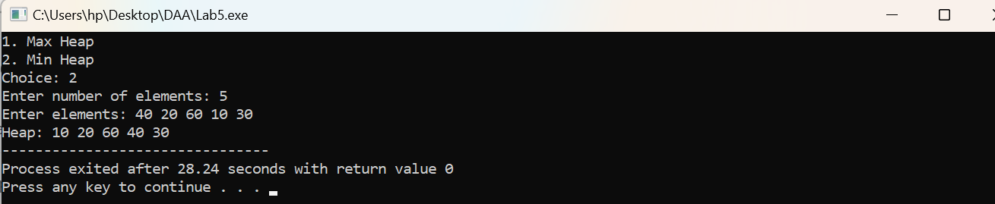

6. Write a program for sorting given array in ascending/descending order with n=1000,2000,3000. Find exact time of execution using Heap Sort.
#include <iostream>
#include <chrono>
using namespace std;
using namespace chrono;
void heapify(int a[], int n, int i, bool asc) {
int x = i, l = 2*i+1, r = 2*i+2;
if (l < n && (asc ? a[l] > a[x] : a[l] < a[x]))
x = l;
if (r < n && (asc ? a[r] > a[x] : a[r] < a[x]))
x = r;
if (x != i) {
swap(a[i], a[x]);
heapify(a, n, x, asc);
}}
void heapSort(int a[], int n, bool asc) {
for (int i = n/2-1; i >= 0; i--)
heapify(a, n, i, asc);
for (int i = n-1; i > 0; i--) {
swap(a[0], a[i]);
heapify(a, i, 0, asc);
}}
void test(int n, bool asc) {
int *a = new int[n];
for (int i = 0; i < n; i++)
a[i] = n - i;
auto start = high_resolution_clock::now();
heapSort(a, n, asc);
auto end = high_resolution_clock::now();
cout << "n = " << n << " | Time = "
<< duration_cast<microseconds>(end-start).count()
<< " microseconds\n";
delete[] a;
}
int main() {
int choice;
cout << "1. Ascending\n2. Descending\nChoice: ";
cin >> choice;
bool asc = (choice == 1);
cout << "\nHeap Sort Execution Time\n";
test(1000, asc);
test(2000, asc);
test(3000, asc);
return 0;
}
Output:
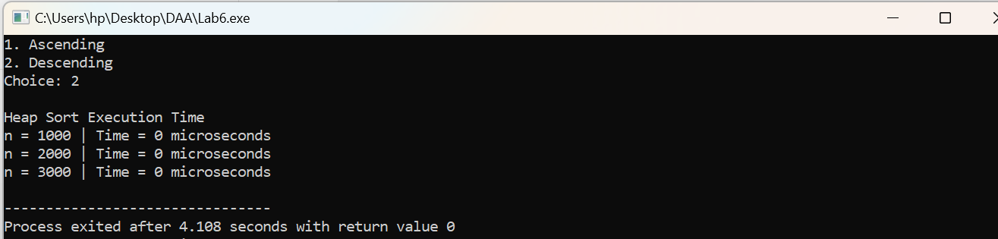

7. Write a program to implement Weighted UNION and Collapsing FIND operations.
#include <iostream>
using namespace std;
int parent[100], sizeSet[100];
int find(int x) {
if (parent[x] != x)
parent[x] = find(parent[x]); // Collapsing Find
return parent[x];
}void weightedUnion(int a, int b) {
a = find(a);
b = find(b);
if (a == b) return;
if (sizeSet[a] < sizeSet[b]) {
parent[a] = b;
sizeSet[b] += sizeSet[a];
} else {
parent[b] = a;
sizeSet[a] += sizeSet[b];
}}int main() {
int n, ch, a, b;
cout << "Enter number of elements: ";
cin >> n;
for (int i = 0; i < n; i++) {
parent[i] = i;
sizeSet[i] = 1;
} do {
cout << "\n1. Weighted Union";
cout << "\n2. Collapsing Find";
cout << "\n3. Display";
cout << "\n4. Exit";
cout << "\nChoice: ";
cin >> ch;
if (ch == 1) {
cin >> a >> b;
weightedUnion(a, b);
cout << "Union performed";
}else if (ch == 2) {
cin >> a;
cout << "Root = " << find(a);
}else if (ch == 3) {
for (int i = 0; i < n; i++)
cout << parent[i] << " ";
}} while (ch != 4);
return 0;
}
Output:
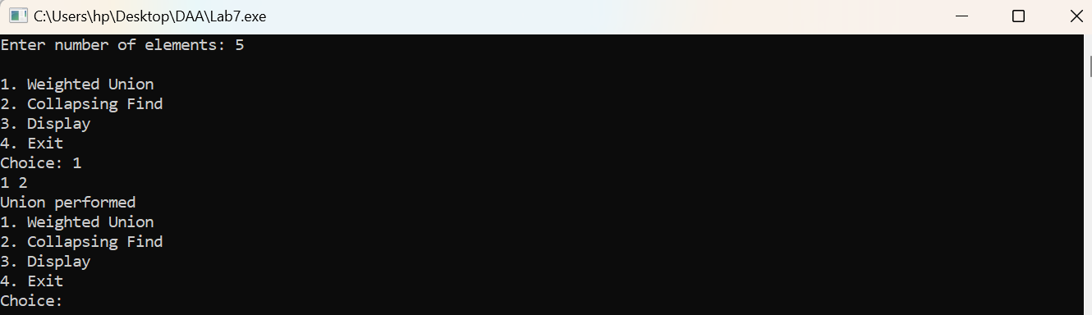

8. Write a program for searching element form given array using binary search forn=1000,2000,3000. Find exact time of execution.
#include <iostream>
#include <chrono>
using namespace std;
using namespace chrono;
int binarySearch(int a[], int n, int key) {
int l = 0, h = n - 1;
while (l <= h) {
int m = (l + h) / 2;
if (a[m] == key)
return m;
if (a[m] < key)
l = m + 1;
else
h = m - 1;
}return -1;
}void test(int n, int key) {
int *a = new int[n];
for (int i = 0; i < n; i++)
a[i] = i + 1;
auto start = high_resolution_clock::now();
int result = binarySearch(a, n, key);
auto end = high_resolution_clock::now();
cout << "n = " << n
<< " | " << (result != -1 ? "Found" : "Not Found")
<< " | Time = "
<< duration_cast<nanoseconds>(end - start).count()
<< " ns\n";
delete[] a;
}
int main() {
int key;
cout << "Enter element to search: ";
cin >> key;
test(1000, key);
test(2000, key);
test(3000, key);
return 0;
}
Output:
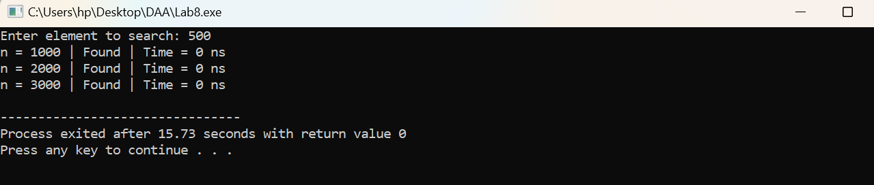

9. Write a program to find minimum and maximum from a given array using MAXMIN.
#include <iostream>
using namespace std;
void maxmin(int a[], int l, int h, int &mn, int &mx) {
if (l == h)
mn = mx = a[l];
else {
int m = (l + h) / 2;
int mn1, mx1;
maxmin(a, l, m, mn, mx);
maxmin(a, m + 1, h, mn1, mx1);
if (mn1 < mn) mn = mn1;
if (mx1 > mx) mx = mx1;
}}
int main() {
int n;
cin >> n;
int a[n];
for (int i = 0; i < n; i++)
cin >> a[i];
int mn, mx;
maxmin(a, 0, n - 1, mn, mx);
cout << "Minimum = " << mn << endl;
cout << "Maximum = " << mx;
return 0;
}
Output:
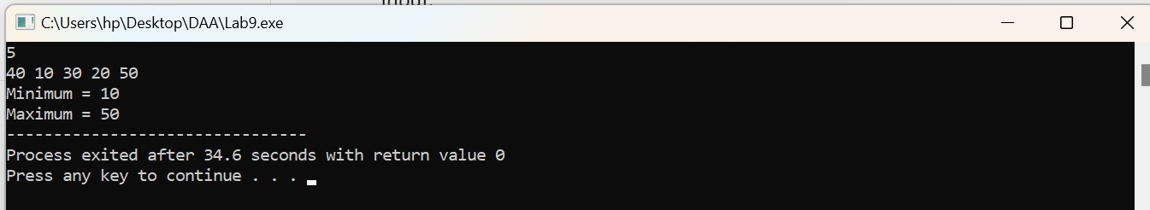

10. Write a program for sorting given array in ascending/descending order with n=1000,2000,3000 find exact time of execution using a) Merge Sort, b) Quick Sort.
#include <iostream>
#include <chrono>
using namespace std;
using namespace chrono;
void merge(int a[], int l, int m, int h, bool asc) {
int i = l, j = m + 1, k = 0;
int t[h - l + 1];
while (i <= m && j <= h)
t[k++] = (asc ? a[i] <= a[j] : a[i] >= a[j]) ? a[i++] : a[j++];
while (i <= m) t[k++] = a[i++];
while (j <= h) t[k++] = a[j++];
for (i = l, k = 0; i <= h; i++, k++)
a[i] = t[k];
}
void mergeSort(int a[], int l, int h, bool asc) {
if (l < h) {
int m = (l + h) / 2;
mergeSort(a, l, m, asc);
mergeSort(a, m + 1, h, asc);
merge(a, l, m, h, asc);
}}
void quickSort(int a[], int l, int h, bool asc) {
if (l >= h) return;
int p = a[h], i = l - 1;
for (int j = l; j < h; j++)
if (asc ? a[j] <= p : a[j] >= p)
swap(a[++i], a[j]);
swap(a[i + 1], a[h]);
int x = i + 1;
quickSort(a, l, x - 1, asc);
quickSort(a, x + 1, h, asc);
}
void test(int n, bool asc) {
int *a = new int[n], *b = new int[n];
for (int i = 0; i < n; i++)
a[i] = b[i] = n - i;
auto s = high_resolution_clock::now();
mergeSort(a, 0, n - 1, asc);
auto e = high_resolution_clock::now();
auto mt = duration_cast<microseconds>(e - s).count();
s = high_resolution_clock::now();
quickSort(b, 0, n - 1, asc);
e = high_resolution_clock::now();
auto qt = duration_cast<microseconds>(e - s).count();
cout << "n = " << n
<< " | Merge = " << mt << " us"
<< " | Quick = " << qt << " us\n";
delete[] a;
delete[] b;
}int main() {
int choice;
cout << "1. Ascending\n2. Descending\nChoice: ";
cin >> choice;
bool asc = choice == 1;
test(1000, asc);
test(2000, asc);
test(3000, asc);
return 0;
}
Output:
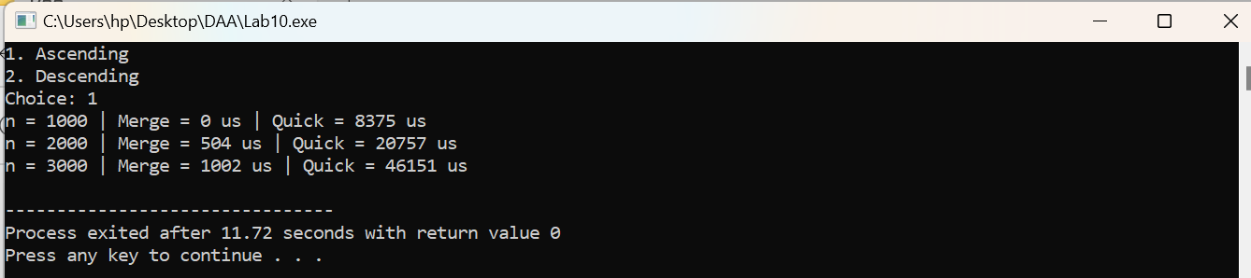

11. Write a program for matrix multiplication using Strassen’s Matrix Multiplication.
#include <iostream>
using namespace std;
int main() {
int A[2][2], B[2][2], C[2][2];
int p1, p2, p3, p4, p5, p6, p7;
cout << "Enter first matrix:\n";
for (int i = 0; i < 2; i++)
for (int j = 0; j < 2; j++)
cin >> A[i][j];
cout << "Enter second matrix:\n";
for (int i = 0; i < 2; i++)
for (int j = 0; j < 2; j++)
cin >> B[i][j];
p1 = A[0][0] * (B[0][1] - B[1][1]);
p2 = (A[0][0] + A[0][1]) * B[1][1];
p3 = (A[1][0] + A[1][1]) * B[0][0];
p4 = A[1][1] * (B[1][0] - B[0][0]);
p5 = (A[0][0] + A[1][1]) * (B[0][0] + B[1][1]);
p6 = (A[0][1] - A[1][1]) * (B[1][0] + B[1][1]);
p7 = (A[0][0] - A[1][0]) * (B[0][0] + B[0][1]);
C[0][0] = p5 + p4 - p2 + p6;
C[0][1] = p1 + p2;
C[1][0] = p3 + p4;
C[1][1] = p5 + p1 - p3 - p7;

cout << "Result:\n";
for (int i = 0; i < 2; i++) {
for (int j = 0; j < 2; j++)
cout << C[i][j] << " ";
cout << endl;
}
return 0;
}
Output:
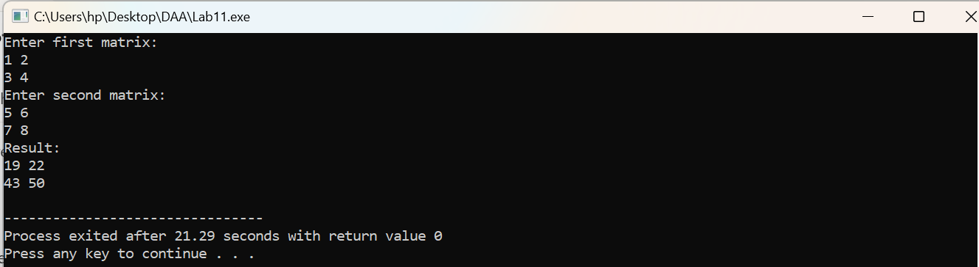

12. Write a program to find solution of Fractional Knapsack instance.
#include <iostream>
#include <algorithm>
using namespace std;
struct Item {
int weight, profit;
double ratio;
};
bool compare(Item a, Item b) {
return a.ratio > b.ratio;
}
int main() {
int n, capacity;
double profit = 0;

cout << "Enter number of items: ";
cin >> n;
Item a[n];
cout << "Enter weight and profit:\n";
for (int i = 0; i < n; i++) {
cin >> a[i].weight >> a[i].profit;
a[i].ratio = (double)a[i].profit / a[i].weight;
}
cout << "Enter capacity: ";
cin >> capacity;

sort(a, a + n, compare);

for (int i = 0; i < n && capacity > 0; i++) {
if (a[i].weight <= capacity) {
capacity -= a[i].weight;
profit += a[i].profit;
} else {
profit += a[i].ratio * capacity;
capacity = 0;
}
}
cout << "Maximum Profit = " << profit;
return 0;
}
Output:
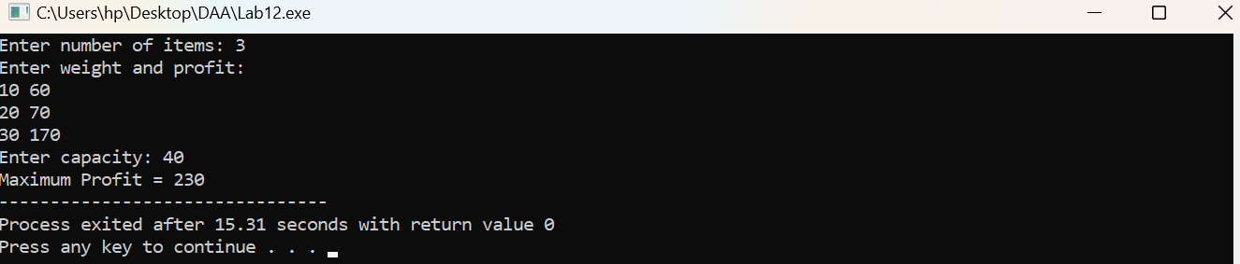

13. Write a program to find Minimum Spanning Tree using Prim’s algorithm.
#include <iostream>
using namespace std;
#define INF 9999
int main() {
int n;
cout << "Enter number of vertices: ";
cin >> n;
int g[n][n], key[n], parent[n], used[n];
cout << "Enter adjacency matrix:\n";
for (int i = 0; i < n; i++)
for (int j = 0; j < n; j++) {
cin >> g[i][j];
if (g[i][j] == 0)
g[i][j] = INF;
}
for (int i = 0; i < n; i++) {
key[i] = INF;
parent[i] = -1;
used[i] = 0;
}
key[0] = 0;
int cost = 0;
cout << "\nEdges in MST:\n";
for (int c = 0; c < n; c++) {
int u = -1;
for (int i = 0; i < n; i++)
if (!used[i] && (u == -1 || key[i] < key[u]))
u = i;
used[u] = 1;
if (parent[u] != -1) {
cout << parent[u] << " - " << u
<< " : " << g[parent[u]][u] << endl;
cost += g[parent[u]][u];
}
for (int v = 0; v < n; v++)
if (!used[v] && g[u][v] < key[v]) {
key[v] = g[u][v];
parent[v] = u;
}
}
cout << "\nMinimum Cost = " << cost;
return 0;
}
Output:
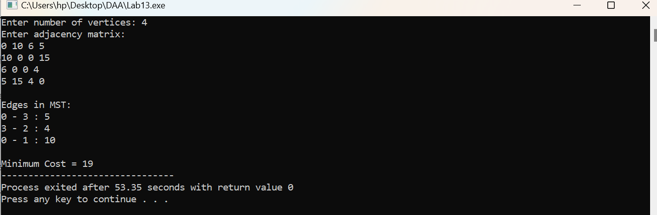

14. Write a program to find Minimum Spanning tree using Kruskal’s algorithm.
#include <iostream>
#include <algorithm>
using namespace std;
struct Edge {
int u, v, weight;
};
bool compare(Edge a, Edge b) {
return a.weight < b.weight;
}int parent[100];
int find(int x) {
if (parent[x] == x)
return x;
return parent[x] = find(parent[x]);
}void unionSet(int a, int b) {
a = find(a);
b = find(b);
if (a != b)
parent[b] = a;
}int main() {
int n, e;
cout << "Enter number of vertices: ";
cin >> n;
cout << "Enter number of edges: ";
cin >> e;
Edge edges[e];
cout << "Enter edges (source destination weight):\n";
for (int i = 0; i < e; i++)
cin >> edges[i].u >> edges[i].v >> edges[i].weight;
sort(edges, edges + e, compare);
for (int i = 0; i < n; i++)
parent[i] = i;
int totalCost = 0, count = 0;
cout << "\nEdges in Minimum Spanning Tree:\n";
for (int i = 0; i < e && count < n - 1; i++) {
int u = edges[i].u;
int v = edges[i].v;
if (find(u) != find(v)) {
cout << u << " - " << v << " : "
<< edges[i].weight << endl;
totalCost += edges[i].weight;
unionSet(u, v);
count++;
}}cout << "\nMinimum Cost = " << totalCost;
return 0;}
Output:
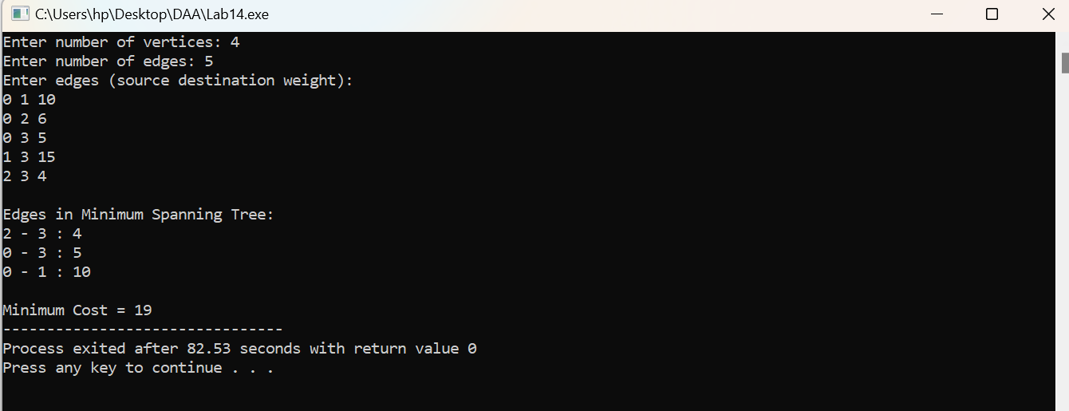
15. Write a program to find Single Source Shortest Path using Dijkstra’salgorithm
#include <iostream>
using namespace std;
#define INF 9999
int main() {
int n, source;
cout << "Enter number of vertices: ";
cin >> n;
int graph[n][n];
cout << "Enter adjacency matrix:\n";
for (int i = 0; i < n; i++)
for (int j = 0; j < n; j++) {
cin >> graph[i][j];
if (graph[i][j] == 0 && i != j)
graph[i][j] = INF;
}
cout << "Enter source vertex: ";
cin >> source;
int distance[n], visited[n];
for (int i = 0; i < n; i++) {
distance[i] = graph[source][i];
visited[i] = 0;
} distance[source] = 0;
for (int count = 0; count < n - 1; count++) {
int u = -1, minDistance = INF;
for (int i = 0; i < n; i++)
if (!visited[i] && distance[i] < minDistance) {
minDistance = distance[i];
u = i;
} if (u == -1)
break;
visited[u] = 1;
for (int v = 0; v < n; v++)
if (!visited[v] && graph[u][v] != INF &&
distance[u] + graph[u][v] < distance[v])
distance[v] = distance[u] + graph[u][v];
} cout << "\nShortest distances from vertex " << source << ":\n";
for (int i = 0; i < n; i++) {
if (distance[i] == INF)
cout << source << " -> " << i << " = Not Reachable\n";
else
cout << source << " -> " << i << " = " << distance[i] << endl;
}return 0;
}
Output:
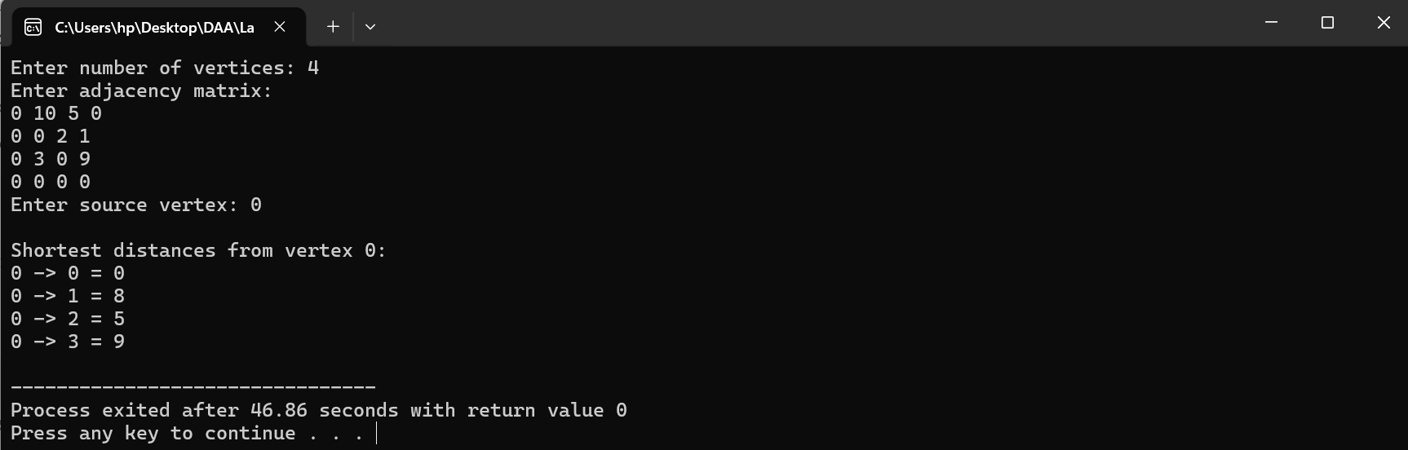
16. Write a program to find solution of Knapsack Instance (0/1).
#include <iostream>
using namespace std;
int main() {
int n, capacity;
cout << "Enter number of items: ";
cin >> n;
int weight[n], profit[n];
cout << "Enter weights: ";
for (int i = 0; i < n; i++)
cin >> weight[i];
cout << "Enter profits: ";
for (int i = 0; i < n; i++)
cin >> profit[i];
cout << "Enter knapsack capacity: ";
cin >> capacity;
int dp[n + 1][capacity + 1];
for (int i = 0; i <= n; i++) {
for (int w = 0; w <= capacity; w++) {
if (i == 0 || w == 0)
dp[i][w] = 0;
else if (weight[i - 1] <= w)
dp[i][w] = max(profit[i - 1] +
dp[i - 1][w - weight[i - 1]],
dp[i - 1][w]);
else
dp[i][w] = dp[i - 1][w];
}
}

cout << "Maximum Profit = " << dp[n][capacity];

return 0;
}
Output:
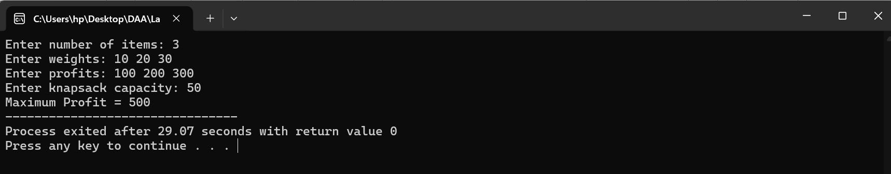

17. Write a program to find solution of Matrix Chain Multiplication.
#include <iostream>
using namespace std;
int main() {
int n;
cout << "Enter number of matrices: ";
cin >> n;
int p[n + 1];
cout << "Enter dimensions: ";
for (int i = 0; i <= n; i++)
cin >> p[i];
int dp[n + 1][n + 1];
for (int i = 1; i <= n; i++)
dp[i][i] = 0;
for (int len = 2; len <= n; len++) {
for (int i = 1; i <= n - len + 1; i++) {
int j = i + len - 1;
dp[i][j] = 999999999;
for (int k = i; k < j; k++) {
int cost = dp[i][k] + dp[k + 1][j]
+ p[i - 1] * p[k] * p[j];
if (cost < dp[i][j])
dp[i][j] = cost;
}
}
}

cout << "Minimum number of multiplications = "
<< dp[1][n];

return 0;
}
Output:
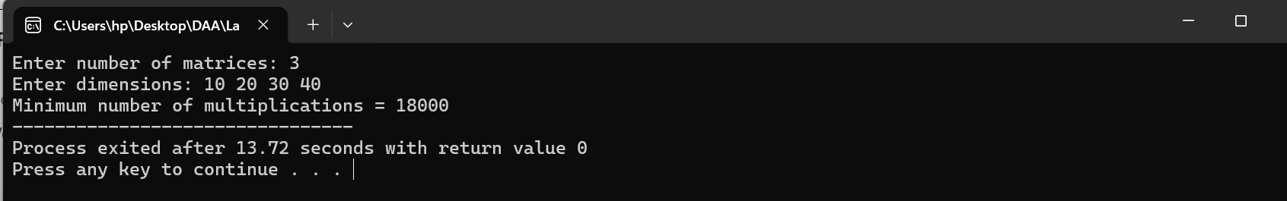

18. Write a program to find shortest path using All Pair Shortest Path algorithm.
#include <iostream>
using namespace std;
#define INF 9999
int main() {
int n;
cout << "Enter number of vertices: ";
cin >> n;
int dist[n][n];
cout << "Enter adjacency matrix:\n";
for (int i = 0; i < n; i++)
for (int j = 0; j < n; j++) {
cin >> dist[i][j];
if (dist[i][j] == 0 && i != j)
dist[i][j] = INF;
}
for (int k = 0; k < n; k++)
for (int i = 0; i < n; i++)
for (int j = 0; j < n; j++)
if (dist[i][k] != INF && dist[k][j] != INF &&
dist[i][k] + dist[k][j] < dist[i][j])
dist[i][j] = dist[i][k] + dist[k][j];
cout << "\nAll Pair Shortest Path Matrix:\n";
for (int i = 0; i < n; i++) {
for (int j = 0; j < n; j++) {
if (dist[i][j] == INF)
cout << "INF ";
else
cout << dist[i][j] << " ";
}
cout << endl;
}
return 0;
}
Output:
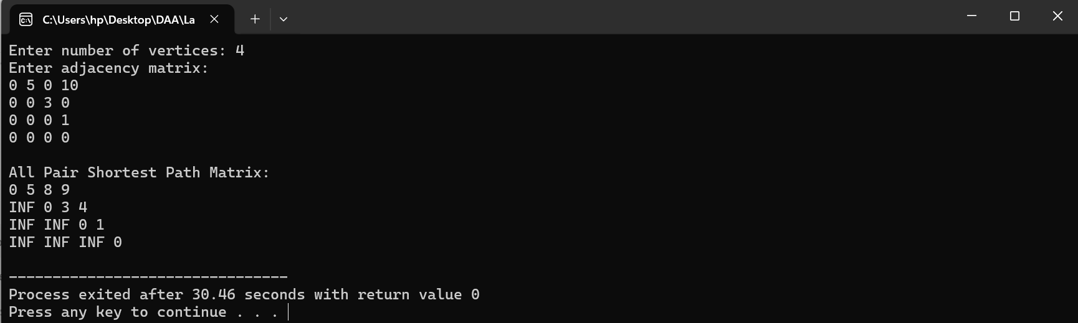

19. Write a program to Traverse Graph – Depth First Search, Breadth First Search.
#include <iostream>
using namespace std;
int graph[10][10], visited[10], n;
void DFS(int v) {
cout << v << " ";
visited[v] = 1;
for (int i = 0; i < n; i++)
if (graph[v][i] == 1 && !visited[i])
DFS(i);
}
void BFS(int start) {
int queue[10], front = 0, rear = 0;

for (int i = 0; i < n; i++)
visited[i] = 0;
queue[rear++] = start;
visited[start] = 1;
while (front < rear) {
int v = queue[front++];
cout << v << " ";
for (int i = 0; i < n; i++) {
if (graph[v][i] == 1 && !visited[i]) {
queue[rear++] = i;
visited[i] = 1;
}} }}
int main() {
int start;
cout << "Enter number of vertices: ";
cin >> n;
cout << "Enter adjacency matrix:\n";
for (int i = 0; i < n; i++)
for (int j = 0; j < n; j++)
cin >> graph[i][j];
cout << "Enter starting vertex: ";
cin >> start;
for (int i = 0; i < n; i++)
visited[i] = 0;
cout << "\nDFS: ";
DFS(start);
cout << "\nBFS: ";
BFS(start);
return 0;
}
Output:
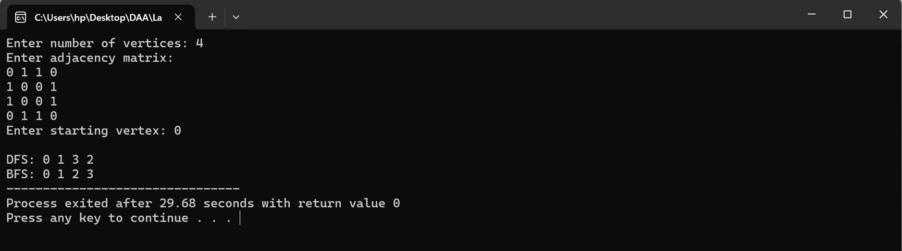

20. Write a program to find all solutions for N-Queen problem using backtracking.
#include <iostream>
using namespace std;
int board[20][20], n;
bool isSafe(int row, int col) {
for (int i = 0; i < row; i++)
if (board[i][col])
return false;
for (int i = row - 1, j = col - 1; i >= 0 && j >= 0; i--, j--)
if (board[i][j])
return false;
for (int i = row - 1, j = col + 1; i >= 0 && j < n; i--, j++)
if (board[i][j])
return false;
return true;
}
void solve(int row) {
if (row == n) {
cout << "Solution:\n";
for (int i = 0; i < n; i++) {
for (int j = 0; j < n; j++)
cout << board[i][j] << " ";
cout << endl;
}
cout << endl;
return;
}
for (int col = 0; col < n; col++) {
if (isSafe(row, col)) {
board[row][col] = 1;
solve(row + 1);
board[row][col] = 0;
}
}
}
int main() {
cout << "Enter value of N: ";
cin >> n;

solve(0);

return 0;
}
Output:
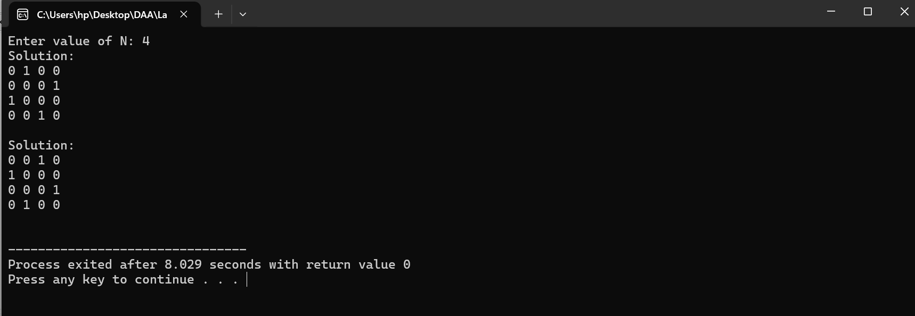

21. Write a program for Graph Colouring using backtracking.
#include <iostream>
using namespace std;
int graph[20][20], color[20], n, m;
bool isSafe(int v, int c) {
for (int i = 0; i < n; i++)
if (graph[v][i] && color[i] == c)
return false;
return true;
}
bool graphColoring(int v) {
if (v == n)
return true;
for (int c = 1; c <= m; c++) {
if (isSafe(v, c)) {
color[v] = c;
if (graphColoring(v + 1))
return true;

color[v] = 0;
} }
return false;
}
int main() {
cout << "Enter number of vertices: ";
cin >> n;

cout << "Enter adjacency matrix:\n";
for (int i = 0; i < n; i++)
for (int j = 0; j < n; j++)
cin >> graph[i][j];

cout << "Enter number of colors: ";
cin >> m;

if (graphColoring(0)) {
cout << "\nGraph Coloring:\n";
for (int i = 0; i < n; i++)
cout << "Vertex " << i << " = Color " << color[i] << endl;
}
else
cout << "Graph cannot be colored using " << m << " colors.";

return 0;
}
Output:
