The University of Azad Jammu and Kashmir, Muzaffarabad



Machine Learning (ML)
(Assignment – 01)

Name | Ubaidullah Awan
Roll no | 2024-SE-17
Semester | ^{5th}
Batch | 2024-2028
Lab | 01
Submitted to | Engr. M. Awais Rathore
Submission date | Oct 23, 2026

Department of Software Engineering

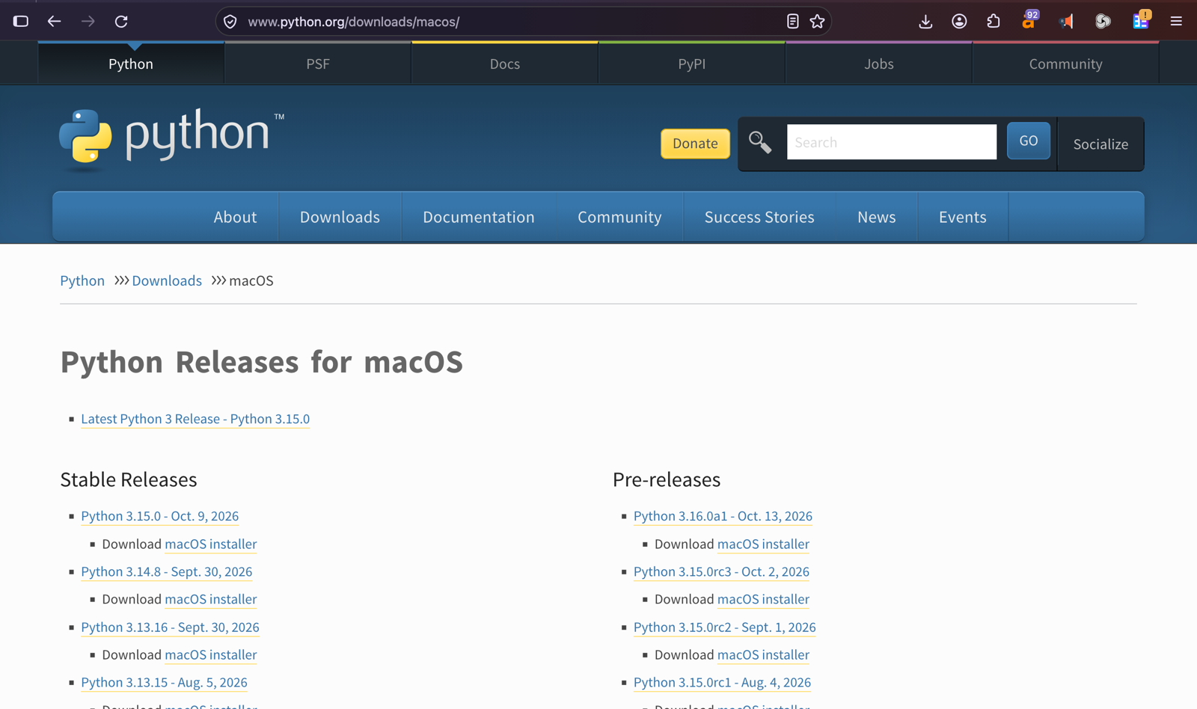
Task:

