The University of Azad Jammu and Kashmir, Muzaffarabad



Digital Image Processing (DIP)
(Lab – 03)

Name | Ubaidullah Awan
Roll no | 2024-SE-17
Semester | ^{5th}
Batch | 2024-2028
Lab | 03
Submitted to | Engr. Fahad Nisar
Submission date | Nov 09, 2026

Department of Software Engineering

Objective
To calculate, implement and compare grayscale intensity transformations (brightness, contrast, negative, gamma), histogram enhancement (global equalization and CLAHE) and thresholding (fixed, Otsu and adaptive), while preventing overflow and interpreting the effect of each operation. Every operation is first worked out by hand in a dry run and then verified in Python (NumPy and OpenCV).
Tools used: Python 3, Jupyter Notebook (VS Code), NumPy, OpenCV (cv2) and Matplotlib.
Submitted files:
- Lab-03.ipynb
- This report
- The input image image.png.

0. Image Loading and Numeric Safety
The input image is loaded with cv.imread("image.png", cv.IMREAD_GRAYSCALE), validated (not None, 8-bit, 2-D, at least 300 × 300), and a copy is kept as the untouched original. All results below use wider types (int16 / float32), np.clip(..., 0, 255) and then astype(np.uint8), and every image is displayed with vmin=0, vmax=255.
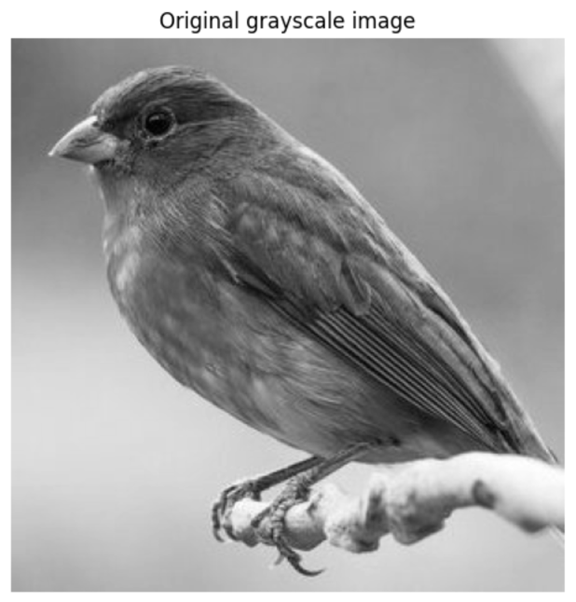

Property | Value
Shape (rows × columns) | (300, 300)
dtype | uint8
Minimum | 0
Maximum | 255

Figure 0: Original grayscale image (uneven lighting: bright top-left, dark bottom-right)

1. Brightness Adjustment

Dry run
Pixels [30, 80, 128, 180, 240]. Rule: s = r + β, then clip to 0–255.
r | r + 40 (raw) | Clipped / final uint8 | r − 40 (raw) | Clipped / final uint8
30 | 70 | 70 | −10 | 0
80 | 120 | 120 | 40 | 40
128 | 168 | 168 | 88 | 88
180 | 220 | 220 | 140 | 140
240 | 280 | 255 | 200 | 200

Python verification: np.clip(px.astype(np.int16) + 40, 0, 255) gives [70, 120, 168, 220, 255] and with −40 gives [0, 40, 88, 140, 200], matching the table.

Lost detail: 240 + 40 = 280 cannot be stored in 8 bits, so it is saturated to 255. Any pixel with r ≥ 215 becomes 255 after +40, so the highlights that were different (for example 220 and 240) merge into one white value. In the same way 30 − 40 = −10 is clipped to 0, and every pixel with r ≤ 40 becomes 0 after −40, so shadow detail disappears. Without a wider type, uint8 arithmetic would wrap around (240 + 40 = 280 → 24), turning a very bright pixel almost black.

Image result
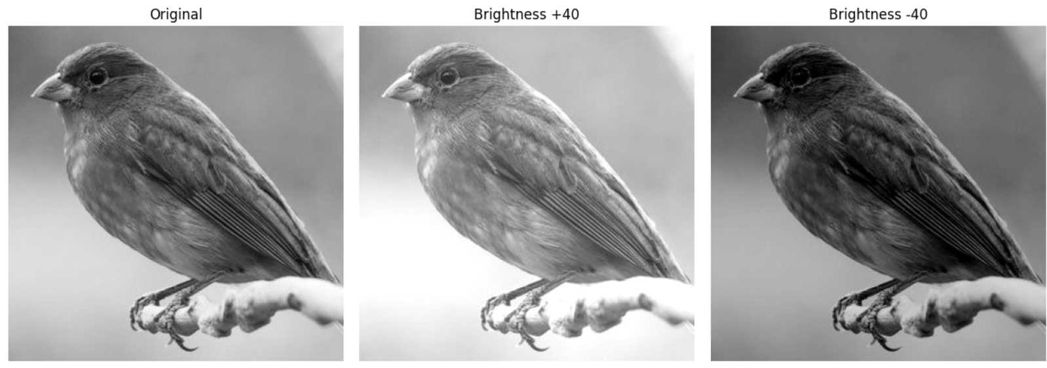
Figure 1: Original, brightness +40 and brightness −40
Observation: the mean intensity moves from 120.78 to 160.78 (+40) and 81.86 (−40). With +40 only 350 pixels (0.13%) were clipped at 255, but with −40 a larger 17,308 pixels (6.60%) were clipped at 0, because the dark corner of this image contains many low values. The nested-loop implementation of +40 produced exactly the same array as the NumPy version (np.array_equal → True).

2. Linear Contrast from Zero (s = αr + β, α = 1.5, β = 0)

Dry run
r | 1.5 × r (raw) | Clip to 0–255 | Truncate (final uint8) | Saturated?
30 | 45 | 45 | 45 | No
80 | 120 | 120 | 120 | No
128 | 192 | 192 | 192 | No
180 | 270 | 255 | 255 | Yes
240 | 360 | 255 | 255 | Yes

Observation: all products here are whole numbers, so truncation changes nothing. The pixels 180 and 240 are saturated; they were 60 levels apart but both end at 255, so their difference is lost. Because the multiplication is applied from 0, every positive pixel also moves upwards, so the image gets brighter as well as more contrasty.

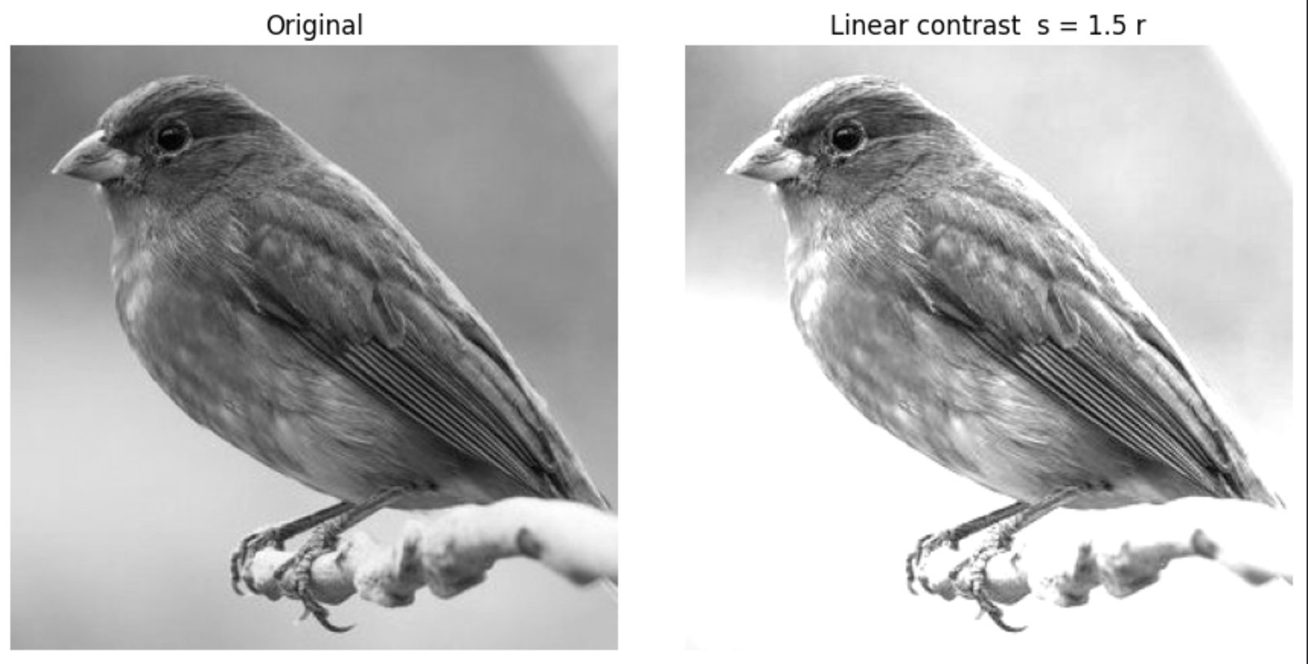
Image result

Figure 2a: Original and linear contrast s = 1.5r

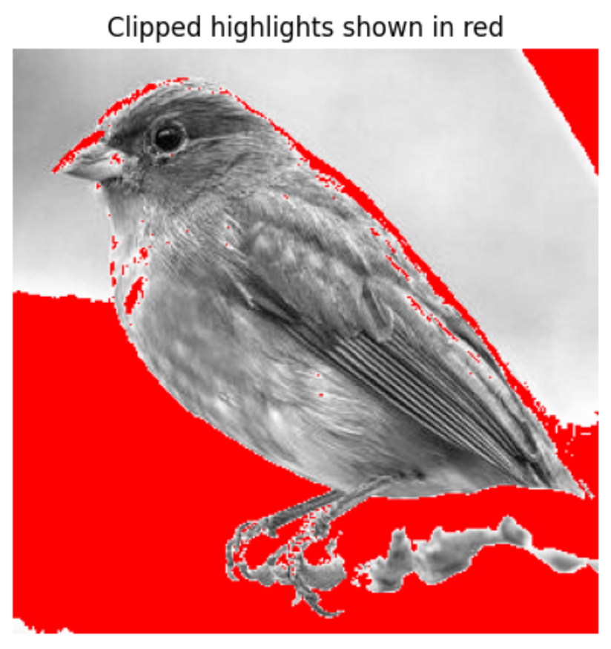

Figure 2b: Clipped highlights (pixels where 1.5r > 255) shown in red

Observation: the mean rises from 120.78 to 176.89 and the standard deviation from 47.73 to 66.06. 41,506 pixels (15.83%) are saturated at 255, so the paper area loses its smooth gradient and the highlight detail is gone.

3. Contrast Centered at 128 (s = (r − 128)α + 128)

Dry run
α = 1.5
r | r − 128 | × 1.5 | + 128 (raw) | Final (clipped)
30 | −98 | −147 | −19 | 0
80 | −48 | −72 | 56 | 56
128 | 0 | 0 | 128 | 128
180 | 52 | 78 | 206 | 206
240 | 112 | 168 | 296 | 255

α = 0.5

r | r − 128 | × 0.5 | + 128 (raw) | Final (clipped)
30 | −98 | −49 | 79 | 79
80 | −48 | −24 | 104 | 104
128 | 0 | 0 | 128 | 128
180 | 52 | 26 | 15664 | 154
240 | 112 | 56 | 184 | 184

Explanation at r = 128: the term (r − 128) is 0, so the output is 0 × α + 128 = 128 for every α. The value 128 is the pivot: values below it are pushed darker and values above it brighter when α > 1 (α = 1.5 clips 30 → 0 and 240 → 255), and they are pulled towards 128 when α < 1. Python gave [0, 56, 128, 206, 255] and [79, 104, 128, 154, 184], matching the tables.

Image result
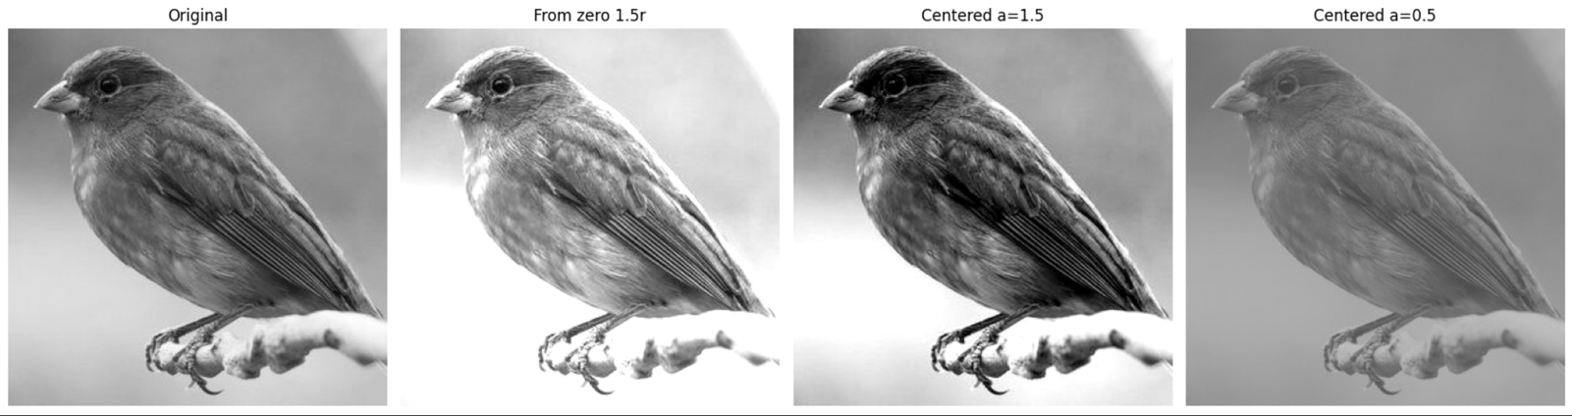

Figure 3: Original, from-zero 1.5r, centered α = 1.5 and centered α = 0.5
Image | Mean | Std. dev. | Min | Max
Original | 120.78 | 47.73 | 5 | 226
From zero, 1.5r | 176.89 | 66.06 | 7 | 255
Centered, α = 1.5 | 118.82 | 67.90 | 0 | 255
Centered, α = 0.5 | 124.14 | 23.87 | 66 | 177

Observation: centered contrast at α = 1.5 increases the spread (std. 47.73 → 67.90) while the average brightness stays almost unchanged (118.82), whereas the from-zero version makes the image much brighter (176.89). With α = 0.5 the contrast is reduced (std. 23.87) and the range shrinks to 66–177, giving a flat, grayish image.

4. Image Negative (s = 255 − r)

Dry run
r | 255 − r | Negative applied again: 255 − (255 − r) | Equal to original?
30 | 225 | 30 | Yes
80 | 175 | 80 | Yes
128 | 127 | 128 | Yes
180 | 75 | 180 | Yes
240 | 15 | 240 | Yes

Observation: the negative reverses the order of the intensities, and applying it twice returns exactly the original, so no information is lost (the operation is its own inverse and never leaves 0–255). Python confirmed this for the image as well (np.array_equal(255 - negative, img) → True).

Image result
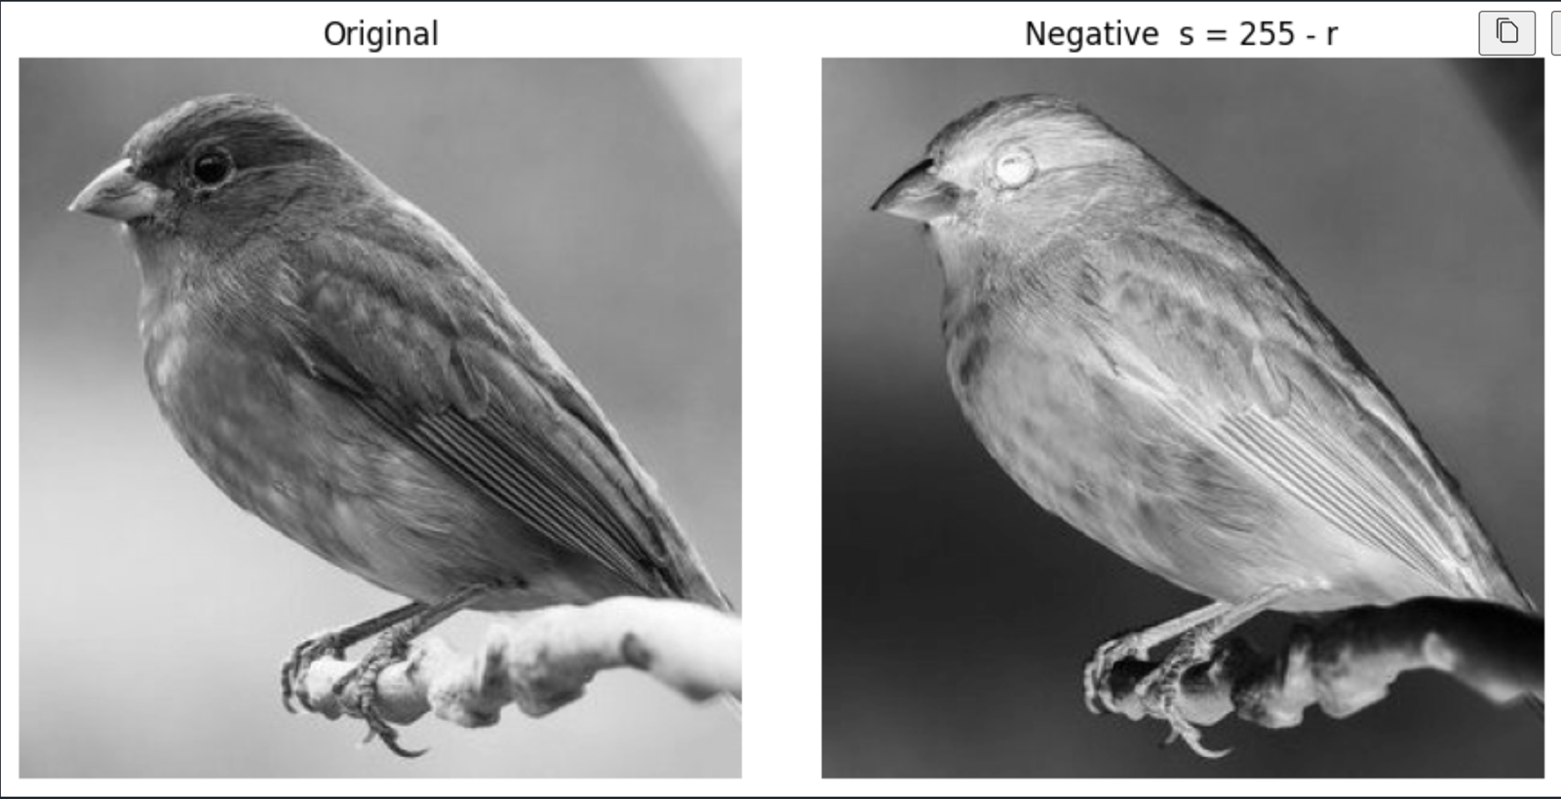
Figure 4: Original and negative image
Where it helps: when important details are bright on a very dark background (for example white bone or lesion regions in an X-ray image), the negative shows them as dark marks on a light background, which the eye can often inspect more easily.

5. Gamma Correction (s = 255 (r/255)^γ)

Dry run
Pixels [0, 64, 128, 192, 255], full precision is kept and only the final value is truncated.
γ = 0.5
r | r / 255 | (r/255)^0.5 | × 255 | Final (truncated)
0 | 0.000000 | 0.000000 | 0.0000 | 0
64 | 0.250980 | 0.500979 | 127.7498 | 127
128 | 0.501961 | 0.708492 | 180.6654 | 180
192 | 0.752941 | 0.867722 | 221.2691 | 221
255 | 1.000000 | 1.000000 | 255.0000 | 255

γ = 2.0
r | r / 255 | (r/255)^2 | × 255 | Final (truncated)
0 | 0.000000 | 0.000000 | 0.0000 | 0
64 | 0.250980 | 0.062991 | 16.0627 | 16
128 | 0.501961 | 0.251965 | 64.2510 | 64
192 | 0.752941 | 0.566920 | 144.5647 | 144
255 | 1.000000 | 1.000000 | 255.0000 | 255

Python verification: gamma 0.5 → [0, 127, 180, 221, 255]; gamma 2.0 → [0, 16, 64, 144, 255]. In both cases 0 and 255 stay fixed.
Difference from the slide example: the slide uses rounded intermediate values and rounds the final result, giving 128 and 181 for r = 64 and r = 128. Here full precision is kept and the output is truncated, so 127.7498 → 127 and 180.6654 → 180. The value 221.2691 gives 221 in both. The difference is only the rounding rule, not the formula. Gamma convention: with s = 255(r/255)^γ, γ < 1 brightens and γ > 1 darkens (the opposite of display-gamma conventions that use the reciprocal).

Image result
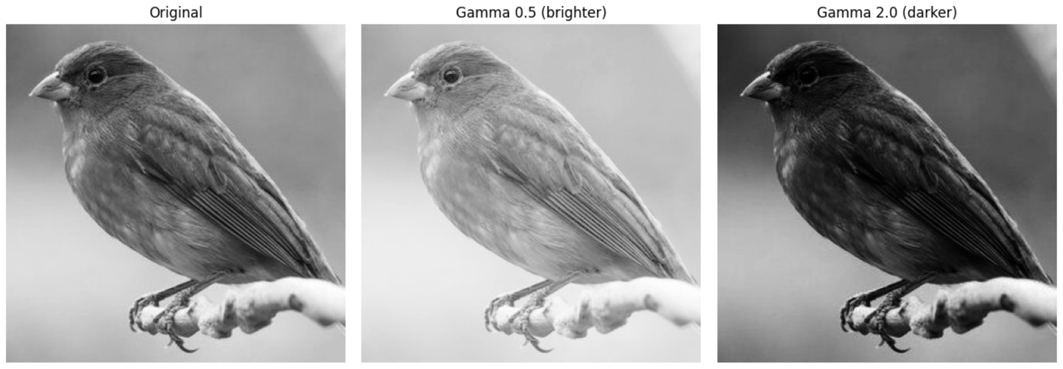
Figure 5: Original, gamma 0.5 and gamma 2.0
Observation: for the originally dark pixels (r < 60) the mean intensity is 37.87; gamma 0.5 raises it to 95.60 and reveals the dark shapes and shaded paper, while gamma 2.0 lowers it to 6.02 and hides them. Applying both gammas to the values 0 and 255 returned [0, 255] each time, confirming that black and white are fixed. Unlike brightness, gamma changes dark tones much more than bright tones.

6. Grayscale Histogram

Dry run
A = [[0, 50, 50, 100], [100, 150, 200, 255]]. Total pixel count N = 2 × 4 = 8.
Intensity | Frequency | Probability (freq / 8)
0 | 1 | 1/8 = 0.125
50 | 2 | 2/8 = 0.250
100 | 2 | 2/8 = 0.250
150 | 1 | 1/8 = 0.125
200 | 1 | 1/8 = 0.125
255 | 1 | 1/8 = 0.125
Total | 8 | 1.000

Why a histogram does not show positions: it only counts how many pixels have each intensity and does not record where they are. Two different images containing the same pixels in a different arrangement have the same histogram; Python confirmed this by rearranging A and getting an identical histogram.

Image result
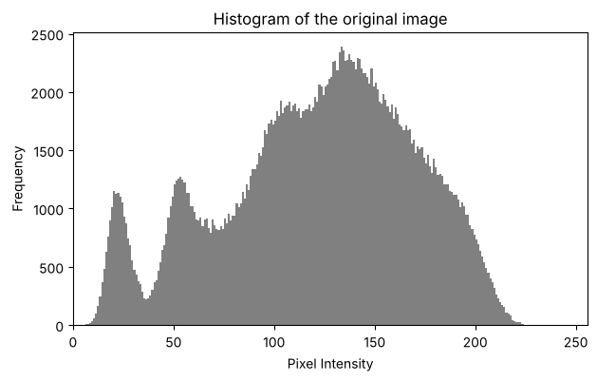
Figure 6: 256-bin histogram of the original image (range 0–256)
Interpretation: most pixels form one wide hump between about 90 and 210 (the paper and background, spread out because the lighting falls off across the page), while two small separate peaks near 20 and 55 are the dark text and shapes. No pixels exceed about 226, so the image does not use the full 0–255 range and its contrast is limited (mean 120.78, median 126, std. 47.73).

7. Global Histogram Equalization

Dry run
Pixels [50, 50, 100, 150], N = 4. CDFmin = 0.50 (lowest nonzero CDF). Rounding is to the nearest integer with .5 rounded upward.
Value | Frequency | Cumulative count | CDF | 255 × CDF | 255 × (CDF − 0.5)/(1 − 0.5)
50 | 2 | 2 | 2/4 = 0.50 | 127.5 → 128 | 0
100 | 1 | 3 | 3/4 = 0.75 | 191.25 → 191 | 127.5 → 128
150 | 1 | 4 | 4/4 = 1.00 | 255 | 255

Output lists (for the pixel list [50, 50, 100, 150]):
- Method 1, 255 × CDF: [128, 128, 191, 255]
- Method 2, 255 × (CDF − CDFmin)/(1 − CDFmin): [0, 0, 128, 255]
cv.equalizeHist on the same pixels returned [0, 0, 128, 255], so the second method (with CDFmin) matches OpenCV. The first method maps the darkest pixel to 128 instead of 0, so it does not use the full range.

Image result
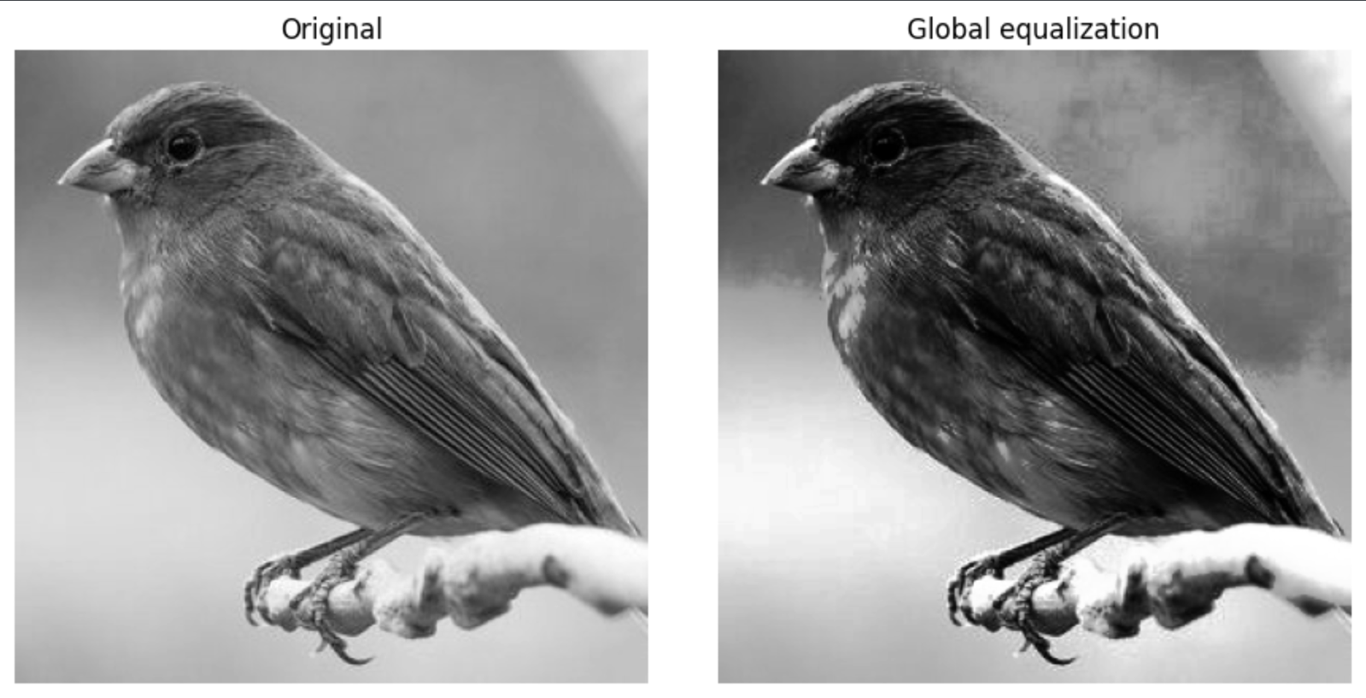

Figure 7a: Original and globally equalized image
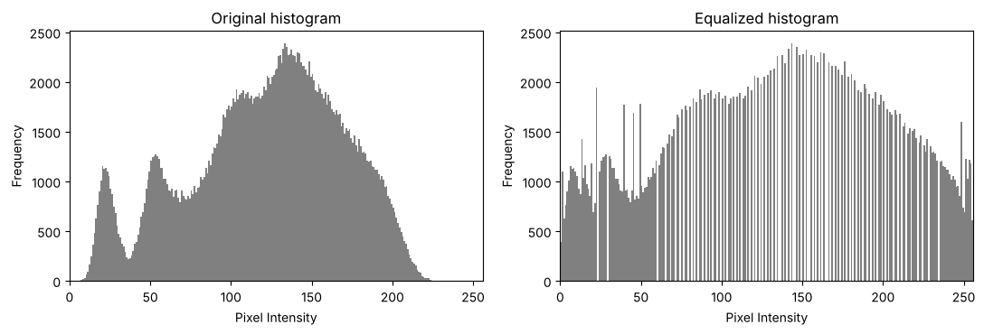
Figure 7b: Histograms of the original and equalized images
Observation: equalization spreads the intensities over the full range (min/max 5/226 → 0/255; std. 47.73 → 73.68), so the text and shapes become crisper. Detail does not improve everywhere: because one global mapping is used, the bright upper-left corner moves towards white (mean 190.7 → 236.2) and the dark lower-right corner gets darker (50.4 → 27.5), so the lighting difference actually becomes stronger. Noise is amplified: in a flat dark patch the standard deviation rose from 4.48 to 6.92. The equalized histogram is spread out with gaps, which is normal for 8-bit data.

8. CLAHE (clipLimit = 2.0, tileGridSize = (8, 8))

Dry run
Four-bin histogram [6, 2, 0, 0] (total 8) with an absolute bin cap of 4 (simplified model).
Step | Bin 0 | Bin 1 | Bin 2 | Bin 3 | Total
Original histogram | 6 | 2 | 0 | 0 | 8
After clipping at 4 | 4 | 2 | 0 | 0 | 6 (excess = 2)
Excess per bin (2 / 4) | +0.5 | +0.5 | +0.5 | +0.5 | +2
After redistribution | 4.5 | 2.5 | 0.5 | 0.5 | 8
Cumulative counts | 4.5 | 7.0 | 7.5 | 8.0 | —
New CDF (÷ 8) | 0.5625 | 0.875 | 0.9375 | 1.0 | —
Old CDF (no clipping) | 0.75 | 1.0 | 1.0 | 1.0 | —

Meaning: clipping removes the tall peak in bin 0 and spreads its excess over all bins, so the first CDF step falls from 0.75 to 0.5625. The slope of the CDF is the contrast gain, so the amplification of the dominant intensity is limited (mapping to levels 0–3: 2.25 → 1.69 for bin 0). Why interpolation is needed: each tile has its own mapping, so two neighbouring tiles would send the same intensity to different outputs and visible seams would appear at tile borders; CLAHE therefore blends the mappings of neighbouring tiles bilinearly for every pixel. This simplified model differs from OpenCV’s integer redistribution, and the absolute cap of 4 is not the same thing as OpenCV’s clipLimit parameter.

Image result
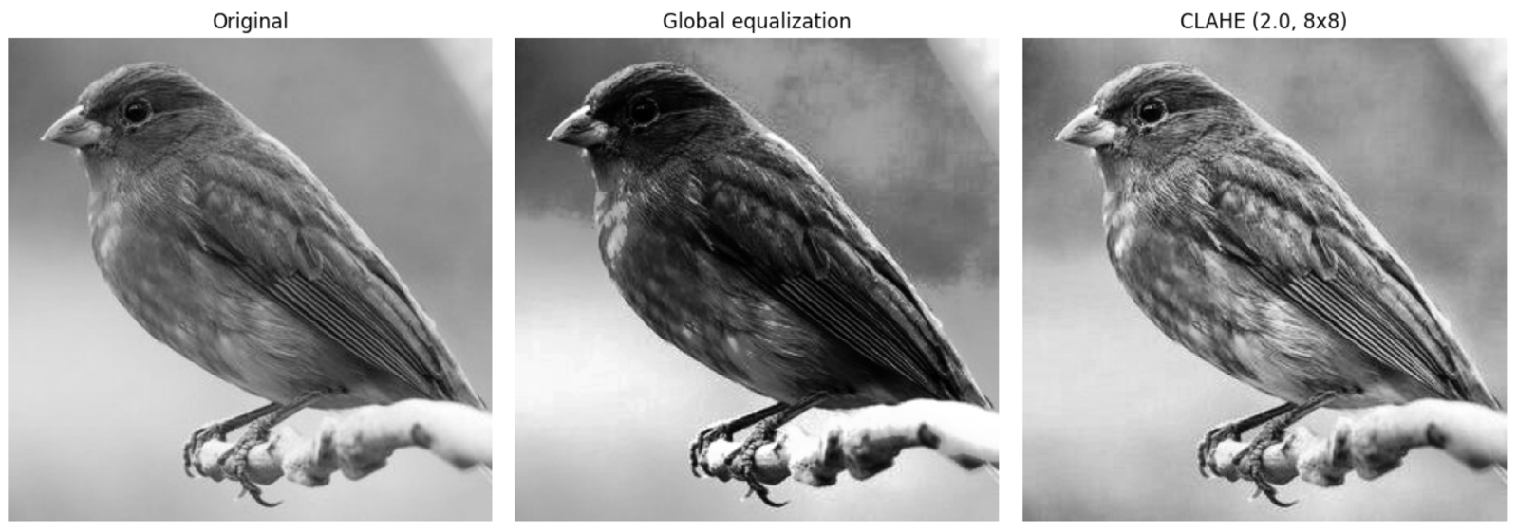
Figure 8: Original, global equalization and CLAHE
Observation: tileGridSize=(8, 8) means the image is divided into 8 × 8 = 64 tiles (each about 64 × 64 pixels here); it is not the pixel size of a tile. Global equalization increased the brightness gap between the upper-left and lower-right corners from 140.4 (original) to 208.7, while CLAHE reduced it to 108.5, giving a much more even background and readable text across the page, with only mild noise amplification because of the clip limit.

9. Fixed Binary Thresholding

Dry run
Pixels [0, 80, 127, 128, 180, 255]. Rule: output 255 if r > T, otherwise 0.
r | r > 127 ? | Output (T = 127) | r > 180 ? | Output (T = 180)
0 | No | 0 | No | 0
80 | No | 0 | No | 0
127 | No (equal) | 0 | No | 0
128 | Yes | 255 | No | 0
180 | Yes | 255 | No (equal) | 0
255 | Yes | 255 | Yes | 255
White pixels |  | 3 |  | 1

Observation: raising T from 127 to 180 reduces the white pixels from 3 to 1; a higher threshold classifies fewer pixels as white. A pixel equal to T stays 0 because the rule is strictly “greater than”. Python and OpenCV (cv.THRESH_BINARY) gave identical results.

Image result
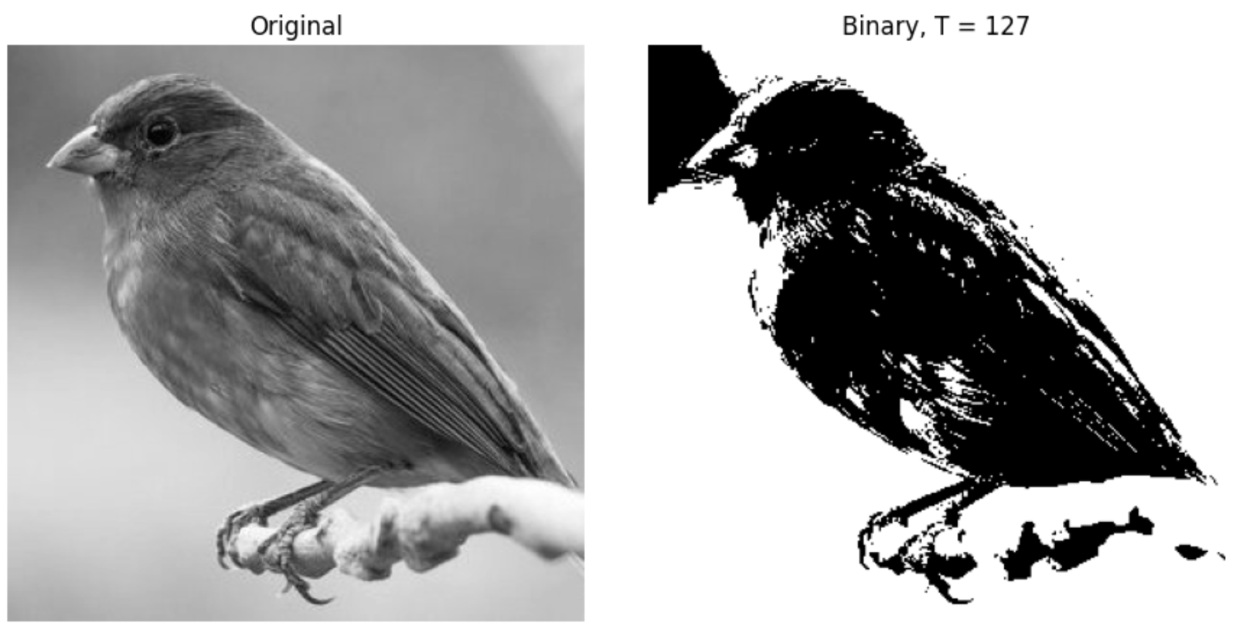
Figure 9: Original and binary image (T = 127)
Observation: the unique values in the binary image are [0, 255] and 48.94% of the pixels are white. Because the lighting is uneven, the lower-right part of the paper falls below 127 and turns black together with the text, so the fixed threshold cannot separate text from background there.

10. Otsu Thresholding

Dry run
Pixels [0, 1, 4, 5] without rescaling. Classes: class 0 = r ≤ T, class 1 = r > T. Score = w0 · w1 · (μ0 − μ1)².
T | Class 0 | Class 1 | w0 | w1 | μ0 | μ1 | w0·w1·(μ0 − μ1)²
0 | {0} | {1, 4, 5} | 0.25 | 0.75 | 0 | 3.333 | 0.1875 × 11.11 = 2.083
1 | {0, 1} | {4, 5} | 0.5 | 0.5 | 0.5 | 4.5 | 0.25 × 16 = 4.000
2 | {0, 1} | {4, 5} | 0.5 | 0.5 | 0.5 | 4.5 | 4.000
3 | {0, 1} | {4, 5} | 0.5 | 0.5 | 0.5 | 4.5 | 4.000
4 | {0, 1, 4} | {5} | 0.75 | 0.25 | 1.667 | 5 | 0.1875 × 11.11 = 2.083

Result: the maximum score is 4.0 and it is tied for T = 1, 2 and 3, so the smallest tied value T = 1 is chosen. Predicted mask (r > 1): [0, 0, 255, 255]. OpenCV returned threshold 1.0 and mask [0, 0, 255, 255], which matches the prediction. The tie occurs because no pixel has the values 2 or 3, so those thresholds give the same split.

Image result
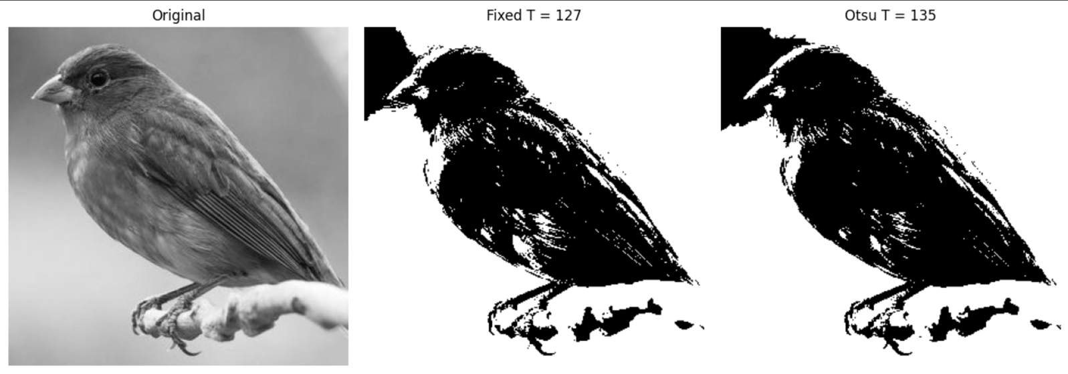
Figure 10a: Original, fixed threshold T = 127 and Otsu threshold
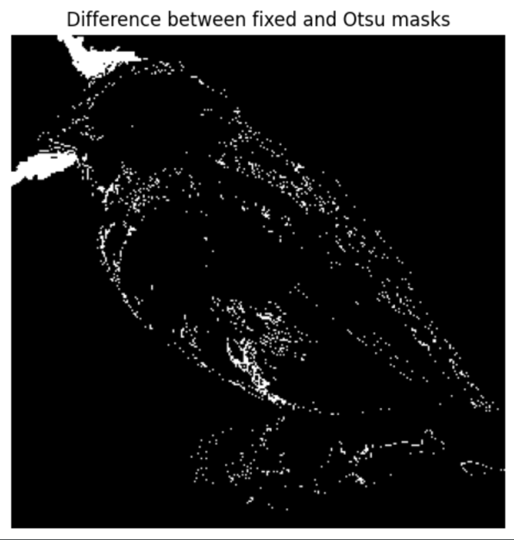
Figure 10b: Pixels where the fixed and Otsu masks differ (white)

Observation: OpenCV’s Otsu method returned T = 112 for this image. Compared with the fixed mask, 29,113 pixels (11.11%) differ, mostly along the diagonal band where the lighting changes. Otsu automatically chose a better global value than 127, but it is still one global threshold, so the dark lower-right region is still lost.

11. Adaptive Gaussian Thresholding (blockSize = 11, C = 2)

Dry run
3 × 3 neighbourhood [[100, 100, 100], [100, 120, 140], [140, 140, 140]] with Gaussian weights [[1, 2, 1], [2, 4, 2], [1, 2, 1]] / 16.
Row | Pixels × weights (÷16 later) | Row sum
1 | 100·1 + 100·2 + 100·1 = 100 + 200 + 100 | 400
2 | 100·2 + 120·4 + 140·2 = 200 + 480 + 280 | 960
3 | 140·1 + 140·2 + 140·1 = 140 + 280 + 140 | 560
Total | 400 + 960 + 560 = 1920 | 1920

- Weighted mean = 1920 / 16 = 120
- Threshold T = mean − C = 120 − 2 = 118
- Centre pixel r = 120: 120 > 118 is true, so the output is 255 (white).
- A pixel equal to T (118): 118 > 118 is false, so the output is 0 (black).
OpenCV’s cv.adaptiveThreshold on the same 3 × 3 patch (blockSize = 3) also gave 255 for the centre pixel. For the image task a larger 11 × 11 neighbourhood is used.

Image result
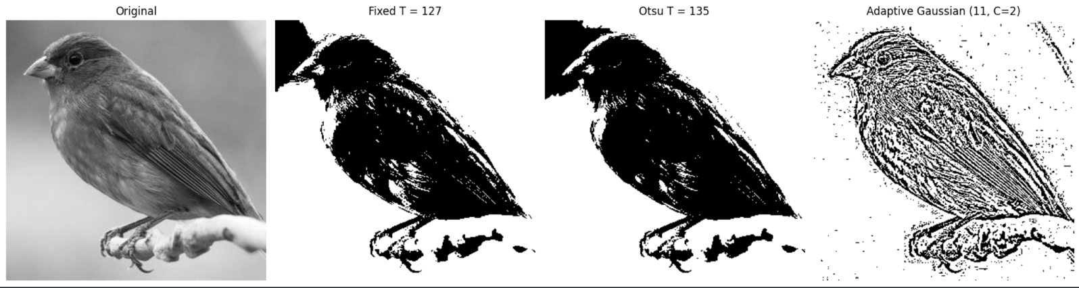
Figure 11: Original, fixed T = 127, Otsu T = 112 and adaptive Gaussian (blockSize 11, C = 2)

Method | White pixels (whole image) | White pixels in dark lower-right corner
Fixed, T = 127 | 48.94% | 0.00%
Otsu, T = 112 | 60.04% | 0.00%
Adaptive Gaussian | 64.39% | 64.12%

Observation: both global thresholds turn the whole shadowed lower-right region black, so the text there is lost. The adaptive threshold follows the local brightness, so the text and shape outlines are recovered everywhere on the page. Its weakness is that in flat areas the local mean is almost equal to the pixel value, so with C = 2 the small noise (σ ≈ 4) produces speckle; a larger C or a blur before thresholding would reduce this.

12. Explanation of Key Concepts
Overflow and clipping. A uint8 pixel can only store 0–255. Doing arithmetic directly in uint8 wraps around modulo 256 (240 + 40 = 280 → 24), which is overflow and makes bright pixels dark. To avoid it, the calculation is done in int16 or float32, then np.clip(..., 0, 255) limits the result (saturation) and finally astype(np.uint8) truncates any fraction. Clipping protects the format, but it throws information away because different values become the same 0 or 255.
Brightness versus contrast. Brightness adds a constant β to every pixel, which shifts the whole histogram left or right without changing the distances between pixels. Contrast multiplies by α, which changes the distances between pixels: from zero, 1.5r also brightens, while the centered form (r − 128)α + 128 changes only the spread around the pivot 128, leaving 128 unchanged.

Gamma convention. This lab uses s = 255(r/255)^γ on normalised values. γ < 1 brightens (mainly the dark and middle tones), γ > 1 darkens, γ = 1 does nothing, and 0 and 255 always stay fixed.

Global versus local enhancement. Global equalization and global thresholds (fixed or Otsu) use one rule for the entire image, so they work well when the lighting is even and the histogram is well separated. When the lighting is uneven, as in this image, local methods are better: CLAHE equalizes tile by tile with a limit on noise amplification, and adaptive thresholding computes a different threshold for every neighbourhood.

Conclusion
In this lab, eleven intensity operations were calculated by hand, predicted, and verified in Python. All dry-run results matched NumPy/OpenCV, including the equalization mapping that includes CDFmin and the Otsu threshold with its tie rule. The experiments showed that safe arithmetic (wider types, clipping) is essential, that gamma and centered contrast change the image differently from simple brightness, and that for unevenly lit images CLAHE and adaptive thresholding give clearly better results than their global versions.

