The University of Azad Jammu and Kashmir, Muzaffarabad



Digital Image Processing (DIP)
(Lab – 01)

Name | Ubaidullah Awan
Roll no | 2024-SE-17
Semester | ^{5th}
Batch | 2024-2028
Lab | 01
Submitted to | Engr. Fahad Nisar
Submission date | Oct 23, 2026

Department of Software Engineering

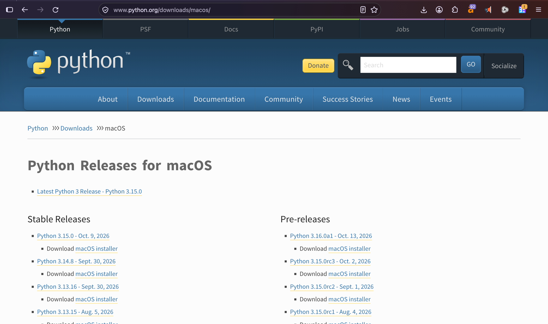
Step # 01: Python version Installation
Figure 1 Application Installation
Figure 2Python setup download
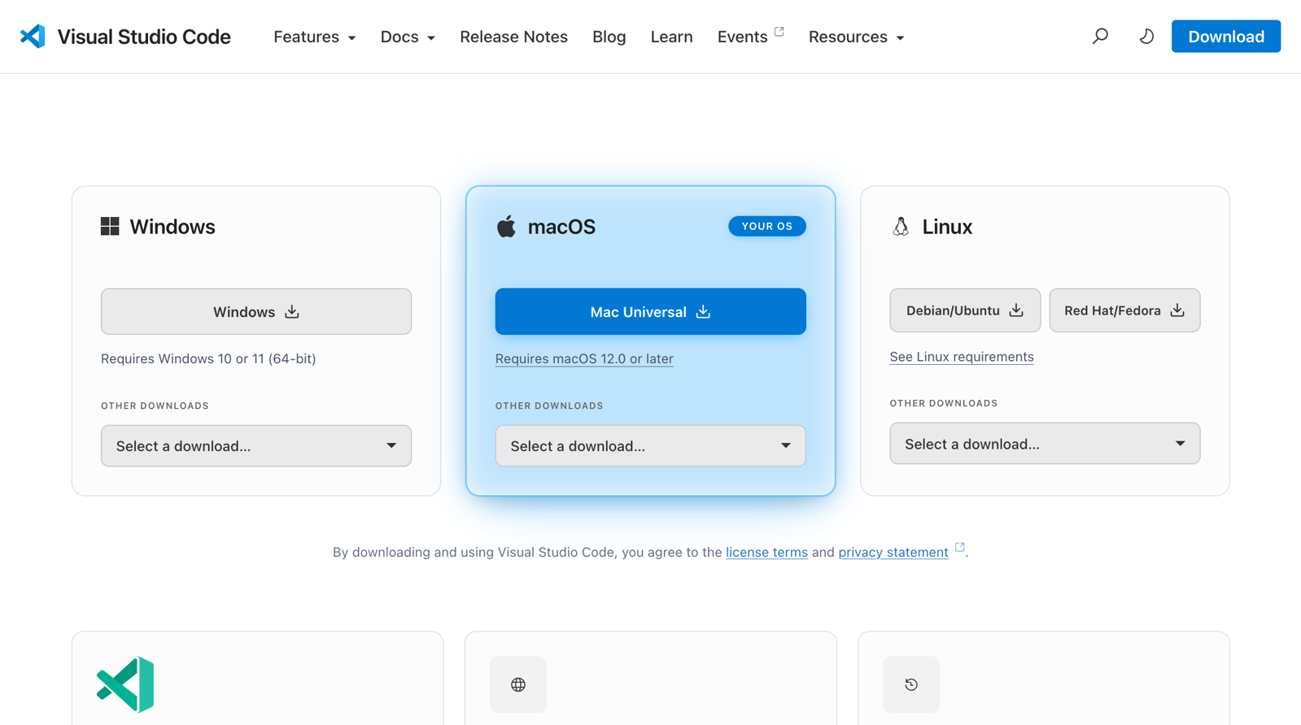
Step #02: Vs code Installation
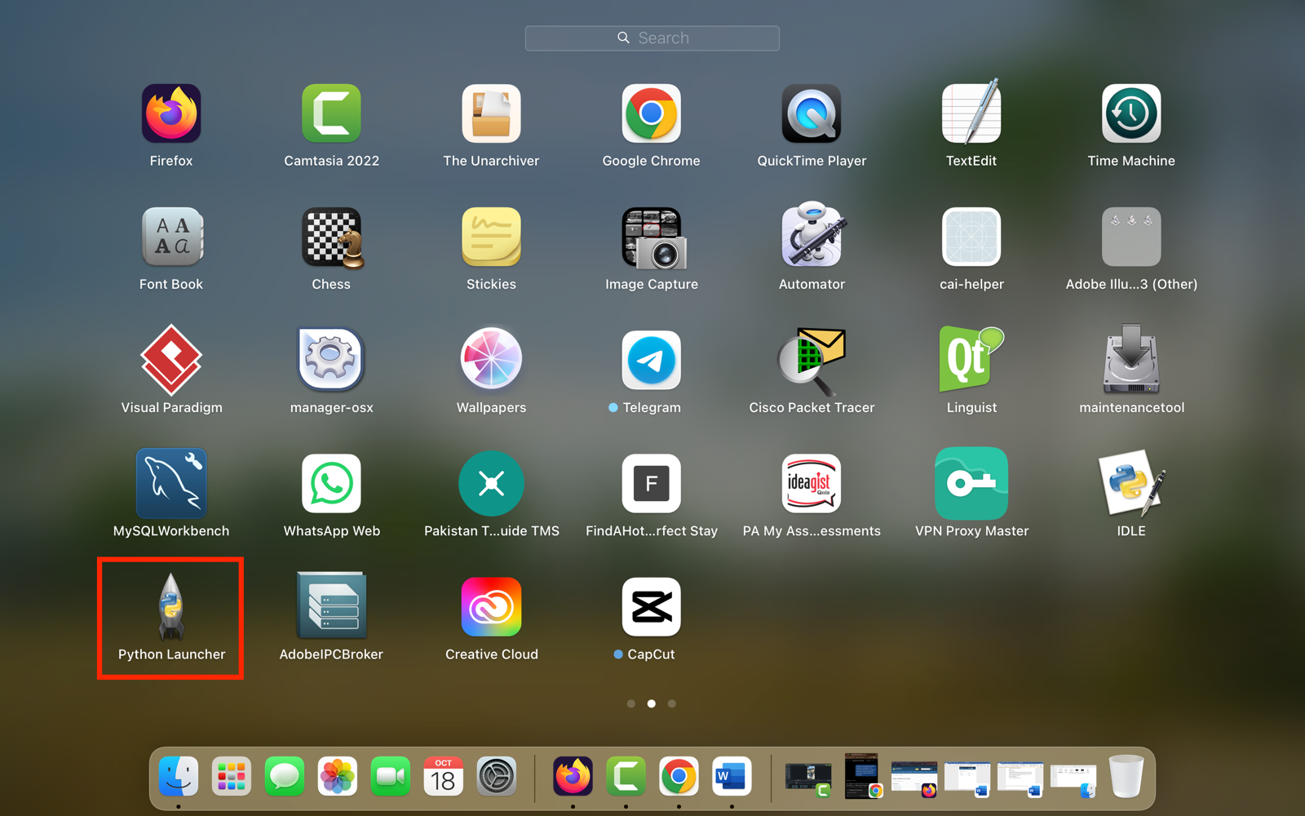

Step #03: Python version in Cmd
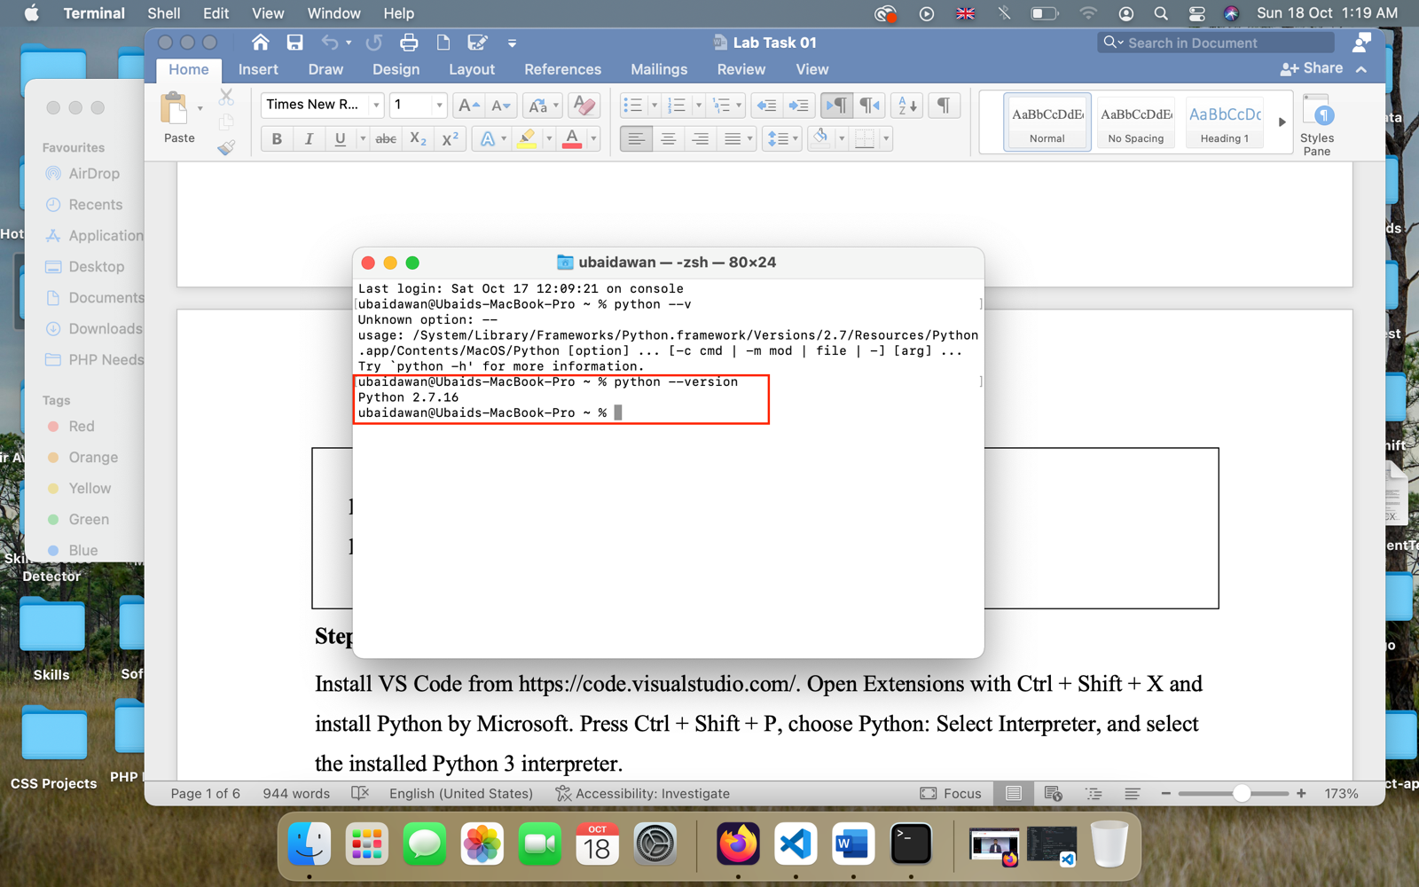
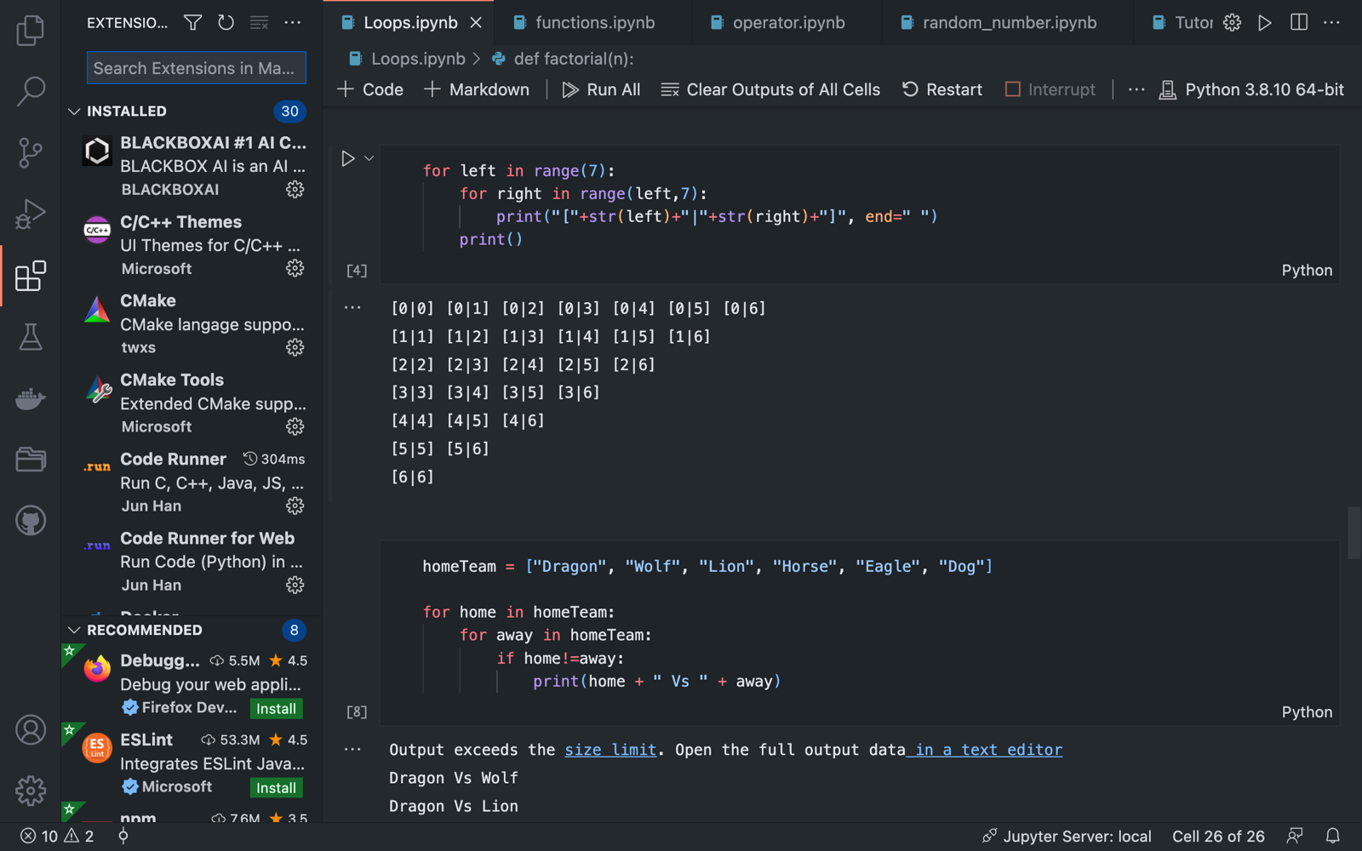

Step #04: Installing Extensions in Vscode
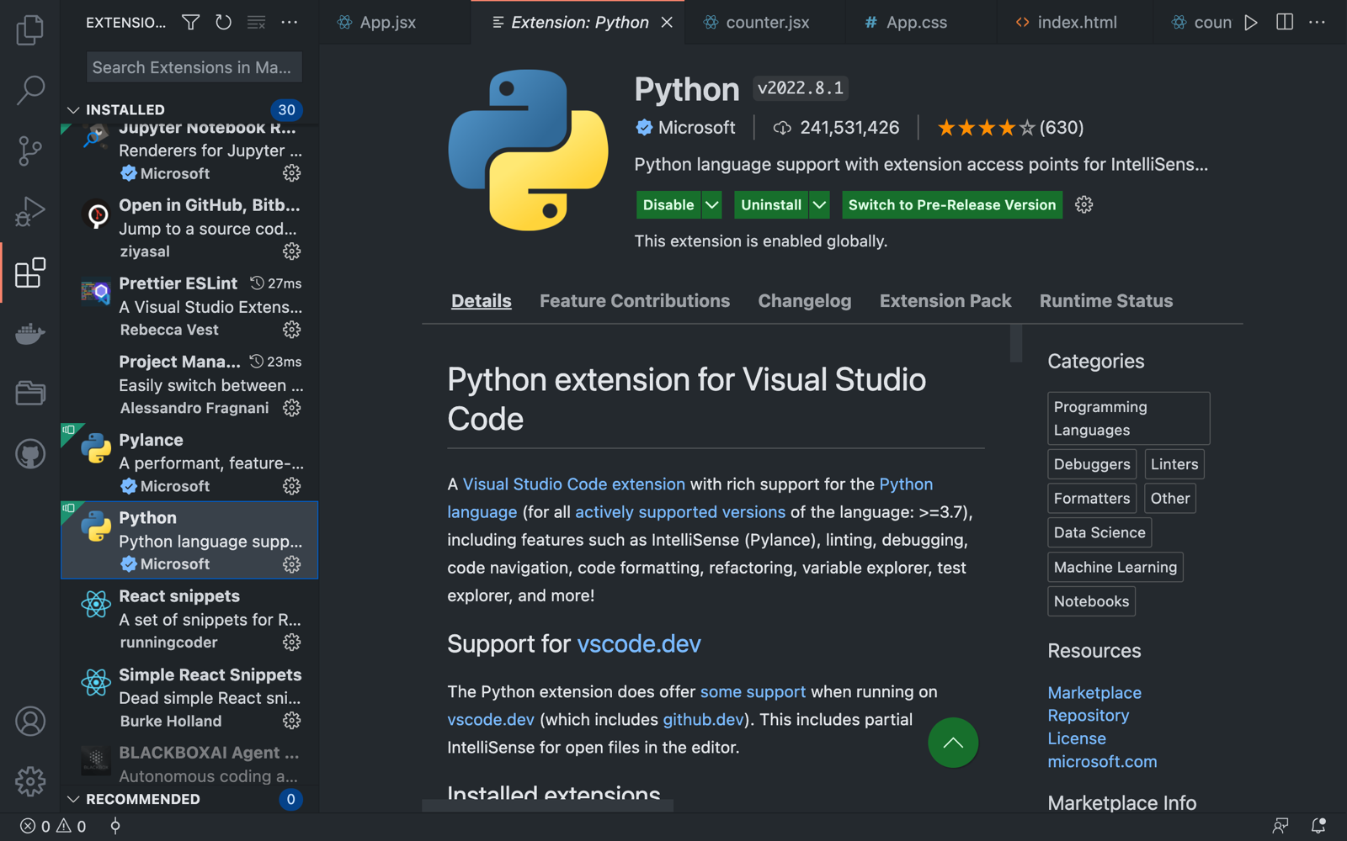

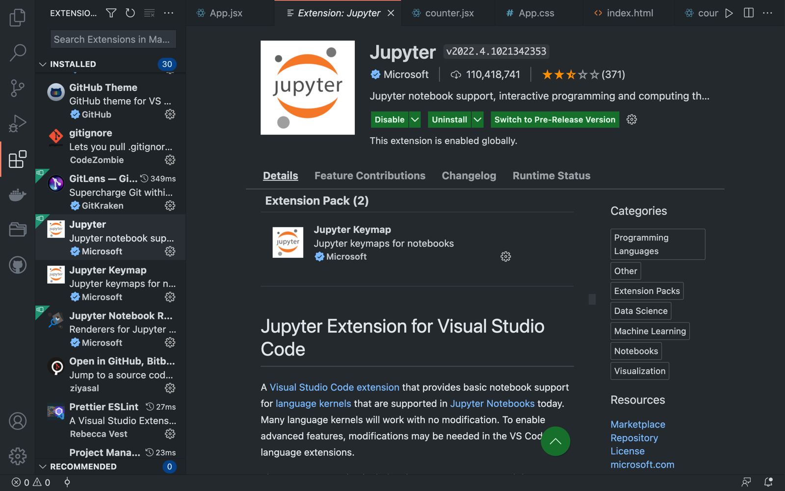

Step #06: Running code and solving exercises
