
The University of Azad Jammu and Kashmir, Muzaffarabad

DBMS Open-Ended Lab Assignment
Car Rental Management System
Short Report — Design, Normalization and Optimization

Name | Ubaidullah Awan
Roll no | 2024-SE-17
Semester | ^{4th}
Batch | 2024-2028
Subject | Database Systems
Lab | Open Ended Lab
Submitted to | Engr. M. Awais Rathore
Submission date | September 21, 2026

Department of Software Engineering

1. Problem Analysis and Database Design
CarGo Rentals needs a relational database that avoids duplicate customer and vehicle data, records rentals and returns, maintains payments, calculates charges, and prevents an unavailable vehicle from being rented again. The solution therefore separates the main business entities into Customer, Vehicle, Rental, ReturnRecord, and Payment tables.
Table | Primary Key | Purpose
Customer | CustomerID | Stores customer identity/contact information once.
Vehicle | VehicleID | Stores vehicle details, daily rate and current availability status.
Rental | RentalID | Links a customer and vehicle for a rental period and stores the agreed rate/charge.
ReturnRecord | ReturnID | Stores one return inspection/condition record for a completed rental.
Payment | PaymentID | Stores one or more payments associated with a rental.

Important design decisions: Customer phone and CNIC and VehicleNumber are UNIQUE; foreign keys preserve referential integrity; CHECK constraints reject invalid rates, dates, quantities and fees; status columns use controlled ENUM values; and DailyRateAtRental is stored in Rental so historical charges remain correct if the vehicle's current rate changes.

2. Task 2 — Normalization (1NF to 3NF)
The original spreadsheet-style record contains: RentalID, CustomerName, CustomerPhone, VehicleNumber, VehicleModel, DailyRate, RentalDate, ReturnDate and PaymentAmount.

2.1 First Normal Form (1NF)
1NF requires each field to contain one atomic value and each row to represent one rental. The supplied record already has scalar values, so it can be represented as a relation such as Rental_1NF(RentalID, CustomerName, CustomerPhone, VehicleNumber, VehicleModel, DailyRate, RentalDate, ReturnDate, PaymentAmount), with RentalID as the key.
Problem still present: customer and vehicle facts are repeated for every rental. Repeating Ali Khan's phone number or ABC-123's model/rate creates update anomalies; deleting the only rental could also remove the only stored copy of customer/vehicle facts.

2.2 Second Normal Form (2NF)
Because RentalID is a single-column primary key, there are no partial dependencies on part of a composite key; therefore the 1NF relation technically satisfies 2NF. However, important transitive dependencies remain: RentalID determines VehicleNumber, VehicleNumber determines VehicleModel and DailyRate; similarly RentalID identifies a customer and the customer's identity determines contact data.
A cleaner 2NF-oriented decomposition separates repeating entities: Customer(CustomerID, CustomerName, CustomerPhone), Vehicle(VehicleID, VehicleNumber, VehicleModel, DailyRate), and Rental(RentalID, CustomerID, VehicleID, RentalDate, ReturnDate, PaymentAmount). This substantially reduces duplication.

2.3 Third Normal Form (3NF)
3NF removes non-key attributes that depend on other non-key attributes and separates facts with their own lifecycle. The final design uses Customer, Vehicle, Rental, ReturnRecord and Payment. Customer details depend only on CustomerID; vehicle details depend only on VehicleID; rental-period facts depend only on RentalID; return-condition facts are stored in ReturnRecord; and payment facts are stored in Payment. This prevents customer/vehicle update anomalies and allows multiple payments without repeating the entire rental.
Stage | Main improvement | Anomaly/redundancy addressed
1NF | Atomic columns and one rental per row | Removes repeating groups/non-atomic values.
2NF | Separate reusable customer and vehicle facts | Reduces repeated customer/vehicle data.
3NF | Separate Rental, ReturnRecord and Payment responsibilities | Removes transitive/lifecycle dependencies and update/insert/delete anomalies.

3. Task 3 — JOIN Queries

The following section contains all four required JOIN queries.
- Q1 uses INNER JOIN because each rental must have a valid customer and vehicle.
- Q2 starts from Customer and uses LEFT JOIN so customers with zero rentals still appear.
- Q3 starts from Vehicle and LEFT JOINs only Active rentals so available/maintenance vehicles also appear.
- Q4 uses LEFT JOIN plus COUNT(RentalID) so a customer with no rentals receives a count of 0.
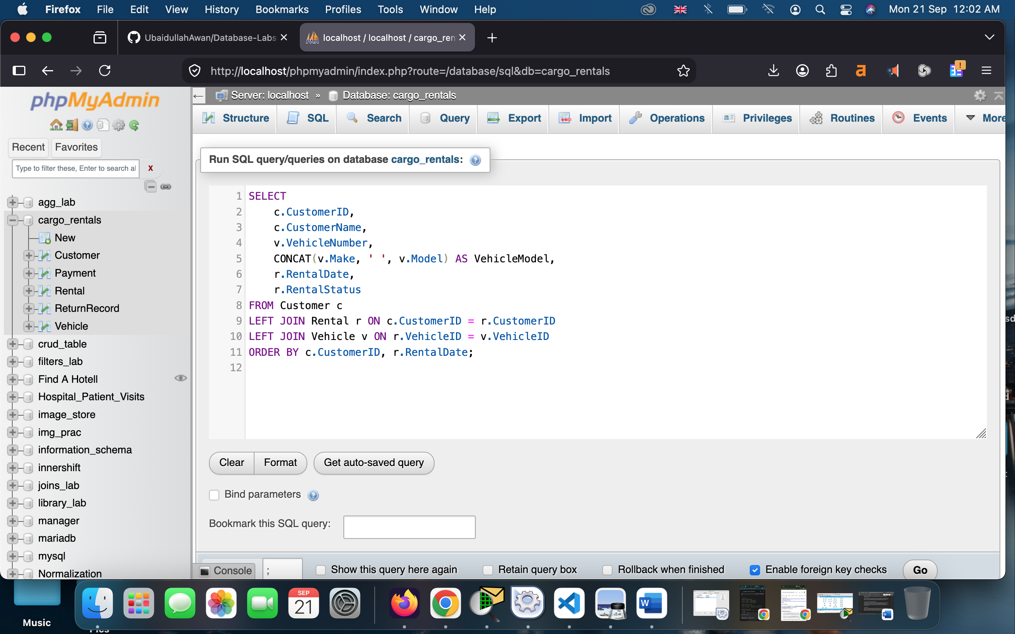
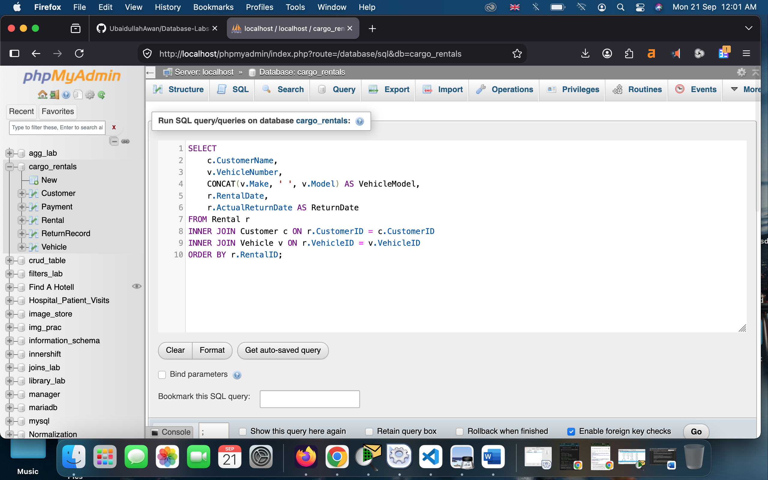
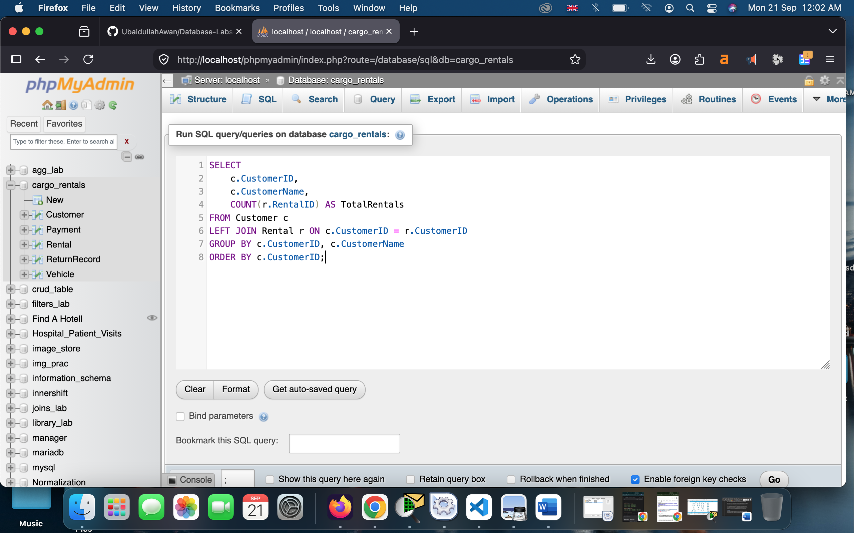
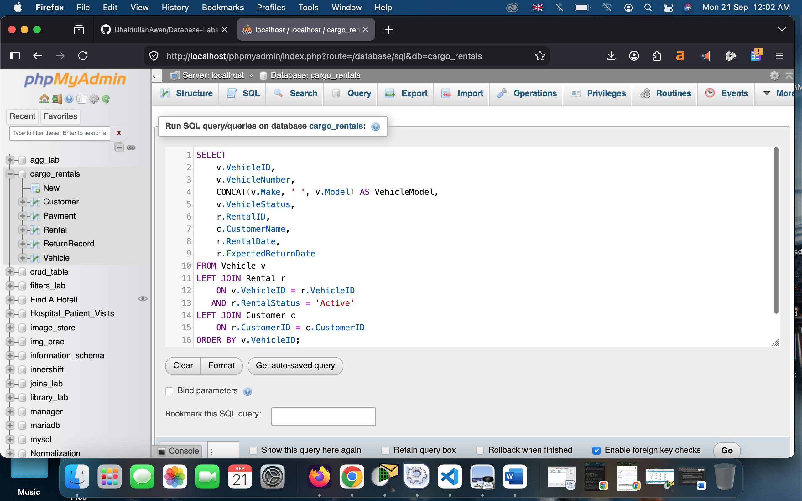

4. Task 4 — View
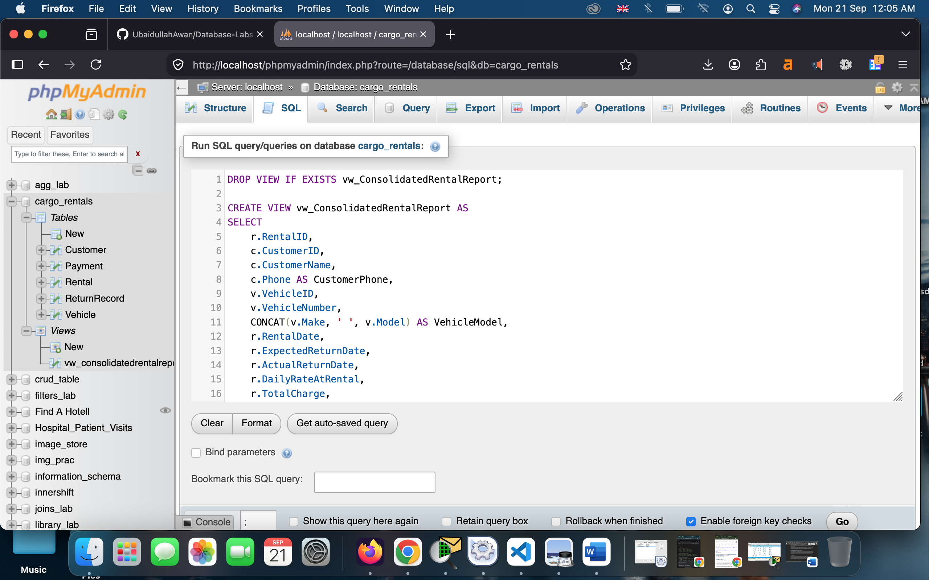
The view vw_ConsolidatedRentalReport combines rental, customer, vehicle and payment information. It shows the agreed rental rate, total charge, amount paid and remaining balance in one reusable report, so management does not need to rewrite multiple joins and payment aggregation for routine reporting. The reference screenshots are in the following:

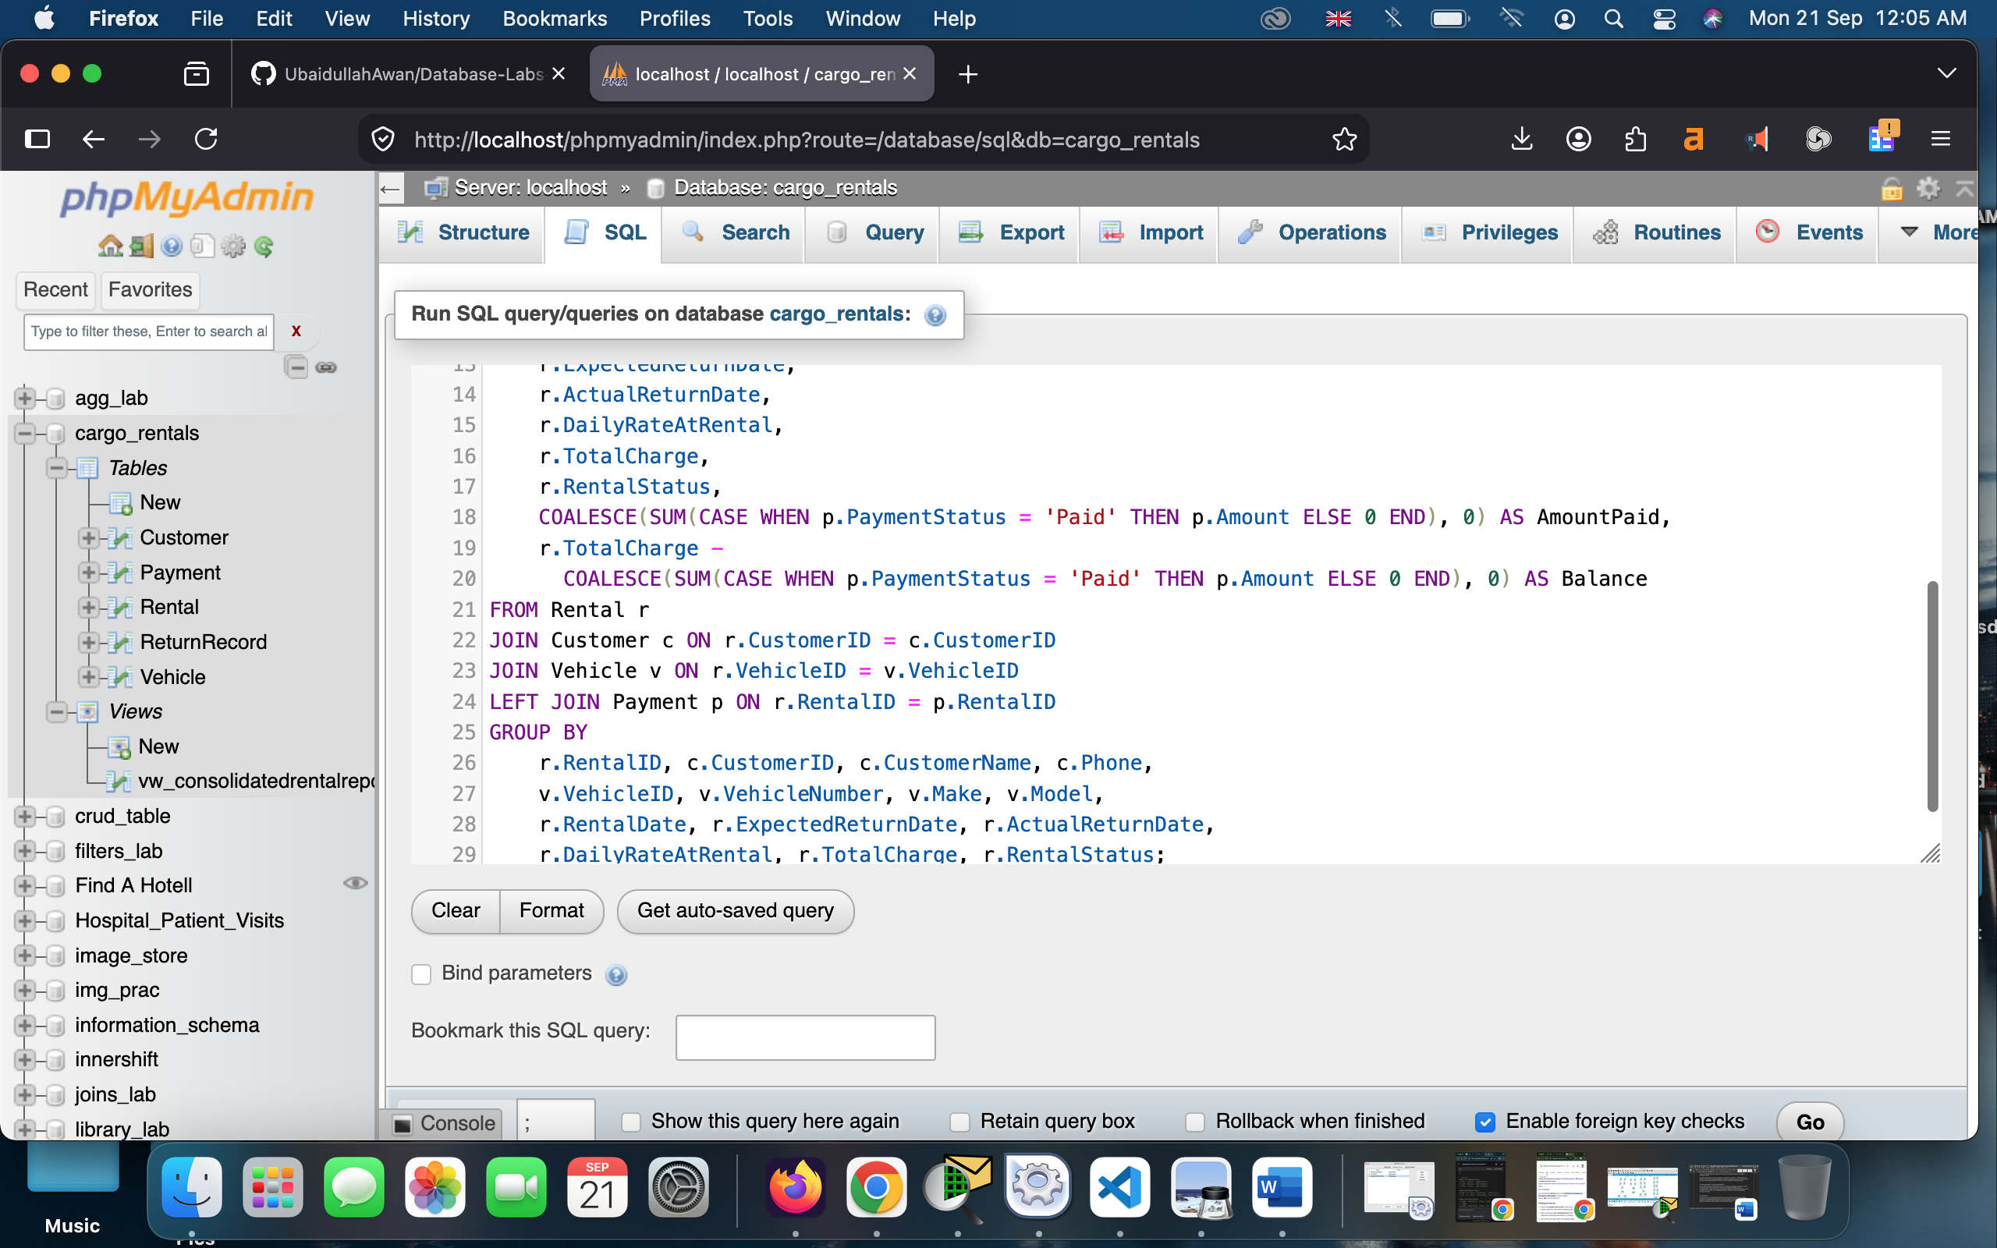

5. Trigger Implementation
The SQL solution includes validation and status triggers. Before an active rental is inserted, the vehicle must be Available; after insertion it becomes Rented; and when the rental changes from Active to Returned/Cancelled, the vehicle becomes Available again. This enforces the scenario requirement that an already rented vehicle cannot be rented again.

6. Task 6 — Stored Procedure
sp_RegisterRental(CustomerID, VehicleID, RentalDate, ExpectedReturnDate) validates the dates and customer, locks the selected vehicle row, checks availability, obtains the current daily rate, calculates the number of rental days and total charge, inserts the rental, and commits the transaction. The row lock plus trigger reduces the risk of two concurrent users renting the same vehicle.
Charge formula used: RentalDays = max(DATEDIFF(ExpectedReturnDate, RentalDate), 1), and TotalCharge = RentalDays × DailyRate. This matches the example in the handout where 2026-09-01 to 2026-09-04 at PKR 5,000 gives PKR 15,000.

7. Task 7 — Optimization Analysis
Potential inefficiency: as Rental and Payment grow, frequent joins and filters by CustomerID, VehicleID, RentalStatus and RentalID can require scanning many rows. This slows customer-history reports and the current-vehicle-rental report.
Improvement: the solution creates indexes on Rental(CustomerID), Rental(VehicleID, RentalStatus), Rental(RentalStatus, RentalDate, ExpectedReturnDate), and Payment(RentalID, PaymentStatus). The composite VehicleID/RentalStatus index is particularly useful for finding an active rental for a specific vehicle. An EXPLAIN statement is included in the SQL file so the execution plan can be inspected before/after indexing.
Consistency optimization: the rental procedure uses a transaction and SELECT ... FOR UPDATE on the vehicle row. This is not only a speed consideration; it protects the availability check from a race condition in which two sessions might otherwise read the same vehicle as Available at nearly the same time.

8. Demonstration
This step includes showing or exhibiting the visuals of implementation of database creation, table creating, and primary key implementation and others etc. The screenshots for the Sql joins queries and view implementation have already been provided above. Let me add here the screenshots, portraying the implementation of database creation in PhpMyAdmin.

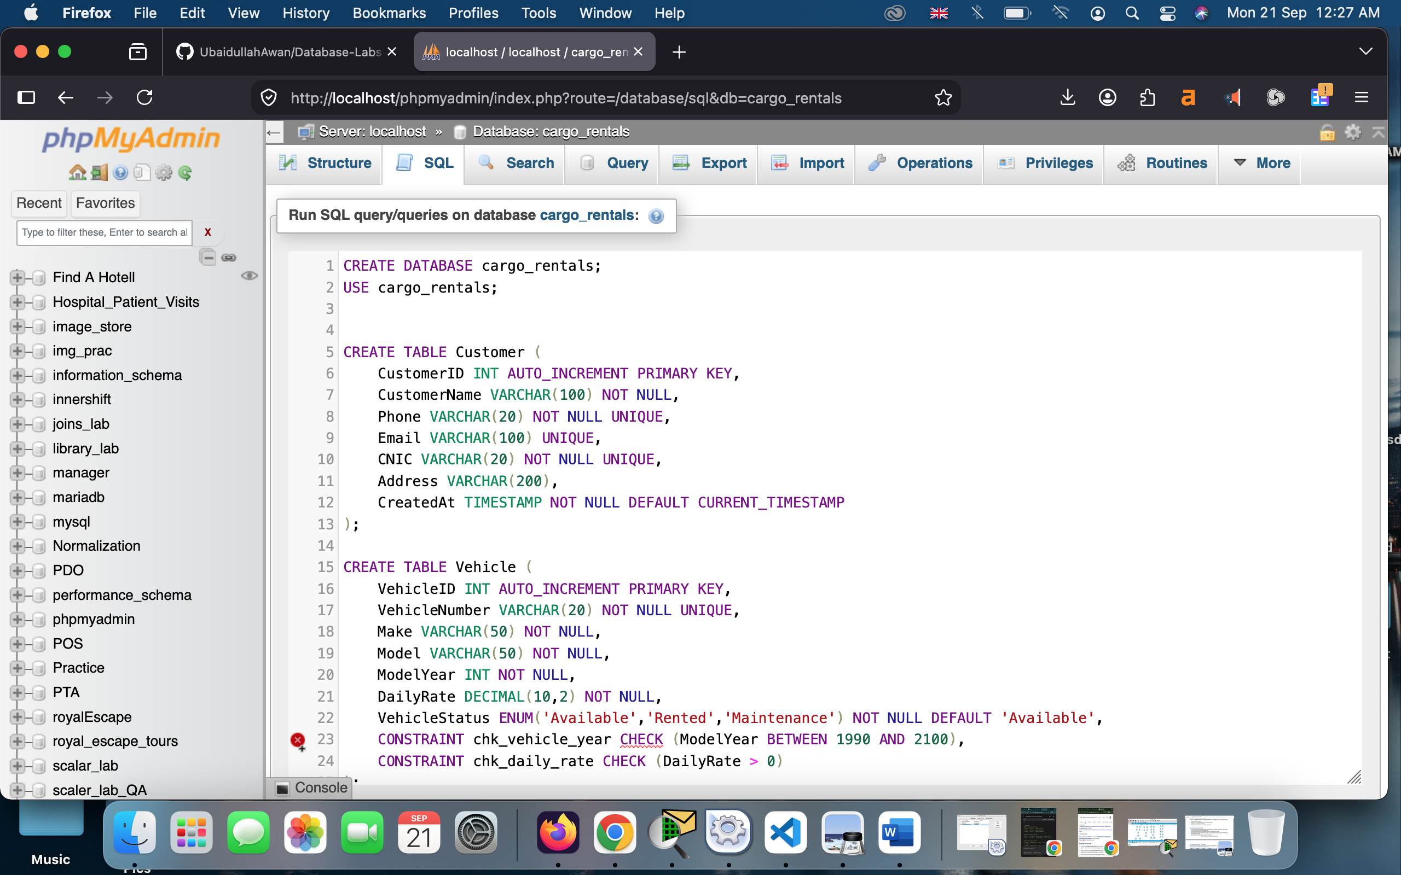
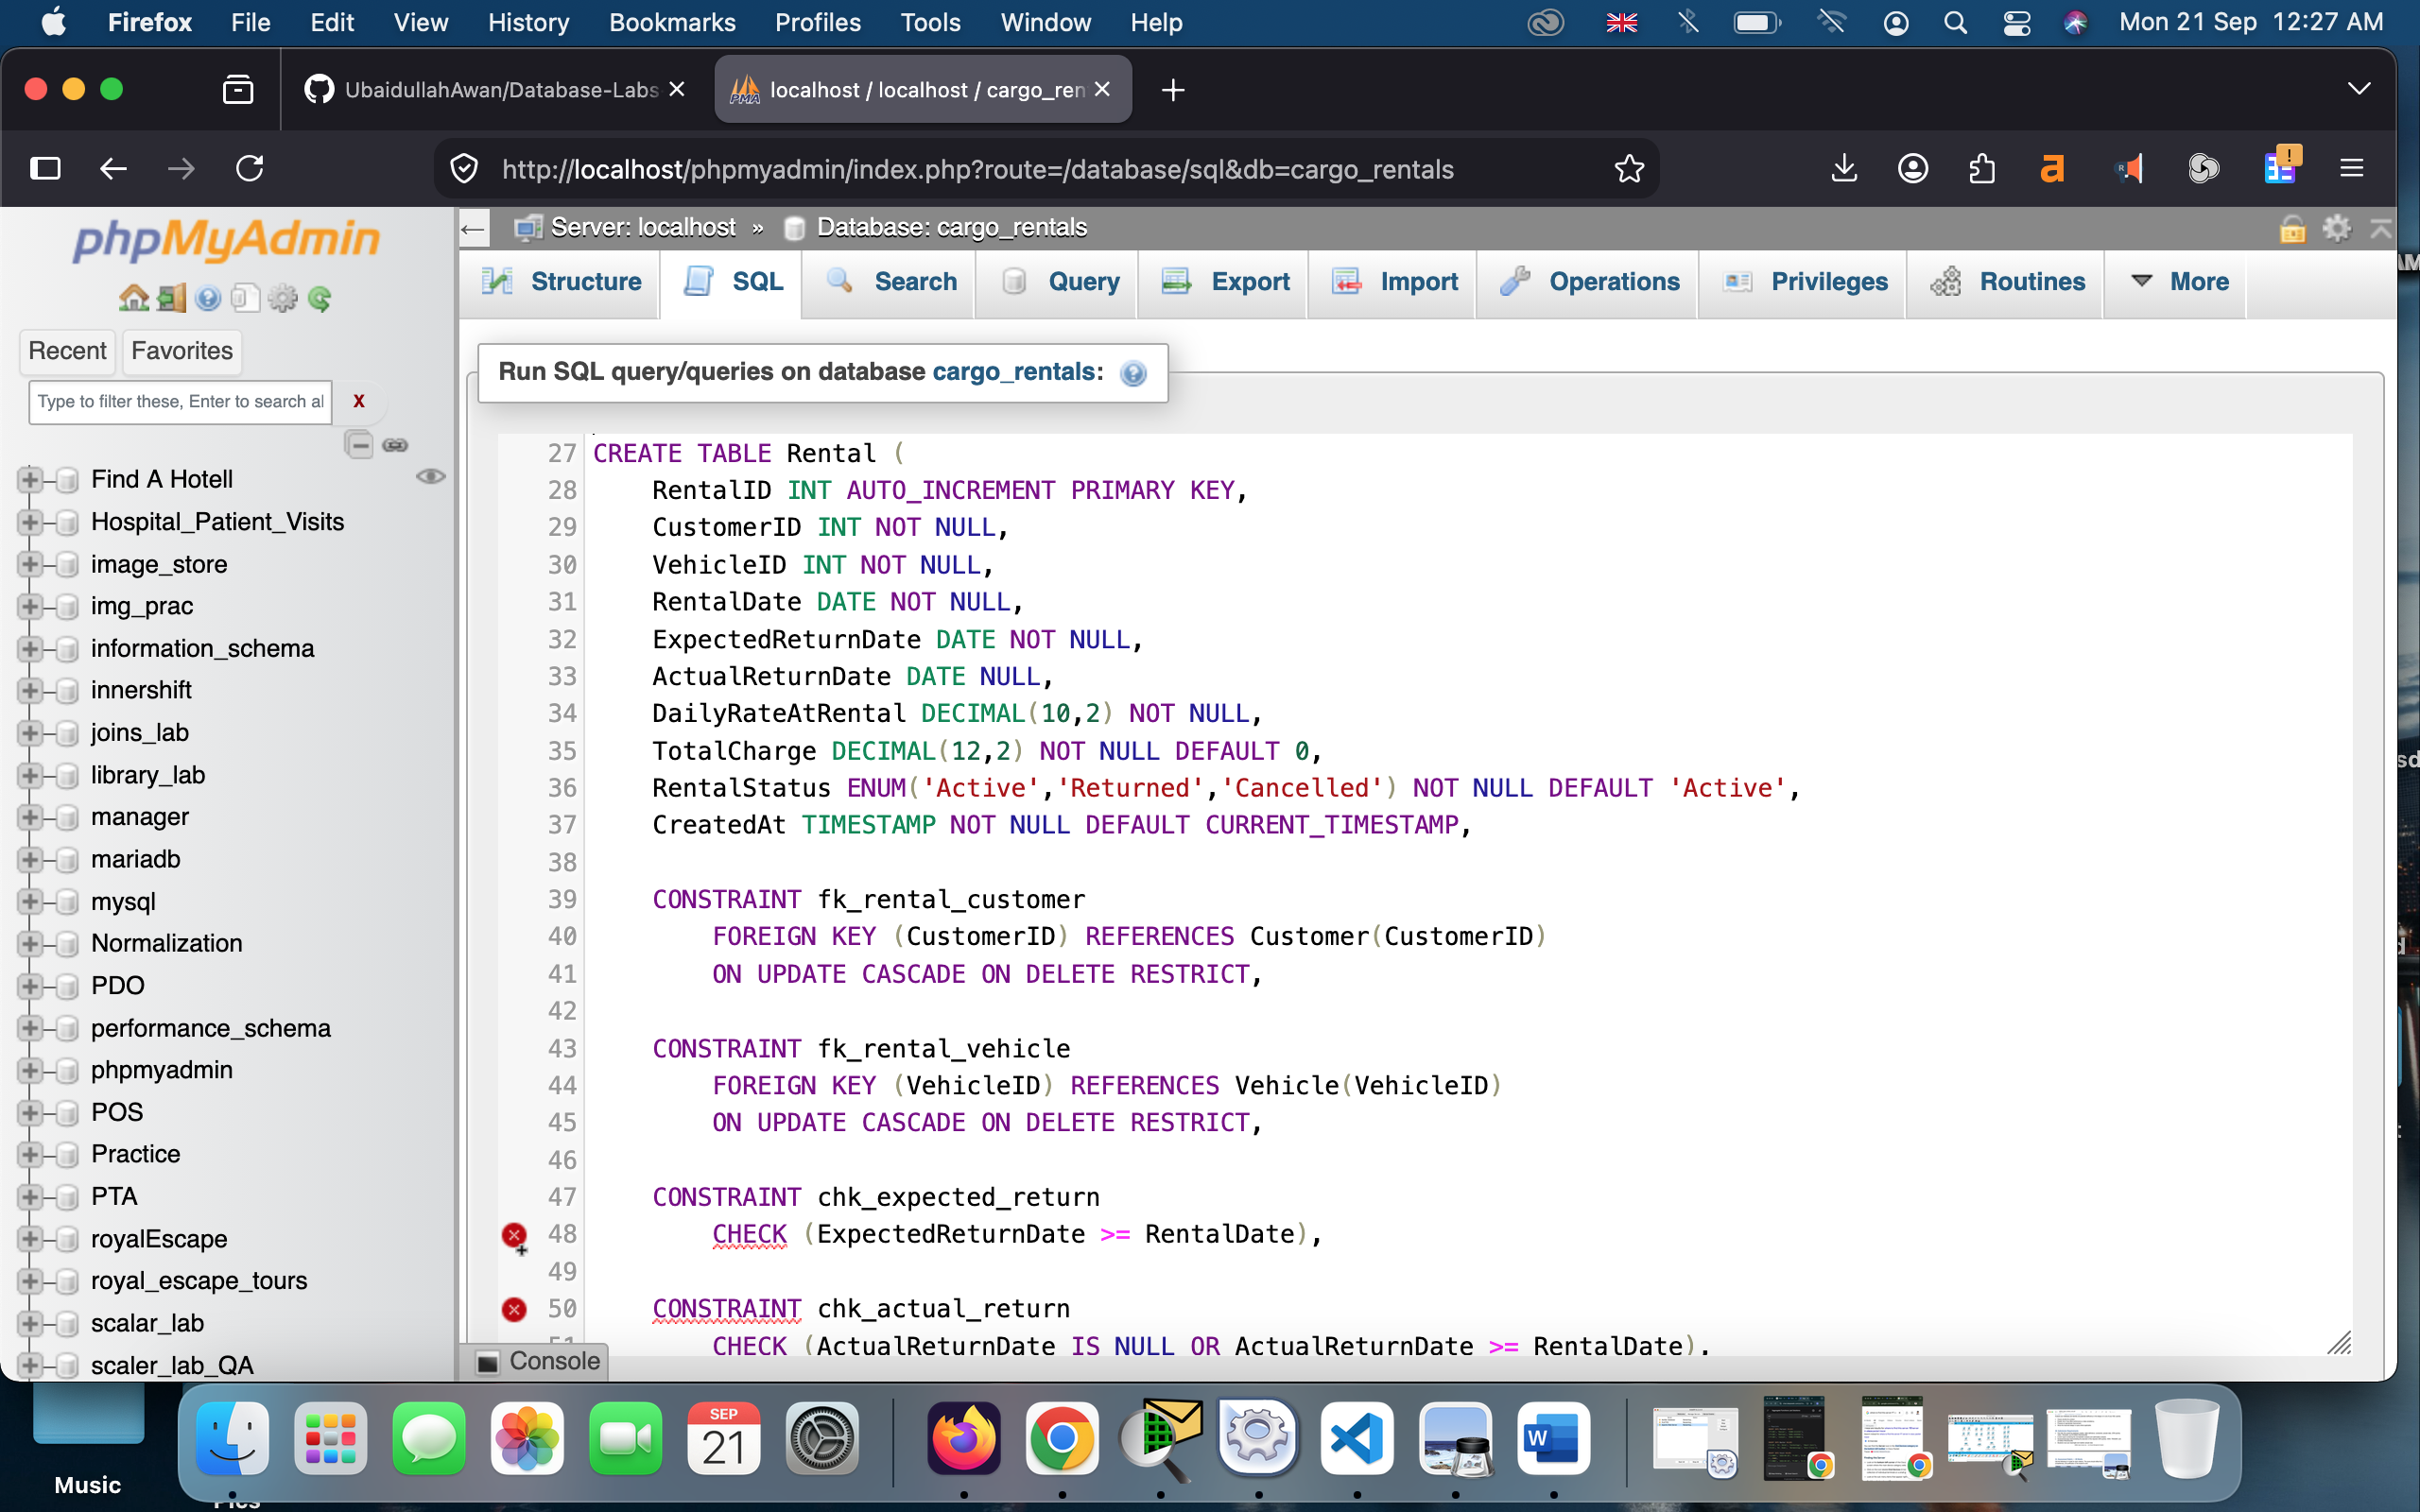
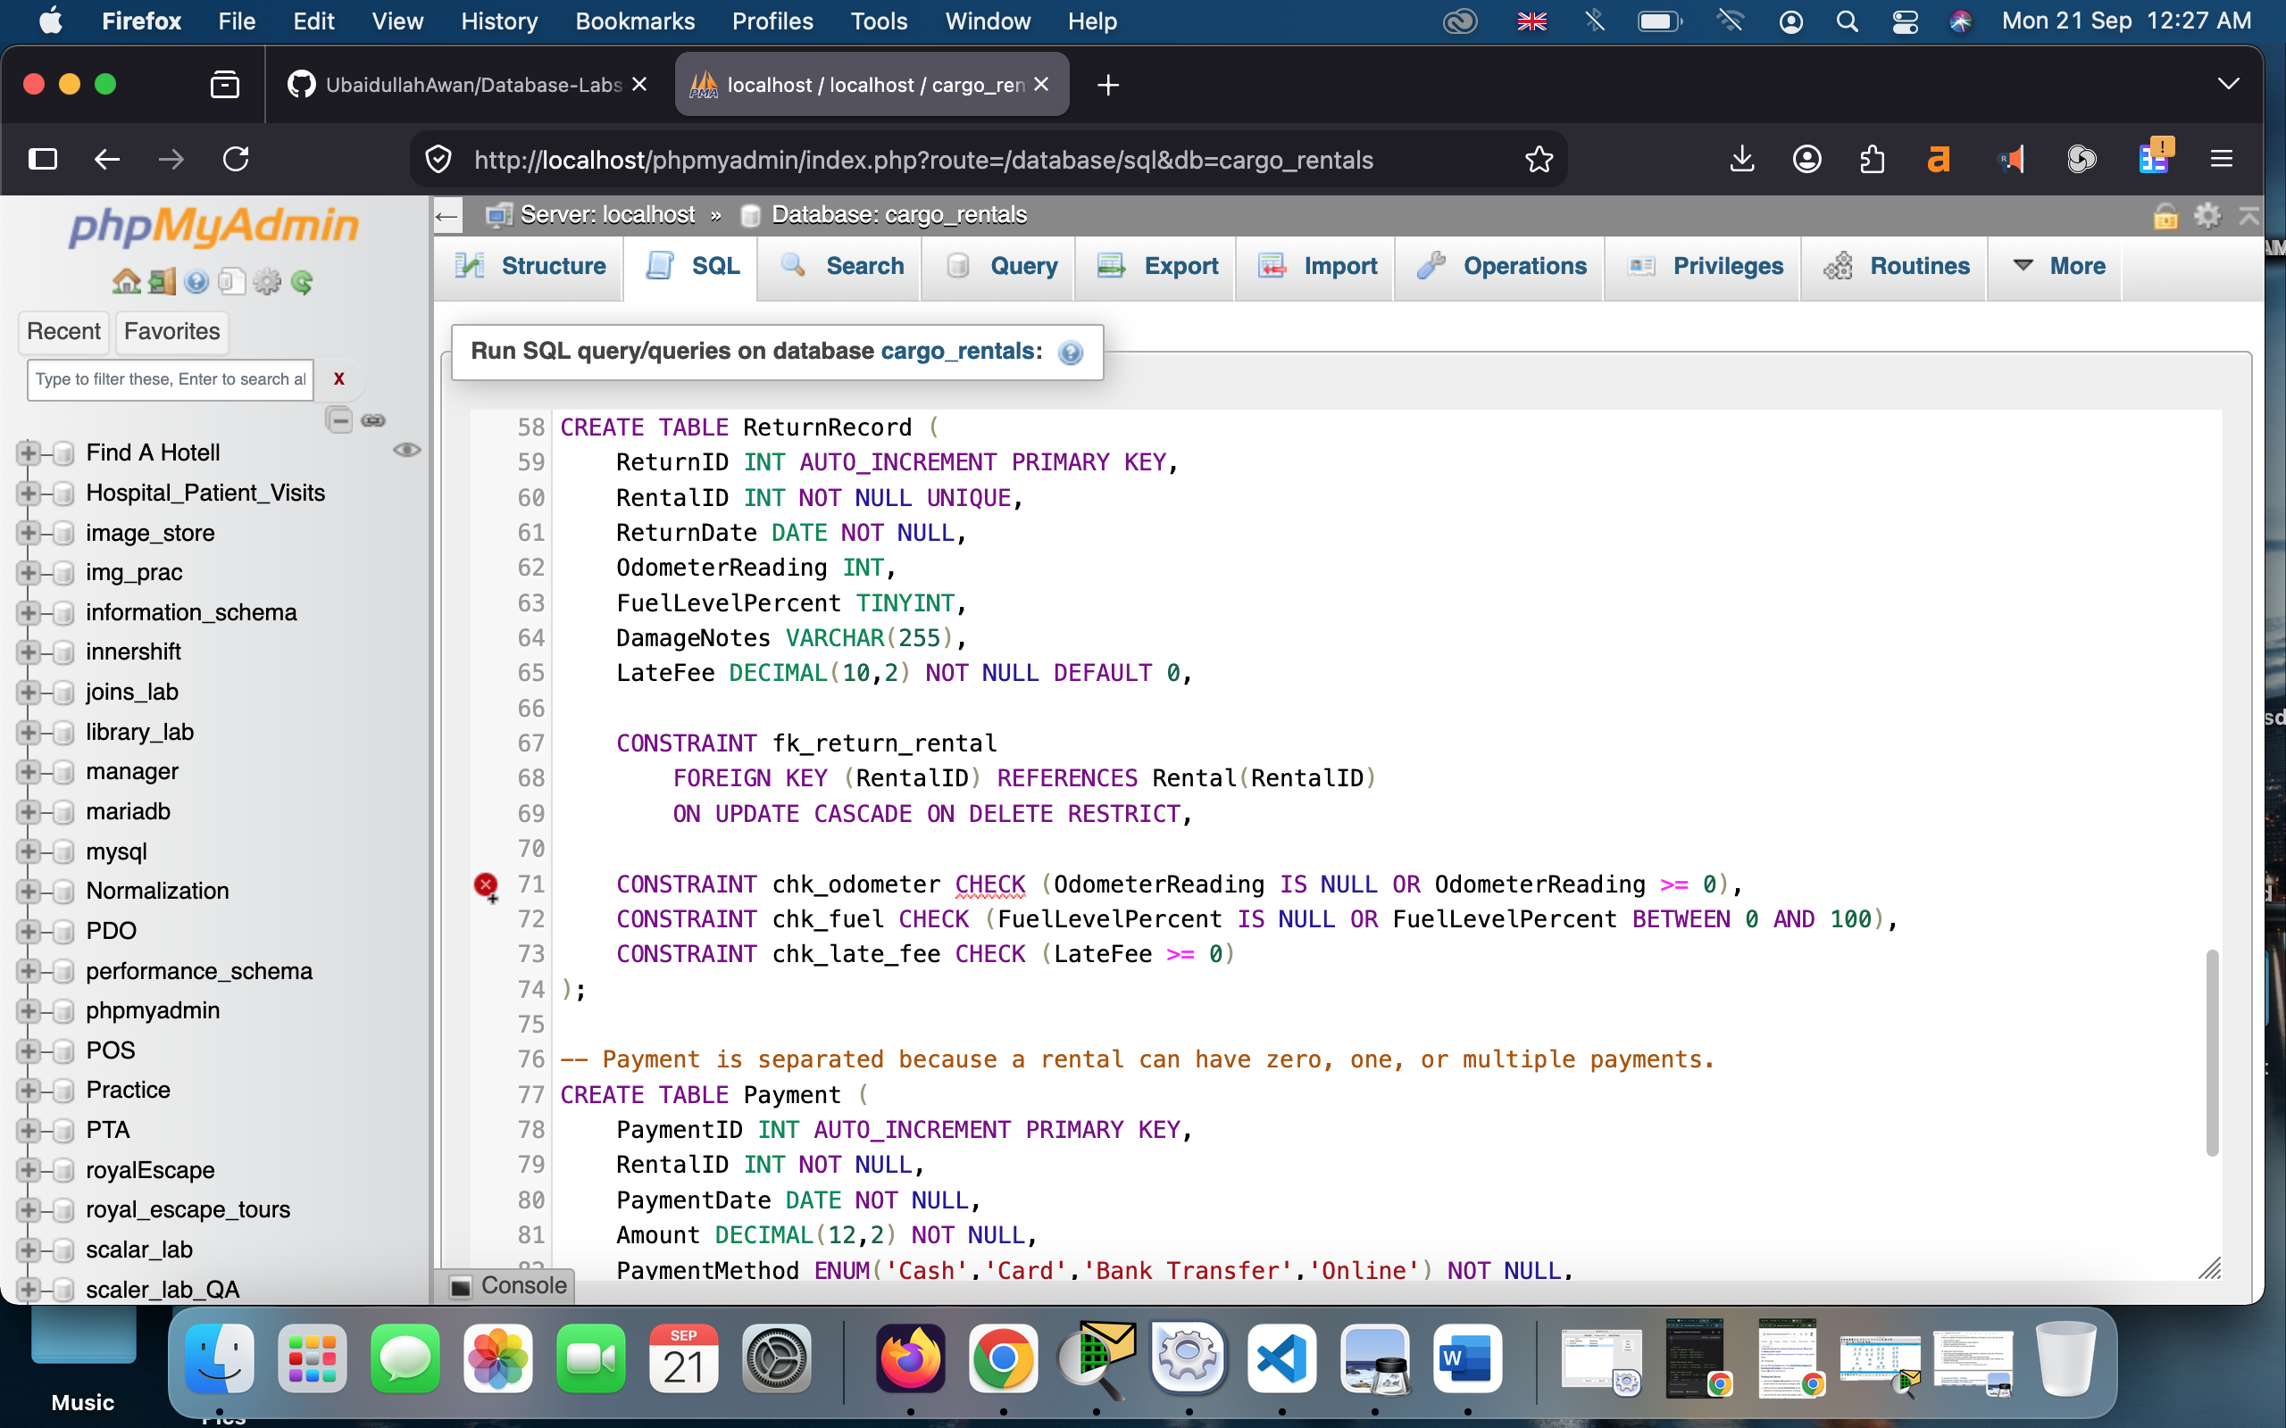
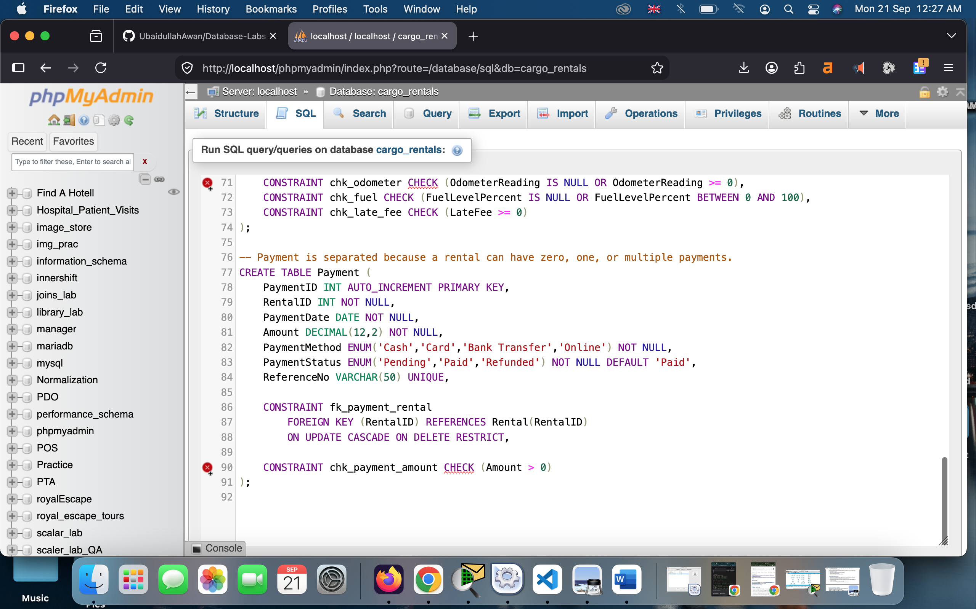

Realistic sample data:
In the tables created, I have inserted certain sample data to run join queries and create view for it. The data insertion screenshots are in the following:
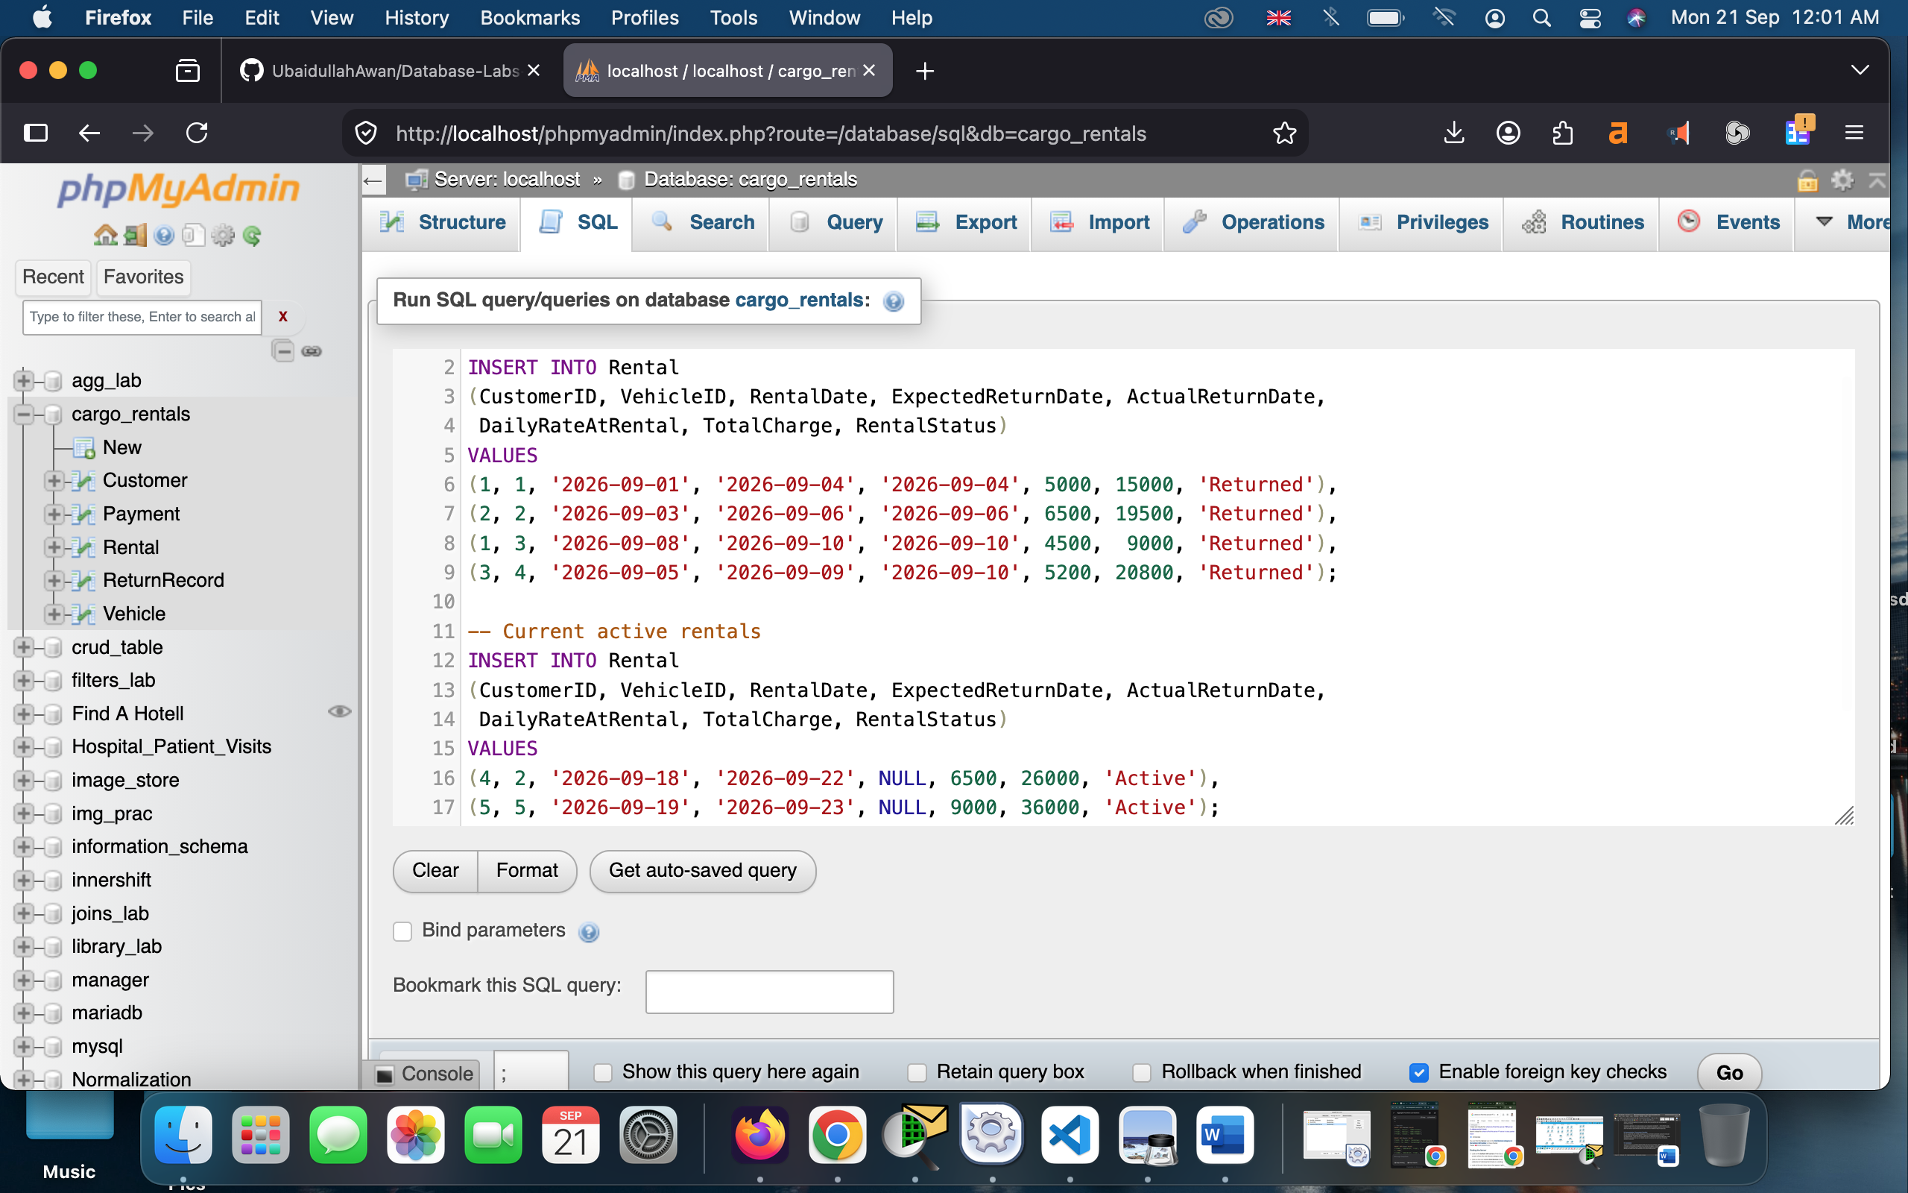
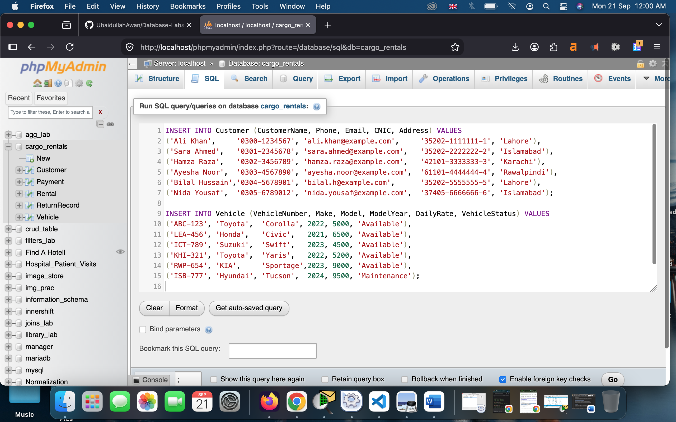

9. Conclusion
The final solution is a normalized relational design with keys and constraints, realistic data, appropriate JOIN types, a consolidated management view, business-rule triggers, a transactional rental-registration procedure, and targeted indexes. Together these features address the duplication, inconsistency, reporting difficulty and double-rental risks described in the CarGo Rentals scenario.

