

The University of Azad Jammu and Kashmir, Muzaffarabad

DBMS Open-Ended Lab
Car Rental Management System
Short Report — Design, Normalization and Optimization

Name | Ubaidullah Awan
Roll no | 2024-SE-17
Semester | ^{4th}
Batch | 2024-2028
Subject | Database Systems
Lab | Open Ended Lab
Submitted to | Engr. M. Awais Rathore
Submission date | September 21, 2026

Department of Software Engineering
1. What Is Done and How
The spreadsheet-based record described in the scenario was redesigned as a relational database with four tables: Customers, Vehicles, Rentals and Payments. Primary keys, foreign keys and CHECK/DEFAULT/UNIQUE constraints were added to prevent duplicate or inconsistent data. Sample data, four JOIN queries, one view, three triggers (to enforce the "vehicle already rented" rule) and one stored procedure (to register a rental and auto-calculate its charge) were implemented and tested. A normalization walkthrough (1NF-3NF) and an optimization analysis are given below, with the justification for every decision.
2. Database Design & Implementation — Justification
Four entities were identified directly from the scenario: a customer rents a vehicle, which creates a rental, which is settled by one or more payments.
Table | Key Design Choice | Why
Customers | CustomerID PK (surrogate); Phone, Email, CNIC UNIQUE | A customer can rent many vehicles over time, so customer data is stored once and referenced, not repeated per rental. UNIQUE stops duplicate customer records.
Vehicles | VehicleNumber PK (natural key); Status CHECK IN ('Available','Rented','Maintenance'); DailyRate CHECK > 0 | Number plate is already unique in the real world, so it is used as the PK. The Status column directly enforces "a vehicle cannot be rented twice at once", the core business rule.
Rentals | RentalID PK; CustomerID & VehicleNumber FK; CHECK(ExpectedReturnDate >= RentalDate) | Represents the many-to-many relationship between customers and vehicles over time (a customer can rent many vehicles; a vehicle can be rented by many customers, but not concurrently).
Payments | PaymentID PK; RentalID FK; AmountPaid CHECK >= 0; PaymentMethod CHECK IN (...) | A rental may be paid in full, partially, or not yet — kept separate so partial/late payments do not distort the Rentals table.

Foreign keys (CustomerID, VehicleNumber, RentalID) enforce referential integrity — a rental cannot reference a non-existent customer or vehicle, and a payment cannot reference a non-existent rental. Indexes were added on all foreign-key columns because they are used in every JOIN (see Section 5, Optimization).

3. Normalization (1NF → 3NF) — Justification
Starting point (as given): one flat record per rental mixing customer, vehicle and payment facts:
RentalID | CustomerName | CustomerPhone | VehicleNumber | VehicleModel | DailyRate | RentalDate | ReturnDate | PaymentAmount
R001 | Ali Khan | 0300-1234567 | ABC-123 | Toyota Corolla | 5000 | 2026-09-01 | 2026-09-04 | 15000

3.1 Functional Dependencies Identified
- RentalID → CustomerName, CustomerPhone, VehicleNumber, VehicleModel, DailyRate, RentalDate, ReturnDate, PaymentAmount (the key determines every other attribute)

- CustomerPhone → CustomerName (a phone number identifies exactly one customer — transitive dependency, not on RentalID)

- VehicleNumber → VehicleModel, DailyRate (a vehicle number identifies exactly one model and rate — transitive dependency)
3.2 1NF — Relation and Justification
Relation: Rental_1NF ( RentalID (PK), CustomerName, CustomerPhone, VehicleNumber, VehicleModel, DailyRate, RentalDate, ReturnDate, PaymentAmount )

Attribute | Role
RentalID | Primary Key
CustomerName | Non-key
CustomerPhone | Non-key
VehicleNumber | Non-key
VehicleModel | Non-key
DailyRate | Non-key
RentalDate | Non-key
ReturnDate | Non-key
PaymentAmount | Non-key

Justification: every cell holds a single atomic value and there is no repeating group (e.g. no multi-valued VehicleNumber list in one row), so the table qualifies for 1NF as a single relation.

3.3 2NF — Relation and Justification
Relation: Rental_2NF ( RentalID (PK), CustomerName, CustomerPhone, VehicleNumber, VehicleModel, DailyRate, RentalDate, ReturnDate, PaymentAmount ) — attributes unchanged from 1NF.
Justification: 2NF is violated only by a partial dependency — a non-key attribute depending on part of a composite primary key. Here the primary key, RentalID, is a single attribute, so "part of the key" does not exist and no partial dependency is possible. Every non-key attribute is therefore fully (not partially) dependent on the whole key, and Rental_2NF is identical to Rental_1NF. 2NF is satisfied without decomposition; the real redundancy is transitive, and is resolved next in 3NF.
3.4 3NF — Relations and Justification

2NF is still not 3NF because CustomerPhone→CustomerName and VehicleNumber→VehicleModel,DailyRate are transitive dependencies (a non-key attribute determining other non-key attributes). This is what causes CustomerName and VehicleModel/DailyRate to repeat on every rental row. Decomposing Rental_2NF into three relations removes every transitive dependency:
Relation | Attributes | Key
Customer_3NF | CustomerPhone, CustomerName | PK: CustomerPhone
Vehicle_3NF | VehicleNumber, VehicleModel, DailyRate | PK: VehicleNumber
Rental_3NF | RentalID, CustomerPhone, VehicleNumber, RentalDate, ReturnDate, PaymentAmount | PK: RentalID · FK: CustomerPhone → Customer_3NF · FK: VehicleNumber → Vehicle_3NF

In Rental_3NF every remaining non-key attribute (RentalDate, ReturnDate, PaymentAmount) depends only on RentalID directly — no transitive path remains. Redundancy is removed (CustomerName/VehicleModel/DailyRate now stored once, not per rental) and the update anomaly is fixed (correcting a phone number or a daily rate now means editing exactly one row).
3.5 Mapping to the Implemented Schema
The physical design in Section 2 refines Rental_3NF in two small ways, both still consistent with 3NF: (1) a surrogate CustomerID replaces CustomerPhone as the customer key, since a phone number can change but should not force updating every referencing row;
(2) PaymentAmount is split into its own Payments relation, because a rental can have zero, one, or several payments (partial/late payment), which a single PaymentAmount column cannot represent without repeating rows or losing data (an insertion anomaly). The result is exactly the four tables — Customers, Vehicles, Rentals, Payments — implemented and justified in Section 2.

4. JOIN Queries — Justification

Q1 — Rental details for every rental (customer, vehicle, dates). Uses INNER JOIN because every rental in this system always has a valid customer and vehicle (enforced by the foreign keys), so no row can be lost.

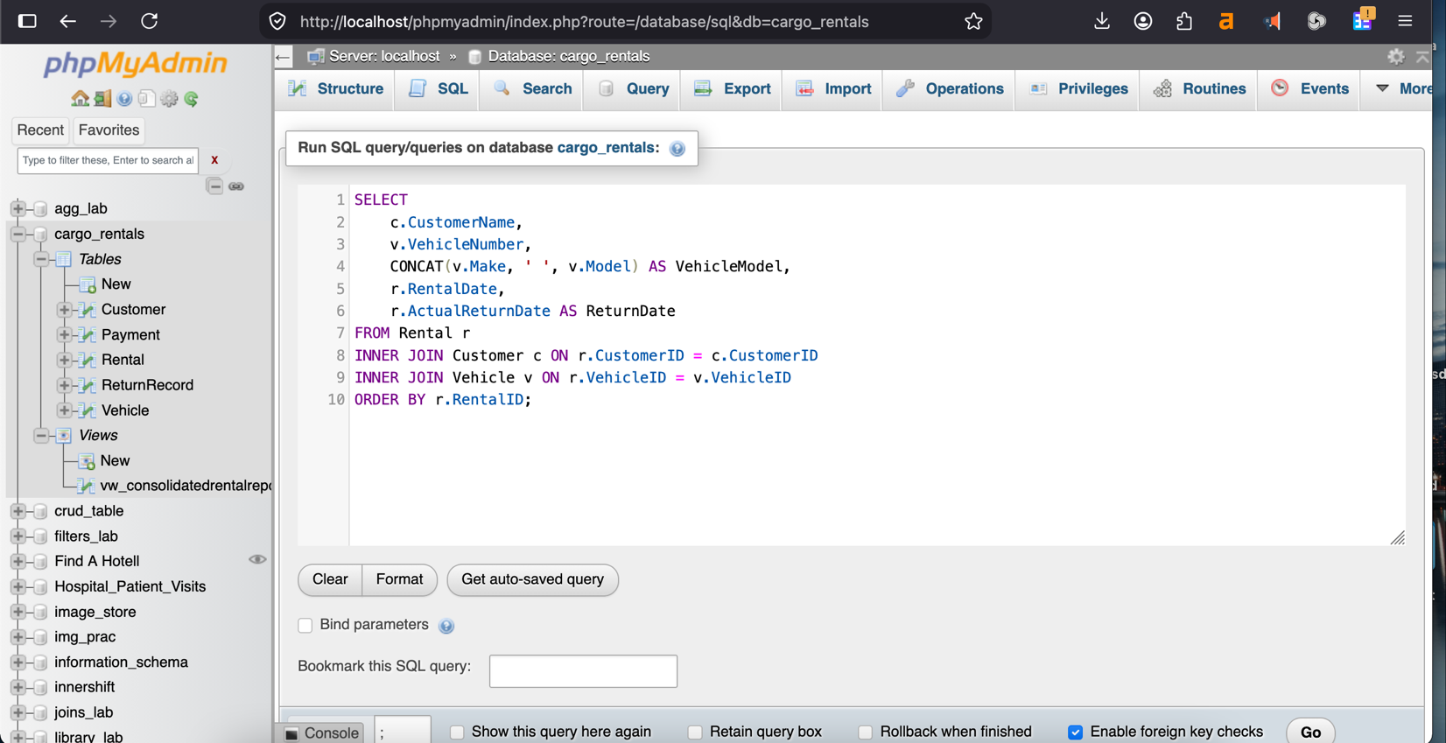
Query1:

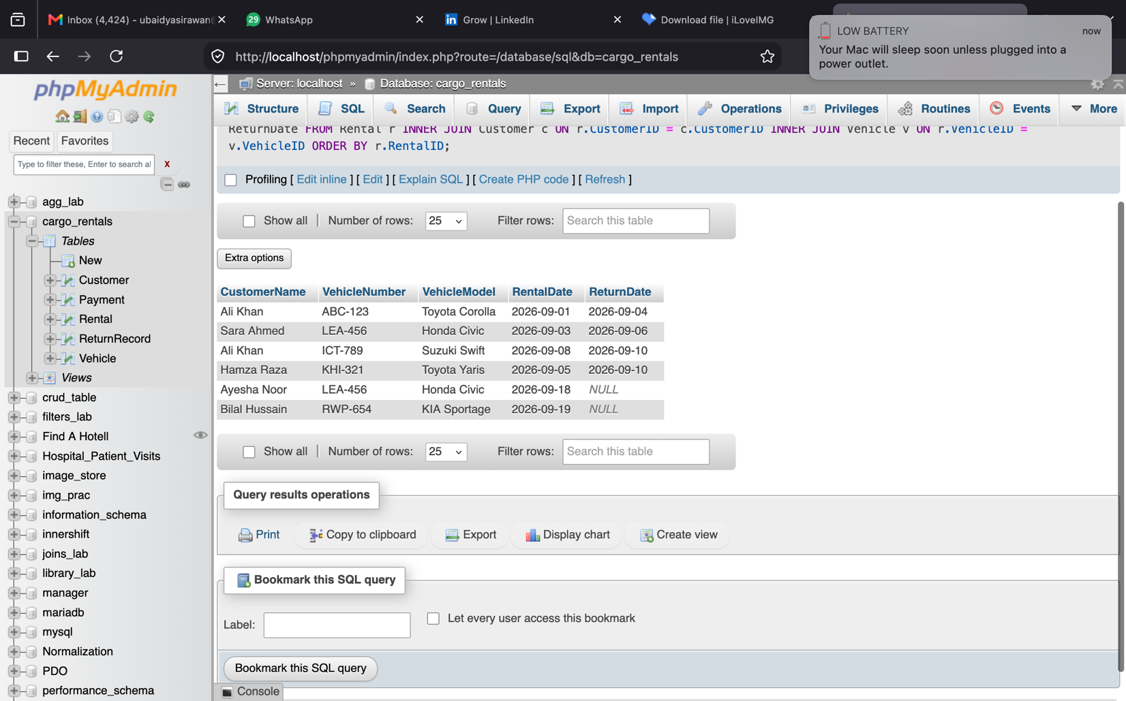
Output1:

Q2 — All customers with the vehicles they rented, including customers who never rented. Uses LEFT JOIN from Customers so that unmatched customers still appear, with NULLs for vehicle columns.

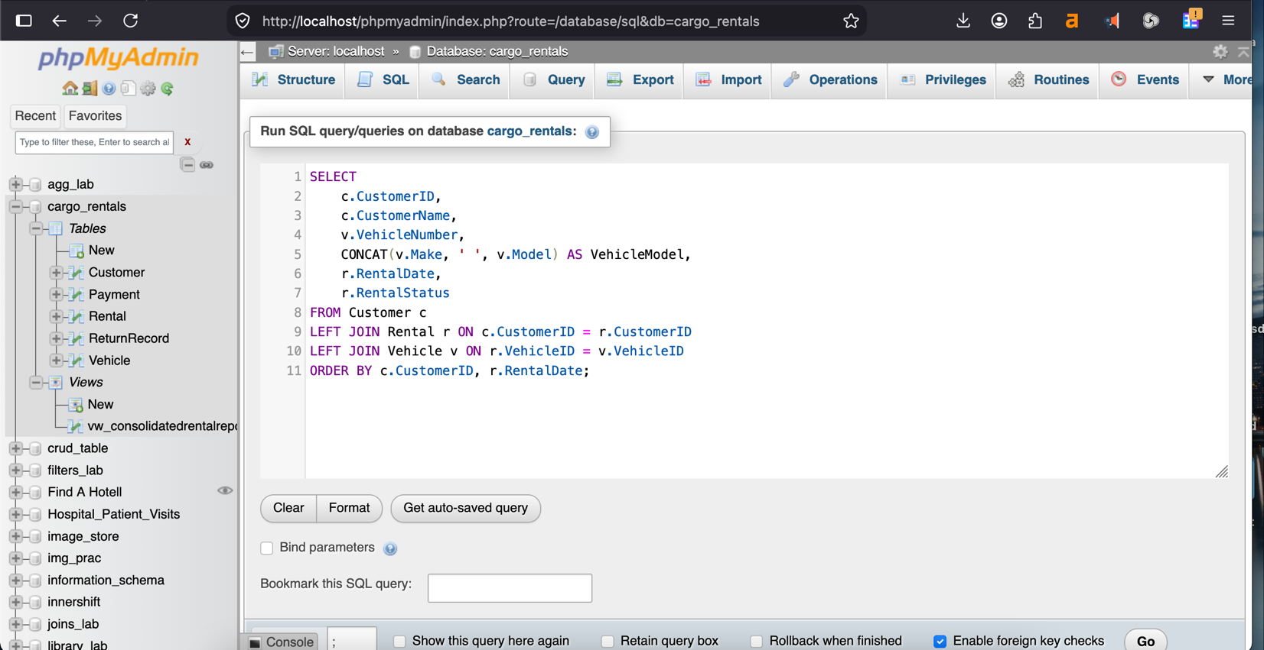
Query2:

Output2:

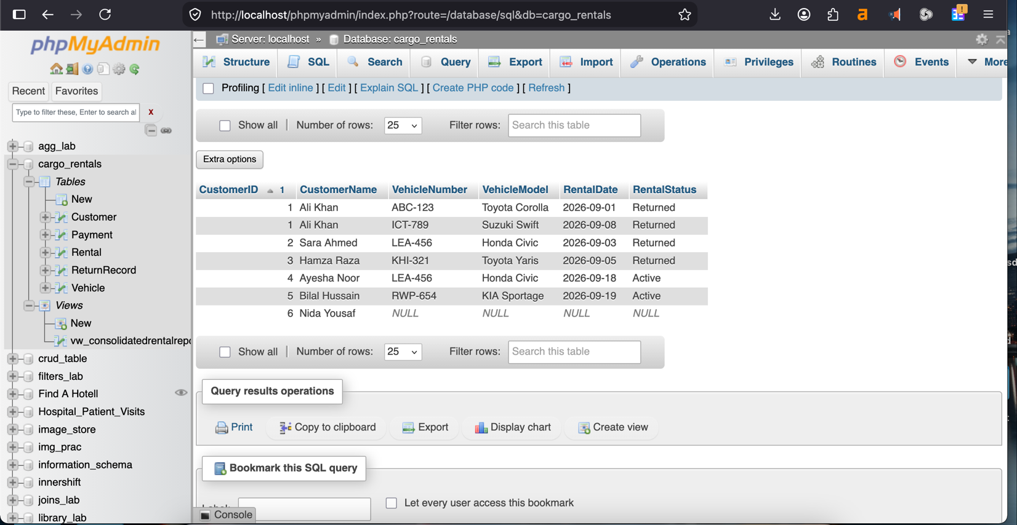

Q3 — All vehicles with their current rental (if any), including vehicles not currently rented. Uses LEFT JOIN from Vehicles, filtered to the open rental (ActualReturnDate IS NULL) so a vehicle's rental history does not duplicate it once per past rental.

Query3:
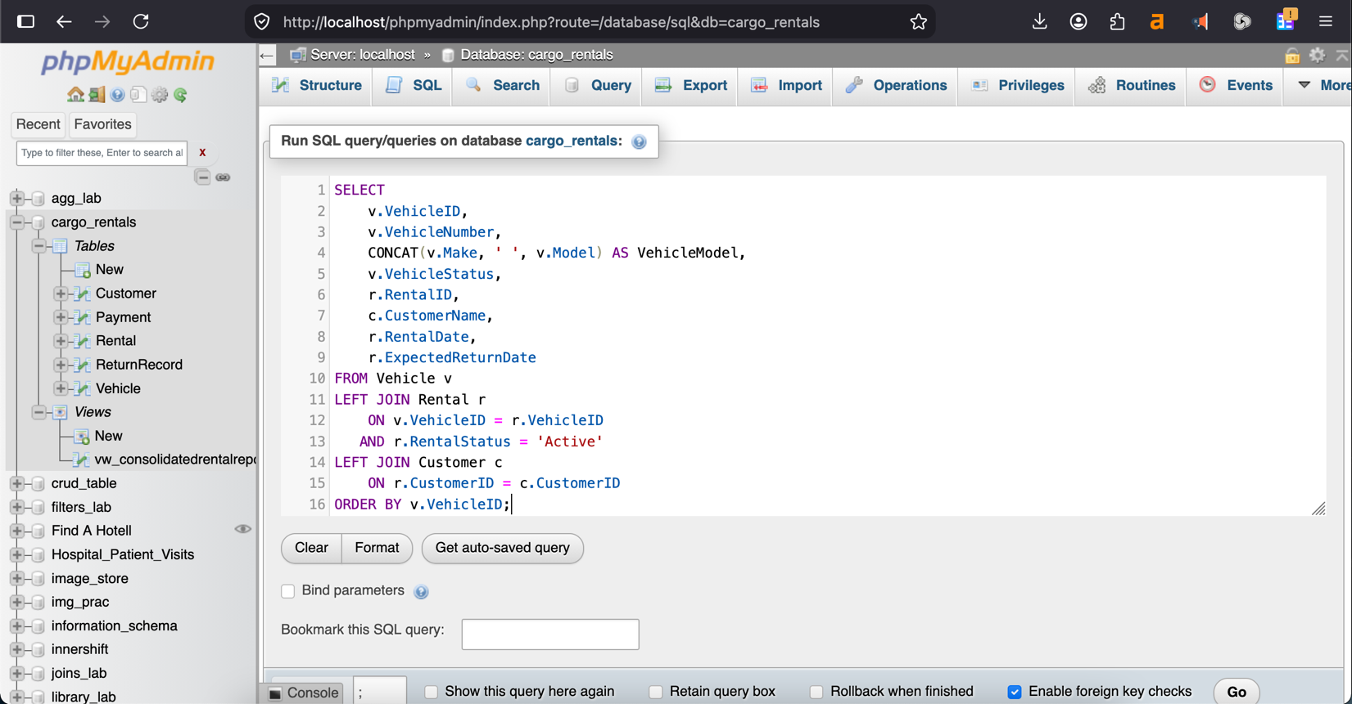
Output3:
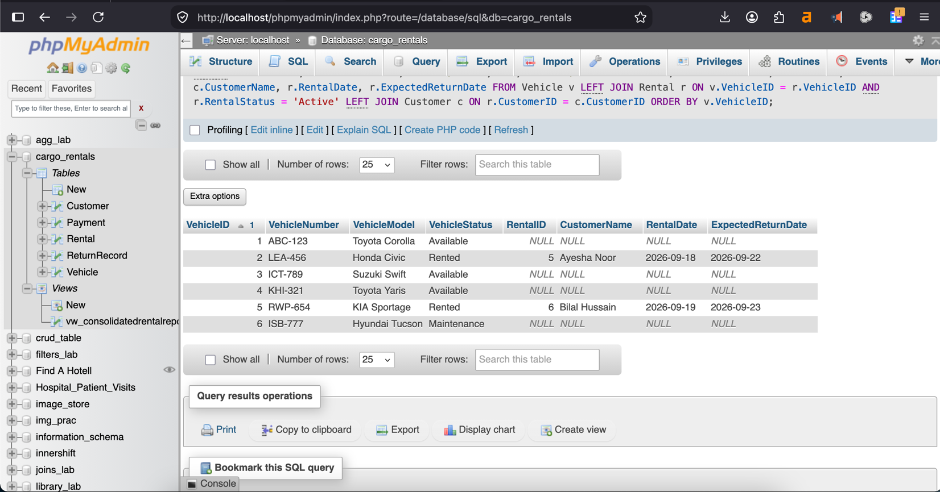
Q4 — Total rentals per customer, including customers with zero rentals. Uses LEFT JOIN + COUNT, which counts only matched Rentals rows (RentalID), so a customer with no matching row correctly gets 0, not 1.

Query4:
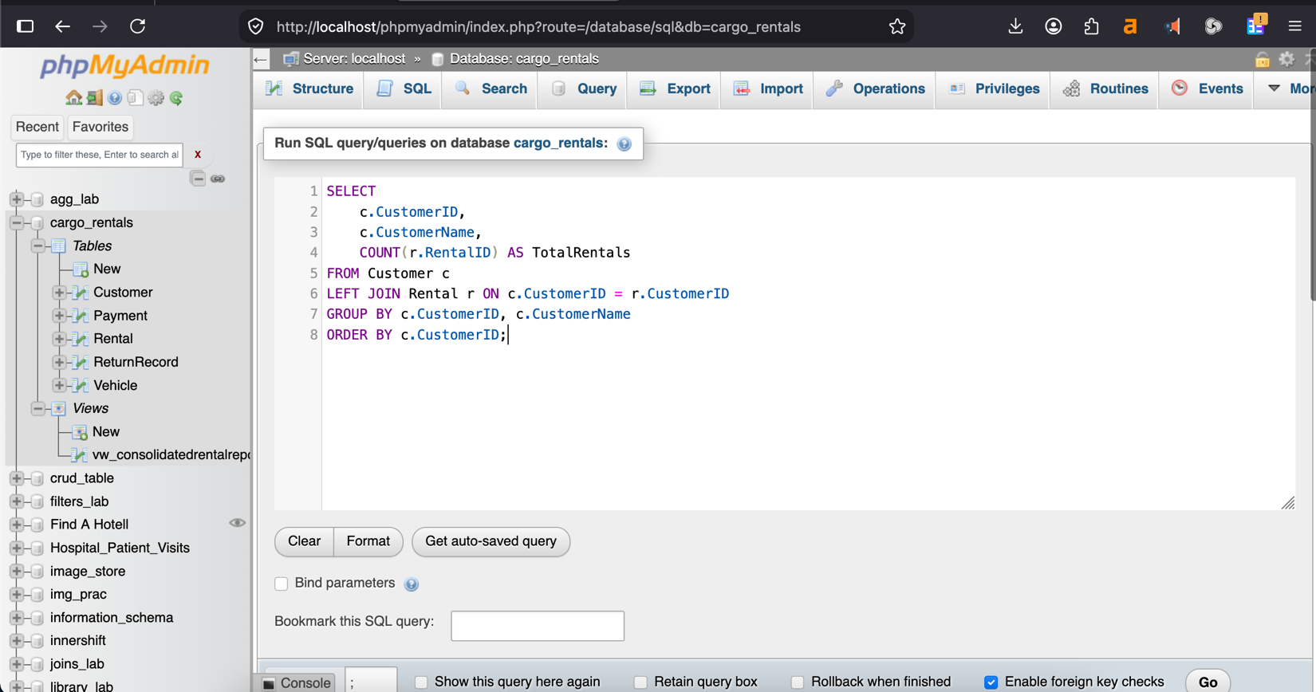

Output4:
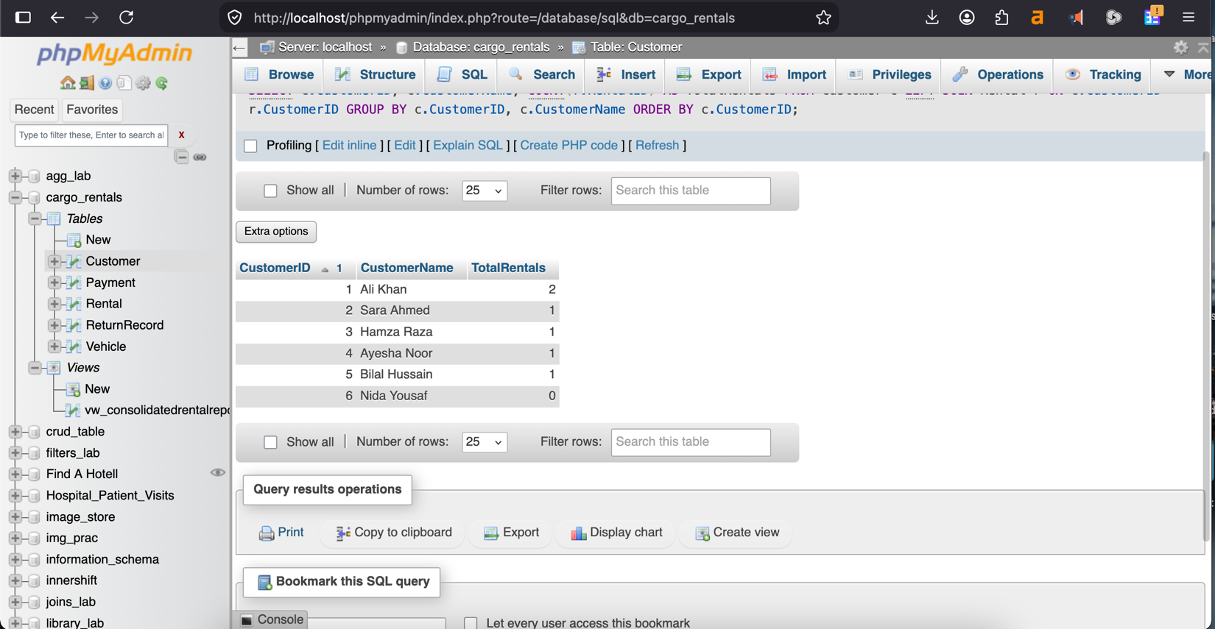
5. View — vw_RentalReport
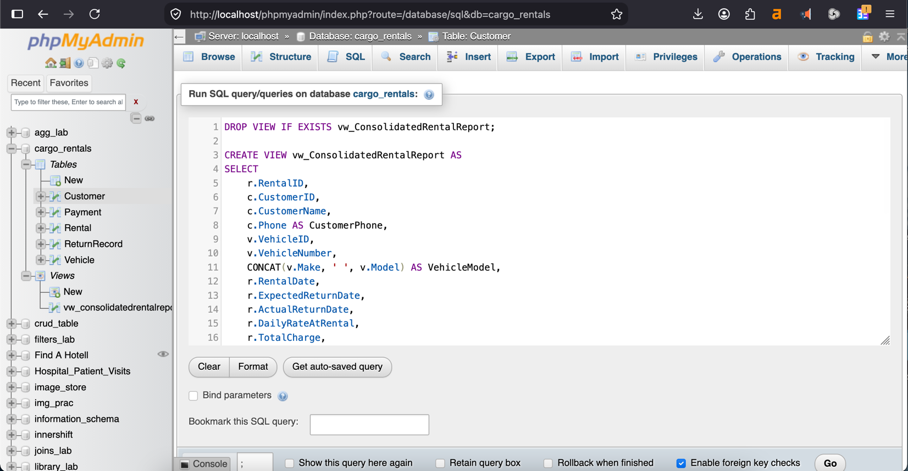
The view joins Customers, Vehicles, Rentals and Payments into a single consolidated rental report (customer, vehicle, dates, charge, amount paid, balance).

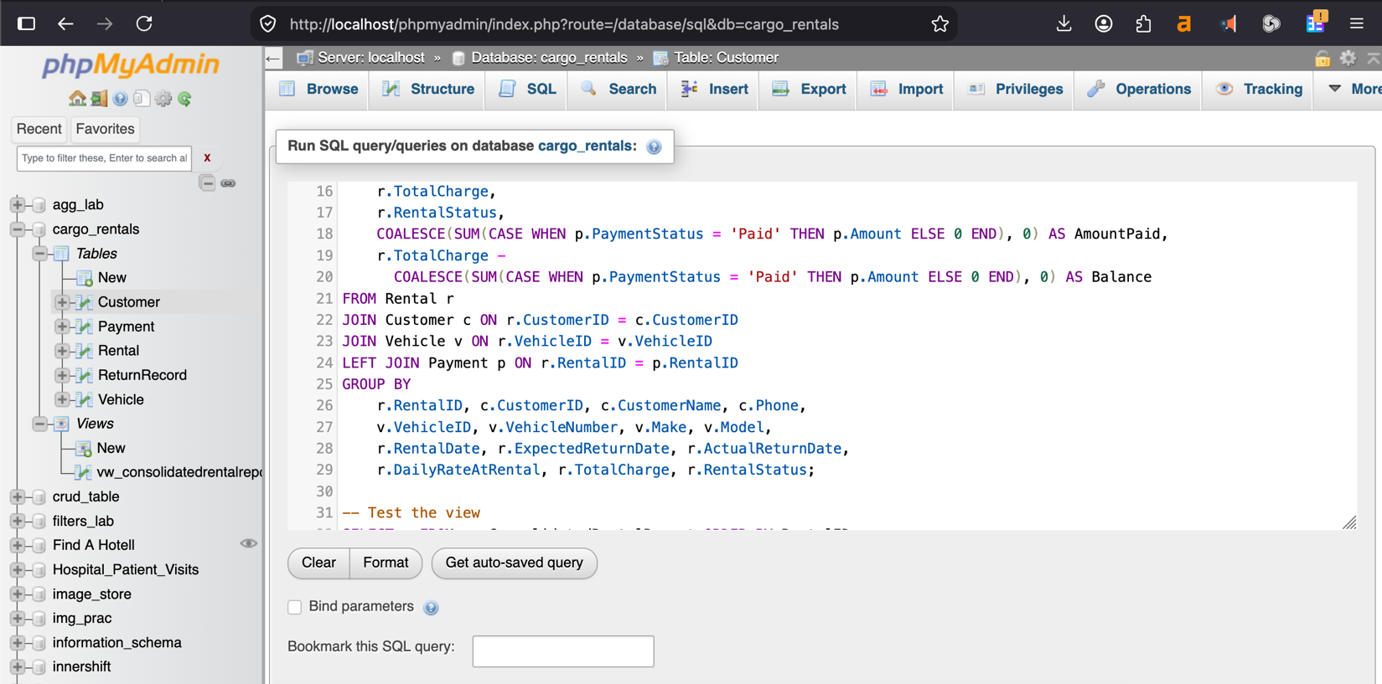
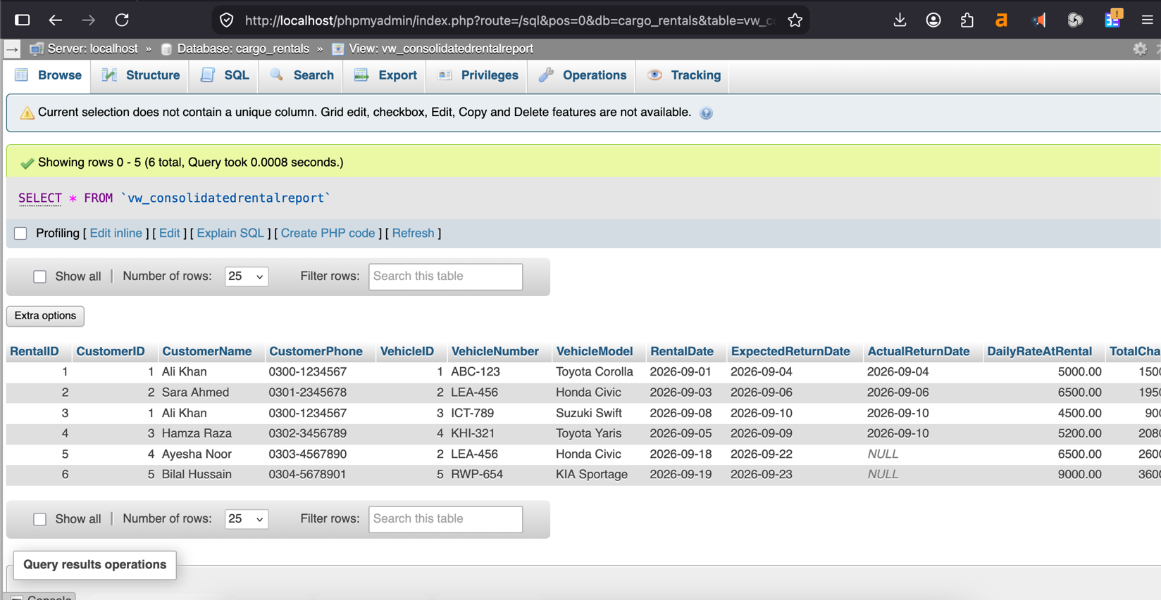
Output:

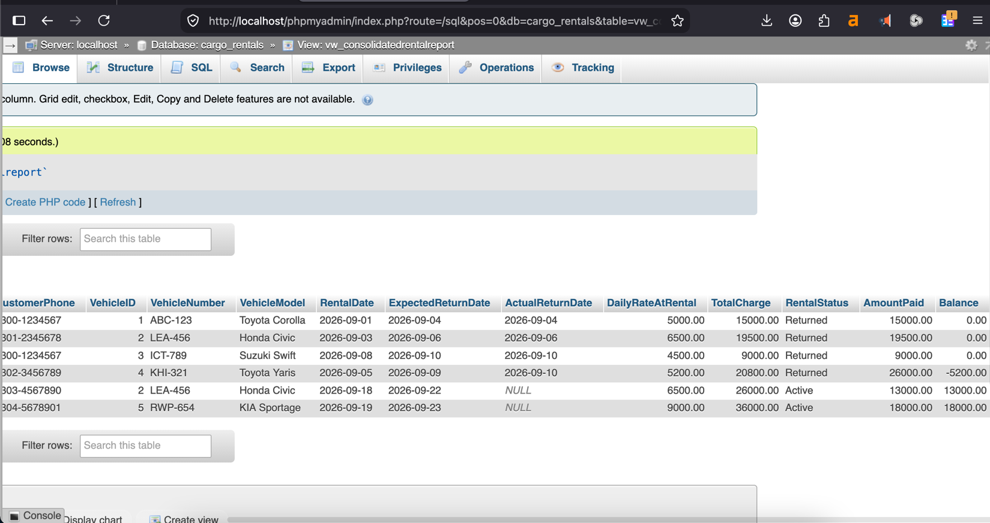

It is useful because management asked specifically for consolidated rental reports; instead of re-writing the four-table JOIN every time, staff (or a reporting tool) can simply run "SELECT * FROM vw_RentalReport". It also automatically shows any unpaid balance, which supports collections/follow-up.
6. Trigger — Enforcing "No Double Rental"
The scenario's core rule — "a vehicle should not be available for another rental while it is already rented" — is enforced with three triggers instead of relying on the application layer, so the rule holds no matter which program writes to the database:
- trg_before_rental_insert: blocks the INSERT with a SIGNAL error if the vehicle's Status is already 'Rented'.
- trg_after_rental_insert: automatically flips Vehicles.Status to 'Rented' once a rental is accepted.
- trg_after_rental_return: automatically flips Vehicles.Status back to 'Available' when ActualReturnDate is filled in.
This keeps Vehicles.Status always correct without any extra application code, and it is what makes the fast availability check in Section 7 possible.
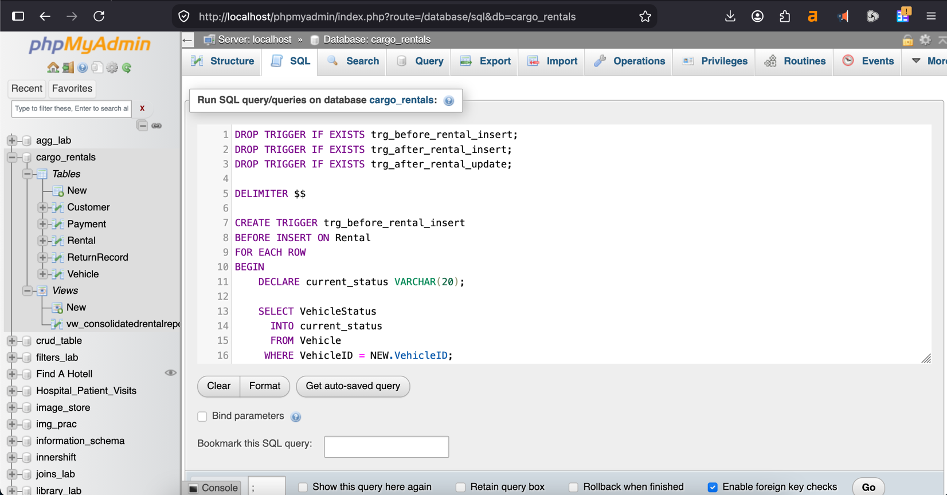
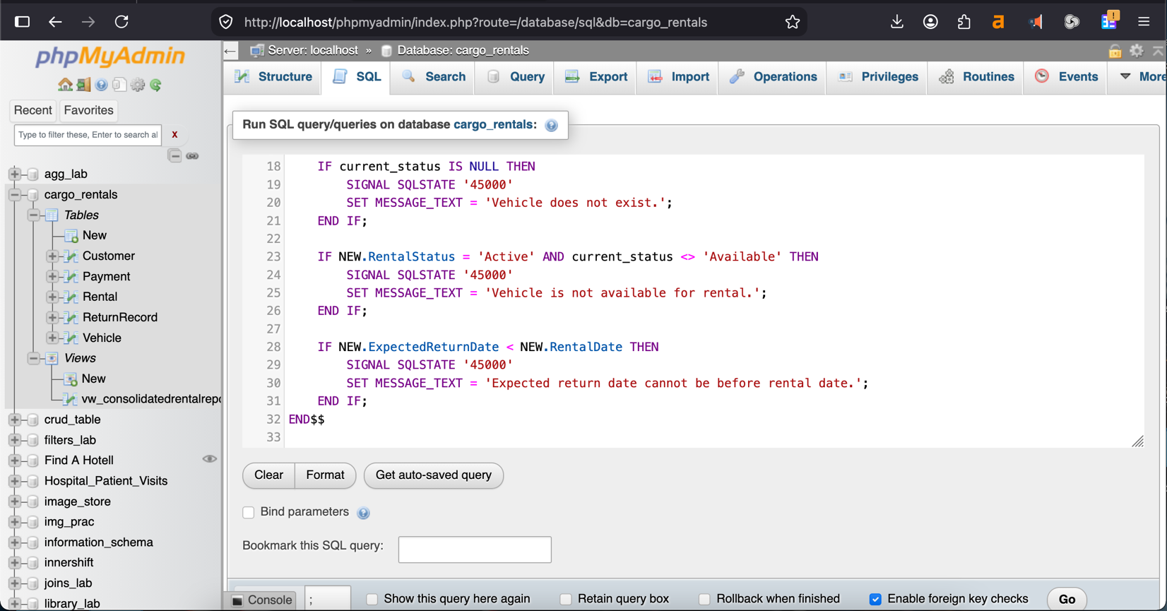

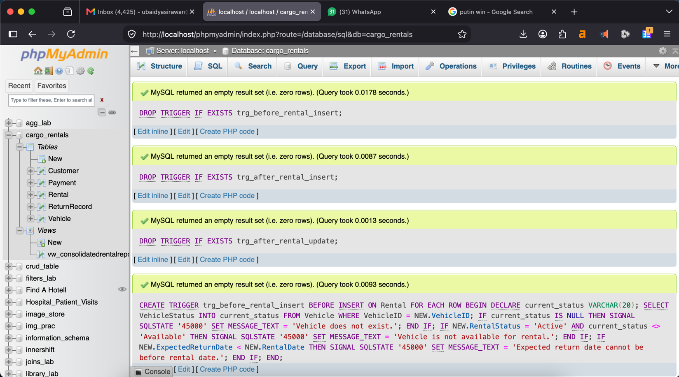

7. Stored Procedure — RegisterRental:
CarGo's staff need a simple, reliable way to book out a car at the counter: pick a customer, pick a vehicle, pick the dates, and get the charge — without doing the maths by hand each time. RegisterRental does exactly this in one call:
CALL RegisterRental(4, 'ABC-123', '2026-09-21', '2026-09-24');
-- Charge = DailyRate x days = 5000 x 3 = 15000
-- returns: NewRentalID, RentalCharge
- Input: CustomerID, VehicleNumber, RentalDate, ReturnDate.
- Logic: reads the vehicle's DailyRate, multiplies it by the number of days (DATEDIFF), and inserts the rental.
- Output: the new RentalID and the calculated charge, shown to the staff member immediately.
This keeps the charge calculation in one place (the database) instead of in every front-end screen, so it is always computed the same way and cannot be entered wrong by staff.
8. Optimization Analysis:
Problem: CarGo's staff need to know "is this vehicle free right now?" many times a day at the counter. The direct way to answer this is:
Q3 — LEFT JOIN Vehicles to Rentals and check for an open rental (ActualReturnDate IS NULL). This works, but it means re-scanning the entire rental history just to answer a yes/no question, and that history only keeps growing.
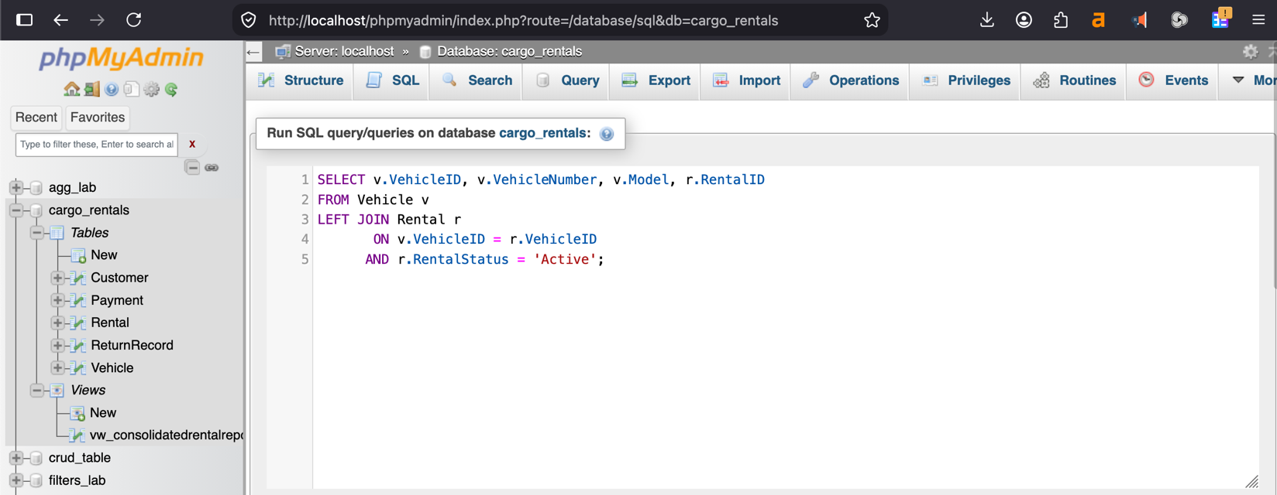

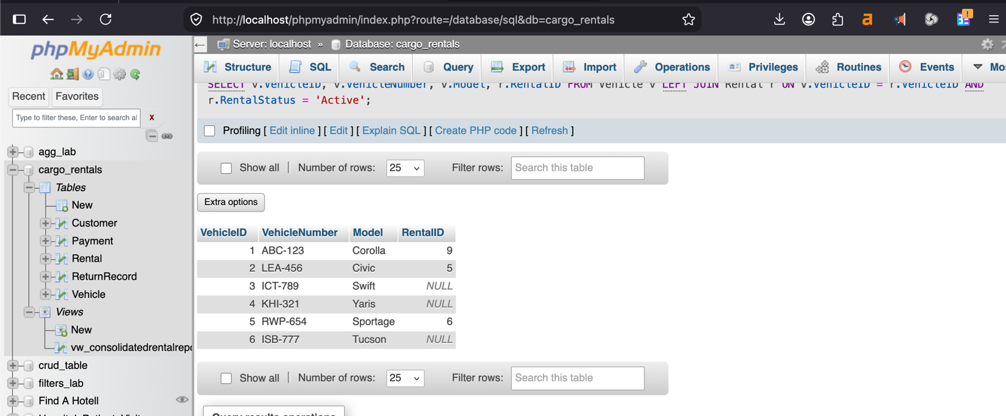
Improvement: the triggers in Section 6 already keep Vehicles.Status up to date every time a rental is made or returned. So the same availability question can be answered straight from Vehicles, with no join at all:
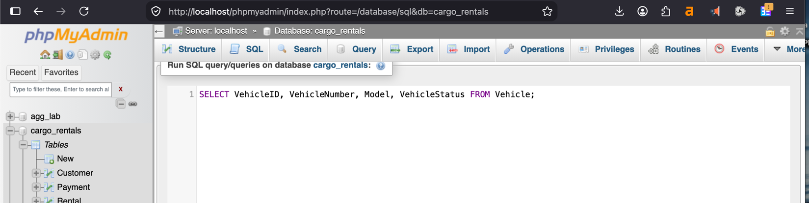
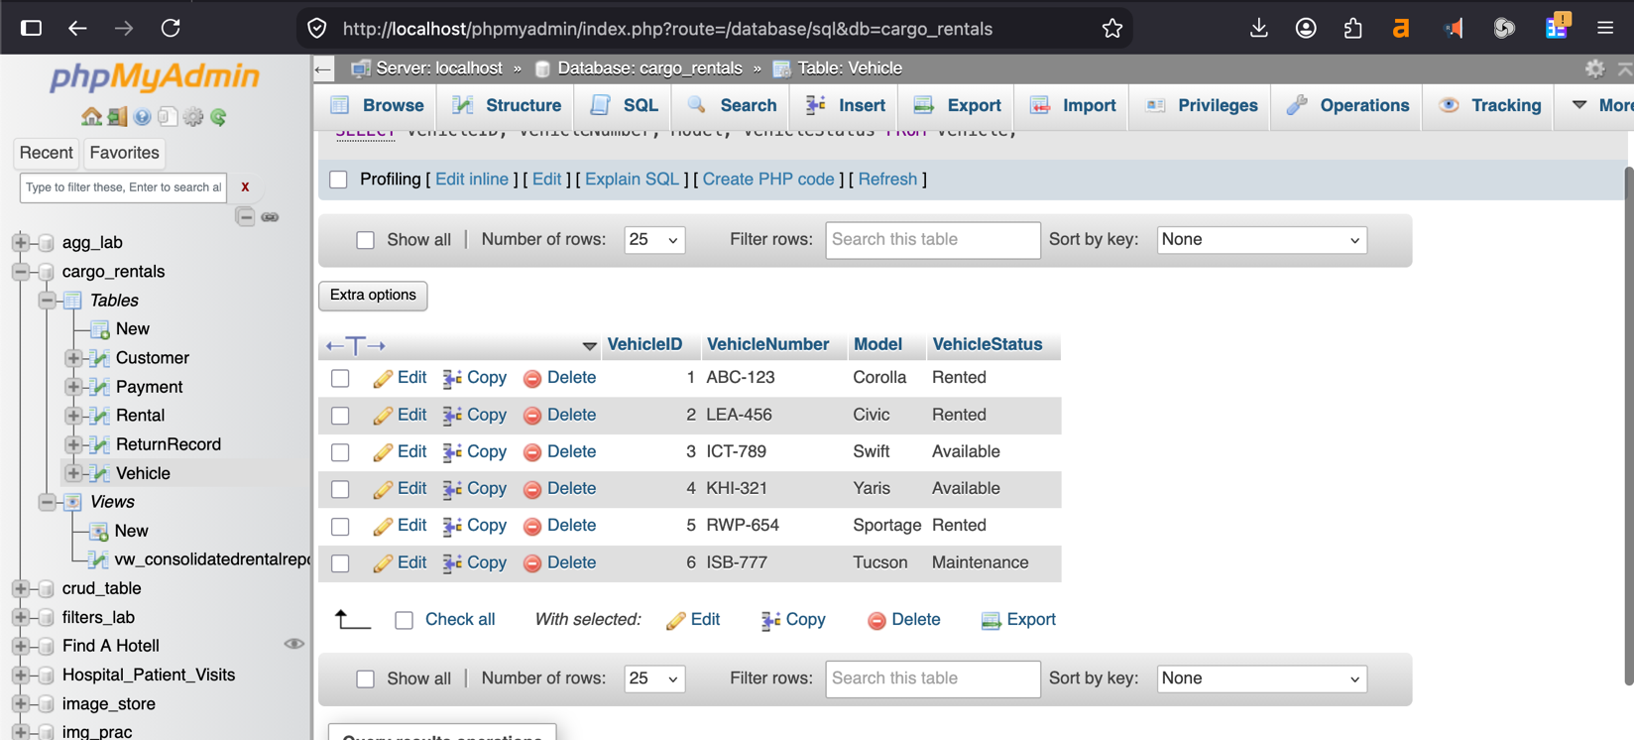
Why it's safe: Status is redundant data (it could always be re-derived from Rentals), but because the trigger keeps it accurate automatically, reading it directly is safe and far cheaper — the counter query no longer grows slower as rental history piles up. The foreign-key indexes from Section 2 still speed up Q1, Q2 and Q4, which genuinely do need the full rental history.
9. Conclusion:
CarGo Rentals started with one spreadsheet-style record mixing customer, vehicle, rental and payment details, which caused the exact problems described in the scenario: repeated customer/vehicle data, inconsistent edits, and no easy way to answer questions like "who has rented what" or "which cars are free right now." Normalizing that record into Customers, Vehicles, Rentals and Payments removed the redundancy and the update/insertion anomalies that came with it, while primary keys, foreign keys and CHECK constraints stop the bad data (duplicate customers, negative rates, vehicles double-booked) that the company was struggling with. The JOIN queries and the vw_RentalReport view directly give management the rental-history and currently-rented-vehicle reports it asked for; the triggers enforce the single most important business rule — a vehicle cannot be rented twice at once — automatically, at the database level; and the RegisterRental procedure gives staff a fast, error-free way to book a rental and calculate its charge. The optimization step then made the most frequent counter operation, checking vehicle availability, cheap and constant-time instead of scanning the whole rental history. Together, these pieces turn the original spreadsheet into a small relational database that is consistent, enforces its own rules, and answers CarGo's day-to-day questions directly.

