The University of Azad Jammu and Kashmir, Muzaffarabad


Software Construction & Development (SC&A)
(Lab – 01)

Name | Ubaidullah Awan
Roll no | 2024-SE-17
Semester | ^{5th}
Batch | 2024-2028
Lab | 01
Submitted to | Engr. Asma Javaid
Submission date | Oct 27, 2026

Department of Software Engineering

Q1. Use Case Diagram for an Online Ticket Reservation System
The online ticket reservation system allows a customer to search for available tickets, view schedules, select a ticket or seat, enter passenger details, pay online, and receive an electronic ticket. An administrator manages routes or events and schedules. A payment gateway processes payments.

Actors
- Customer: searches for tickets, checks availability, selects a ticket or seat, enters passenger details, pays, receives an e-ticket, and views or cancels a booking.
- Payment Gateway: processes the customer’s payment and returns the payment result.
- Administrator: manages routes/events and schedules and updates ticket availability.

Main Use Cases
- Register / Log In
- Search Tickets
- View Schedule and Availability
- Select Ticket / Seat
- Enter Passenger Details
- Make Payment
- Receive E-Ticket
- View / Cancel Booking
- Manage Routes and Schedules

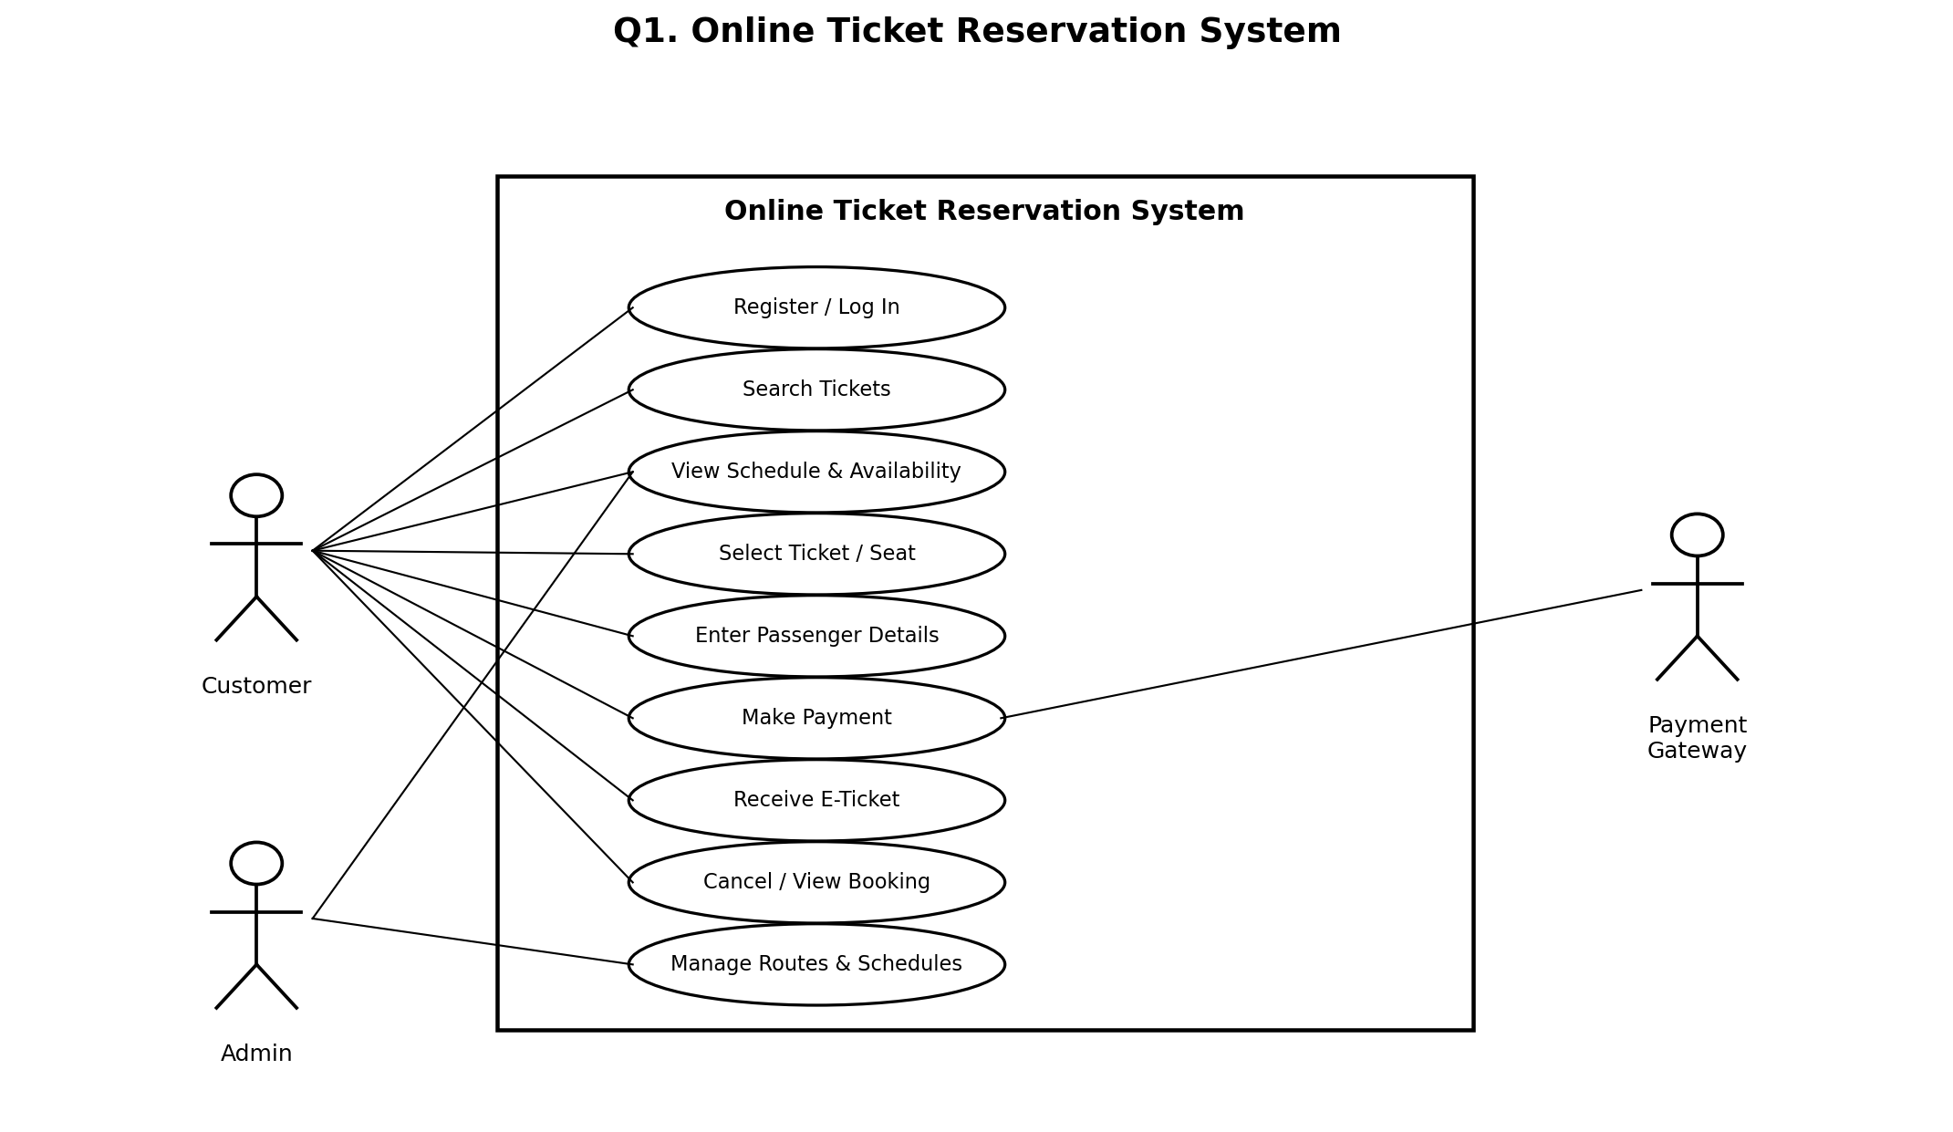
Use case diagram:

Q2. Credit Card Processing System

A. Actors
- Customer: selects an item, presents the credit card, reviews and signs the receipt, and returns the signed receipt.
- Vendor / Cashier: prepares the bill, operates the card reader, enters or requests the transaction amount, and provides the receipt.
- Bank / Card Authorization System: checks the available credit/balance and approves or declines the transaction. This external actor is included to represent the card authorization step.

B. Use Cases
- Select Item
- Prepare Bill
- Present / Swipe Card
- Request Transaction Amount
- Authorize / Process Payment
- Check Credit Limit / Balance
- Print Receipt / Statement
- Sign Receipt
- Return Signed Receipt

C. Basic Transaction Flow
- The customer selects the item to purchase.
- The vendor prepares a bill for the selected item.
- The customer presents the credit card and the vendor swipes it using the card reader.
- The transaction amount is entered/requested and sent for processing.
- The card-processing system checks the available credit and authorizes or declines the transaction.
- If approved, the machine prints a receipt or transaction statement and the vendor gives it to the customer.
- The customer signs the receipt and returns the signed copy to the vendor.

Use case diagram:
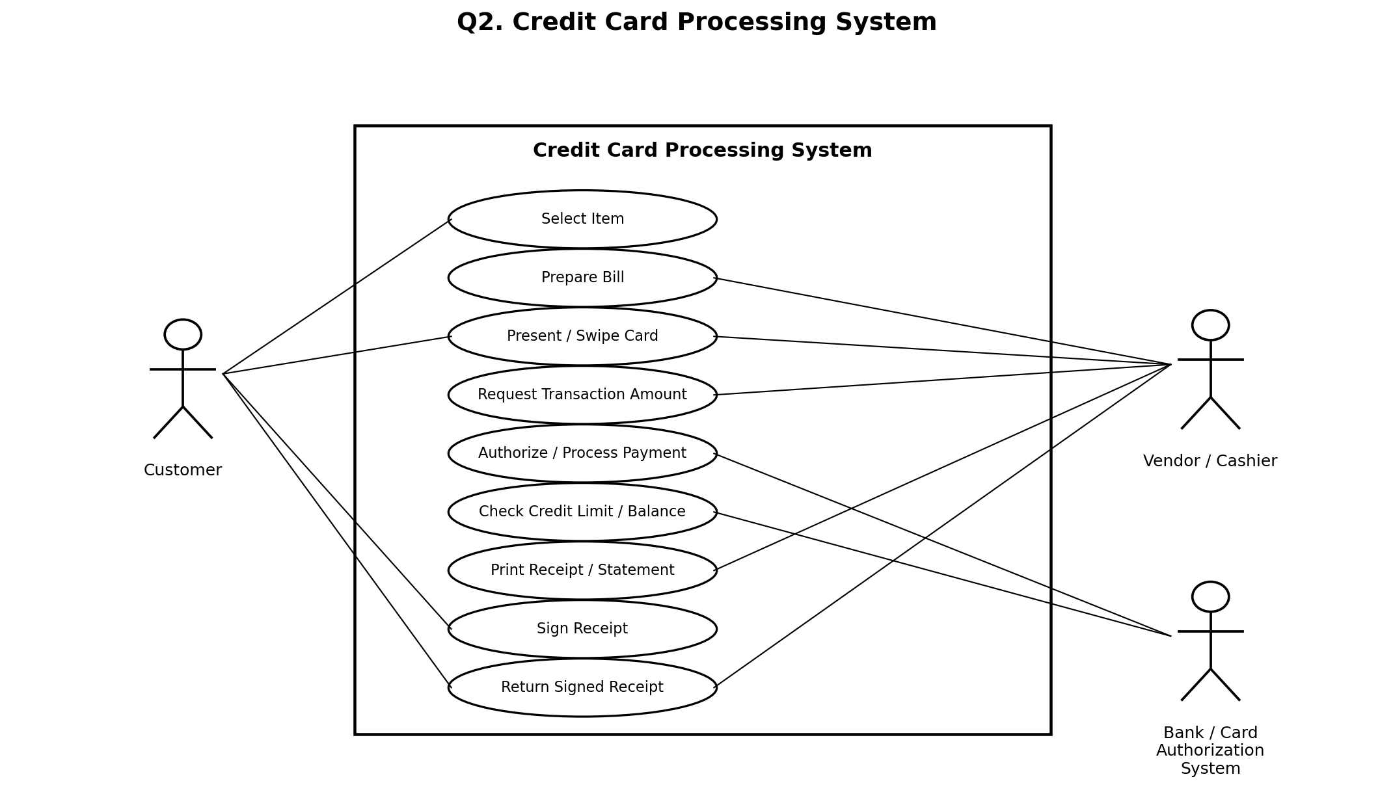

Note: The diagrams identify the main actors and functions. The bank/card authorization system is shown as an external actor because card payments normally require an issuer or payment processor.

